Relationship between asthma, obesity and other comorbidities: the Australasian Severe Asthma Registry

Authors
Hayley A Scott, PhD,^{a,b} Joy Lee, MBChB, PhD,^{c,d,e} Eve Denton, MD, PhD,^{d,e} Adrian Barnett, MD,^{f} Paul Griffiths, MD,^{g} Peter G Middleton, MD, PhD,^{h,i} Philip M Hansbro, PhD^{j}

Institutional Affiliations
ª School of Biomedical Sciences and Pharmacy, The University of Newcastle, University Drive, Callaghan, NSW, Australia.
^{b} Immune Health Research Program, Hunter Medical Research Institute, Lot 1 Kookaburra Circuit, New Lambton Heights, NSW, Australia.
^{c} Department of Respiratory and Sleep Medicine, Austin Health, Melbourne VIC, Australia.
^{d} School of Translational Medicine, Monash University, Melbourne, VIC, Australia.
^{e} Asthma, Allergy and Clinical Immunology, Respiratory Medicine, Alfred Hospital, Melbourne, VIC, Australia.
^{f} Department of Respiratory and Sleep Medicine, Mater Hospital, South Brisbane, QLD, Australia.
^{g} Department of Respiratory Medicine, North Shore Hospital, Auckland, New Zealand.
^{h} Department of Respiratory and Sleep Medicine, Westmead Hospital, NSW, Australia.
^{i} Ludwig Engel Centre for Respiratory Research, The Westmead Institute for Medical Research, NSW, Australia.
^{j} Centre for Inflammation, Centenary Institute and University of Technology Sydney, Faculty of Science, School of Life Sciences, Sydney, NSW, Australia.

Corresponding Author
Dr Hayley Scott, hayley.scott@newcastle.edu.au,
Phone: +61 2 4042 0113, Fax: +61 2 4042 0046
Immune Health Research Program, Level 2 West, Hunter Medical Research Institute.
Lot 1 Kookaburra Circuit, New Lambton Heights NSW 2305, Australia.

Appendix E1 – Supplementary Methods
Patients
Patients were >18 years old and had confirmed asthma demonstrated by variable airflow obstruction (VAO), either at their first visit or documented within the past 10 years. VAO was demonstrated by either bronchodilator response (>200ml and/or 12% post 400mcg salbutamol), airway hyperresponsiveness (AHR) to bronchial provocation challenge agent, peak flow variability (>12% over 1 week) or variability in forced expiratory volume in 1-second (FEV₁, >12% within last two months). Patients with severe asthma were on the highest level of recommended treatment [maximal inhaled corticosteroid (ICS) therapy with second controller] and had poor asthma control, as manifested by one or more of the following¹⁷:
- Poor symptom control: asthma control questionnaire (ACQ6) >1.5, asthma control test ACT <20);
- Frequent, severe exacerbations (>/2 bursts of systemic corticosteroids >3 days in the last 12 months;
- Serious exacerbation (hospitalisation, intensive care unit ICU stay or mechanical ventilation in the last 12months); and/or
- Persistent airflow limitation (FEV₁<80% predicted with reduced FEV₁/forced vital capacity, FVC).

The comparison group was adults with non-severe asthma who were also prescribed maintenance inhaled controller therapy and had partially-to-well controlled asthma, defined as an ACQ6 <1.5¹⁸ or ACT >20,¹⁹ and stable disease with no history of infection, exacerbation or change in preventer therapy in the previous 4 weeks. Patients with cognitive impairment, highly dependent on medical care, an inability to attend study visits, other primary lung disease, significant life-limiting comorbidity, or any history of malignancy were excluded. Patients who had a current asthma exacerbation were not enrolled during the exacerbation, but were eligible to be enrolled when stable.

Supplementary Tables

Table S1. Clinical asthma and inflammatory characteristics, according to asthma severity.
Characteristic | Severe asthma (n=882) | Non-severe asthma (n=137) | P-value

Lung function
Pre-bronchodilator FEV₁ %pred (n=765) | 64.9 (21.4) | 80.4 (20.1) | <0.001
Post-bronchodilator FEV₁ %pred (n=702) | 71.5 (21.9) | 83.2 (20.6) | <0.001
Pre-bronchodilator FVC %pred (n=756) | 82.1 (19.3) | 91.8 (23.3) | <0.001
Pre-bronchodilator %FEV₁/FVC (n=789) | 62.0 (13.8) | 69.6 (12.9) | <0.001
Asthma control (ACQ6) score (n=902) | 2.35 (1.31) | 0.95 (0.98) | <0.001
AQLQ score (n=888) | 4.55 (1.26) | 5.84 (0.99) | <0.001
Activity limitation domain | 4.65 (1.38) | 5.92 (1.04) | <0.001
Symptoms domain | 4.43 (1.46) | 5.79 (1.04) | <0.001
Emotional function domain | 4.46 (1.70) | 5.85 (1.24) | <0.001
Environmental stimuli domain | 4.70 (1.59) | 5.72 (1.14) | <0.001
Exacerbation in previous year (n, %) | 682/879 (77.6%) | 60/136 (44.1%) | <0.001
No. of exacerbations in previous year (n=506) | 1 (0, 3) | 0 (0, 0) | <0.001
Hospitalised (n, %) | 183/882 (20.8%) | 8/137 (5.8%) | <0.001
Intensive care unit stay (n, %) | 34/882 (3.9%) | 2/137 (1.5%) | 0.158
Visited emergency room (n, %) | 157/882 (17.8%) | 6/137 (4.4%) | <0.001
Unscheduled doctor visit (n, %) | 318/882 (36.1%) | 33/137 (24.1%) | 0.006
Oral corticosteroids prescribed (n, %) | 621/882 (70.4%) | 50/137 (36.5%) | <0.001

Airway inflammation
Sputum eosinophils (%) (n=118) | 2.5 (0.5, 12.3) | 1.1 (0.3, 4.5) | 0.039
Eosinophilic asthma (n, %) | 195/388 (50.3%) | 30/76 (39.5%) | 0.085
Sputum neutrophils (%) (n=116) | 31.0 (15.5, 57.3) | 19.1 (8.4, 40.0) | 0.129
Neutrophilic asthma (n, %) | 17/88 (19.3%) | 1/28 (3.6%) | 0.045
FeNO (ppb) (n=433) | 25 (12, 54) | 22 (14, 39) | 0.259

Definition of abbreviations: ACQ = Asthma Control Questionnaire; AQLQ = Asthma-related Quality of Life Questionnaire; FeNO = fractional exhaled nitric oxide; FEV₁ = forced expiratory volume in 1 second; FVC = forced vital capacity.

Table S2. Presence of pulmonary and extrapulmonary comorbidities, according to asthma severity.
Comorbidity (n, %) | Severe asthma  (n=882) | Non-severe asthma (n=137) | P-value

Pulmonary and upper airways
Allergic rhinitis | 437 (49.6%) | 68 (49.6%) | 0.985
Chronic rhinosinusitis | 78 (8.8%) | 8 (5.8%) | 0.239
Nasal polyps | 169 (19.2%) | 14 (10.2%) | 0.011
Vocal cord dysfunction | 58 (6.6%) | 4 (2.9%) | 0.096
Obstructive sleep apnea | 139 (15.8%) | 10 (7.3%) | 0.009
Bronchiectasis | 68 (7.7%) | 4 (2.9%) | 0.042
Chronic obstructive pulmonary disease | 83 (9.4%) | 5 (3.7%) | 0.026
Hyperventilation dysfunctional breathing | 20 (2.3%) | 1 (0.7%) | 0.239
Allergic bronchopulmonary aspergillosis | 42 (4.8%) | 3 (2.2%) | 0.173

Extra-pulmonary

Metabolic disease
Obesity | 423 (48.0%) | 40 (29.2%) | <0.001
Diabetes | 108 (12.2%) | 11 (8.0%) | 0.153

Cardiovascular disease
Myocardial infarction | 20 (2.3%) | 3 (2.2%) | 0.955
Stroke | 6 (0.7%) | 2 (1.5%) | 0.336
Other cardiovascular disease | 166 (18.8%) | 41 (29.9%) | 0.003

Psychiatric disease
Anxiety | 154 (17.5%) | 19 (13.9%) | 0.298
Depression | 177 (20.1%) | 22 (16.1%) | 0.271
Gastro-oesophageal reflux disease (GORD) | 376 (42.6%) | 45 (32.9%) | 0.030
Osteoporosis | 118 (13.4%) | 11 (8.0%) | 0.080

Allergic disease
Eczema | 146 (16.6%) | 26 (19.0%) | 0.481
Anaphylaxis | 61 (6.9%) | 8 (5.8%) | 0.641

Table S3. Prevalence of comorbidities that are being actively managed.
Comorbidity | Severe asthma | Non-severe asthma | P-value
Allergic rhinitis | 362/412 (87.9%) | 49/62 (79.0%) | 0.056
Nasal polyps | 141/160 (88.1%) | 12/13 (92.3%) | 0.650
Vocal cord dysfunction | 35/47 (74.5%) | 3/4 (75.0%) | 0.981
Obstructive sleep apnoea | 108/128 (84.4%) | 8/9 (88.9%) | 0.716
Bronchiectasis | 55/59 (93.2%) | 2/3 (66.7%) | 0.099
COPD | 72/75 (96.0%) | 4/4 (100.0%) | 0.683
GORD | 298/316 (94.3%) | 24/31 (77.4%) | 0.001
Definition of abbreviations: COPD = chronic obstructive pulmonary disease; GORD: gastro-oesophageal reflux disease.

Table S4. Mean differences in patient characteristics, according to asthma severity and obesity status.
 | BMI ≥30 versus BMI <30 |  | Severe versus Non-severe Asthma |  | Obesity x Asthma Severity Interaction
 | Mean Difference (95% CI) | P-value | Mean Difference (95% CI) | P-value | Obesity x Asthma Severity Interaction
Age (years) (n=934) | 1.5 (-0.4 to 3.5) | 0.116 | 1.7 (-1.5 to 3.5) | 0.302 | 0.073
Age at asthma onset (years) (n=849) | -0.8 (-3.4 to 1.9) | 0.571 | 0.3 (-3.4 to 4.6) | 0.879 | 0.309
Respiratory Medications
ICS dose (BDP µg/day) (n=952) | 157 (41, 274) | 0.008 | 971 (861 to 1082) | <0.001 | 0.990
OCS dose (mg/day) (n=952) | 0.6 (-0.3 to 1.5) | 0.184 | 1.6 (0.7 to 2.4) | 0.001 | 0.746
Pack years of current and ex-smokers (n=353) | 3.1 (-1.2 to 7.4) | 0.154 | 8.9 (3.9 to 13.9) | 0.001 | 0.072
Lung function
Pre-bronchodilator FEV₁ %pred (n=733) | -1.6 (-4.7 to 1.5) | 0.315 | -13.8 (-18.5 to -9.1) | <0.001 | 0.519
Post-bronchodilator FEV₁ %pred (n=673) | -1.6 (-5.0 to 1.7) | 0.331 | -10.7 (-15.7 to -5.7) | <0.001 | 0.600
Pre-bronchodilator FVC %pred (n=724) | -5.2 (-8.3 to -2.1) | 0.001 | -8.4 (-13.8 to -2.1) | 0.002 | 0.212
Pre-bronchodilator %FEV₁/FVC (n=745) | 3.1 (1.1 to 5.1) | 0.003 | -7.9 (-11.0 to -4.8) | <0.001 | 0.013
Asthma control (ACQ) score (n=853) | 0.33 (0.16 to 0.50) | <0.001 | 1.21 (0.99 to 1.43) | <0.001 | 0.237
AQLQ score (n=837) | -0.36 (-0.54 to -0.19) | <0.001 | -1.04 (-0.54 to -0.19) | <0.001 | 0.137
Activity limitation domain | -0.45 (-0.63 to -0.27) | <0.001 | -1.00 (-0.63 to -0.27) | <0.001 | 0.097
Symptoms domain | -0.32 (-0.51 to -0.13) | 0.001 | -1.10 (-1.36 to -0.84) | <0.001 | 0.264
Emotional function domain | -0.27 (-0.50 to -0.05) | 0.018 | -1.17 (-1.47 to -0.86) | <0.001 | 0.403
Environmental stimuli domain | -0.30 (-0.51 to -0.09) | 0.005 | -0.79 (-1.07 to -0.51) | <0.001 | 0.079
No. of exacerbations in previous year (n=455) | 0.4 (-0.1 to 0.8) | 0.122 | 1.0 (0.5 to 1.5) | <0.001 | 0.848
Airway Inflammation
Sputum %eosinophils (n=116) | -3.2 (-8.3 to 1.8) | 0.205 | 5.5 (-0.1 to 11.1) | 0.055 | 0.386
Sputum %neutrophils (n=115) | 12.1 (1.7 to 22.4) | 0.023 | 4.5 (-9.0 to 17.9) | 0.512 | 0.879
FeNO (ppb) (n=433) | -6.5 (-14.6 to 1.6) | 0.113 | 3.9 (-5.1 to 12.9) | 0.396 | 0.364

ANCOVA models adjusted for asthma severity, obesity, inhaled corticosteroid dose (beclomethasone dipropionate equivalents/day), oral corticosteroid dose (mg/day), biologic use (yes/no) and smoking status (never/ex/current). Definition of abbreviations: ACQ = Asthma Control Questionnaire; AQLQ = Asthma-related Quality of Life Questionnaire; BDP = beclomethasone dipropionate; FeNO = fractional exhaled nitric oxide; FEV₁ = forced expiratory volume in 1 second; FVC = forced vital capacity; ICS = inhaled corticosteroid; OCS = oral corticosteroid.

Table S5. Patient characteristics, according to asthma severity and availability of sputum data.
Characteristic | Severe asthma |  |  | Non-severe asthma
Characteristic | Sputum Data Available (n=89) | Sputum Data Not Available (n=793) | P-value | Sputum Data Available (n=28) | Sputum Data Not Available (n=109) | P-value
BMI (kg/m²) (n=1,019) | 31.2 (7.9) | 30.8 (8.1) | 0.731 | 28.0 (6.3) | 28.4 (5.6) | 0.776
Sex (%female) (n=1,017) | 53.9% | 63.6% | 0.074 | 53.6% | 58.7% | 0.623
Age (years) (n=1,000) | 56.4 (14.4) | 54.5 (14.9) | 0.243 | 55.1 (17.2) | 53.8 (16.5) | 0.728
Age at asthma onset (years) (n=881) | 27.5 (21.0) | 22.5 (19.0) | 0.043 | 15.9 (16.2) | 24.6 (20.9) | 0.051

Respiratory Medications
ICS dose (BDP µg/day) (n=1,018) | 2000 (1600, 2000) | 1600 (1000, 2000) | <0.001 | 800 (400, 1300) | 800 (400, 1000) | 0.579
OCS dose for OCS users (mg/day) (n=981) | 10 (5, 13) | 10 (5, 15) | 0.809 | - | 10 (8, 25)
Pack years of current and ex-smokers (n=372) | 12 (4, 26) | 11 (4, 27) | 0.640 | 7 (1, 31) | 7 (1, 16) | 0.572

Lung function
Pre-bronchodilator FEV₁ %pred (n=765) | 71.8 (22.4) | 64.0 (21.0) | 0.002 | 81.9 (17.8) | 80.0 (20.8) | 0.667
Post-bronchodilator FEV₁ %pred (n=702) | 76.9 (22.5) | 70.7 (21.8) | 0.025 | 84.7 (16.8) | 82.7 (21.6) | 0.667
Pre-bronchodilator FVC %pred (n=756) | 83.0 (18.4) | 82.0 (19.5) | 0.646 | 88.3 (12.3) | 92.8 (25.5) | 0.397
Pre-bronchodilator %FEV₁/FVC (n=789) | 66.3 (14.3) | 61.4 (13.6) | 0.003 | 72.5 (12.4) | 68.8 (12.9) | 0.202
Asthma control (ACQ6) score (n=902) | 1.92 (1.11) | 2.40 (1.32) | 0.001 | 0.74 (0.45) | 1.00 (1.07) | 0.201
AQLQ score (n=888) | 5.04 (1.22) | 4.49 (1.37) | <0.001 | 6.01 (0.69) | 5.80 (1.05) | 0.307
Activity limitation domain | 5.18 (1.25) | 4.58 (1.39) | <0.001 | 6.04 (0.88) | 5.88 (1.08) | 0.477
Symptoms domain | 4.86 (1.33) | 4.38 (1.46) | 0.004 | 5.96 (0.63) | 5.74 (1.12) | 0.322
Emotional function domain | 5.06 (1.54) | 4.39 (1.70) | <0.001 | 6.12 (0.87) | 5.78 (1.31) | 0.196
Environmental stimuli domain | 5.15 (1.51) | 4.64 (1.59) | 0.005 | 5.88 (0.98) | 5.68 (1.18) | 0.421
No. of exacerbations in previous year (n=506) | 0 (0, 0) | 1 (0, 3) | <0.001 | 0 (0, 0) | 0 (0, 0) | 0.150
FeNO (ppb) (n=433) | 13 (6, 22) | 29 (13, 63) | <0.001 | 19 (12, 25) | 25 (16, 40) | 0.040

BMI = body mass index; ICS = inhaled corticosteroid; BDP = beclomethasone dipropionate; OCS = oral corticosteroid; AQLQ = asthma-related quality of life; FeNO = fractional exhaled nitric oxide; - no observations.

Table S6. Comorbidities present in patients, according to asthma severity and obesity status.
Comorbidity (n, %) | Severe Asthma |  |  | Non-severe Asthma |  |  | P-value*
Comorbidity (n, %) | BMI <30kg/m²  (n=459) | BMI ≥30 kg/m²  (n=423) | P-value | BMI <30 kg/m²  (n=97) | BMI ≥30 kg/m²  (n=40) | P-value | P-value*
Upper airways and Pulmonary
Allergic rhinitis | 228 (49.7%) | 209 (49.4%) | 0.938 | 50 (51.6%) | 18 (45.0%) | 0.486 | 0.921
Chronic rhinosinusitis | 39 (8.5%) | 39 (9.2%) | 0.706 | 5 (5.2%) | 3 (7.5%) | 0.595 | 0.629
Nasal polyps | 88 (19.2%) | 81 (19.2%) | 0.993 | 7 (7.2%) | 7 (17.5%) | 0.071 | 0.037
Vocal cord dysfunction | 24 (5.2%) | 34 (8.0%) | 0.093 | 1 (1.0%) | 3 (7.5%) | 0.041 | 0.048
Obstructive sleep apnoea | 33 (7.2%) | 106 (25.1%) | <0.001 | 4 (4.1%) | 6 (15.0%) | 0.026 | <0.001
Bronchiectasis | 39 (8.5%) | 29 (6.9%) | 0.361 | 3 (3.1%) | 1 (2.5%) | 0.851 | 0.167
Chronic obstructive pulmonary disease | 47 (10.2%) | 36 (8.5%) | 0.380 | 1 (1.0%) | 4 (10.0%) | 0.011 | 0.033
Hyperventilation dysfunctional breathing | 9 (2.0%) | 11 (2.6%) | 0.524 | 1 (1.0%) | 0 (0.0%) | 0.519 | 0.576
Allergic bronchopulmonary aspergillosis | 32 (7.0%) | 10 (2.4%) | 0.001 | 2 (2.1%) | 1 (2.5%) | 0.873 | 0.005
Extrapulmonary
Metabolic disease
Diabetes | 28 (6.1%) | 80 (18.9%) | <0.001 | 4 (4.1%) | 7 (17.5%) | 0.009 | <0.001
Cardiovascular disease
Heart attack | 10 (2.2%) | 10 (2.4%) | 0.853 | 2 (2.1%) | 1 (2.5%) | 0.873 | 0.996
Stroke | 1 (0.2%) | 5 (1.2%) | 0.082 | 0 (0.0%) | 2 (5.0%) | 0.027 | 0.005
Other cardiovascular disease | 75 (16.3%) | 91 (21.5%) | 0.050 | 22 (22.7%) | 19 (47.5%) | 0.004 | <0.001
Psychiatric disease
Anxiety | 63 (13.7%) | 91 (21.5%) | 0.002 | 14 (14.4%) | 5 (12.5%) | 0.766 | 0.014
Depression | 73 (15.9%) | 104 (24.6%) | 0.001 | 16 (16.5%) | 6 (15.0%) | 0.828 | 0.008
Gastro-oesophageal reflux disease | 173 (37.7%) | 203 (48.0%) | 0.002 | 24 (24.7%) | 21 (52.5%) | 0.002 | <0.001
Osteoporosis | 63 (13.7%) | 55 (13.0%) | 0.753 | 7 (7.2%) | 4 (10.0%) | 0.586 | 0.338
Allergic disease
Eczema | 67 (14.6%) | 79 (18.7%) | 0.103 | 16 (16.5%) | 10 (25.0%) | 0.248 | 0.206
Anaphylaxis | 26 (5.7%) | 35 (8.3%) | 0.127 | 5 (5.2%) | 3 (7.5%) | 0.595 | 0.417

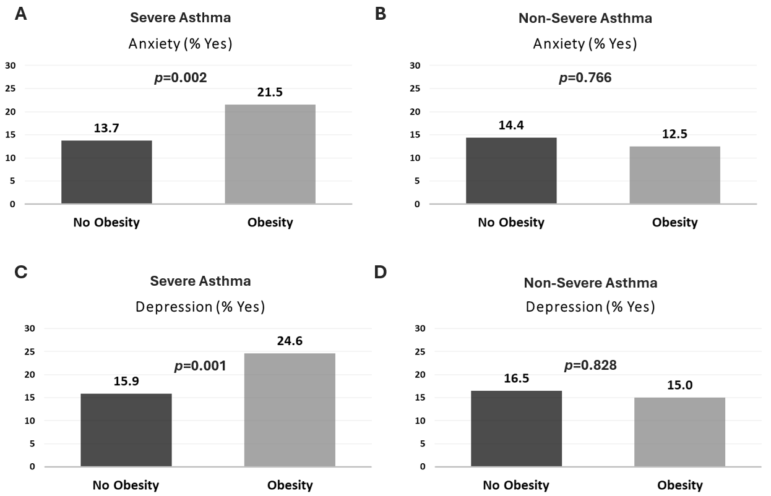
Figure S1. Proportion of patients who had anxiety with a) severe asthma, and b) non-severe asthma, according to obesity status. And proportion of patients who had depression with c) severe asthma, and d) non-severe asthma, according to obesity status.

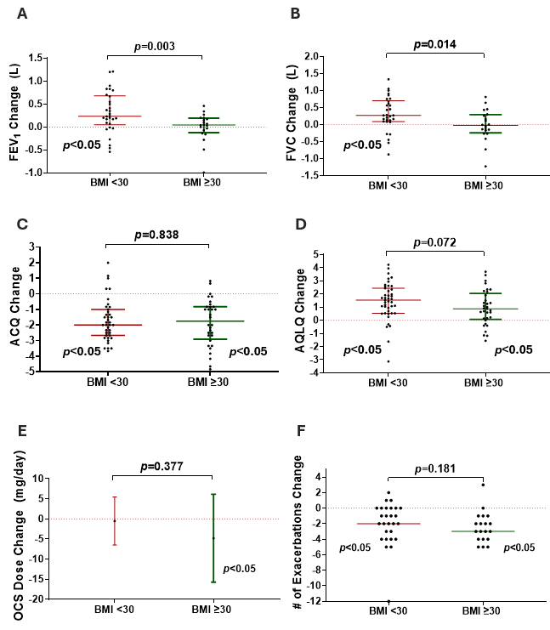
Figure S2. Change in a) FEV₁, b) FVC, c) asthma control (ACQ6), d) asthma-related quality of life (AQLQ score), e) daily oral corticosteroid dose, and f) number of asthma exacerbations experienced in the preceding 12 months, in patients with severe asthma prescribed biologic therapy according to obesity status. P-values represent between group differences in change, while significant within group changes are also indicated.

