Supplementary Table S1. List of anti-cancer agents.
Categories | Anti-cancer agents
Cytotoxic  chemotherapy | 5-fluorouracil, azacytidine, belotecan, bleomycin, capecitabine, carboplatin, cisplatin, cyclophosphamide, cytarabine, dacarbazine, daunorubicin, decitabine, docetaxel, doxorubicin, epirubicin, etoposide, gemcitabine, gimeracil/oteracil/tegafur, ifosfamide, irinotecan, mercaptopurine, methotrexate, mitomycin C, oxaliplatin, paclitaxel, pemetrexed, vinblastine, vinorelbine
Immune checkpoint inhibitors | atezolizumab, durvalumab, ipilimumab, nivolumab, pembrolizumab

Supplementary Table S2. Clinical characteristics of the study population before and after matching in patients with advanced stage.
Characteristics | Before matching |  |  | After matching
Characteristics | CC cohort  n (%) | ICI cohort  n (%) | SMD | Matched CC cohort  n (%) | Matched ICI cohort  n (%) | SMD
Total, n | 17,900 | 11,068 | - | 11,064 | 11,064 | -
Sex*
Male | 14,163 (79.1) | 9,070 (81.9) | 0.071 | 8,994 (81.3) | 9,068 (82.0) | 0.017
Female | 3,737 (20.9) | 1,998 (18.1) | 0.071 | 2,070 (18.7) | 1,996 (18.0) | 0.017
Age*
< 55 | 1,302 (7.3) | 818 (7.4) | 0.004 | 871 (7.9) | 818 (7.4) | 0.018
55-64 | 3,954 (22.1) | 2,516 (22.7) | 0.015 | 2,544 (23.0) | 2,515 (22.7) | 0.006
65-74 | 6,942 (38.8) | 4,536 (41.0) | 0.045 | 4,456 (40.3) | 4,535 (41.0) | 0.015
≥ 75 | 5,702 (31.9) | 3,195 (28.9) | 0.064 | 3,193 (28.9) | 3,196 (28.9) | 0.001
Modified CCI score*
0–1 | 4,441 (24.8) | 2,835 (25.6) | 0.019 | 2,869 (25.9) | 2,835 (25.6) | 0.007
2–3 | 6,978 (39.0) | 4,268 (38.6) | 0.009 | 4,252 (38.4) | 4,268 (38.6) | 0.003
4–5 | 4,042 (22.6) | 2,535 (22.9) | 0.008 | 2,529 (22.9) | 2,533 (22.9) | 0.001
≥ 6 | 2,439 (13.6) | 1,430 (12.9) | 0.021 | 1,414 (12.8) | 1,428 (12.9) | 0.004
Comorbidities*
MI | 664 (3.7) | 431 (3.9) | 0.010 | 428 (3.9) | 429 (3.9) | < 0.001
CHF | 2,597 (14.5) | 1,602 (14.5) | 0.001 | 1,612 (14.6) | 1,600 (14.5) | 0.003
PVD | 4,782 (26.7) | 2,956 (26.7) | < 0.001 | 2,930 (26.5) | 2,953 (26.7) | 0.005
CVD | 3,246 (18.1) | 1,988 (18.0) | 0.004 | 1,997 (18.0) | 1,986 (18.0) | 0.003
CPD | 13,476 (75.3) | 8,214 (74.2) | 0.025 | 8,192 (74.0) | 8,212 (74.2) | 0.004
PUD | 6,792 (37.9) | 4,105 (37.1) | 0.018 | 4,116 (37.2) | 4,102 (37.1) | 0.003
Hepatic disease | 7,530 (42.1) | 4,580 (41.4) | 0.014 | 4,547 (41.1) | 4,579 (41.4) | 0.006
Renal disease | 1,161 (6.5) | 687 (6.2) | 0.011 | 676 (6.1) | 687 (6.2) | 0.004
Diabetes | 7,248 (40.5) | 4,633 (41.9) | 0.028 | 4,588 (41.5) | 4,631 (41.9) | 0.008
Rheumatic disease | 1,262 (7.1) | 693 (6.3) | 0.032 | 707 (6.4) | 691 (6.2) | 0.006
IBD | 63 (0.4) | 36 (0.3) | 0.005 | 37 (0.3) | 36 (0.3) | 0.002
Anemia | 4,302 (24.0) | 2,883 (26.0) | 0.047 | 2,838 (25.7) | 2,881 (26.0) | 0.009
CC, cytotoxic chemotherapy; CCI, Charlson’s comorbidity index; CHF, congestive heart failure; CPD, chronic pulmonary disease; CVD, cerebrovascular disease; IBD, inflammatory bowel disease; MI, myocardial infarction; PUD, peptic ulcer disease; PVD, peripheral vascular disease; SMD, standardized mean difference
*means covariates used for propensity score matching.

Supplementary Table S3. Clinical characteristics of the study population before and after matching in patients without lung resection surgery.
Characteristics | Before matching |  |  | After matching
Characteristics | CC cohort  n (%) | ICI cohort  n (%) | SMD | Matched CC cohort  n (%) | Matched ICI cohort  n (%) | SMD
Total, n | 22,382 | 12,817 | - | 12,816 | 12,816
Sex*
Male | 17,967 (80.3) | 10,586 (82.6) | 0.059 | 10,508 (82.0) | 10,586 (82.6) | 0.016
Female | 4,415 (19.7) | 2,231 (17.4) | 0.059 | 2,308 (18.0) | 2,230 (17.4) | 0.016
Age*
< 55 | 1,714 (7.7) | 976 (7.6) | 0.002 | 924 (7.2) | 976 (7.6) | 0.015
55-64 | 5,299 (23.7) | 3,000 (23.4) | 0.006 | 2,976 (23.2) | 3,000 (23.4) | 0.004
65-74 | 8,870 (39.6) | 5,297 (41.3) | 0.035 | 5,282 (41.2) | 5,297 (41.3) | 0.002
≥ 75 | 6,499 (29.0) | 3,544 (27.7) | 0.031 | 3,634 (28.4) | 3,543 (27.6) | 0.016
Modified CCI score*
0–1 | 5,629 (25.1) | 3,291 (25.7) | 0.012 | 3,190 (24.9) | 3,291 (25.7) | 0.018
2–3 | 8,892 (39.7) | 5,037 (39.3) | 0.009 | 5,112 (39.9) | 5,037 (39.3) | 0.012
4–5 | 4,963 (22.2) | 2,880 (22.5) | 0.007 | 2,901 (22.6) | 2,880 (22.5) | 0.004
≥ 6 | 2,898 (12.9) | 1,609 (12.6) | 0.012 | 1,613 (12.6) | 1,608 (12.5) | 0.001
Comorbidities*
MI | 833 (3.7) | 478 (3.7) | < 0.001 | 452 (3.5) | 478 (3.7) | 0.011
CHF | 3,120 (13.9) | 1,810 (14.1) | 0.005 | 1,815 (14.2) | 1,810 (14.1) | 0.001
PVD | 5,869 (26.2) | 3,347 (26.1) | 0.002 | 3,393 (26.5) | 3,346 (26.1) | 0.008
CVD | 3,975 (17.8) | 2,259 (17.6) | 0.004 | 2,267 (17.7) | 2,259 (17.6) | 0.002
CPD | 16,916 (75.6) | 9,556 (74.6) | 0.024 | 9,630 (75.1) | 9,555 (74.6) | 0.013
PUD | 8,426 (37.6) | 4,742 (37.0) | 0.013 | 4,738 (37.0) | 4,741 (37.0) | < 0.001
Hepatic disease | 9,330 (41.7) | 5,286 (41.2) | 0.009 | 5,344 (41.7) | 5,285 (41.2) | 0.009
Renal disease | 1,371 (6.1) | 759 (5.9) | 0.009 | 767 (6.0) | 759 (5.9) | 0.003
Diabetes | 8,946 (40.0) | 5,313 (41.5) | 0.030 | 5,302 (41.4) | 5,313 (41.5) | 0.002
Rheumatic disease | 1,520 (6.8) | 782 (6.1) | 0.028 | 810 (6.3) | 781 (6.1) | 0.009
IBD | 82 (0.4) | 41 (0.3) | 0.008 | 29 (0.2) | 41 (0.3) | 0.018
Anemia | 5,007 (22.4) | 3,232 (25.2) | 0.067 | 3,298 (25.7) | 3,232 (25.2) | 0.012
CC, cytotoxic chemotherapy; CCI, Charlson’s comorbidity index; CHF, congestive heart failure; CPD, chronic pulmonary disease; CVD, cerebrovascular disease; IBD, inflammatory bowel disease; MI, myocardial infarction; PUD, peptic ulcer disease; PVD, peripheral vascular disease; SMD, standardized mean difference
*means covariates used for propensity score matching.

Supplementary Table S4. Clinical characteristics of the study population before and after matching in radiotherapy-naïve patients.
Characteristics | Before matching |  |  | After matching
Characteristics | CC cohort  n (%) | ICI cohort  n (%) | SMD | Matched CC cohort  n (%) | Matched ICI cohort  n (%) | SMD
Total, n | 22,540 | 8,640 | - | 8,637 | 8,637 | -
Sex*
Male | 16,487 (73.1) | 7,119 (82.4) | 0.216 | 7,078 (81.9) | 7,116 (82.4) | 0.011
Female | 6,053 (26.9) | 1,521 (17.6) | 0.216 | 1,559 (18.1) | 1,521 (17.6) | 0.011
Age*
< 55 | 2,026 (9.0) | 551 (6.4) | 0.095 | 563 (6.5) | 551 (6.4) | 0.006
55-64 | 5,742 (25.5) | 1,779 (20.6) | 0.114 | 1,766 (20.4) | 1,779 (20.6) | 0.004
65-74 | 9,013 (40.0) | 3,577 (41.4) | 0.029 | 3,601 (41.7) | 3,577 (41.4) | 0.006
≥ 75 | 5,759 (25.6) | 2,733 (31.6) | 0.137 | 2,707 (31.3) | 2,730 (31.6) | 0.006
Modified CCI score*
0–1 | 5,415 (24.0) | 2,108 (24.4) | 0.009 | 2,094 (24.2) | 2,108 (24.4) | 0.004
2–3 | 9,095 (40.4) | 3,321 (38.4) | 0.039 | 3,281 (38.0) | 3,320 (38.4) | 0.009
4–5 | 5,158 (22.9) | 2,010 (23.3) | 0.009 | 2,029 (23.5) | 2,010 (23.3) | 0.005
≥ 6 | 2,872 (12.7) | 1,201 (13.9) | 0.034 | 1,233 (14.3) | 1,199 (13.9) | 0.011
Comorbidities*
MI | 767 (3.4) | 350 (4.1) | 0.035 | 346 (4.0) | 349 (4.0) | 0.002
CHF | 2,975 (13.2) | 1,311 (15.2) | 0.057 | 1,337 (15.5) | 1,309 (15.2) | 0.009
PVD | 5,727 (25.4) | 2,407 (27.9) | 0.056 | 2,451 (28.4) | 2,404 (27.8) | 0.012
CVD | 4,110 (18.2) | 1,620 (18.8) | 0.013 | 1,631 (18.9) | 1,619 (18.7) | 0.004
CPD | 17,323 (76.9) | 6,515 (75.4) | 0.034 | 6,508 (75.4) | 6,514 (75.4) | 0.002
PUD | 9,040 (40.1) | 3,235 (37.4) | 0.055 | 3,254 (37.7) | 3,235 (37.5) | 0.005
Hepatic disease | 9,705 (43.1) | 3,622 (41.9) | 0.023 | 3,634 (42.1) | 3,621 (41.9) | 0.003
Renal disease | 1,339 (5.9) | 564 (6.5) | 0.025 | 556 (6.4) | 562 (6.5) | 0.003
Diabetes | 8,968 (39.8) | 3,743 (43.3) | 0.072 | 3,757 (43.5) | 3,740 (43.3) | 0.004
Rheumatic disease | 1,624 (7.2) | 541 (6.3) | 0.037 | 554 (6.4) | 541 (6.3) | 00.006
IBD | 75 (0.3) | 28 (0.3) | 0.002 | 26 (0.3) | 28 (0.3) | 0.004
Anemia | 5,395 (23.9) | 2,365 (27.4) | 0.080 | 2,351 (27.2) | 2,362 (27.3) | 0.003
CC, cytotoxic chemotherapy; CCI, Charlson’s comorbidity index; CHF, congestive heart failure; CPD, chronic pulmonary disease; CVD, cerebrovascular disease; IBD, inflammatory bowel disease; MI, myocardial infarction; PUD, peptic ulcer disease; PVD, peripheral vascular disease; SMD, standardized mean difference
*means covariates used for propensity score matching.

Supplementary Table S5. Clinical characteristics of the study population before and after matching among patients receiving first-line therapy.
Characteristics | Before matching |  |  | After matching
Characteristics | CC cohort  n (%) | ICI cohort  n (%) | SMD | Matched CC cohort  n (%) | Matched ICI cohort  n (%) | SMD
Total, n | 31,180 | 6,072 | - | 6,072 | 6,072 | -
Sex*
Male | 24,370 (78.2) | 5,193 (85.5) | 0.182 | 5,190 (85.5) | 5,193 (85.5) | 0.001
Female | 6,810 (21.8) | 879 (14.5) | 0.182 | 882 (14.5) | 879 (14.5) | 0.001
Age*
< 55 | 2,732 (8.8) | 332 (5.5) | 0.120 | 345 (5.7) | 332 (5.5) | 0.009
55-64 | 8,219 (26.4) | 1,227 (20.2) | 0.141 | 1,187 (19.5) | 1,227 (20.2) | 0.017
65-74 | 12,856 (41.2) | 2,529 (41.7) | 0.009 | 2,573 (42.4) | 2,529 (41.7) | 0.015
≥ 75 | 7,373 (23.6) | 1,984 (32.7) | 0.208 | 1,967 (32.4) | 1,984 (32.7) | 0.006
Modified CCI score*
0–1 | 7,464 (23.9) | 1,422 (23.4) | 0.012 | 1,411 (23.2) | 1,422 (23.4) | 0.004
2–3 | 12,644 (40.6) | 2,304 (37.9) | 0.053 | 2,315 (38.1) | 2,304 (37.9) | 0.004
4–5 | 7,116 (22.8) | 1,455 (24.0) | 0.027 | 1,460 (24.0) | 1,455 (24.0) | 0.002
≥ 6 | 3,956 (12.7) | 891 (14.7) | 0.059 | 886 (14.6) | 891 (14.7) | 0.002
Comorbidities*
MI | 1,127 (3.6) | 256 (4.2) | 0.032 | 237 (3.9) | 256 (4.2) | 0.016
CHF | 4,163 (13.4) | 1,020 (16.8) | 0.100 | 1,028 (16.9) | 1,020 (16.8) | 0.004
PVD | 7,995 (25.6) | 1,741 (28.7) | 0.069 | 1,748 (28.8) | 1,741 (28.7) | 0.003
CVD | 5,676 (18.2) | 1,202 (19.8) | 0.041 | 1,202 (19.8) | 1,202 (19.8) | < 0.001
CPD | 24,046 (77.1) | 4,526 (74.5) | 0.061 | 4,531 (74.6) | 4,526 (74.5) | 0.002
PUD | 12,345 (39.6) | 2,232 (36.8) | 0.058 | 2,240 (36.9) | 2,232 (36.8) | 0.003
Hepatic disease | 13,385 (42.9) | 2,557 (42.1) | 0.017 | 2,570 (42.3) | 2,557 (42.1) | 0.004
Renal disease | 1,821 (5.8) | 436 (7.2) | 0.056 | 423 (7.0) | 436 (7.2) | 0.008
Diabetes | 12,480 (40.0) | 2,689 (44.3) | 0.087 | 2,691 (44.3) | 2,689 (44.3) | 0.001
Rheumatic disease | 2,144 (6.9) | 396 (6.5) | 0.014 | 425 (7.0) | 396 (6.5) | 0.019
IBD | 103 (0.3) | 20 (0.3) | < 0.001 | 21 (0.3) | 20 (0.3) | 0.003
Anemia | 6,952 (22.3) | 1,633 (26.9) | 0.109 | 1,613 (26.6) | 1,633 (26.9) | 0.007
CC, cytotoxic chemotherapy; CCI, Charlson’s comorbidity index; CHF, congestive heart failure; CPD, chronic pulmonary disease; CVD, cerebrovascular disease; IBD, inflammatory bowel disease; MI, myocardial infarction; PUD, peptic ulcer disease; PVD, peripheral vascular disease; SMD, standardized mean difference
*means covariates used for propensity score matching.

Supplementary Table S6. Clinical characteristics of the study population before and after matching among patients receiving immune checkpoint inhibitor monotherapy.
Characteristics | Before matching |  |  | After matching
Characteristics | CC cohort  n (%) | ICI cohort  n (%) | SMD | Matched CC cohort  n (%) | Matched ICI cohort  n (%) | SMD
Total, n | 33,200 | 7,990 | - | 7,988 | 7,988 | -
Sex*
Male | 25,195 (75.9) | 6,437 (80.6) | 0.111 | 6,466 (80.9) | 6,436 (80.6) | 0.010
Female | 8,005 (24.1) | 1,553 (19.4) | 0.111 | 1,522 (19.1) | 1,552 (19.4) | 0.010
Age*
< 55 | 3,055 (9.2) | 749 (9.4) | 0.006 | 697 (8.7) | 749 (9.4) | 0.023
55-64 | 8,800 (26.5) | 1,998 (25.0) | 0.034 | 2,042 (25.6) | 1,997 (25.0) | 0.013
65-74 | 13,497 (40.7) | 3,218 (40.3) | 0.008 | 3,184 (39.9) | 3,218 (40.3) | 0.009
≥ 75 | 7,848 (23.6) | 2,025 (25.3) | 0.040 | 2,065 (25.9) | 2,024 (25.3) | 0.012
Modified CCI score*
0–1 | 8,195 (24.7) | 2,148 (26.9) | 0.051 | 2,101 (26.3) | 2,147 (26.9) | 0.013
2–3 | 13,451 (40.5) | 3,210 (40.2) | 0.007 | 3,199 (40.0) | 3,210 (40.2) | 0.003
4–5 | 7,454 (22.5) | 1,714 (21.5) | 0.024 | 1,739 (21.8) | 1,714 (21.5) | 0.008
≥ 6 | 4,100 (12.3) | 918 (11.5) | 0.026 | 949 (11.9) | 917 (11.5) | 0.012
Comorbidities*
MI | 1,154 (3.5) | 273 (3.4) | 0.003 | 285 (3.6) | 273 (3.4) | 0.008
CHF | 4,324 (13.0) | 985 (12.3) | 0.021 | 993 (12.4) | 984 (12.3) | 0.003
PVD | 8,426 (25.4) | 1,952 (24.4) | 0.022 | 1,914 (24.0) | 1,951 (24.4) | 0.011
CVD | 5,915 (17.8) | 1,305 (16.3) | 0.039 | 1,350 (16.9) | 1,305 (16.3) | 0.015
CPD | 25,368 (76.4) | 5,962 (74.6) | 0.042 | 5,959 (74.6) | 5,961 (74.6) | 0.001
PUD | 13,013 (39.2) | 3,014 (37.7) | 0.030 | 3,060 (38.3) | 3,013 (37.7) | 0.012
Hepatic disease | 14,161 (42.7) | 3,250 (40.7) | 0.040 | 3,386 (42.4) | 3,249 (40.7) | 0.035
Renal disease | 1,887 (5.7) | 411 (5.1) | 0.024 | 425 (5.3) | 410 (5.1) | 0.008
Diabetes | 13,121 (39.5) | 3,203 (40.1) | 0.012 | 3,241 (40.6) | 3,201 (40.1) | 0.010
Rheumatic disease | 2,250 (6.8) | 464 (5.8) | 0.039 | 457 (5.7) | 463 (5.8) | 0.003
IBD | 112 (0.3) | 28 (0.4) | 0.002 | 28 (0.4) | 27 (0.3) | 0.002
Anemia | 7,350 (22.1) | 1,974 (24.7) | 0.061 | 1,991 (24.9) | 1,973 (24.7) | 0.005
CC, cytotoxic chemotherapy; CCI, Charlson’s comorbidity index; CHF, congestive heart failure; CPD, chronic pulmonary disease; CVD, cerebrovascular disease; IBD, inflammatory bowel disease; MI, myocardial infarction; PUD, peptic ulcer disease; PVD, peripheral vascular disease; SMD, standardized mean difference
*means covariates used for propensity score matching.

Supplementary Table S7. Clinical characteristics of the study population before and after matching in patients without systemic corticosteroid use.
Characteristics | Before matching |  |  | After matching
Characteristics | CC cohort  n (%) | ICI cohort  n (%) | SMD | Matched CC cohort  n (%) | Matched ICI cohort  n (%) | SMD
Total, n | 19,892 | 9,905 | - | 9,905 | 9,905 | -
Sex*
Male | 15,022 (75.5) | 8,133 (82.1) | 0.158 | 8,118 (82.0) | 8,133 (82.1) | 0.004
Female | 4,870 (24.5) | 1,772 (17.9) | 0.158 | 1,787 (18.0) | 1,772 (17.9) | 0.004
Age*
< 55 | 1,724 (8.7) | 799 (8.1) | 0022 | 793 (8.0) | 799 (8.1) | 0.002
55-64 | 5,151 (25.9) | 2,351 (23.7) | 0.050 | 2,364 (23.9) | 2,351 (23.7) | 0.003
65-74 | 8,048 (40.5) | 4,084 (41.2) | 0.016 | 4,117 (41.6) | 4,084 (41.2) | 0.007
≥ 75 | 4,969 (25.0) | 2,671 (27.0) | 0.045 | 2,631 (26.6) | 2,671 (27.0) | 0.009
Modified CCI score*
0–1 | 4,974 (25.0) | 2,592 (26.2) | 0.027 | 2,545 (25.7) | 2,592 (26.2) | 0.011
2–3 | 8,042 (40.4) | 3,882 (39.2) | 0.025 | 3,885 (39.2) | 3,882 (39.2) | 0.001
4–5 | 4,382 (22.0) | 2,180 (22.0) | < 0.001 | 2,207 (22.3) | 2,180 (22.0) | 0.007
≥ 6 | 2,494 (12.5) | 1,251 (12.6) | 0.003 | 1,268 (12.8) | 1,251 (12.6) | 0.005
Comorbidities*
MI | 695 (3.5) | 343 (3.5) | 0.002 | 351 (3.5) | 343 (3.5) | 0.004
CHF | 2,690 (13.5) | 1,328 (13.4) | 0.003 | 1,404 (14.2) | 1,328 (13.4) | 0.022
PVD | 5,027 (25.3) | 2,545 (25.7) | 0.010 | 2,533 (2.6) | 2,545 (25.7) | 0.003
CVD | 3,591 (18.1) | 1,739 (17.6) | 0.013 | 1,730 (17.5) | 1,739 (17.6) | 0.002
CPD | 1,509 (76.5) | 7,408 (74.8) | 0.039 | 7,454 (75.3) | 7,408 (74.8) | 0.011
PUD | 7,599 (38.2) | 3,706 (37.4) | 0.016 | 3,684 (37.2) | 3,706 (37.4) | 0.005
Hepatic disease | 8,400 (42.2) | 4,050 (40.9) | 0.027 | 4,048 (40.9) | 4,050 (40.9) | < 0.001
Renal disease | 1,193 (6.0) | 574 (5.8) | 0.009 | 567 (5.7) | 574 (5.8) | 0.003
Diabetes | 7,792 (39.2) | 4,136 (41.8) | 0.053 | 4,116 (41.6) | 4,136 (41.8) | 0.004
Rheumatic disease | 1,269 (6.4) | 584 (5.9) | 0.020 | 600 (6.1) | 584 (5.9) | 0.007
IBD | 60 (0.3) | 35 (0.4) | 0.009 | 37 (0.4) | 35 (0.4) | 0.003
Anemia | 4,356 (21.9) | 2,531 (25.6) | 0.087 | 2,541 (25.7) | 2,531 (25.6) | 0.002
CC, cytotoxic chemotherapy; CCI, Charlson’s comorbidity index; CHF, congestive heart failure; CPD, chronic pulmonary disease; CVD, cerebrovascular disease; IBD, inflammatory bowel disease; MI, myocardial infarction; PUD, peptic ulcer disease; PVD, peripheral vascular disease; SMD, standardized mean difference
*means covariates used for propensity score matching.

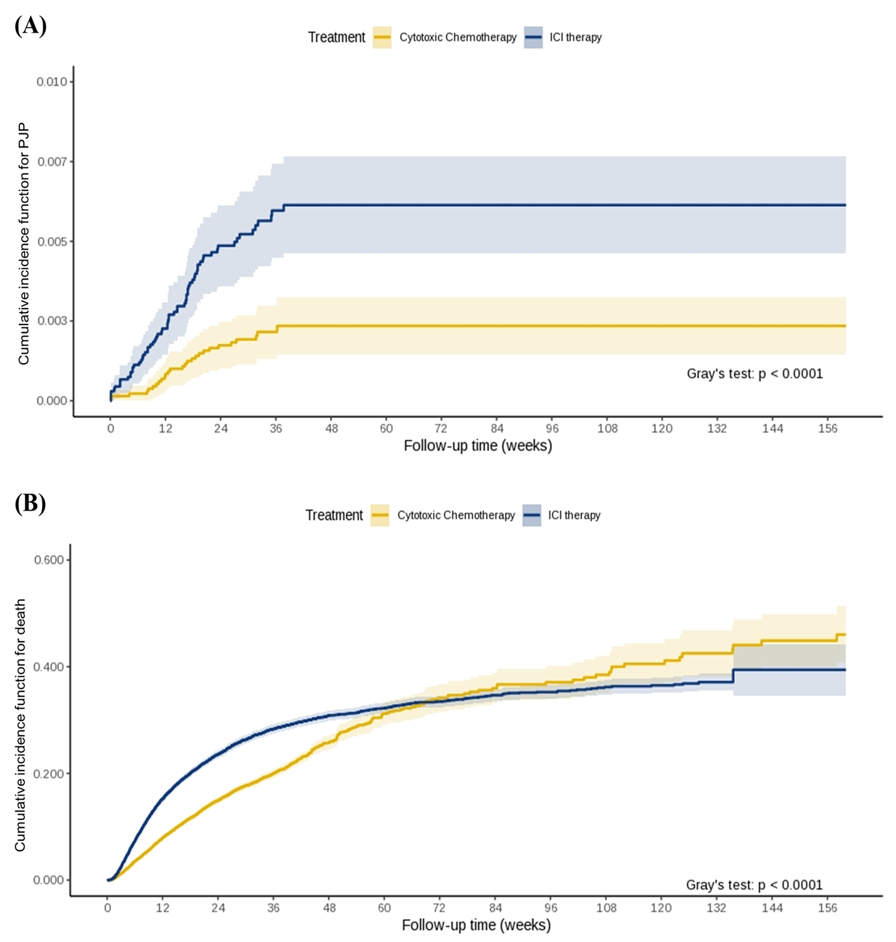
Supplementary Figure S1. Cumulative incidence functions for Pneumocystis jirovecii pneumonia (A) and death (B) in the competing-model.

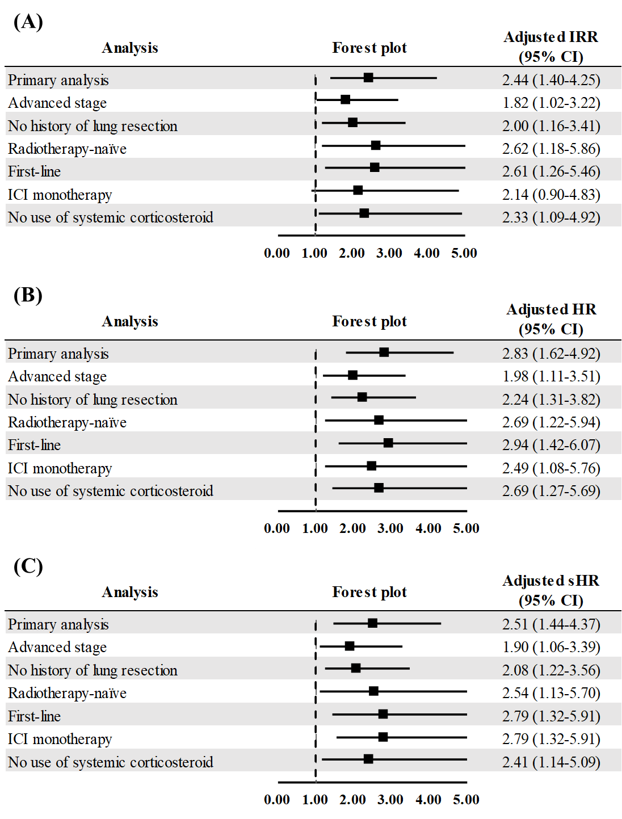
Supplementary Figure S2. Sensitivity analyses of the association between atezolizumab use and risk of Pneumocystis jirovecii pneumonia: (A), adjusted incidence rate ratios; (B), adjusted hazard ratios; (C), adjusted subdistribution hazard ratio. The analysis was adjusted for sex, age, modified Charlson’s comorbidity index, and comorbidities.
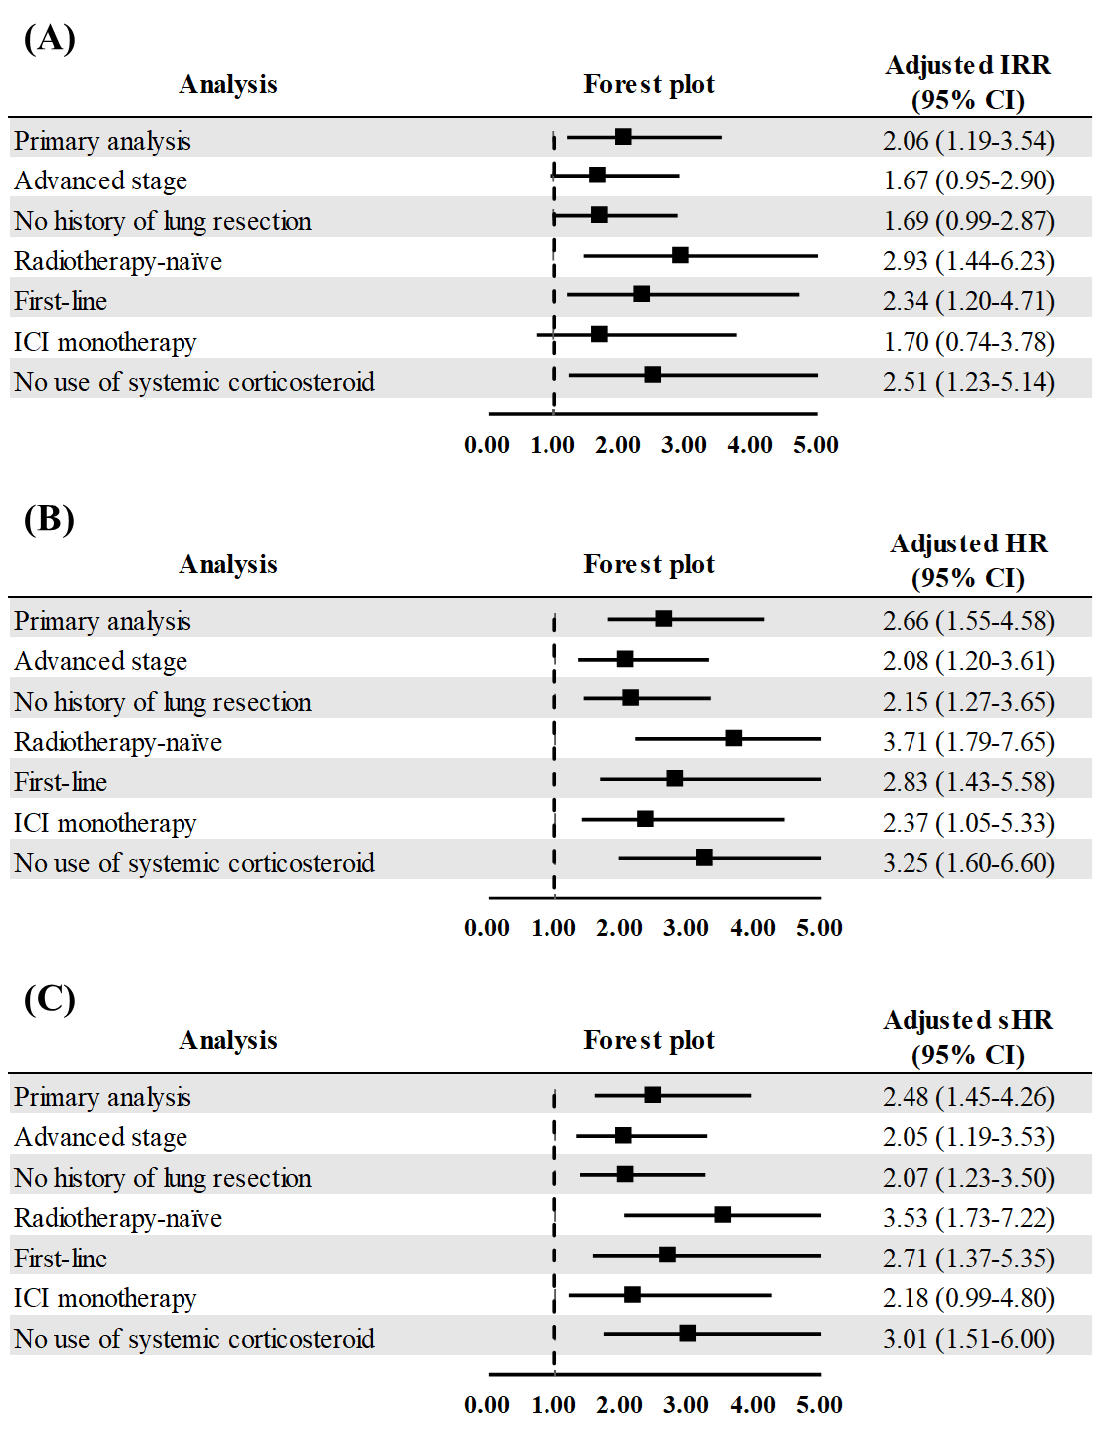
Supplementary Figure S3. Sensitivity analyses of the association between pembrolizumab use and risk of Pneumocystis jirovecii pneumonia: (A), adjusted incidence rate ratios; (B), adjusted hazard ratios; (C), adjusted subdistribution hazard ratio. The analysis was adjusted for sex, age, modified Charlson’s comorbidity index, and comorbidities.

