Supplementary material
Figure S1. Clinical trial participation.
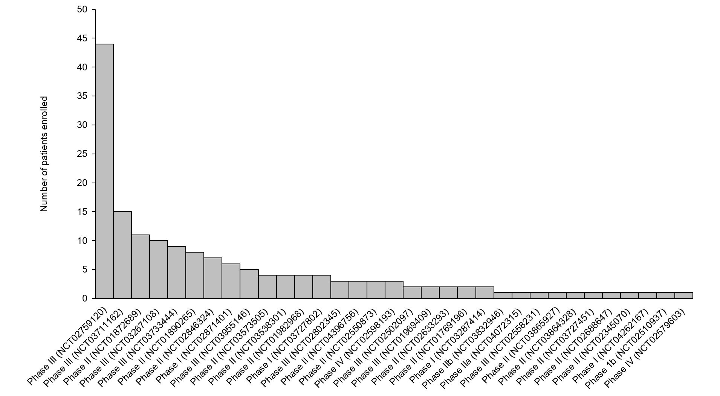

Table S1. Proportion of patients who met the criteria studied at any time during follow-up in the registry.
 | Met criterion, n (%)
Age ≥40 years | 1001 (100)
Definite or probable IPF, or possible IPF with lung biopsy | 929 (92.8)
FVC ≥45% predicted | 923 (92.2)
DLco ≥25–≤95% predicted | 888 (88.7)
FEV₁/FVC >0.7 | 962 (96.1)
No chronic liver disease | 886 (88.5)
No chronic kidney disease | 935 (93.4)
Met all criteria simultaneously | 703 (70.2)
N=1001.

Table S2. Characteristics at enrollment of patients who did not participate in a clinical trial based on whether they met all the criteria studied* during follow-up.
 | Met criteria (n=583) | Did not meet criteria (n=275)
Age, years | 69.9 (7.4) | 70.2 (8.9)
Male | 425 (72.9) | 210 (76.4)
Race
Non-Hispanic white | 538 (92.3) | 232 (88.5)
Black | 8 (1.4) | 7 (2.7)
Hispanic | 15 (2.6) | 18 (6.9)
Other | 22 (3.8) | 5 (1.9)
Body mass index, kg/m² | 29.2 (4.7) | 29.0 (5.5)
Number of comorbidities | 2.0 (1.0, 2.0) | 2.0 (1.0, 3.0)
Current or former smoker | 392 (67.2) | 182 (66.2)
Private insurance or managed care | 350 (60.0) | 155 (56.4)
FVC % predicted | 75.7 (15.6) | 66.3 (20.0)
DLco % predicted | 45.4 (13.6) | 36.8 (17.1)
GAP index [Ley 2012] | 4 (3, 5) | 5 (4, 6)
Composite Physiologic Index (CPI) [Wells 2003] | 50.2 (10.6) | 57.1 (13.2)
Definite IPF† | 397 (68.1) | 151 (54.9)
Oxygen use at rest | 75 (12.9) | 101 (36.7)
Oxygen use with activity | 96 (16.5) | 41 (14.9)
Antifibrotic therapy use | 310 (53.2) | 136 (49.5)
SGRQ total score | 36.9 (23.4, 50.2) | 45.2 (31.1, 62.5)
SGRQ activity score | 53.5 (35.8, 72.3) | 66.2 (47.6, 79.9)
SGRQ impact score | 23.8 (12.3, 38.9) | 32.1 (17.1, 51.8)
SGRQ symptoms score | 42.2 (29.1, 58.6) | 49.6 (32.9, 68.3)
Per capita income for ZIP code, $1000 | 30.8 (24.3, 42.0) | 31.2 (24.8, 40.5)
Household income for ZIP code, $1000 | 60.3 (47.5, 79.4) | 60.8 (48.1, 78.1)
Lives in rural area | 125 (21.4) | 49 (17.8)
Social deprivation index [US Center for Disease Control and Prevention] | 37.0 (18.0, 58.0) | 37.0 (17.0, 60.5)
Data are mean (SD), median (Q1, Q3) or n (%) of patients with available data.
*Age ≥40 years; definite or probable IPF, or possible IPF with lung biopsy; FVC ≥45% predicted; DLco ≥25–≤95% predicted; FEV₁/FVC >0.7; no history of chronic liver disease; no history of chronic kidney disease
†Based on ATS/ERS/JRS/ALAT 2011 guidelines [Raghu 2011].
Table S3. Comparison of univariable Cox model fits accounting and not accounting for site heterogeneity using robust standard error estimates.
 | Standard version |  | Robust version
 | Hazard ratio (95% CI) | P-value | Hazard ratio (95% CI) | P-value
Demographics
Age, per 5 years older | 0.84 (0.75, 0.93) | 0.001 | 0.84 (0.77, 0.91) | <0.001
Female | 0.76 (0.51, 1.13) | 0.174 | 0.76 (0.51, 1.13) | 0.177
Race |  | 0.747 |  | 0.729
Black vs non-Hispanic White | 0.44 (0.06, 3.13) |  | 0.44 (0.07, 2.85)
Hispanic vs non-Hispanic White | 0.87 (0.32, 2.34) |  | 0.87 (0.37, 2.04)
Other vs non-Hispanic White | 0.66 (0.21, 2.08) |  | 0.66 (0.16, 2.74)
BMI, per 1 kg/m² higher | 1.04 (1.00, 1.07) | 0.025 | 1.04 (1.01, 1.07) | 0.022
Insurance |  | 0.039 |  | 0.031
Medicare/Medicaid vs private insurance/managed care | 0.66 (0.46, 0.95) |  | 0.66 (0.46, 0.94)
Other/insured vs private insurance/managed care | 0.37 (0.09, 1.52) |  | 0.37 (0.09, 1.57)
Disease characteristics
FVC % predicted, per 5 units higher | 1.03 (0.99, 1.09) | 0.183 | 1.03 (0.98, 1.09) | 0.244
DLco % predicted, per 5 units higher | 1.00 (0.94, 1.06) | 0.970 | 1.00 (0.96, 1.05) | 0.961
Oxygen use |  | 0.313 |  | 0.364
With activity vs none | 0.87 (0.54, 1.40) |  | 0.87 (0.47, 1.59)
At rest vs none | 0.65 (0.36, 1.15) |  | 0.65 (0.36, 1.18)
Antifibrotic therapy use | 1.78 (1.26, 2.52) | 0.001 | 1.78 (1.17, 2.70) | 0.007
Patient-reported outcomes
SGRQ total score, per 5 units higher | 1.03 (0.99, 1.08) | 0.169 | 1.03 (0.99, 1.07) | 0.1112
SGRQ activity score, per 5 units higher | 1.02 (0.98, 1.06) | 0.318 | 1.02 (0.99, 1.05) | 0.270
SGRQ impact score, per 5 units higher | 1.03 (0.98, 1.07) | 0.236 | 1.03 (0.99, 1.06) | 0.122
SGRQ symptoms score, per 5 units higher | 1.03 (0.99, 1.07) | 0.168 | 1.03 (1.00, 1.06) | 0.088
Socioeconomic factors
Per capita income for ZIP code, per $10K higher | 0.96 (0.87, 1.07) | 0.500 | 0.96 (0.87, 1.07) | 0.504
Household income for patient’s ZIP code, per $10K higher | 1.01 (0.95, 1.08) | 0.757 | 1.01 (0.94, 1.08) | 0.779
Lives in rural area | 0.60 (0.37, 0.98) | 0.039 | 0.60 (0.35, 1.03) | 0.065
Social deprivation index score, per 10 units higher | 1.01 (0.95, 1.08) | 0.761 | 1.01 (0.94, 1.08) | 0.773

Table S4. Changes in SGRQ total score among patients who did not participate in a clinical trial but met all the criteria studied* and patients who participated in clinical trials.
 | Did not participate in a clinical trial | Participated in a clinical trial
SGRQ total score, n | 245 | 67
Value at clinical trial enrollment/criteria met | 36.0 (18.9) | 36.8 (14.6)
Change in value 12 months after clinical trial enrollment/criteria met | 3.2 (12.4) | 5.2 (16.9)
Unadjusted difference in change at 12 months | −2.03 (−5.67, 1.61)
Adjusted difference in change at 12 months† | −1.48 (−4.88, 1.92)
Data are mean (SD) or mean (95% CI). p>0.05 for all differences.
*Age ≥40 years; definite or probable IPF, or possible IPF with lung biopsy; FVC ≥45% predicted; DLco ≥25–≤95% predicted; FEV₁/FVC >0.7; no history of chronic liver disease; no history of chronic kidney disease.
†Adjusted for the value for SGRQ and FVC % predicted at trial enrollment/when criteria met and age, sex, and oxygen use at registry enrollment.

