Nicotine Formulation and Tobacco Flavour in Electronic Cigarette Aerosols Differentially Regulate Alveolar Epithelial Barrier Function and Gene Expression

Evaluation of ECAM-cell chamber device
To verify the reproducible delivery of the aerosol dose provided to each Transwell during the in vitro biological exposure runs, mass deposition was quantified in a series of independent validation experiments.. For this validation, a custom 3 mm thick piece of acrylic was placed into the base of each transwell in the BAT cell chamber. The exposure chamber setup houses six standard 12-well Transwell inserts (Costar 3460, Corning, New York, USA), each featuring a growth surface area of 1.12 cm² per insert.

To capture the falling aerosol, 200 μL of dimethyl sulfoxide (DMSO) was pipetted into each transwell. Aerosol deposition on Transwells was measured by collecting DMSO fluid layer after 30 puffs of PG/VG & Nic e-liquid inside theECAM-cell chamber device.

The dosimetry tracking framework was adapted from the fluorometric methodologies established by Davis et al. (2017) [1]. Initial method development phases were conducted to ascertain whether raw e-liquids and their generated aerosol condensates possessed sufficient intrinsic autofluorescence to facilitate chemical-free mass tracking. Spectrophotometric scanning confirmed that both the raw liquid phase and the generated ECAM aerosol condensates exhibited highly robust autofluorescent signal profiles when evaluated across the 300 nm, $350 nm, and 405 nm excitation bands, aligning precisely with the historical ranges validated by Davis et al. [1].

Consequently, standard mass validation exposures were conducted using 30 continuous puffs of a baseline unflavoured PG/VG and freebase nicotine e-liquid inside the integrated ECAM-cell chamber system. Following exposure, the apical DMSO collection layers were sampled and analysed using a PerkinElmer EnSpire Multi-Mode Plate Reader configured to an optimized excitation wavelength of 350 nm and an emission wavelength of 440 nm. This specific optical configuration leverages the natural autofluorophore properties of the thermalized humectant-nicotine matrix, permitting precise quantitative mass determination via a pre-established standard calibration curve without requiring destructive chemical tags or artificial dye tracing [1].

Based on these fluorometric measurements, the average mass deposition per individual Transwell insert was determined to be 2.1×10⁻³ ± 7.7 ×10⁻⁴ mg of aerosols per puff. This mass yields a direct particle deposition concentration of approximately 1.87 ×10⁻³ mg/cm³ across the active Transwell surface area.

For system context, the primary aerosol condensate mass generated per puff at the outlet of the vaping device was measured to be 22.5 ± 1.8 mg. While the total volumetric flow rate produced by the vape device was 1080 ml/min, the sampling exit flow drawn through the cell chamber was restricted to 20 mL/min. Consequently, a split-flow occurs where approximately 1.85% of the primary generated aerosol stream successfully passes into the cell chamber housing (Figure 2a and b). Given that a portion of this entering aerosol naturally condenses along the internal walls of the connecting intake tubing before reaching the cells, the direct fluorometric measurement of the sedimented mass 2.1×10⁻³ mg/puff per Transwell) was exclusively utilized as the dosing metric, inherently accounting for all system line-losses and bypassing the need for theoretical airborne concentration modelling.

Comparison of ALI and Liquid-Phase Exposure Conditions
To validate the physiological relevance of our platform, we compared the cellular effects of e-cigarette aerosol exposure using the ECAM-cell chamber against a traditional liquid-phase exposure method. For the liquid-phase condition, cells were treated by directly adding either raw PG/VG e-liquid or collected PG/VG aerosol condensates (AC) to the apical surface, both diluted in Dulbecco’s Phosphate-Buffered Saline (DPBS). Pure DPBS was used as the liquid-phase control group to serve as a matching vehicle blank.

On day 9, NCI-H441 cells were exposed either via the ECAM-cell chamber or by adding diluted e-liquids/aerosol condensates (100 µL in DPBS) to the apical surface. After 24 h, transepithelial electrical resistance (TEER) and lactate dehydrogenase (LDH) release were assessed. For ALI experiments, the control-air served as the primary comparator, while the in-transwell control provided a baseline reference for epithelial behaviour in the absence of airflow or aerosol exposure.

Control (no-exposure) and control-air groups showed no significant differences in TEER or LDH, confirming that airflow alone did not affect barrier function or viability. By contrast, control liquid-phase (DPBS) significantly reduced TEER (747 ± 54 to 507 ± 42 Ω·cm², p ≤ 0.05), without altering LDH leakage. This indicates that pooling liquid on top of an ALI-adapted monolayer causes physical barrier impairment and alters ion transport even without causing toxic cell death.
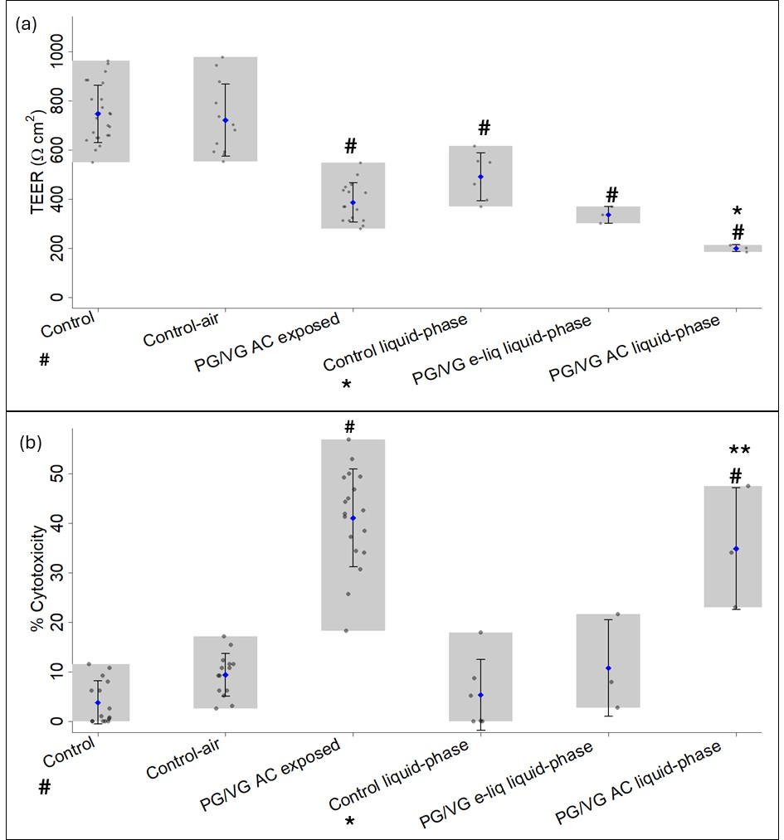
Figure S1:a) TEER value and b) cytotoxicity as measured by LDH release for control, control-air, exposed to PG/VG aerosols condensates (PG/VG AC exposed) in the ECAM-cell chamber device and control liquid-phase (DPBS), PG/VG e-liquid liquid-phase exposure, PG/VG. Aerosol Condensate (AC) liquid-phase exposure. Data are presented as mean ± SD. Error bars indicate standard deviation, and grey boxes illustrate the range of measured values. Data are presented as mean ± SD. Error bars represent standard deviation, and grey boxes indicate the range of measured values. Control, control -air and Aerosol exposure conditions were assessed across three independent experiments with 3–6 Transwells per condition per experiment, while liquid-phase conditions were assessed using three Transwells per condition. Statistical significance is indicated as follows: # compared with control (p ≤ 0.001); * compared with Control liquid-phase (* p ≤ 0.01, ** p ≤ 0.001).
As shown in Figure S1, liquid-phase exposure to e-liquids and aerosol condensates (AC) further reduced TEER. Notably, AC exposure significantly increased cytotoxicity compared with the liquid-phase control (p ≤ 0.001), with condensates exerting stronger effects than e-liquids (data not shown for other e-liquids and condensates). These findings indicate that direct liquid-phase exposure does not accurately recapitulate the effects of EC aerosols on alveolar epithelial cells. In liquid-based exposures, the presence of a fluid layer on the apical surface disrupts epithelial polarity and baseline barrier function, confounding interpretation of TEER changes and deviating from physiologically relevant air–liquid interface (ALI) conditions. In contrast, ALI exposure with the ECAM-cell chamber maintained physiological conditions and provided reproducible data, confirming its suitability for vaping toxicology studies. The results show that the ALI setup better mimics physiological inhalation, while liquid-phase exposure highlights differences when aerosols or condensates are directly applied to the apical side of cells. Overall, ALI exposure more reliably reflects in vivo aerosol-cell interactions, whereas liquid-phase exposure introduces artifacts that may exaggerate barrier disruption.

References
1 Davis ES, Sassano MF, Goodell H, et al. E-Liquid Autofluorescence can be used as a Marker of Vaping Deposition and Third-Hand Vape Exposure. Sci Rep. 2017;7. doi: 10.1038/s41598-017-07862-w

