Supplemental information

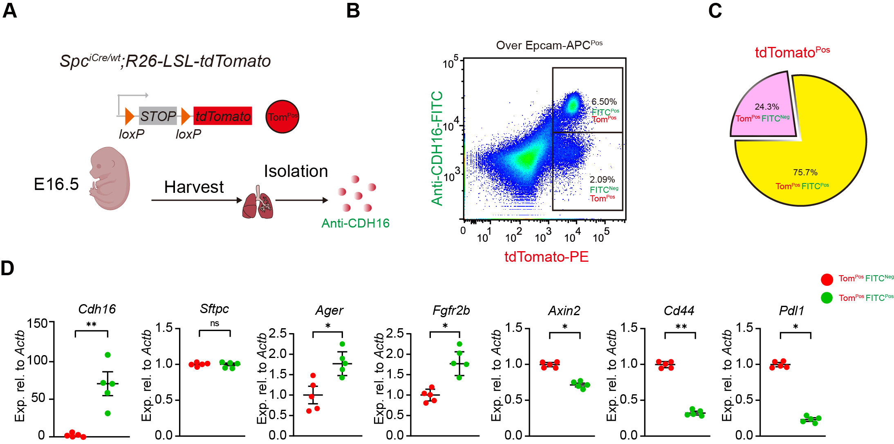
Figure S1. Comparison between Cdh16^{Pos} and Cdh16^{Neg} from Spc^{Pos} lineage
(A) Schematic representation of Spc^{Pos} lineage tracing. (F) FACS based sorting on tdTomato^{Pos} and Cdh16^{Pos} cells. (C) FACS based quantification on tdTomato^{Pos} and Cdh16^{Pos} cells. (D) qRT-PCR on sorted Tom^{Pos}FITC^{Neg} and Tom^{Pos}FITC^{Pos} cells showing differential expressions of Cdh16, Sftpc, Ager, Fgfr2b, Axin2, Cd44, Pdl1 (n=5). *p < 0.05; **p < 0.01; ns: not significant.

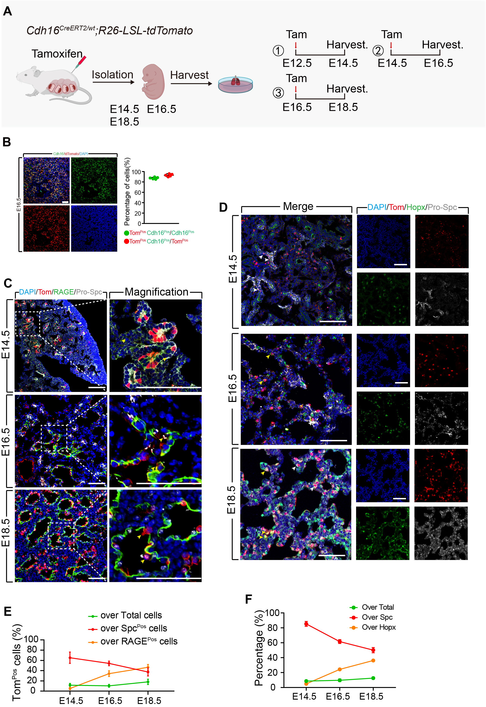
Figure S2. Dynamics of Cdh16^{Pos} cells at different stages of embryonic lung development
(A) Schematic representation of Cdh16 lineage tracing. (B) Co-staining of Cdh16 antibody with tdTomato on lineage traced E16.5 lungs (n= 5 form 3 litter of pups), scale bar: 50μm. (C) IF staining for tdTomato, pro-SPC, and RAGE at different developmental stages, scale bar: 50μm. (D) IF staining for tdTomato, pro-SPC, and Hopx at different developmental stages, scale bar: 50μm. (E) IF-based quantification for tdTomato-labeled Cdh16^{Pos} cells among total, Spc^{Pos} and RAGE^{Pos} cells, respectively (n= 5 form 3 litter of pups). (F) IF-based quantification for tdTomato-labeled Cdh16^{Pos} cells among total, Spc^{Pos} and Hopx^{Pos} cells, respectively (n= 5 form 3 litter of pups).
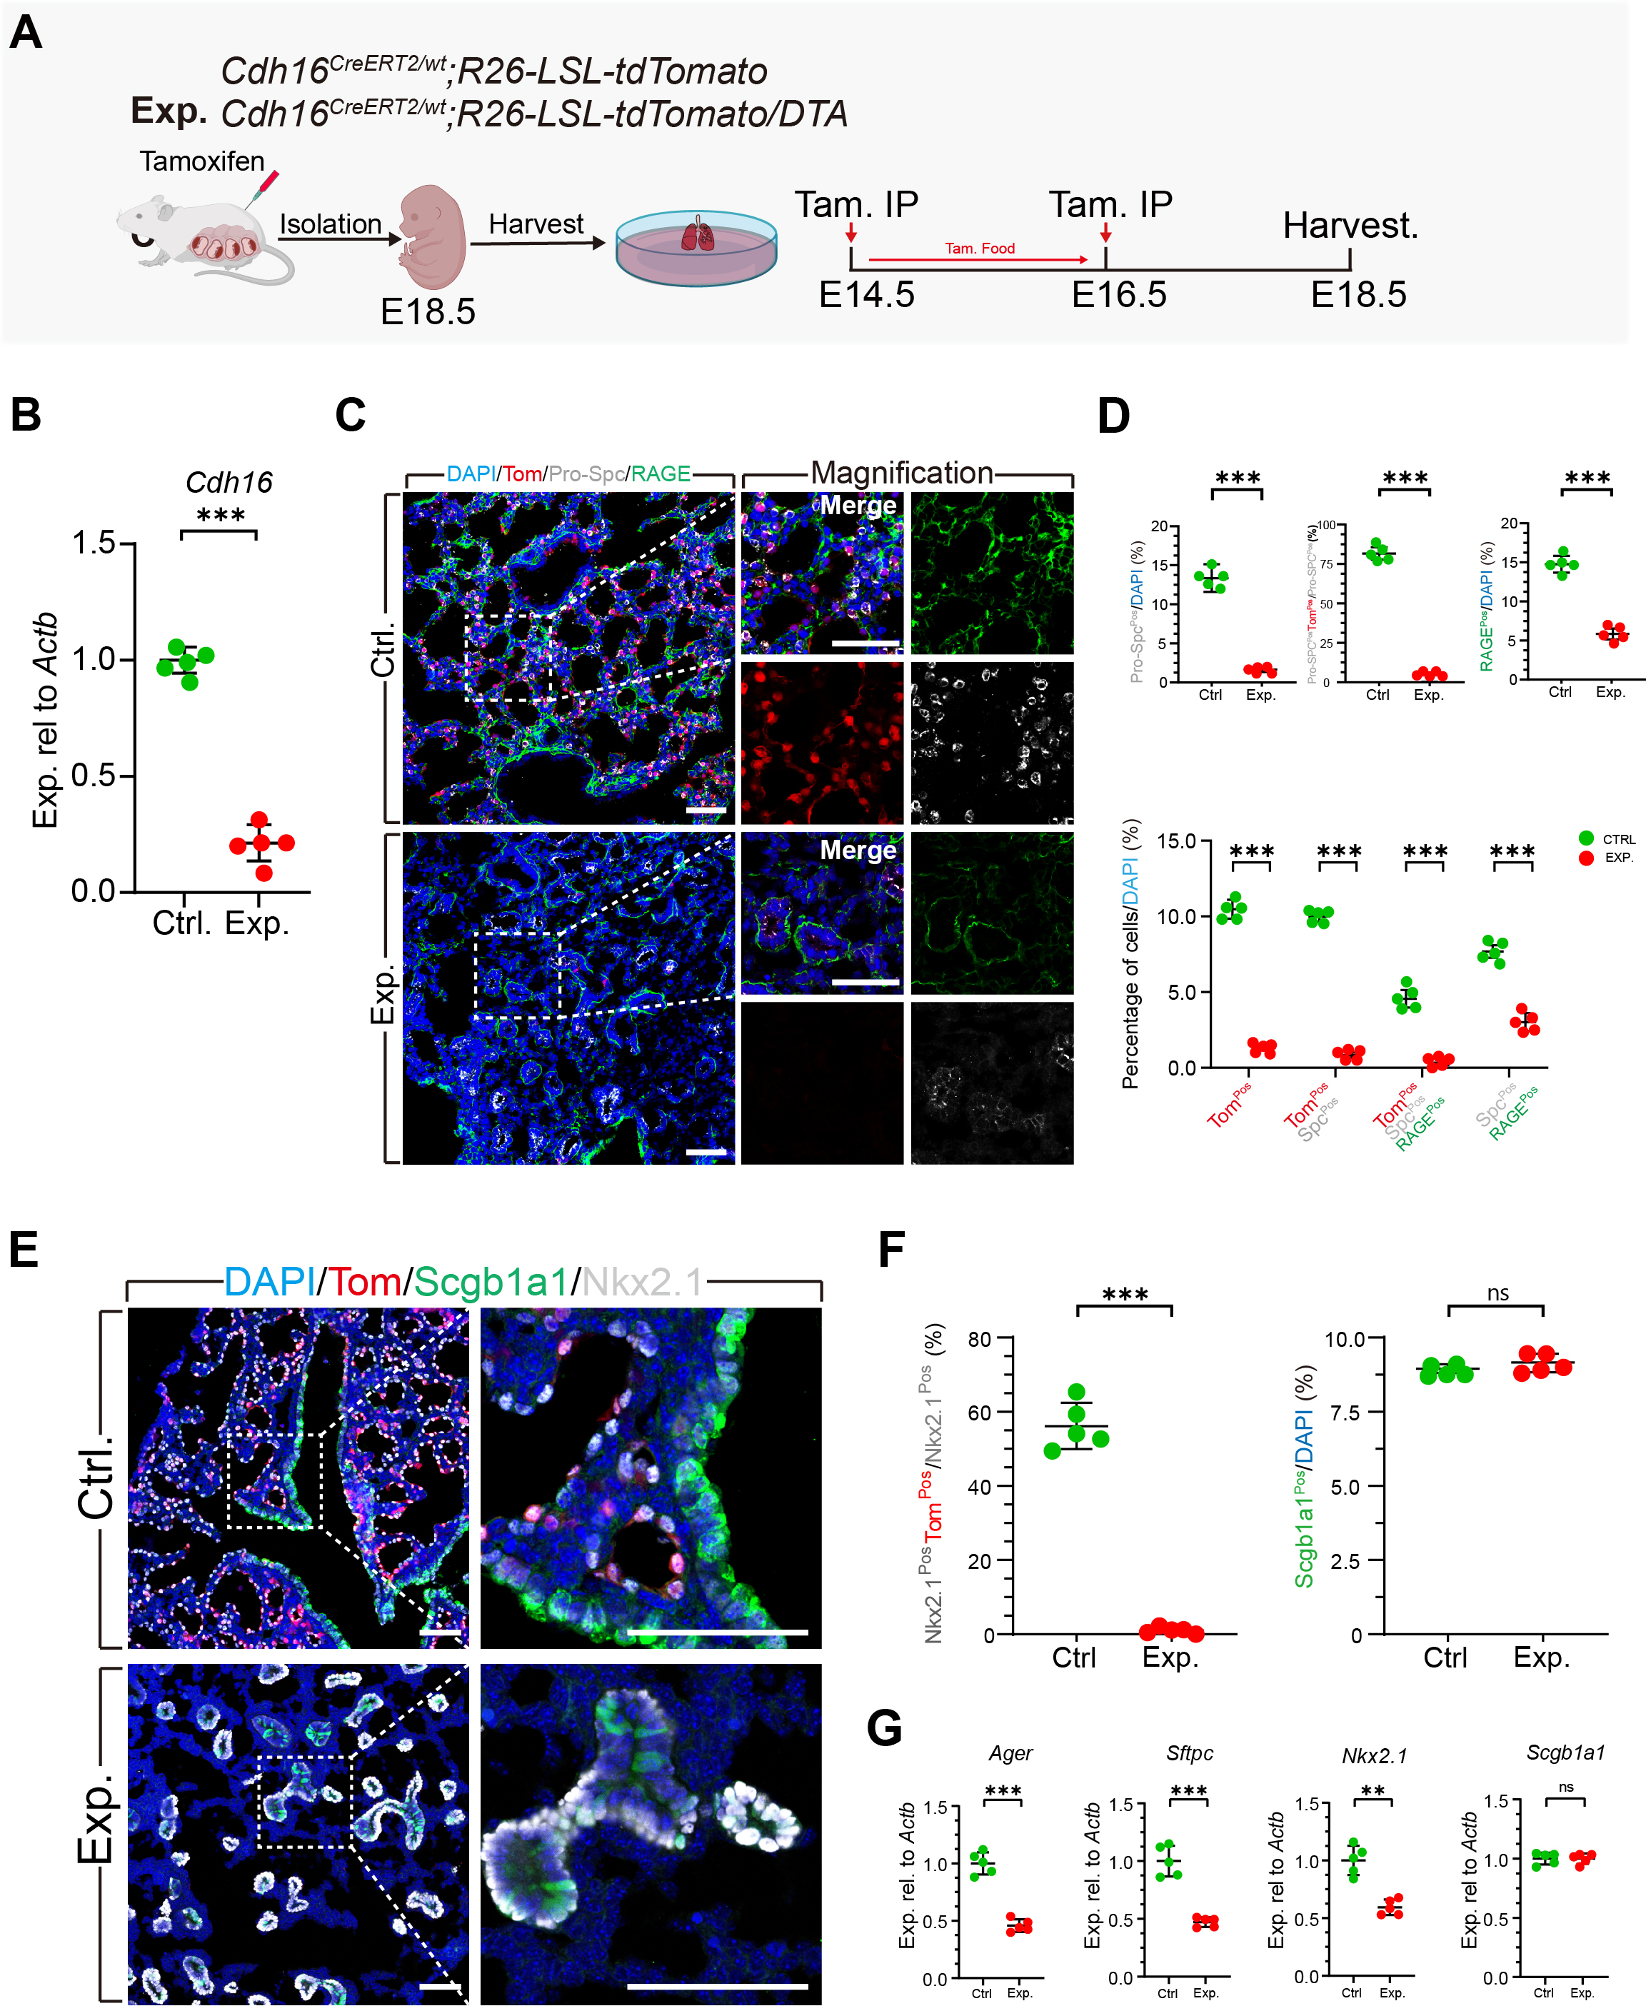
Figure S3. Ablation of Cdh16 lineage impairs alveolar morphogenesis with defective AT2 to AT1 differentiation
(A) Schematic representation of Cdh16 lineage labeling and experimental design for cell ablation. (B) Relative RNA expression of Cdh16 in groups (n=5 embryonic lungs from 3 pups). (C) IF staining for Tomato, Spc and RAGE, scale bar: 50μm. (D) IF-based quantification of Tom^{Pos} cells, Tom^{Pos}pro-Spc^{Pos}, Tom^{Pos}pro-Spc^{Pos} RAGE^{Pos} and pro-Spc^{Pos} RAGE^{Pos} cells as percentages of total cells, Tom^{Pos}pro-Spc^{Pos} cells as percentages of pro-Spc^{Pos} cells (n=5 embryonic lungs from 3 litter of pups). (E) IF staining for tdTomato, Nkx2.1 and Scgb1a1, scale bar: 50μm. (F) IF-based quantification of Tom^{Pos} Nkx2.1^{Pos} cells as percentages of Nkx2.1^{Pos} cells and Scgb1a1^{Pos} cells as percentages of total cells (n=5 embryonic lungs from 3 litter of pups). (G) Quantitative PCR for Ager, Sftpc, Nkx2.1, Scgb1a1 relative transcriptional levels in groups (n=5 form 3 litter of pups). All data are presented as means ± SEM. Statistical significance denoted as **P <0.01, ***P <0.001, ns：not significant.
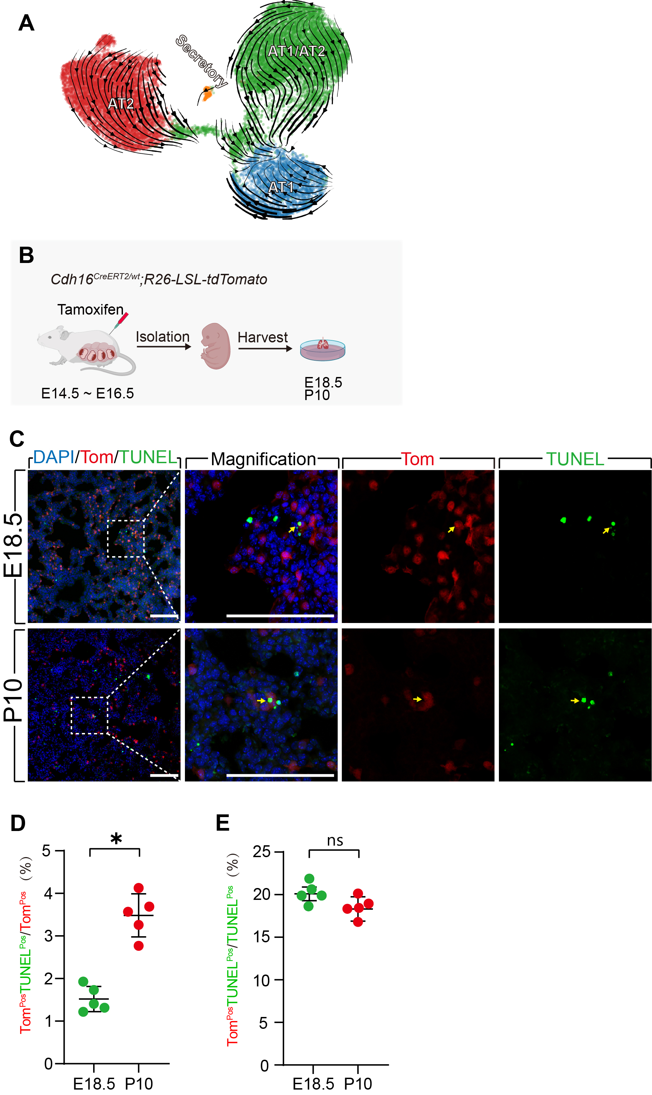
Figure S4. RNA velocity and apoptosis of Cdh16^{Pos} cells in lung development
(A) RNA velocity plot. (B) Schematic illustration of the experimental design. (C) Representative immunofluorescence images showing lineage-labeled Cdh16^{Pos} cells (Tom, red), apoptotic cells (TUNEL, green), and nuclei (DAPI, blue) in lung sections at E18.5 and P10, scale bar: 50μm. (D) Quantification of apoptotic Cdh16 lineage cells, expressed as the percentage of Tom^{Pos} TUNEL^{Pos} cells among total Tom^{Pos} cells. (E) Quantification of apoptotic Cdh16 lineage cells, expressed as the percentage of Tom^{Pos} TUNEL^{Pos} cells among TUNEL^{Pos} cells. All data are presented as means ± SEM. Statistical significance denoted as *P <0.05, ns：not significant.
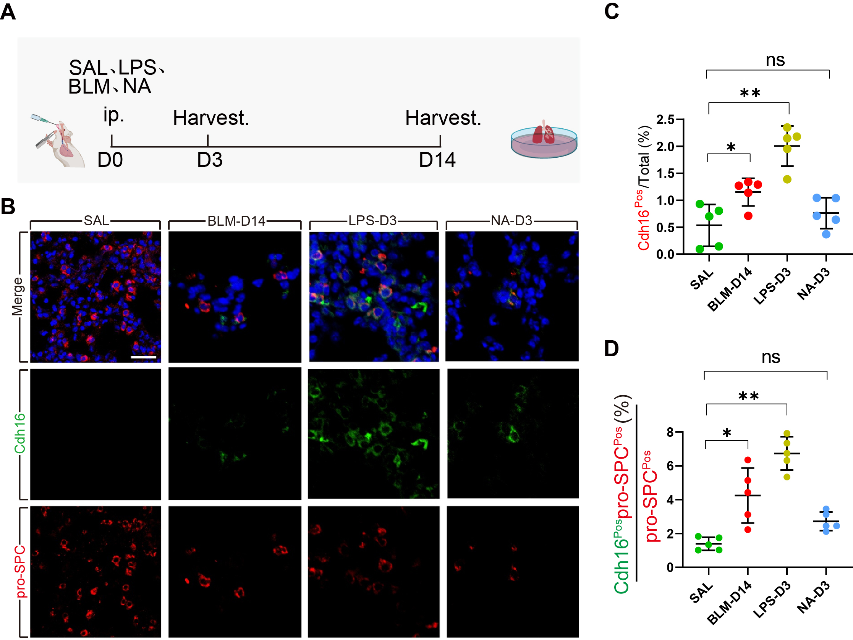
Figure S5. Cdh16 expression is activated during lung injuries
(A) Schematic illustration of the experimental design. (B) IF for Cdh16, pro-SPC in normal (SAL) and injury groups scale bar: 50μm. (C) Quantification for the ratio of Cdh16-expression (Cdh16^{Pos}) cells in total cells among groups (n=5). (D) Quantification for the ratio of Cdh16^{Pos} cells in pro-SPC-expression (SPC^{Pos}) cells among groups (n=5). scale bar: 50μm. All data are presented as means ± SEM. Statistical significance denoted as *P <0.05, **P <0.01. ns：not significant.

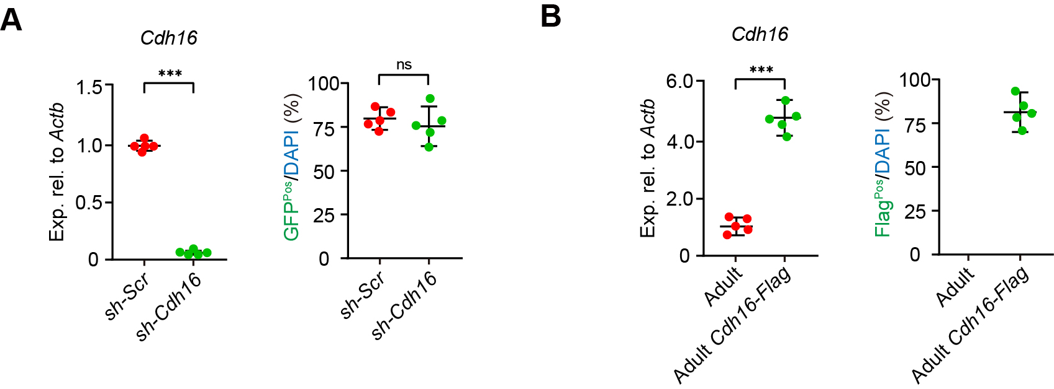
Figure S6. Quantification on plasmids transduction efficiency
(A) Quantitative RTPCR for Cdh16 transcriptional levels and IF based quantification showing GFP expression in sh-Scr-GFP and sh-Cdh16-GFP transduced alveolospheres. (B) Quantitative RTPCR for Cdh16 transcriptional levels and IF based quantification showing Flag expression in Cdh16-Flag transduced alveolospheres. Statistical significance denoted as *P <0.05, **P <0.01. ns：not significant.

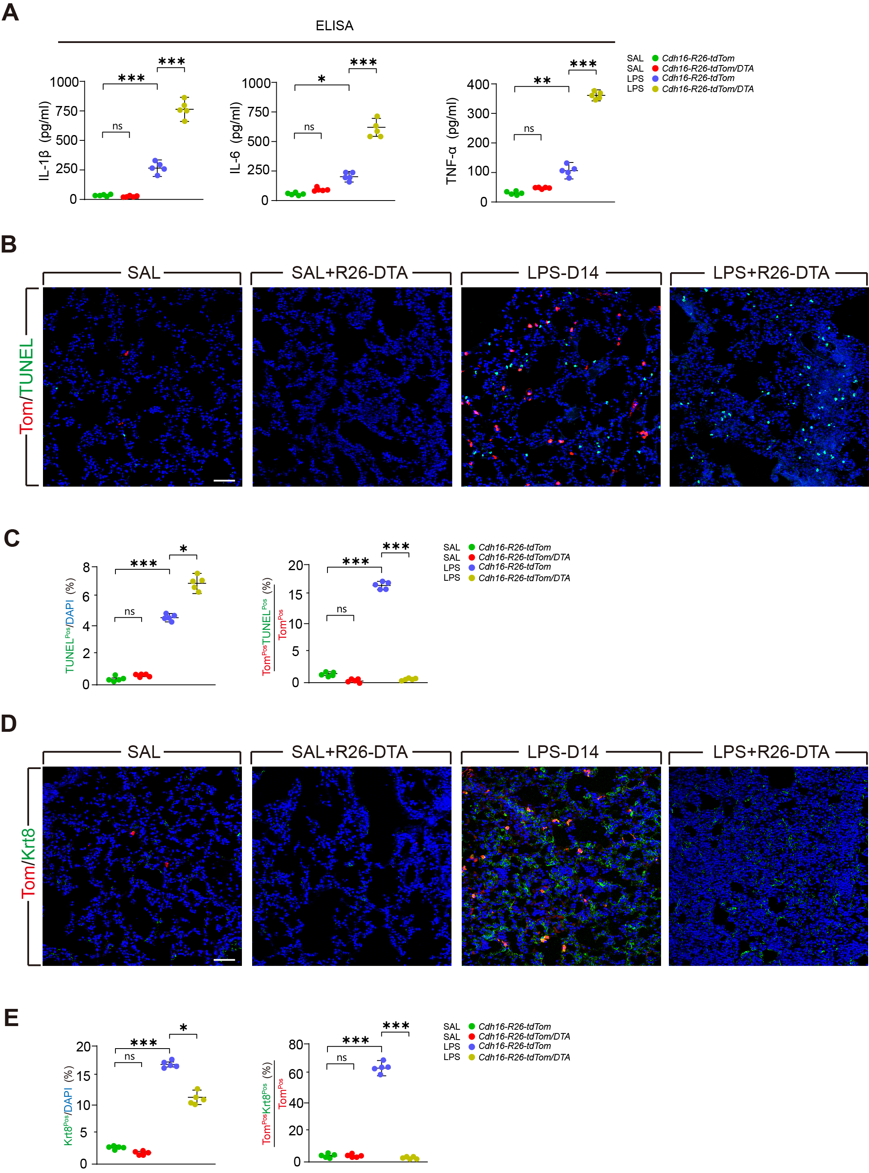
Figure S7. Cdh16 lineage is required for alveolar regeneration following LPS-induced lung injury
(A) ELISA quantification of IL-1β, IL-6, and TNF-α levels in BALF from groups. (B) IF co-staining of tdTomato with TUNEL in groups, scale bar: 50μm. (C) Quantification for the ratio of TUNEL^{Pos}Tom^{Pos} apoptotic cells in total Tom^{Pos} cells (n=5). (B) IF co-staining of tdTomato with Krt8 in groups, scale bar: 50μm. (C) Quantification for the ratio of Tom^{Pos}Krt8^{Pos} cells in total Tom^{Pos} cells (n=5).

Table S1. Antibodies and the dilutions
Antibodies | Sources | Dilution
Anti-Cdh1 | Cell Signaling Technology (#Cat No.: 3195S) | 1:200
Anti-Cdh16 | NOVUS (#Cat No.: NBP2-45157) | 1:200
Anti-Hopx | Atlas Antibodies (#Cat No.: HPA030180) | 1:100
Anti-Krt9 | Abcam (#Cat No.: ab167398) | 1:100
Anti-Krt8 | Santa cruz (#Cat No.:sc-8020) | 1:100
Anti-Nkx2-1 | Abcam (#Cat No.: ab227652) | 1:200
Anti-Pcna | Abcam (#Cat No.: ab29) | 1:200
Anti- Pro-Spc | MERCK (#Cat No.: AB3786) | 1:200
Anti-RAGE | R&D systems (#Cat No.: MAB1179-100) | 1:200
Anti-Rfp | Rockland (#Cat No.: 600-401-379) | 1:200
Anti-Sox9 | R&D systems (#Cat No.: AF3075) | 1:200
Anti-Aqp5 | Santa Cruze (#Cat No.: sc-514022) | 1:100
Anti-Scgb1a1 | Thermo Fisher Scientific (#Cat No.: PA5-102469) | 1:200
Alexa Fluor 568 Donkey anti-rabbit | Thermo Fisher Scientific (#Cat No.: A10042) | 1:800
Alexa Fluor 647 Donkey anti-rabbit | Thermo Fisher Scientific (#Cat No.: A32795) | 1:800
Alexa Fluor 647 Donkey anti-mouse | Thermo Fisher Scientific (#Cat No.: A31571) | 1:600
Alexa Fluor 488 Donkey anti-mouse | Thermo Fisher Scientific (#Cat No.: A21202) | 1:800
Alexa Fluor 488 Donkey anti-mouse IgG1 | Thermo Fisher Scientific (#Cat No.: A21121) | 1:600
Alexa Fluor 488 Donkey anti-rat | Thermo Fisher Scientific (#Cat No.: A-21208) | 1:600
Anti-Cd31-APC | BioLegend (#Cat No.: 102410) | 1:200
Anti-Cd326-APC | BioLegend (#Cat No.: 147708) | 1:200
Anti-Cd45-APC | BioLegend (#Cat No.: 118214) | 1:200

Table S2. qRT-PCR Primers
Gene names | Primers
Cdh16 | Forward 5’-GAGGCCCAAGACACAGATAAG-3’
 | Reverse 5’-CCCAGCAGACAGAGTCAATG-3’
Sftpc | Forward 5’-GTCCTCGTTGTCGTGGTGATTG-3’
 | Reverse 5’-AAGGTAGCGATGGTGTCTGCTC-3’
Scgb1a1 | Forward 5’-GCTTACACAGAGGACTTGTTAGG-3’
 | Reverse 5’-AGCCTGTTCACTGGTGTTCCAG-3’
Axin2 | Forward 5’-GTTCCACAGGCGTCATCTCCTT-3’
 | Reverse 5’-CTGGGTGGAGGTACATTGATG-3’
Cd44 | Forward 5’-CGGAACCACAGCCTCCTTTCAA-3’
 | Reverse 5’-TGCCATCCGTTCTGAAACCACG-3’
Pdl1 | Forward 5’-TGCGGACTACAAGCGAATCACG-3’
 | Reverse 5’-CTCAGCTTCTGGATAACCCTCG-3’
Fgfr2b | Forward 5’-CCAGCACTGGAGCCTTATTAT-3’
 | Reverse 5’-GTGGTTGATGGACCCGTATT-3’
Ager | Forward 5’-GCCACTGGAATTGTCGATGAGG-3’
 | Reverse 5’-GCTGTGAGTTCAGAGGCAGGAT-3’
Hopx | Forward 5’-ATTCCACCACGCTGTGCCTCAT-3’
 | Reverse 5’-AGTCTGTGACGGATCTGCACTC-3’
Nkx2.1 | Forward 5’-CAGGACACCATGAGGAACAGCG-3’
 | Reverse 5’-GCCATGTTCTTGCTCACGTCCC-3’
Actb | Forward 5’-CTCCCTGGAGAAGAGCTATGA-3’
 | Reverse 5’-CCAAGAAGGAAGGCTGGAAA-3’

