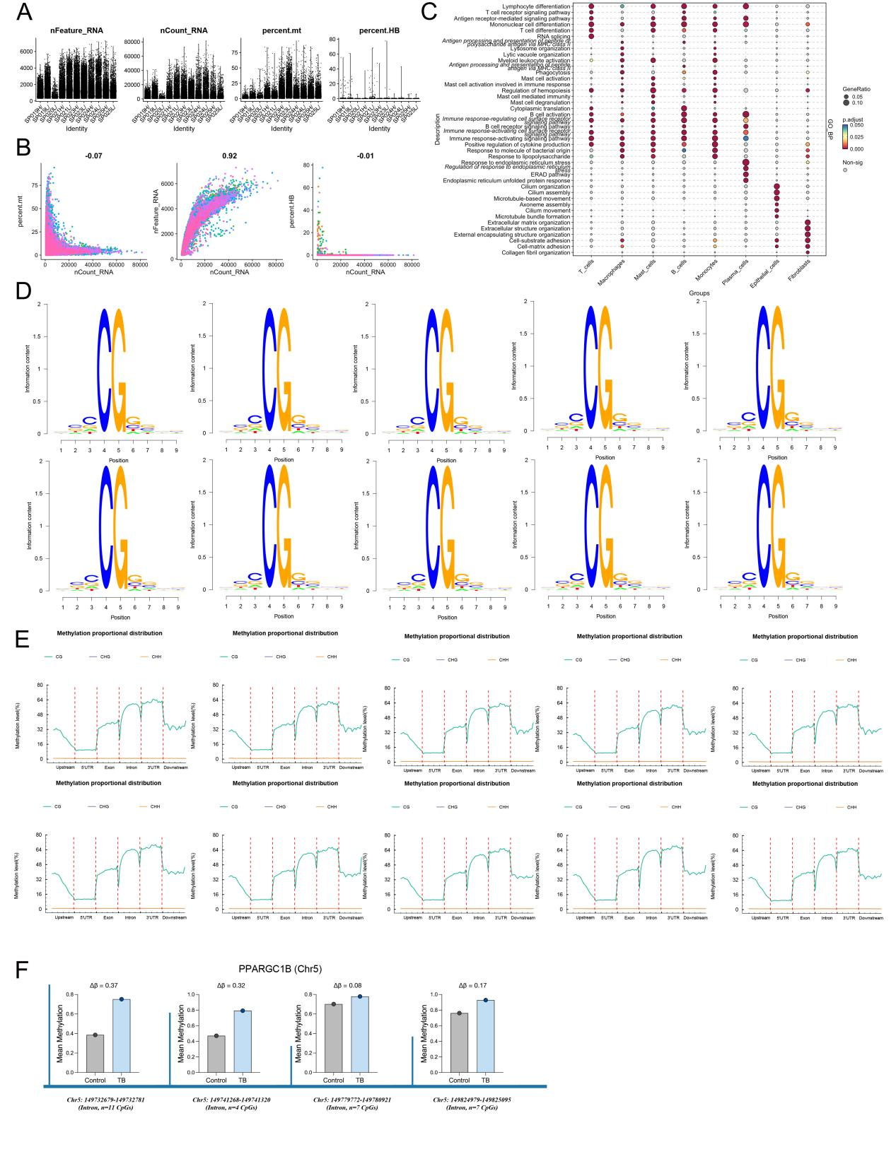
SFigure1 Integrated single-cell transcriptomic and DNA methylation profiling of human tuberculosis lung tissues.
- Quality control plots for single-cell analysis (human TB vs. control lung tissues).
- Enrichment analysis bubble plot of single-cell analysis of human TB vs. control lung tissues.
- The feature Logo diagram shows the distribution of CG.mc (the first row is for TB samples, and the second row is for control samples).
- Distribution of methylation levels of different gene functional elements (the first row is for TB samples, and the second row is for control samples).
- DNA methylation levels of PPARGC1B (Chr5) in different genomic regions comparing control and tuberculosis (TB) groups. Four intronic regions of PPARGC1B are shown with their respective chromosomal coordinates and the number of CpG sites analyzed. Bar graphs display mean methylation levels with individual data points. Δβ values indicate the methylation difference between TB and control groups, showing consistently higher methylation levels in TB samples across all examined regions.

