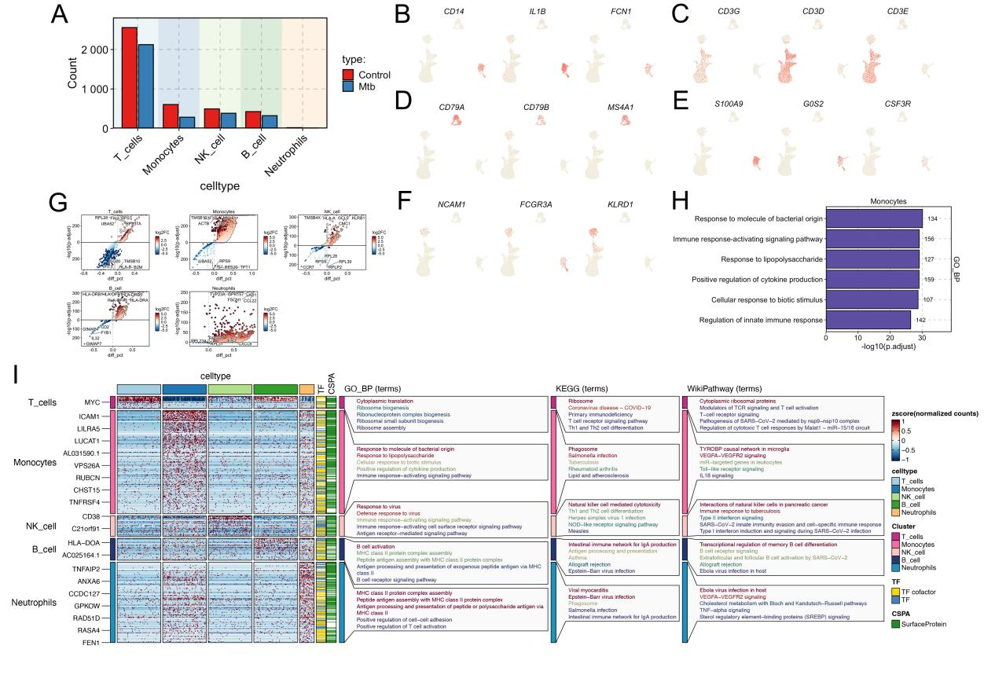
SFigure2 Single-cell transcriptomic profiling reveals immune cell composition and functional alterations in peripheral blood from tuberculosis patients.
- The cell ratio plot shows the differences between cell clusters in TB blood samples and control blood samples for single-cell analysis.
- F) The Umap graph shows the expression of marker genes in different cell clusters (TB blood samples and control blood samples).
(G)The volcano map shows the distribution of differentially expressed genes in different cell clusters (TB blood samples and control blood samples).
(H)The GO enrichment analysis bar chart shows the biological functions of monocytes.
(I)Functional enrichment analysis of the main cell clusters (TB blood samples and control blood samples).

