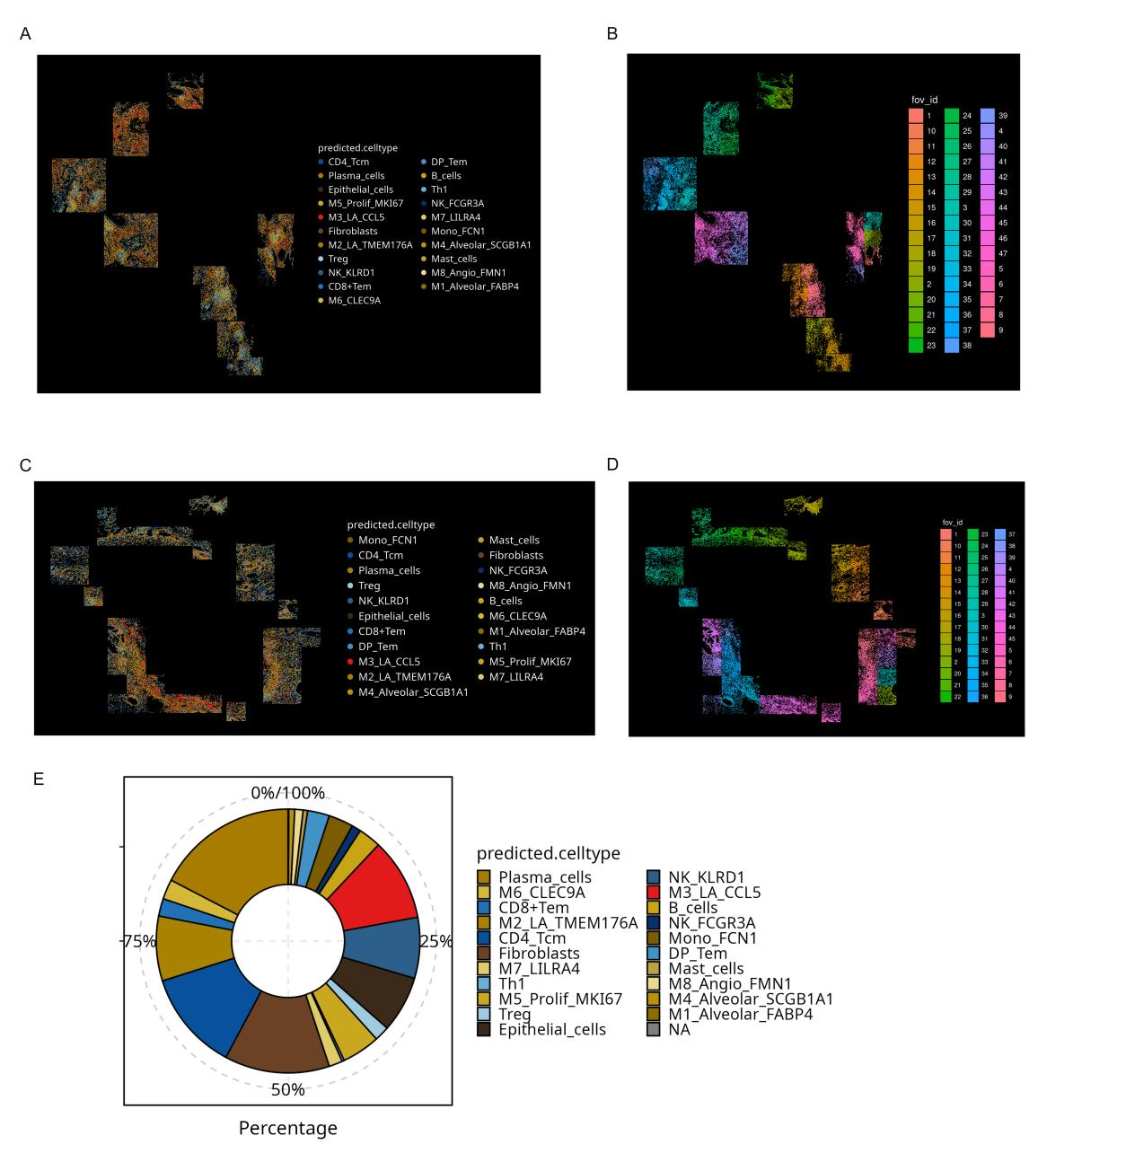
SFigure3 Global spatial distribution and cellular composition of annotated cell types in tuberculosis lung tissues.
(A) Global spatial distribution map of annotated cell types in sample 1.
(B) Field-of-view FOV location map corresponding to sample 1.
(C) Global spatial distribution map of annotated cell types in tuberculosis sample 2.
(D) Field-of-view FOV location map corresponding to tuberculosis sample 2.
(E) Donut plot showing the integrated proportions of annotated cell types after merging samples 1 and 2.

