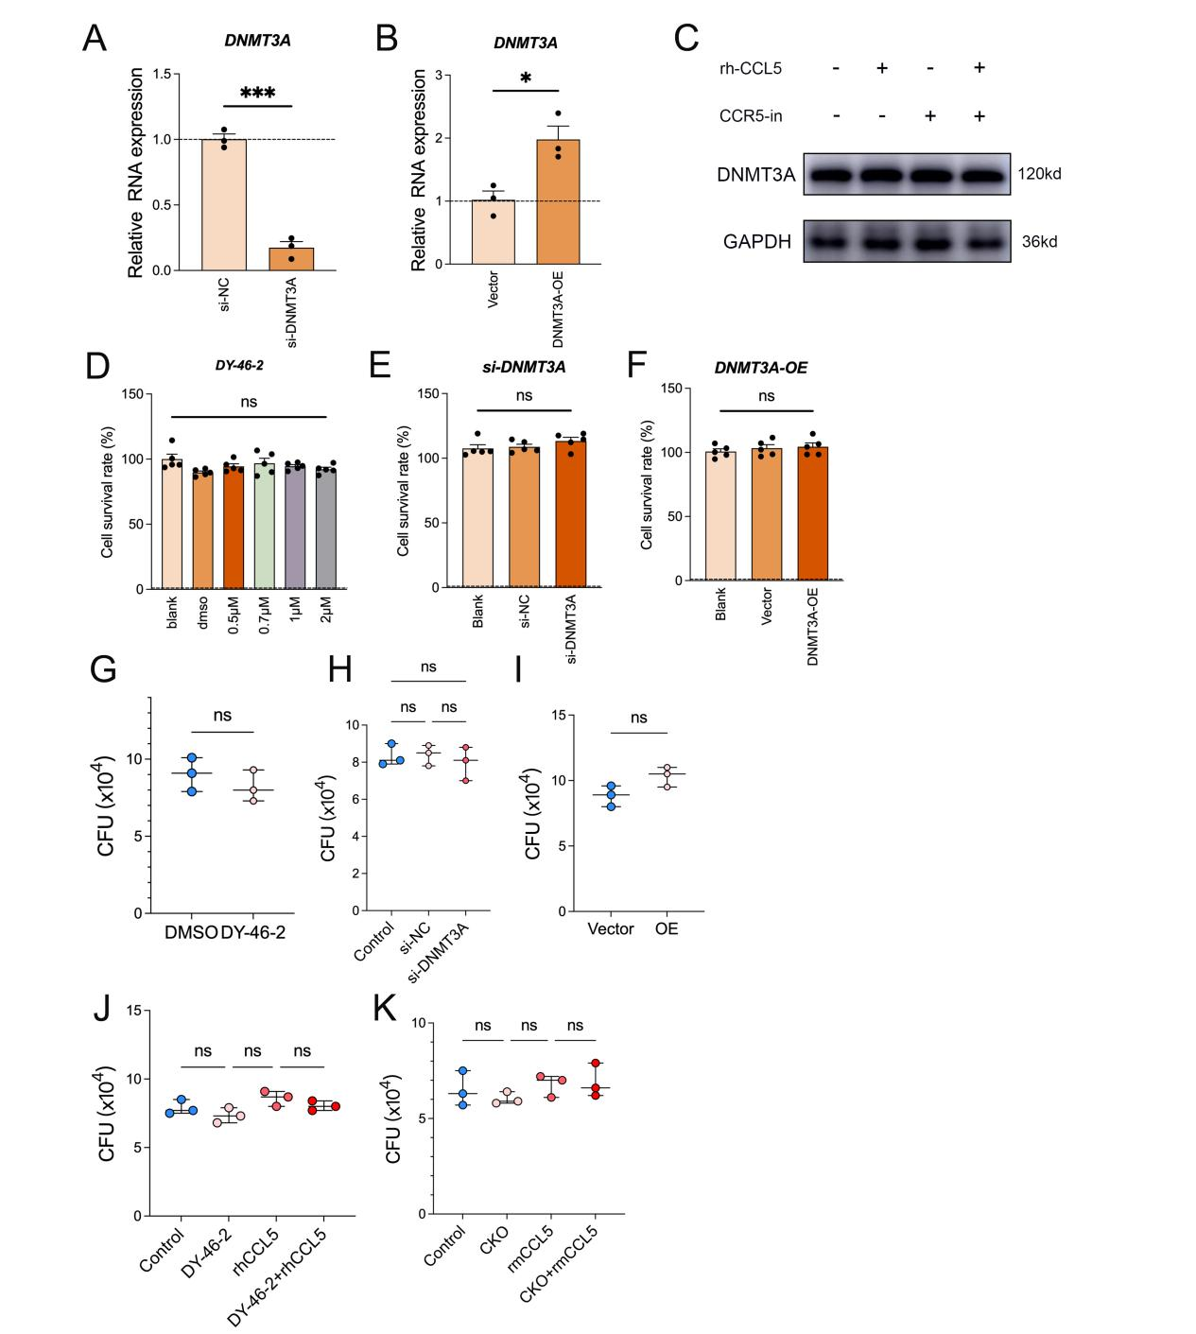

SFigure5 DNMT3A promotes intracellular mycobacterial survival through CCL5 upregulation.
- B) Validation of DNMT3A knockdown (A) and overexpression (B) efficiency (RNA level). Total RNA was extracted from THP-1–derived macrophages 72 h after transfection with siRNA or transduction with DNMT3A-overexpressing virus, and knockdown/overexpression efficiency was assessed by RT-qPCR. ACTB was used for normalization. *P<0.05, ***P<0.001
- Western blot analysis of DNMT3A in THP-1–derived macrophages under the indicated conditions. Cultured macrophages were treated with rhCCL5 or maraviroc for 48h. Cells were then infected with Mycobacterium tuberculosis (H37Rv) at MOI = 5. After 4 h infection and washing to remove extracellular bacteria, macrophages were cultured for an additional 20 hours. After the indicated culture period, cells were lysed and subjected to western blotting. GAPDH served as a loading control.
(D-F) Cell viability was measured by CCK-8 assay in THP-1–derived macrophages following treatment with the DNMT3A inhibitor DY-46-2 (D), transfection with siRNA (E), or transduction with overexpression lentivirus (F). Forty-eight hours after the above treatments, cells were infected with H37Rv (MOI = 5) for 4 h; extracellular bacteria were then washed away, and cell viability was assessed after an additional 72 h of culture.
(G-I) THP-1–derived macrophages were treated with DY-46-2 (G), transfected with si-DNMT3A (H), or transduced with DNMT3A overexpression lentivirus (DNMT3A-OE) (I). Cells were then infected with Mycobacterium tuberculosis at MOI = 5 for 4 h, washed to remove extracellular bacteria, and cultured for an additional 3 days. After 72h, macrophages were lysed, and bacterial burden was determined by CFU plating; colonies were enumerated 21–28 days after plating. Data are shown as CFU (×10⁴). Data were analyzed by one-way ANOVA. P values < 0.05 were considered statistically significant. (ns: P＞0.05)
(J) THP-1–derived macrophages were treated with DY-46-2 and/or supplemented with rhCCL5 as indicated and infected with Mycobacterium tuberculosis at MOI = 5 for 4 h, washed to remove extracellular bacteria, and cultured for an additional 3 days. After 72h, macrophages were lysed, and bacterial burden was determined by CFU plating; colonies were enumerated 21–28 days after plating. Data are shown as CFU (×10⁴). Data were analyzed by one-way ANOVA. P values < 0.05 were considered statistically significant (ns: P＞0.05).
(K) Mouse BMDM-derived macrophages from WT or myloid-specific KO mice were supplemented with rmCCL5 as indicated, followed by infection with Mycobacterium tuberculosis at MOI = 5 for 4 h. After washing to remove extracellular bacteria, macrophages were cultured for an additional 3 days. After 72h, macrophages were lysed, and bacterial burden was determined by CFU plating; colonies were enumerated 21–28 days after plating. Data are shown as CFU (×10⁴). Data were analyzed by one-way ANOVA. P values < 0.05 were considered statistically significant (ns: P＞0.05)

