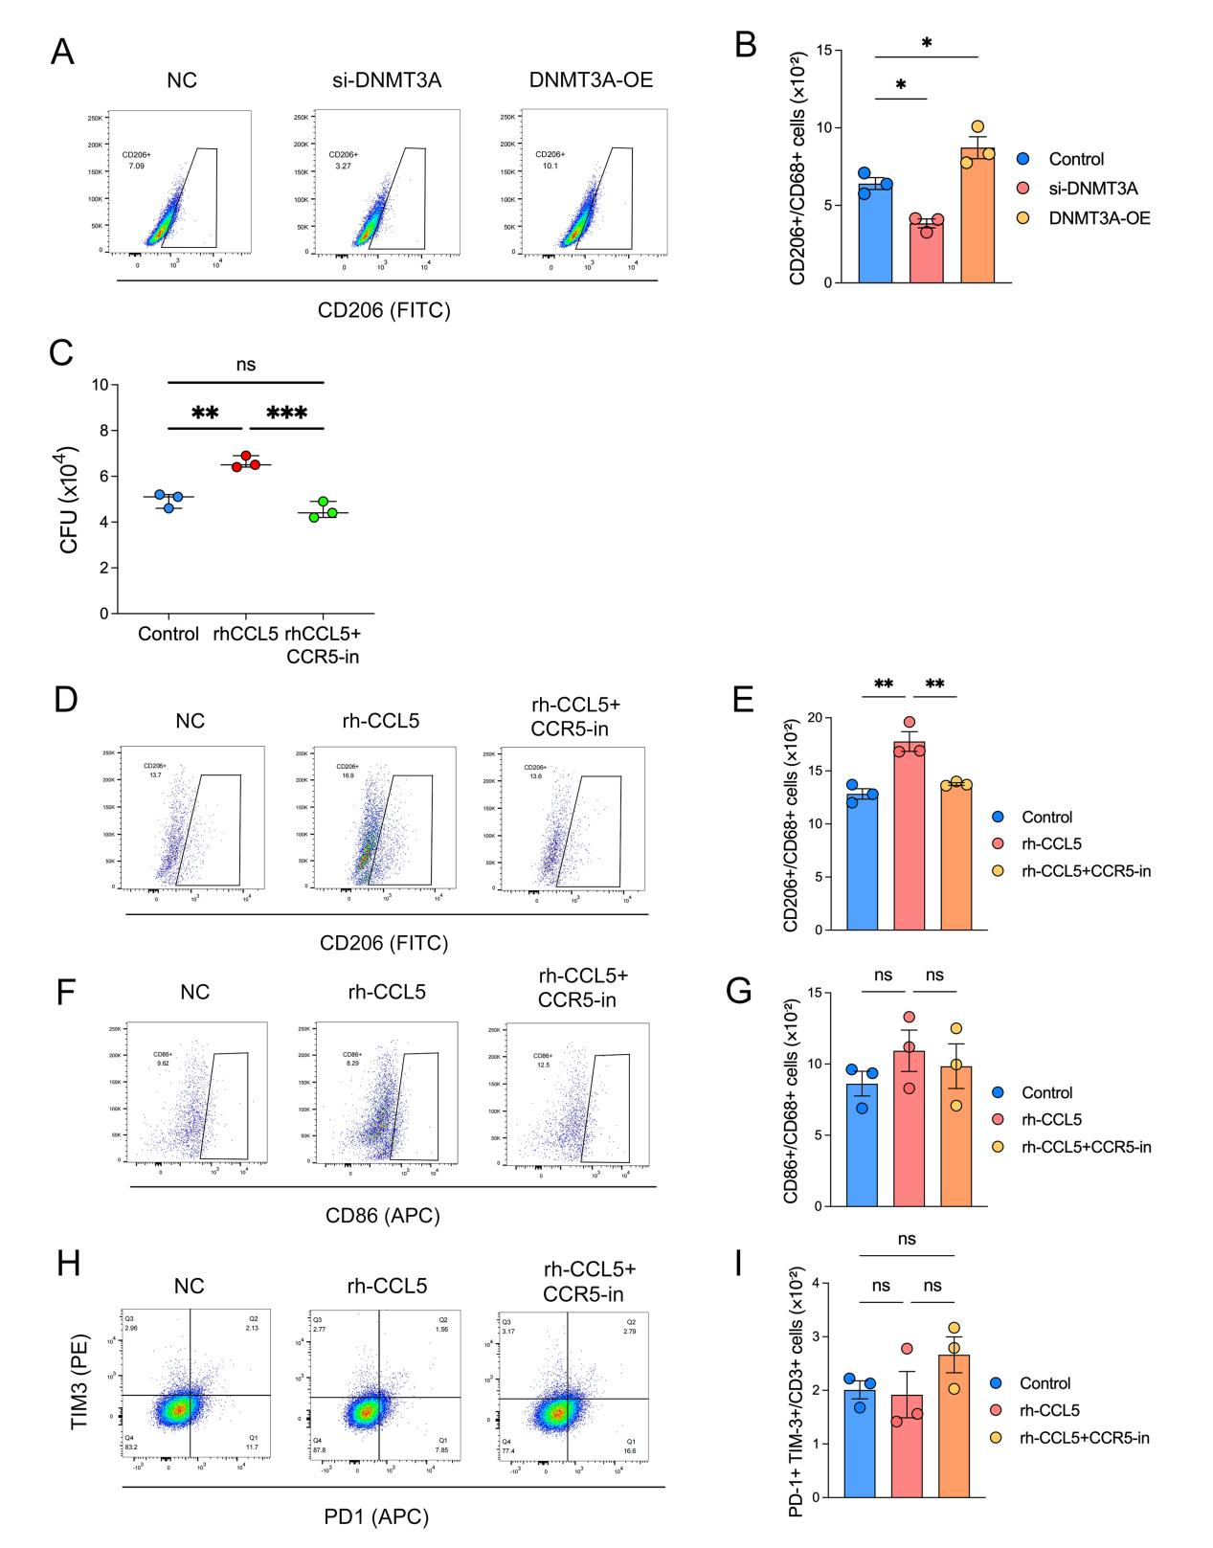

SFigure6 CCL5–CCR5 autocrine signaling in CCL5⁺ macrophages drives M2 polarization and establishes an immunosuppressive microenvironment.
- Representative flow cytometry gating plots for macrophage polarization analysis. THP-1–derived macrophages were transfected with si-DNMT3A, or transduced with DNMT3A overexpression lentivirus (DNMT3A-OE). Cells were then infected with Mycobacterium tuberculosis at MOI = 5 for 4 h, washed to remove extracellular bacteria, and co-cultured with Jurkat T cells for an additional 3 days. After 72h, macrophages were collected for flow cytometry analysis.
- Bar graphs show the proportion of CD206+CD68+ macrophages from flow cytometry analysis. Data are presented as mean ± SEM. Statistical significance was determined by one-way ANOVA.
- THP-1–derived macrophages were treated with maraviroc and/or supplemented with rhCCL5 as indicated and infected with Mycobacterium tuberculosis at MOI = 5 for 4 h, washed to remove extracellular bacteria, and co-cultured with Jurkat T cells for an additional 3 days. After 72h, macrophages were lysed, and bacterial burden was determined by CFU plating; colonies were enumerated 21–28 days after plating. Data are shown as CFU (×10⁴). Data were analyzed by one-way ANOVA. P values < 0.05 were considered statistically significant. (**P<0.01, ***P<0.001)
- Representative flow cytometry gating plots for macrophage polarization analysis.
THP-1–derived macrophages were treated with maraviroc and/or supplemented with rhCCL5 as indicated and infected with Mycobacterium tuberculosis at MOI = 5 for 4 h, washed to remove extracellular bacteria, and cultured for an additional 3 days. After 72h, macrophages were collected for flow cytometry analysis.
- Bar graphs show the proportion of CD206+CD68+ macrophages from flow cytometry analysis. Data are presented as mean ± SEM. Statistical significance was determined by one-way ANOVA. (**P<0.01)
- Representative flow cytometry gating plots for macrophage polarization analysis.
THP-1–derived macrophages were treated with maraviroc and/or supplemented with rhCCL5 as indicated and infected with Mycobacterium tuberculosis at MOI = 5 for 4 h, washed to remove extracellular bacteria, and cultured for an additional 3 days. After 72h, macrophages were collected for flow cytometry analysis.
- Bar graphs show the proportion of CD86+CD68+ macrophages from flow cytometry analysis. Data are presented as mean ± SEM. Statistical significance was determined by one-way ANOVA. (ns: P＞0.05)
- Representative flow cytometry gating plots for exhausted T cells (PD1+TIM3+) analysis. Jurkat T cells were treated with maraviroc and/or supplemented with rhCCL5 as indicated. After 72h, Jurkat T cells were collected for flow cytometry analysis.
- Bar graphs show the proportion of PD1+TIM3+ Jurkat T cells from flow cytometry analysis. Data are presented as mean ± SEM. Statistical significance was determined by one-way ANOVA. (ns: P＞0.05)

