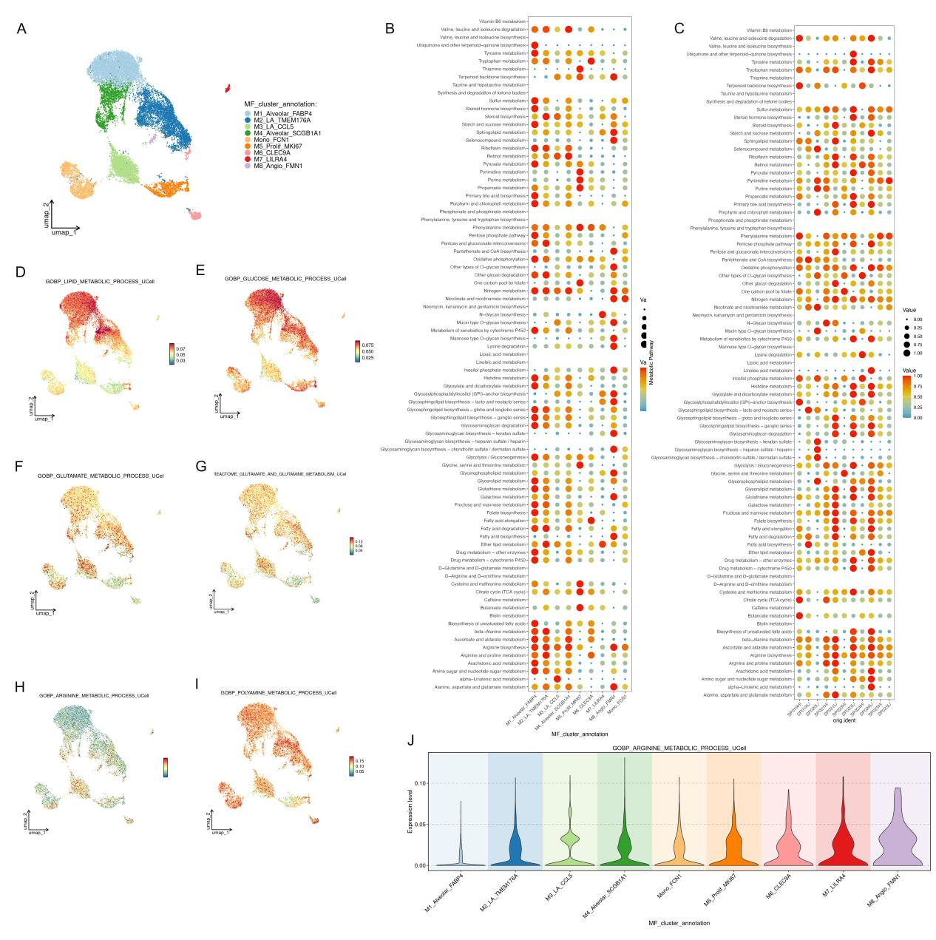
SFigure7 Metabolic pathway heterogeneity across macrophage subsets in tuberculosis lung tissues.
(A) UMAP visualization showing the clustering and annotation of macrophage subsets identified in lung tissues from tuberculosis patients.
(B) Bubble plot showing metabolic pathway enrichment across macrophage subsets.
(C) Bubble plot showing metabolic pathway enrichment across tuberculosis samples.
(D) UMAP feature plot showing the activity score distribution of the GO lipid metabolic process across macrophage subsets.
(E) UMAP feature plot showing the activity score distribution of the GO glucose metabolic process across macrophage subsets.
(F) UMAP feature plot showing the activity score distribution of the GO glutamate metabolic process across macrophage subsets.
(G) UMAP feature plot showing the activity score distribution of reactome glutamine and glutamate metabolism across macrophage subsets.
(H) UMAP feature plot showing the activity score distribution of the GO arginine metabolic process across macrophage subsets.

(I) UMAP feature plot showing the activity score distribution of the GO polyamine metabolic process across macrophage subsets.
(J) Violin plot showing the distribution of GO arginine metabolic process activity scores among different macrophage subsets.

