Additional files

Effect of Ni²⁺, Zn²⁺, and Co²⁺ on Green Rust Transformation to Magnetite

Orion Farrª, Evert J. Elzinga^{b}, Nathan Yee^{a,c}*

ªDepartment of Earth and Planetary Sciences Rutgers University, Piscataway, NJ 08854, USA
^{b}Department of Earth and Environmental Sciences, Rutgers University−Newark, Newark, NJ 07102, USA
^{c}Department of Environmental Sciences, Rutgers University, New Brunswick, NJ 08901, USA

*Corresponding author: nyee@envsci.rutgers.edu

Figure S1. Production of H₂ gas. GR suspensions were heated at 85ºC under anoxic conditions and headspace was analyzed using gas chromatography.

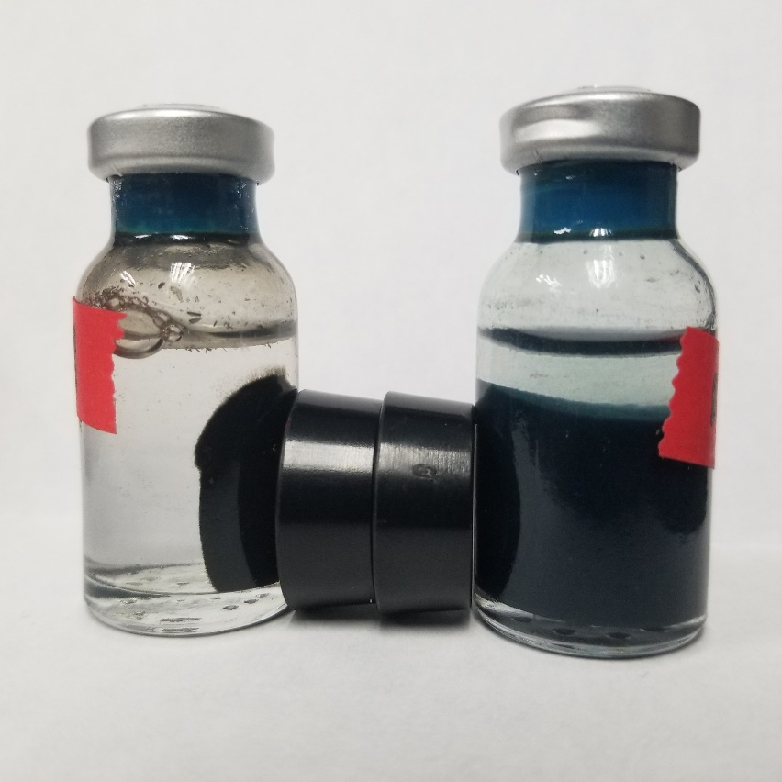

Figure S2. Formation of a magnetic product. GR samples were heated at 85ºC for 24 hours. The starting GR material is shown on the right and the magnetic product is shown on the left.

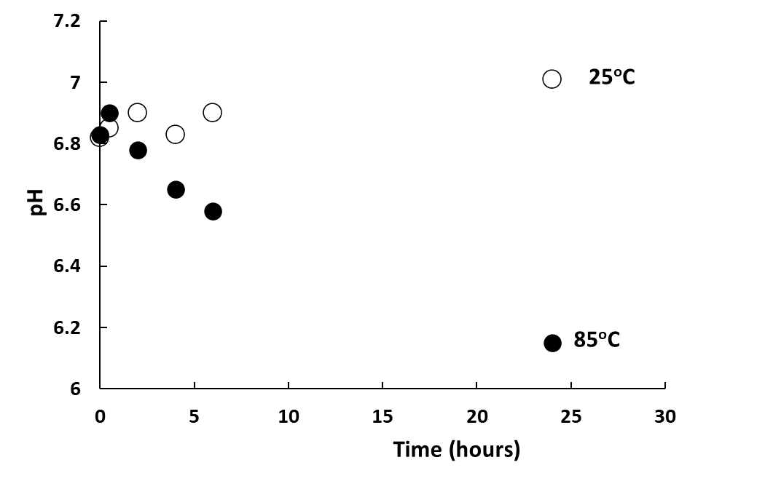

Figure S3. Change in solution pH during GR transformation. Open symbols represent the room temperature control experiment and the closed symbol represent GR heated at 85ºC.

Figure S4. Replicate experiments of Ni incorporation during GR transformation to magnetite. Open symbols represent the room temperature control experiment, and the closed symbols represent 3 independent experiments of GR heated at 85ºC in presence of 1 ppm Ni.

Figure S5. 24 hour experiment of Ni incorporation during GR transformation to magnetite. Open symbols represent the room temperature control experiment and the closed symbols represent GR heated at 85ºC.

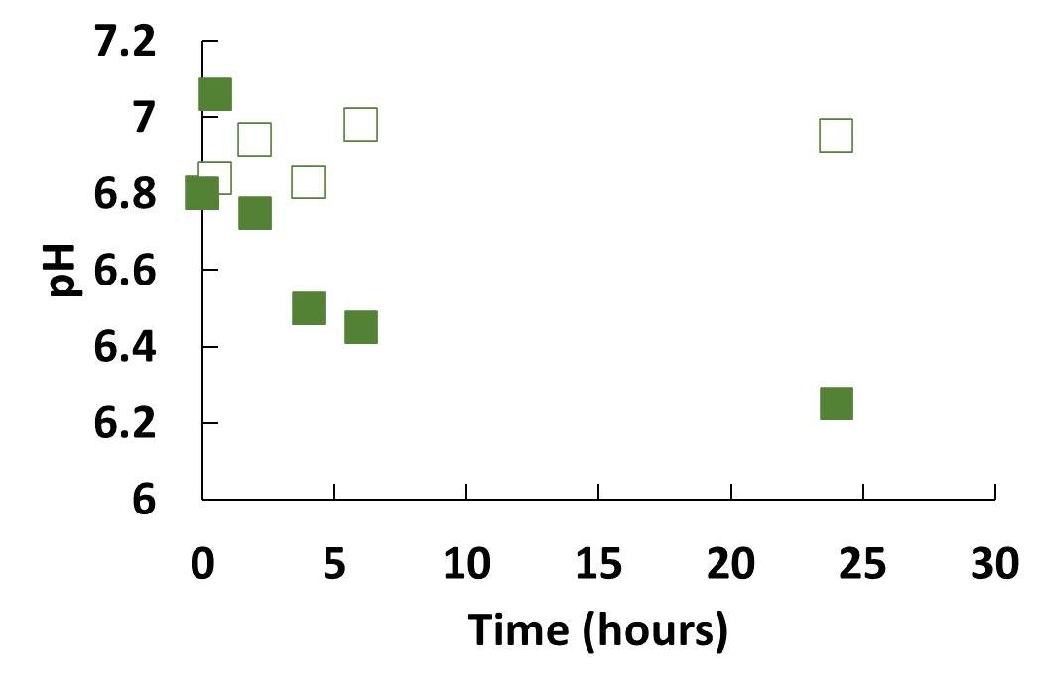
A

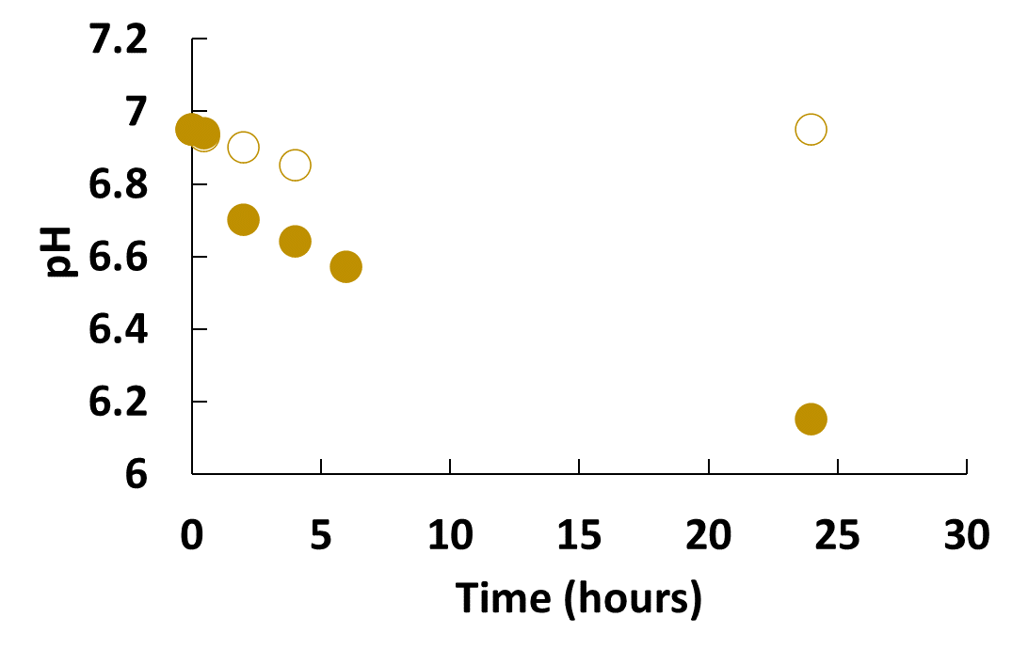
B

C
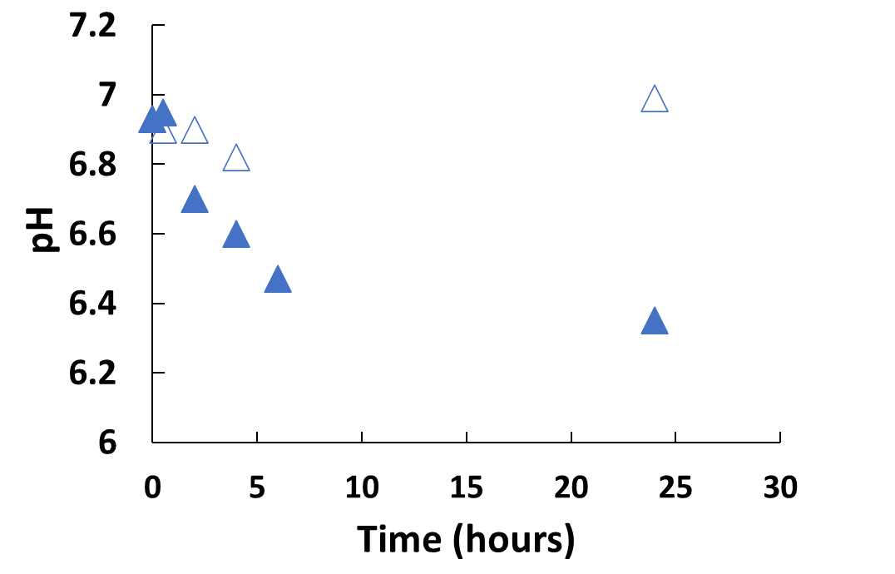

Figure S6. Changes in solution pH during GR transformation in the metal amended experiments. Open symbols represent the room temperature control experiment and the closed symbols represent GR samples heated at 85ºC containing A) nickel, B) zinc, and C) cobalt.

