ADDITIONAL FILE

Machine Learning to Stratify Diabetic Patients using Novel Cardiac Biomarkers and Integrative Genomics
Quincy A. Hathaway,^{1,2} Skyler M. Roth,³ Mark V. Pinti,⁴ Daniel C. Sprando,⁵ Amina Kunovac,^{1,2} Andrya J. Durr,^{1,2} Chris C. Cook,⁶ Garrett K. Fink,¹ Tristen B. Cheuvront,³ Jasmine H. Grossman,³ Ghadah A. Aljahli,³ Andrew D. Taylor,^{1,2} Andrew P. Giromini,⁵ Jessica L. Allen,³ and *John M. Hollander^{1,2}

¹Division of Exercise Physiology, West Virginia University School of Medicine, Morgantown, WV, USA. ²Mitochondria, Metabolism & Bioenergetics Working Group, West Virginia University School of Medicine, Morgantown, WV, USA. ³Department of Chemical and Biomedical Engineering, West Virginia University, Morgantown, WV, USA. ⁴West Virginia University School of Pharmacy, Morgantown, WV, USA. ⁵West Virginia University School of Medicine, Morgantown, WV, USA. ⁶Cardiovascular and Thoracic Surgery, West Virginia University School of Medicine, Morgantown, WV, USA.

*Corresponding Author:
John M. Hollander, Ph.D., F.A.H.A.
Division of Exercise Physiology
West Virginia University School of Medicine
PO Box 9227
1 Medical Center Drive
Morgantown, WV 26506
Tel: 1-(304) 293-3683
Fax: 1-(304) 293-7105
Email: jhollander@hsc.wvu.edu

Additional Tables:
Table S1
Parameter | Non-Diabetic | Pre-Diabetic | Type 2 Diabetic
Age | 58.06 ± 3.692 | 66.43 ± 2.799 | 61.16 ± 3.047
Sex | Male = 15, Female = 1 | Male = 11, Female = 3 | Male = 14, Female = 5
BMI (kg/m²) | 30.11 ± 1.405 | 28.01 ± 1.669 | 29.14 ± 1.448
Coronary Artery Disease | 68.75% ± 11.97% | 78.57% ± 11.38% | 100% ± 0.0%
Hypertension | 81.25% ± 10.08% | 92.86% ± 7.143% | 94.74% ± 5.263%
Valvular Disease | 31.25% ± 11.97% | 21.43% ± 11.38% | 15.79% ± 8.595%
HbA1c | 5.263 ± 0.08892 | 5.914 ± 0.0443 | 8.016 ± 0.4024*#

Table S1: Patient characteristics and demographic information for non-diabetic, pre-diabetic, and type 2 diabetic patients. Groups are considered significantly different if P ≤ 0.05 = * compared to non-diabetic or # compared to pre-diabetic. All data are presented as the mean ± standard error of the mean (SEM). HbA1c = glycated hemoglobin.
Table S2
Software | Purpose | Primer Name | Sequence | Product Size
MethPrimer 2.0 | Bisulfite Overhang PCR Sequencing | TFAM 1 F1 | TCGTCGGCAGCGTCAGATGTGTATAAGAGACAGGGGATAGAGGTGGTTTAATAG | 399
MethPrimer 2.0 | Bisulfite Overhang PCR Sequencing | TFAM 1 R1 | GTCTCGTGGGCTCGGAGATGTGTATAAGAGACAGATACACAACTCTACTCCAAACCTTC | 399
MethPrimer 2.0 | Bisulfite Overhang PCR Sequencing | TFAM 1 F2 | TCGTCGGCAGCGTCAGATGTGTATAAGAGACAGNGGGATAGAGGTGGTTTAATAG | 399
MethPrimer 2.0 | Bisulfite Overhang PCR Sequencing | TFAM 1 R2 | GTCTCGTGGGCTCGGAGATGTGTATAAGAGACAGNATACACAACTCTACTCCAAACCTTC | 399
MethPrimer 2.0 | Bisulfite Overhang PCR Sequencing | TFAM 1 F3 | TCGTCGGCAGCGTCAGATGTGTATAAGAGACAGNNGGGATAGAGGTGGTTTAATAG | 399
MethPrimer 2.0 | Bisulfite Overhang PCR Sequencing | TFAM 1 R3 | GTCTCGTGGGCTCGGAGATGTGTATAAGAGACAGNNATACACAACTCTACTCCAAACCTTC | 399
MethPrimer 2.0 | Bisulfite Overhang PCR Sequencing | TFAM 2 F1 | TCGTCGGCAGCGTCAGATGTGTATAAGAGACAGAAAATGAAGATTAATGGGTTTTA | 356
MethPrimer 2.0 | Bisulfite Overhang PCR Sequencing | TFAM 2 R1 | GTCTCGTGGGCTCGGAGATGTGTATAAGAGACAGCTATTAAACCACCTCTATCCC | 356
MethPrimer 2.0 | Bisulfite Overhang PCR Sequencing | TFAM 2 F2 | TCGTCGGCAGCGTCAGATGTGTATAAGAGACAGNAAAATGAAGATTAATGGGTTTTA | 356
MethPrimer 2.0 | Bisulfite Overhang PCR Sequencing | TFAM 2 R2 | GTCTCGTGGGCTCGGAGATGTGTATAAGAGACAGNCTATTAAACCACCTCTATCCC | 356
MethPrimer 2.0 | Bisulfite Overhang PCR Sequencing | TFAM 2 F3 | TCGTCGGCAGCGTCAGATGTGTATAAGAGACAGNNAAAATGAAGATTAATGGGTTTTA | 356
MethPrimer 2.0 | Bisulfite Overhang PCR Sequencing | TFAM 2 R3 | GTCTCGTGGGCTCGGAGATGTGTATAAGAGACAGNNCTATTAAACCACCTCTATCCC | 356
Primer3 | Chromatin Immunoprecipitation qPCR | D-Loop F1 | CATGGGGAAGCAGATTTGGG | 174
Primer3 | Chromatin Immunoprecipitation qPCR | D-Loop R1 | TTGTAAGCATGGGGAGGGG | 174
Primer3 | Chromatin Immunoprecipitation qPCR | D-Loop F2 | TACATTACTGCCAGCCACCA | 113
Primer3 | Chromatin Immunoprecipitation qPCR | D-Loop R2 | CATGGGGACGAGAAGGGATT | 113
Primer3 | Chromatin Immunoprecipitation qPCR | D-Loop F3 | CTTGACCACCATCCTCCGT | 137
Primer3 | Chromatin Immunoprecipitation qPCR | D-Loop R3 | AGAGCTCCCGTGAGTGGTTA | 137
Primer3 | Chromatin Immunoprecipitation qPCR | D-Loop F4 | GAGCTCTCCATGCATTTGGT | 91
Primer3 | Chromatin Immunoprecipitation qPCR | D-Loop R4 | TACTGCGACATAGGGTGCTC | 91
Primer3 | Chromatin Immunoprecipitation qPCR | D-Loop F5 | GAGCACCCTATGTCGCAGTA | 169
Primer3 | Chromatin Immunoprecipitation qPCR | D-Loop R5 | CTGTGTGGAAAGTGGCTGTG | 169
Primer3 | Chromatin Immunoprecipitation qPCR | D-Loop F6 | GTCTGCACAGCCACTTTCC | 225
Primer3 | Chromatin Immunoprecipitation qPCR | D-Loop R6 | TAGTATGGGAGTGGGAGGGG | 225
Primer3 | Chromatin Immunoprecipitation qPCR | D-Loop F7 | CCCCTCCCACTCCCATACTA | 183
Primer3 | Chromatin Immunoprecipitation qPCR | D-Loop R7 | GGTGATGTGAGCCCGTCTAA | 183

Table S2: Primer design. Using MethPrimer 2.0 for bisulfite converted DNA and Primer3 for chromatin immunoprecipitation, primers were designed to measure TFAM CpG island methylation and TFAM binding to the D-Loop region of the mitochondrial DNA, respectively. TFAM = transcription factor A, mitochondrial.
Table S3
SEED = 2
 | CART Binary
 | Features Implemented in Training and Testing by Trial | Training (Average Accuracy) | Testing (F1 Score) | Train St.D Average | Test St. D
TRIAL 1 | Nuc 5mC, Complex I, III, IV | 0.73 | 0.836 | 0.1778 | 0.092
TRIAL 2 | Methyl, Complex III, IV, V | 0.6782 | 0.74 | 0.1902 | 0.055
TRIAL 3 | Methyl, Nuc 5hm, Complex I | 0.67 | 0.67 | 0.2072 | 0.000
TRIAL 4 | Complex I, III, IV | 0.573 | 0.482 | 0.2218 | 0.085
TRIAL 5 | Methyl, Nuc 5mC, Complex I, Citrate Synthase | 0.7448 | 0.604 | 0.2012 | 0.054
TRIAL 6 | Methyl, Complex I, III | 0.652 | 0.7 | 0.2252 | 0.000
 | LR Binary
 | Features Implemented in Training and Testing by Trial | Training (Average Accuracy) | Testing (F1 Score) | Train St.D Average | Test St. D
TRIAL 1 | Nuc 5mC, Complex I, III, IV | 0.791667 | 0.7 | 0.107044 | 0
TRIAL 2 | Methyl, Complex III, IV, V | 0.583333 | 0.4 | 0.182574 | 0
TRIAL 3 | Methyl, Nuc 5hm, Complex I | 0.708333 | 0.52 | 0.201556 | 0
TRIAL 4 | Complex I, III, IV | 0.608333 | 0.6 | 0.186525 | 0
TRIAL 5 | Methyl, Nuc 5mC, Complex I, Citrate Synthase | 0.725 | 0.6 | 0.175 | 0
TRIAL 6 | Methyl, Complex I, III | 0.633333 | 0.38 | 0.217945 | 0
 | LDA Binary
 | Features Implemented in Training and Testing by Trial | Training (Average Accuracy) | Testing (F1 Score) | Train St.D Average | Test St. D
TRIAL 1 | Nuc 5mC, Complex I, III, IV | 0.741667 | 0.7 | 0.114564 | 0
TRIAL 2 | Methyl, Complex III, IV, V | 0.558333 | 0.4 | 0.175 | 0
TRIAL 3 | Methyl, Nuc 5hm, Complex I | 0.683333 | 0.7 | 0.210159 | 0
TRIAL 4 | Complex I, III, IV | 0.608333 | 0.6 | 0.149304 | 0
TRIAL 5 | Methyl, Nuc 5mC, Complex I, Citrate Synthase | 0.675 | 0.8 | 0.195256 | 0
TRIAL 6 | Methyl, Complex I, III | 0.633333 | 0.49 | 0.187083 | 0
 | KNN Binary
 | Features Implemented in Training and Testing by Trial | Training (Average Accuracy) | Testing (F1 Score) | Train St.D Average | Test St. D
TRIAL 1 | Nuc 5mC, Complex I, III, IV | 0.675 | 0.45 | 0.317214 | 0
TRIAL 2 | Methyl, Complex III, IV, V | 0.825 | 0.2 | 0.195256 | 0
TRIAL 3 | Methyl, Nuc 5hm, Complex I | 0.633333 | 0.67 | 0.15 | 0
TRIAL 4 | Complex I, III, IV | 0.675 | 0.45 | 0.317214 | 0
TRIAL 5 | Methyl, Nuc 5mC, Complex I, Citrate Synthase | 0.633333 | 0.67 | 0.15 | 0
TRIAL 6 | Methyl, Complex I, III | 0.675 | 0.38 | 0.275 | 0
 | NB Binary
 | Features Implemented in Training and Testing by Trial | Training (Average Accuracy) | Testing (F1 Score) | Train St.D Average | Test St. D
TRIAL 1 | Nuc 5mC, Complex I, III, IV | 0.7 | 0.38 | 0.217945 | 0
TRIAL 2 | Methyl, Complex III, IV, V | 0.625 | 0.23 | 0.321131 | 0
TRIAL 3 | Methyl, Nuc 5hm, Complex I | 0.65 | 0.7 | 0.229129 | 0
TRIAL 4 | Complex I, III, IV | 0.6 | 0.29 | 0.229129 | 0
TRIAL 5 | Methyl, Nuc 5mC, Complex I, Citrate Synthase | 0.675 | 0.7 | 0.275 | 0
TRIAL 6 | Methyl, Complex I, III | 0.675 | 0.49 | 0.296859 | 0
 | SVM Binary
 | Features Implemented in Training and Testing by Trial | Training (Average Accuracy) | Testing (F1 Score) | Train St.D Average | Test St. D
TRIAL 1 | Nuc 5mC, Complex I, III, IV | 0.633333 | 0.33 | 0.187083 | 0
TRIAL 2 | Methyl, Complex III, IV, V | 0.633333 | 0.52 | 0.187083 | 0
TRIAL 3 | Methyl, Nuc 5hm, Complex I | 0.608333 | 0.52 | 0.149304 | 0
TRIAL 4 | Complex I, III, IV | 0.633333 | 0.33 | 0.187083 | 0
TRIAL 5 | Methyl, Nuc 5mC, Complex I, Citrate Synthase | 0.658333 | 0.67 | 0.184278 | 0
TRIAL 6 | Methyl, Complex I, III | 0.608333 | 0.52 | 0.149304 | 0

Table S3: Machine learning analyses for physiological/biochemical features using binary classification. CART = Classification and Regression Trees, LR = Logistic Regression, LDA = Linear Discriminant Analysis, KNN = K-Nearest Neighbors, NB = Naïve Bayes, SVM = Support Vector Machines. Nuc = Nuclear, Mito = Mitochondrial, 5mC = 5-methylcytosine, 5hmC = 5-hydroxymethylcytosine, Methyl = S-adenosyl methionine methyltransferase activity, St.D. = standard deviation, binary = non-diabetic and type 2 diabetic, multiple = non-diabetic, prediabetic, and type 2 diabetic.
Table S4
SEED = 22
 | CART Multiple
 | Features Implemented in Training and Testing by Trial | Training (Average Accuracy) | Testing (F1 Score) | Train St.D Average | Test St. D
TRIAL 1 | Mito 5hmC, Nuc 5mC, Complex I, III, V | 0.49 | 0.35 | 0.2968 | 0.000
TRIAL 2 | Nuc 5mC, Complex I, III, IV, V, Citrate Synthase | 0.44 | 0.48 | 0.2828 | 0.079
TRIAL 3 | Methyl, Complex III, V | 0.545 | 0.598 | 0.26 | 0.045
TRIAL 4 | Nuc 5mC, Complex III, V | 0.52 | 0.412 | 0.2266 | 0.049
TRIAL 5 | Methyl, Nuc 5mC, Citrate Synthase | 0.4532 | 0.464 | 0.2362 | 0.048
TRIAL 6 | Methyl, Nuc 5mC, Complex III, Citrate Synthase | 0.4748 | 0.36 | 0.1812 | 0.060
 | LR Multiple
 | Features Implemented in Training and Testing by Trial | Training (Average Accuracy) | Testing (F1 Score) | Train St.D Average | Test St. D
TRIAL 1 | Mito 5hmC ,Nuc 5mC, Complex I, III, V | 0.5 | 0.28 | 0.33541 | 0
TRIAL 2 | Nuc 5mC, Complex I, III, IV, V, Citrate Synthase | 0.5 | 0.26 | 0.316228 | 0
TRIAL 3 | Methyl, Complex III, V | 0.525 | 0.1 | 0.283945 | 0
TRIAL 4 | Nuc 5mC, Complex III, V | 0.525 | 0.27 | 0.283945 | 0
TRIAL 5 | Methyl, Nuc 5mC, Citrate Synthase | 0.45 | 0.22 | 0.291548 | 0
TRIAL 6 | Methyl, Nuc 5mC, Complex III, Citrate Synthase | 0.5 | 0.12 | 0.295804 | 0
 | LDA Multiple
 | Features Implemented in Training and Testing by Trial | Training (Average Accuracy) | Testing (F1 Score) | Train St.D Average | Test St. D
TRIAL 1 | Mito 5hmC ,Nuc 5mC, Complex I, III, V | 0.475 | 0.15 | 0.325 | 0
TRIAL 2 | Nuc 5mC, Complex I, III, IV, V, Citrate Synthase | 0.525 | 0.32 | 0.283945 | 0
TRIAL 3 | Methyl, Complex III, V | 0.6 | 0.11 | 0.339116 | 0
TRIAL 4 | Nuc 5mC, Complex III, V | 0.55 | 0.28 | 0.331662 | 0
TRIAL 5 | Methyl, Nuc 5mC, Citrate Synthase | 0.5 | 0.4 | 0.37081 | 0
TRIAL 6 | Methyl, Nuc 5mC, Complex III, Citrate Synthase | 0.5 | 0.4 | 0.353553 | 0
 | KNN Multiple
 | Features Implemented in Training and Testing by Trial | Training (Average Accuracy) | Testing (F1 Score) | Train St.D Average | Test St. D
TRIAL 1 | Mito 5hmC ,Nuc 5mC, Complex I, III, V | 0.55 | 0.1 | 0.291548 | 0
TRIAL 2 | Nuc 5mC, Complex I, III, IV, V, Citrate Synthase | 0.575 | 0.15 | 0.296859 | 0
TRIAL 3 | Methyl, Complex III, V | 0.516667 | 0.1 | 0.229129 | 0
TRIAL 4 | Nuc 5mC, Complex III, V | 0.516667 | 0.1 | 0.229129 | 0
TRIAL 5 | Methyl, Nuc 5mC, Citrate Synthase | 0.425 | 0.23 | 0.336341 | 0
TRIAL 6 | Methyl, Nuc 5mC, Complex III, Citrate Synthase | 0.491667 | 0.3 | 0.215542 | 0
 | NB Multiple
 | Features Implemented in Training and Testing by Trial | Training (Average Accuracy) | Testing (F1 Score) | Train St.D Average | Test St. D
TRIAL 1 | Mito 5hmC ,Nuc 5mC, Complex I, III, V | 0.4 | 0.15 | 0.3 | 0
TRIAL 2 | Nuc 5mC, Complex I, III, IV, V, Citrate Synthase | 0.45 | 0.22 | 0.269258 | 0
TRIAL 3 | Methyl, Complex III, V | 0.6 | 0.1 | 0.254951 | 0
TRIAL 4 | Nuc 5mC, Complex III, V | 0.475 | 0.15 | 0.283945 | 0
TRIAL 5 | Methyl, Nuc 5mC, Citrate Synthase | 0.491667 | 0.48 | 0.267317 | 0
TRIAL 6 | Methyl, Nuc 5mC, Complex III, Citrate Synthase | 0.475 | 0.22 | 0.378319 | 0
 | SVM Multiple
 | Features Implemented in Training and Testing by Trial | Training (Average Accuracy) | Testing (F1 Score) | Train St.D Average | Test St. D
TRIAL 1 | Mito 5hmC ,Nuc 5mC, Complex I, III, V | 0.366667 | 0.14 | 0.217945 | 0
TRIAL 2 | Nuc 5mC, Complex I, III, IV, V, Citrate Synthase | 0.416667 | 0.14 | 0.241523 | 0
TRIAL 3 | Methyl, Complex III, V | 0.366667 | 0.14 | 0.269258 | 0
TRIAL 4 | Nuc 5mC, Complex III, V | 0.366667 | 0.14 | 0.269258 | 0
TRIAL 5 | Methyl, Nuc 5mC, Citrate Synthase | 0.5 | 0.23 | 0.316228 | 0
TRIAL 6 | Methyl, Nuc 5mC, Complex III, Citrate Synthase | 0.466667 | 0.48 | 0.298608 | 0

Table S4: Machine learning analyses for physiological/biochemical features using multiple classification. CART = Classification and Regression Trees, LR = Logistic Regression, LDA = Linear Discriminant Analysis, KNN = K-Nearest Neighbors, NB = Naïve Bayes, SVM = Support Vector Machines. Nuc = Nuclear, Mito = Mitochondrial, 5mC = 5-methylcytosine, 5hmC = 5-hydroxymethylcytosine, Methyl = S-adenosyl methionine methyltransferase activity, St.D. = standard deviation, binary = non-diabetic and type 2 diabetic, multiple = non-diabetic, prediabetic, and type 2 diabetic.
Table S5
SEED = 16
 | CART Binary
 | Features Implemented in Training and Testing by Trial | Training (Average Accuracy) | Testing (F1 Score) | Train St.D Average | Test St. D
TRIAL 1 | 72, 310, 3010, 4769, 8697, 11419, 11812, 14233, 15904, 16362 | 0.92 | 0.70 | 0.17 | 0
TRIAL 2 | 310, 3010, 4769, 11419, 16362 | 0.92 | 0.58 | 0.17 | 0
TRIAL 3 | 310, 4769, 16362 | 0.77 | 0.58 | 0.18 | 0
TRIAL 4 | 72, 310, 16362 | 0.72 | 0.79 | 0.31 | 0
 | LR Binary
 | Features Implemented in Training and Testing by Trial | Training (Average Accuracy) | Testing (F1 Score) | Train St.D Average | Test St. D
TRIAL 1 | 72, 310, 3010, 4769, 8697, 11419, 11812, 14233, 15904, 16362 | 0.7833 | 0.67 | 0.2506 | 0
TRIAL 2 | 310, 3010, 4769, 11419, 16362 | 0.7833 | 0.67 | 0.2506 | 0
TRIAL 3 | 310, 4769, 16362 | 0.7833 | 0.67 | 0.2506 | 0
TRIAL 4 | 72, 310, 16362 | 0.7833 | 0.67 | 0.2506 | 0
 | LDA Binary
 | Features Implemented in Training and Testing by Trial | Training (Average Accuracy) | Testing (F1 Score) | Train St.D Average | Test St. D
TRIAL 1 | 72, 310, 3010, 4769, 8697, 11419, 11812, 14233, 15904, 16362 | 0.8083 | 0.58 | 0.2983 | 0
TRIAL 2 | 310, 3010, 4769, 11419, 16362 | 0.8917 | 0.58 | 0.175 | 0
TRIAL 3 | 310, 4769, 16362 | 0.7083 | 0.67 | 0.2083 | 0
TRIAL 4 | 72, 310, 16362 | 0.75 | 0.67 | 0.2838 | 0
 | KNN Binary
 | Features Implemented in Training and Testing by Trial | Training (Average Accuracy) | Testing (F1 Score) | Train St.D Average | Test St. D
TRIAL 1 | 72, 310, 3010, 4769, 8697, 11419, 11812, 14233, 15904, 16362 | 0.8917 | 0.45 | 0.175 | 0
TRIAL 2 | 310, 3010, 4769, 11419, 16362 | 0.8917 | 0.45 | 0.175 | 0
TRIAL 3 | 310, 4769, 16362 | 0.7583 | 0.52 | 0.2399 | 0
TRIAL 4 | 72, 310, 16362 | 0.7333 | 0.33 | 0.2261 | 0
 | NB Binary
 | Features Implemented in Training and Testing by Trial | Training (Average Accuracy) | Testing (F1 Score) | Train St.D Average | Test St. D
TRIAL 1 | 72, 310, 3010, 4769, 8697, 11419, 11812, 14233, 15904, 16362 | 0.775 | 0.67 | 0.2473 | 0
TRIAL 2 | 310, 3010, 4769, 11419, 16362 | 0.7833 | 0.67 | 0.2506 | 0
TRIAL 3 | 310, 4769, 16362 | 0.7833 | 0.67 | 0.2506 | 0
TRIAL 4 | 72, 310, 16362 | 0.7833 | 0.67 | 0.2506 | 0
 | SVM Binary
 | Features Implemented in Training and Testing by Trial | Training (Average Accuracy) | Testing (F1 Score) | Train St.D Average | Test St. D
TRIAL 1 | 72, 310, 3010, 4769, 8697, 11419, 11812, 14233, 15904, 16362 | 0.6 | 0.33 | 0.2409 | 0
TRIAL 2 | 310, 3010, 4769, 11419, 16362 | 0.7833 | 0.67 | 0.2506 | 0
TRIAL 3 | 310, 4769, 16362 | 0.7833 | 0.67 | 0.2506 | 0
TRIAL 4 | 72, 310, 16362 | 0.7833 | 0.67 | 0.2506 | 0

Table S5: Machine learning analyses for mitochondrial SNP features using binary classification. CART = Classification and Regression Trees, LR = Logistic Regression, LDA = Linear Discriminant Analysis, KNN = K-Nearest Neighbors, NB = Naïve Bayes, SVM = Support Vector Machines. St.D. = standard deviation, binary = non-diabetic and type 2 diabetic, multiple = non-diabetic, prediabetic, and type 2 diabetic.
Table S6
SEED = 87
 | CART Multiple
 | Features Implemented in Training and Testing by Trial | Training (Average Accuracy) | Testing (F1 Score) | Train St.D Average | Test St. D
TRIAL 1 | 114, 143, 151, 195, 310, 3010, 4295, 4769, 7028, 8860, 9055, 9840, 10398, 11812, 12246, 13401, 14766, 15191, 15223, 16124, 16183, 16189, 16270, 16336, 16344, 16362, 16390, 16519 | 0.67 | 0.576 | 0.23 | 0.009
TRIAL 2 | 4295, 7028, 10398, 16362, 16390 | 0.808 | 0.5 | 0.171 | 0
TRIAL 3 | 7028, 10398, 16362 | 0.758 | 0.5 | 0.181 | 0
TRIAL 4 | 114, 143, 151, 195, 310, 16124, 16183, 16189, 16270, 16336, 16344, 16362, 16390, 16519 | 0.33 | 0.12 | 0.309 | 0
 | LR Multiple
 | Features Implemented in Training and Testing by Trial | Training (Average Accuracy) | Testing (F1 Score) | Train St.D Average | Test St. D
TRIAL 1 | 114, 143, 151, 195, 310, 3010, 4295, 4769, 7028, 8860, 9055, 9840, 10398, 11812, 12246, 13401, 14766, 15191, 15223, 16124, 16183, 16189, 16270, 16336, 16344, 16362, 16390, 16519 | 0.6667 | 0.38 | 0.2789 | 0
TRIAL 2 | 4295, 7028, 10398, 16362, 16390 | 0.6167 | 0.5 | 0.2333 | 0
TRIAL 3 | 7028, 10398, 16362 | 0.6417 | 0.5 | 0.2329 | 0
TRIAL 4 | 114, 143, 151, 195, 310, 16124, 16183, 16189, 16270, 16336, 16344, 16362, 16390, 16519 | 0.3917 | 0.15 | 0.2238 | 0
 | LDA Multiple
 | Features Implemented in Training and Testing by Trial | Training (Average Accuracy) | Testing (F1 Score) | Train St.D Average | Test St. D
TRIAL 1 | 114, 143, 151, 195, 310, 3010, 4295, 4769, 7028, 8860, 9055, 9840, 10398, 11812, 12246, 13401, 14766, 15191, 15223, 16124, 16183, 16189, 16270, 16336, 16344, 16362, 16390, 16519 | 0.575 | 0.58 | 0.2621 | 0
TRIAL 2 | 4295, 7028, 10398, 16362, 16390 | 0.7833 | 0.5 | 0.159 | 0
TRIAL 3 | 7028, 10398, 16362 | 0.7583 | 0.5 | 0.1805 | 0
TRIAL 4 | 114, 143, 151, 195, 310, 16124, 16183, 16189, 16270, 16336, 16344, 16362, 16390, 16519 | 0.3833 | 0.15 | 0.2533 | 0
 | KNN Multiple
 | Features Implemented in Training and Testing by Trial | Training (Average Accuracy) | Testing (F1 Score) | Train St.D Average | Test St. D
TRIAL 1 | 114, 143, 151, 195, 310, 3010, 4295, 4769, 7028, 8860, 9055, 9840, 10398, 11812, 12246, 13401, 14766, 15191, 15223, 16124, 16183, 16189, 16270, 16336, 16344, 16362, 16390, 16519 | 0.5417 | 0.25 | 0.2451 | 0
TRIAL 2 | 4295, 7028, 10398, 16362, 16390 | 0.7583 | 0.5 | 0.1805 | 0
TRIAL 3 | 7028, 10398, 16362 | 0.7583 | 0.5 | 0.1805 | 0
TRIAL 4 | 114, 143, 151, 195, 310, 16124, 16183, 16189, 16270, 16336, 16344, 16362, 16390, 16519 | 0.35 | 0.14 | 0.2784 | 0
 | NB Multiple
 | Features Implemented in Training and Testing by Trial | Training (Average Accuracy) | Testing (F1 Score) | Train St.D Average | Test St. D
TRIAL 1 | 114, 143, 151, 195, 310, 3010, 4295, 4769, 7028, 8860, 9055, 9840, 10398, 11812, 12246, 13401, 14766, 15191, 15223, 16124, 16183, 16189, 16270, 16336, 16344, 16362, 16390, 16519 | 0.45 | 0.35 | 0.2303 | 0
TRIAL 2 | 4295, 7028, 10398, 16362, 16390 | 0.6167 | 0.68 | 0.2048 | 0
TRIAL 3 | 7028, 10398, 16362 | 0.5417 | 0.68 | 0.1873 | 0
TRIAL 4 | 114, 143, 151, 195, 310, 16124, 16183, 16189, 16270, 16336, 16344, 16362, 16390, 16519 | 0.3917 | 0.46 | 0.3119 | 0
 | SVM Multiple
 | Features Implemented in Training and Testing by Trial | Training (Average Accuracy) | Testing (F1 Score) | Train St.D Average | Test St. D
TRIAL 1 | 114, 143, 151, 195, 310, 3010, 4295, 4769, 7028, 8860, 9055, 9840, 10398, 11812, 12246, 13401, 14766, 15191, 15223, 16124, 16183, 16189, 16270, 16336, 16344, 16362, 16390, 16519 | 0.45 | 0.14 | 0.2014 | 0
TRIAL 2 | 4295, 7028, 10398, 16362, 16390 | 0.4917 | 0.14 | 0.1557 | 0
TRIAL 3 | 7028, 10398, 16362 | 0.5417 | 0.3 | 0.1502 | 0
TRIAL 4 | 114, 143, 151, 195, 310, 16124, 16183, 16189, 16270, 16336, 16344, 16362, 16390, 16519 | 0.45 | 0.14 | 0.2014 | 0

Table S6: Machine learning analyses for mitochondrial SNP features using multiple classification. CART = Classification and Regression Trees, LR = Logistic Regression, LDA = Linear Discriminant Analysis, KNN = K-Nearest Neighbors, NB = Naïve Bayes, SVM = Support Vector Machines. St.D. = standard deviation, binary = non-diabetic and type 2 diabetic, multiple = non-diabetic, prediabetic, and type 2 diabetic.
Table S7
SEED = 8
 | CART Binary
 | Features Implemented in Training and Testing by Trial | Training (Average Accuracy) | Testing (F1 Score) | Train St.D Average | Test St. D
TRIAL 1 | CpG 24, CpG 26, CpG 28, CpG 29, CpG 39 | 0.86336 | 0.742 | 0.17244 | 0.06572671
TRIAL 2 | CpG 24, CpG 28, CpG 29, CpG 39 | 0.88336 | 0.718 | 0.15724 | 0.06572671
TRIAL 3 | CpG 24, CpG 26, CpG 28, CpG 29 | 0.89002 | 0.79 | 0.12708 | 0
TRIAL 4 | CpG 24, CpG 28, CpG 29 | 0.925 | 0.79 | 0.1146 | 0
TRIAL 5 | CpG 24, CpG 29 | 0.9 | 0.67 | 0.1225 | 0
 | LR Binary
 | Features Implemented in Training and Testing by Trial | Training (Average Accuracy) | Testing (F1 Score) | Train St.D Average | Test St. D
TRIAL 1 | CpG 24, CpG 26, CpG 28, CpG 29, CpG 39 | 0.733333 | 0.49 | 0.189297 | 0
TRIAL 2 | CpG 24, CpG 28, CpG 29, CpG 39 | 0.791667 | 0.6 | 0.190941 | 0
TRIAL 3 | CpG 24, CpG 26, CpG 28, CpG 29 | 0.775 | 0.7 | 0.190212 | 0
TRIAL 4 | CpG 24, CpG 28, CpG 29 | 0.833333 | 0.58 | 0.139443 | 0
TRIAL 5 | CpG 24, CpG 29 | 0.766667 | 0.8 | 0.238048 | 0
 | LDA Binary
 | Features Implemented in Training and Testing by Trial | Training (Average Accuracy) | Testing (F1 Score) | Train St.D Average | Test St. D
TRIAL 1 | CpG 24, CpG 26, CpG 28, CpG 29, CpG 39 | 0.758333 | 0.58 | 0.141667 | 0
TRIAL 2 | CpG 24, CpG 28, CpG 29, CpG 39 | 0.808333 | 0.58 | 0.129368 | 0
TRIAL 3 | CpG 24, CpG 26, CpG 28, CpG 29 | 0.758333 | 0.58 | 0.087003 | 0
TRIAL 4 | CpG 24, CpG 28, CpG 29 | 0.808333 | 0.58 | 0.129368 | 0
TRIAL 5 | CpG 24, CpG 29 | 0.733333 | 0.58 | 0.226078 | 0
 | KNN Binary
 | Features Implemented in Training and Testing by Trial | Training (Average Accuracy) | Testing (F1 Score) | Train St.D Average | Test St. D
TRIAL 1 | CpG 24, CpG 26, CpG 28, CpG 29, CpG 39 | 0.625 | 0.45 | 0.214897 | 0
TRIAL 2 | CpG 24, CpG 28, CpG 29, CpG 39 | 0.65 | 0.49 | 0.181812 | 0
TRIAL 3 | CpG 24, CpG 26, CpG 28, CpG 29 | 0.683333 | 0.45 | 0.177951 | 0
TRIAL 4 | CpG 24, CpG 28, CpG 29 | 0.783333 | 0.7 | 0.113039 | 0
TRIAL 5 | CpG 24, CpG 29 | 0.858333 | 0.9 | 0.182764 | 0
 | NB Binary
 | Features Implemented in Training and Testing by Trial | Training (Average Accuracy) | Testing (F1 Score) | Train St.D Average | Test St. D
TRIAL 1 | CpG 24, CpG 26, CpG 28, CpG 29, CpG 39 | 0.7 | 0.52 | 0.201384 | 0
TRIAL 2 | CpG 24, CpG 28, CpG 29, CpG 39 | 0.7 | 0.52 | 0.201384 | 0
TRIAL 3 | CpG 24, CpG 26, CpG 28, CpG 29 | 0.758333 | 0.52 | 0.234076 | 0
TRIAL 4 | CpG 24, CpG 28, CpG 29 | 0.783333 | 0.52 | 0.194365 | 0
TRIAL 5 | CpG 24, CpG 29 | 0.783333 | 0.52 | 0.224227 | 0
 | SVM Binary
 | Features Implemented in Training and Testing by Trial | Training (Average Accuracy) | Testing (F1 Score) | Train St.D Average | Test St. D
TRIAL 1 | CpG 24, CpG 26, CpG 28, CpG 29, CpG 39 | 0.625 | 0.7 | 0.289276 | 0
TRIAL 2 | CpG 24, CpG 28, CpG 29, CpG 39 | 0.716667 | 0.6 | 0.236291 | 0
TRIAL 3 | CpG 24, CpG 26, CpG 28, CpG 29 | 0.783333 | 0.58 | 0.217945 | 0
TRIAL 4 | CpG 24, CpG 28, CpG 29 | 0.783333 | 0.58 | 0.15899 | 0
TRIAL 5 | CpG 24, CpG 29 | 0.783333 | 0.67 | 0.194365 | 0

Table S7: Machine learning analyses for Transcription Factor A, Mitochondrial (TFAM) CpG island methylation features using binary classification. CART = Classification and Regression Trees, LR = Logistic Regression, LDA = Linear Discriminant Analysis, KNN = K-Nearest Neighbors, NB = Naïve Bayes, SVM = Support Vector Machines. CpG = cytosine nucleotide followed by a guanine nucleotide, St.D. = standard deviation, binary = non-diabetic and type 2 diabetic, multiple = non-diabetic, prediabetic, and type 2 diabetic.
Table S8
SEED = 22
 | CART Multiple
 | Features Implemented in Training and Testing by Trial | Training (Average Accuracy) | Testing (F1 Score) | Train St.D Average | Test St. D
TRIAL 1 | CpG 1, CpG 5, CpG 14, CpG 20, CpG 23, CpG 24, CpG 33, TFAM CpG | 0.71836 | 0.668 | 0.19942 | 0.05761944
TRIAL 2 | CpG 1, CpG 14, CpG 20, CpG 23, CpG 24, CpG 33, TFAM CpG | 0.69832 | 0.666 | 0.20908 | 0.06024948
TRIAL 3 | CpG 1, CpG 20, CpG 23, CpG 24, TFAM CpG | 0.73168 | 0.6 | 0.19586 | 0
TRIAL 4 | CpG 1, CpG 14, CpG 20, CpG 23, CpG 24, CpG 35, TFAM CpG | 0.76668 | 0.644 | 0.21556 | 0.06024948
TRIAL 5 | CpG 1, CpG 20, CpG 23, CpG 24, CpG 35, TFAM CpG | 0.74834 | 0.644 | 0.19818 | 0.06024948
 | LR Multiple
 | Features Implemented in Training and Testing by Trial | Training (Average Accuracy) | Testing (F1 Score) | Train St.D Average | Test St. D
TRIAL 1 | CpG 1, CpG 5, CpG 14, CpG 20, CpG 23, CpG 24, CpG 33, TFAM CpG | 0.491667 | 0.15 | 0.242813 | 0
TRIAL 2 | CpG 1, CpG 14, CpG 20, CpG 23, CpG 24, CpG 33, TFAM CpG | 0.491667 | 0.26 | 0.215542 | 0
TRIAL 3 | CpG 1, CpG 20, CpG 23, CpG 24, TFAM CpG | 0.475 | 0.28 | 0.190212 | 0
TRIAL 4 | CpG 1, CpG 14, CpG 20, CpG 23, CpG 24, CpG 35, TFAM CpG | 0.491667 | 0.26 | 0.242813 | 0
TRIAL 5 | CpG 1, CpG 20, CpG 23, CpG 24, CpG 35, TFAM CpG | 0.466667 | 0.27 | 0.253311 | 0
 | LDA Multiple
 | Features Implemented in Training and Testing by Trial | Training (Average Accuracy) | Testing (F1 Score) | Train St.D Average | Test St. D
TRIAL 1 | CpG 1, CpG 5, CpG 14, CpG 20, CpG 23, CpG 24, CpG 33, TFAM CpG | 0.466667 | 0.22 | 0.227303 | 0
TRIAL 2 | CpG 1, CpG 14, CpG 20, CpG 23, CpG 24, CpG 33, TFAM CpG | 0.466667 | 0.28 | 0.227303 | 0
TRIAL 3 | CpG 1, CpG 20, CpG 23, CpG 24, TFAM CpG | 0.475 | 0.28 | 0.190212 | 0
TRIAL 4 | CpG 1, CpG 14, CpG 20, CpG 23, CpG 24, CpG 35, TFAM CpG | 0.441667 | 0.28 | 0.283945 | 0
TRIAL 5 | CpG 1, CpG 20, CpG 23, CpG 24, CpG 35, TFAM CpG | 0.441667 | 0.28 | 0.283945 | 0
 | KNN Multiple
 | Features Implemented in Training and Testing by Trial | Training (Average Accuracy) | Testing (F1 Score) | Train St.D Average | Test St. D
TRIAL 1 | CpG 1, CpG 5, CpG 14, CpG 20, CpG 23, CpG 24, CpG 33, TFAM CpG | 0.5 | 0.24 | 0.235702 | 0
TRIAL 2 | CpG 1, CpG 14, CpG 20, CpG 23, CpG 24, CpG 33, TFAM CpG | 0.475 | 0.31 | 0.247347 | 0
TRIAL 3 | CpG 1, CpG 20, CpG 23, CpG 24, TFAM CpG | 0.45 | 0.38 | 0.167498 | 0
TRIAL 4 | CpG 1, CpG 14, CpG 20, CpG 23, CpG 24, CpG 35, TFAM CpG | 0.308333 | 0.38 | 0.186525 | 0
TRIAL 5 | CpG 1, CpG 20, CpG 23, CpG 24, CpG 35, TFAM CpG | 0.416667 | 0.38 | 0.247207 | 0
 | NB Multiple
 | Features Implemented in Training and Testing by Trial | Training (Average Accuracy) | Testing (F1 Score) | Train St.D Average | Test St. D
TRIAL 1 | CpG 1, CpG 5, CpG 14, CpG 20, CpG 23, CpG 24, CpG 33, TFAM CpG | 0.45 | 0.13 | 0.124722 | 0
TRIAL 2 | CpG 1, CpG 14, CpG 20, CpG 23, CpG 24, CpG 33, TFAM CpG | 0.475 | 0.26 | 0.153885 | 0
TRIAL 3 | CpG 1, CpG 20, CpG 23, CpG 24, TFAM CpG | 0.55 | 0.11 | 0.256038 | 0
TRIAL 4 | CpG 1, CpG 14, CpG 20, CpG 23, CpG 24, CpG 35, TFAM CpG | 0.45 | 0.28 | 0.201384 | 0
TRIAL 5 | CpG 1, CpG 20, CpG 23, CpG 24, CpG 35, TFAM CpG | 0.5 | 0.28 | 0.207498 | 0
 | SVM Multiple
 | Features Implemented in Training and Testing by Trial | Training (Average Accuracy) | Testing (F1 Score) | Train St.D Average | Test St. D
TRIAL 1 | CpG 1, CpG 5, CpG 14, CpG 20, CpG 23, CpG 24, CpG 33, TFAM CpG | 0.5 | 0.07 | 0.260875 | 0
TRIAL 2 | CpG 1, CpG 14, CpG 20, CpG 23, CpG 24, CpG 33, TFAM CpG | 0.483333 | 0.16 | 0.235112 | 0
TRIAL 3 | CpG 1, CpG 20, CpG 23, CpG 24, TFAM CpG | 0.425 | 0.17 | 0.237024 | 0
TRIAL 4 | CpG 1, CpG 14, CpG 20, CpG 23, CpG 24, CpG 35, TFAM CpG | 0.508333 | 0.07 | 0.248468 | 0
TRIAL 5 | CpG 1, CpG 20, CpG 23, CpG 24, CpG 35, TFAM CpG | 0.508333 | 0.17 | 0.272463 | 0

Table S8: Machine learning analyses for Transcription Factor A, Mitochondrial (TFAM) CpG island methylation features using multiple classification. CART = Classification and Regression Trees, LR = Logistic Regression, LDA = Linear Discriminant Analysis, KNN = K-Nearest Neighbors, NB = Naïve Bayes, SVM = Support Vector Machines. CpG = cytosine nucleotide followed by a guanine nucleotide, TFAM CpG = total CpG methylation of the TFAM promoter region, St.D. = standard deviation, binary = non-diabetic and type 2 diabetic, multiple = non-diabetic, prediabetic, and type 2 diabetic.
Table S9
SEED = 15
 | CART Binary
 | Features Implemented in Training and Testing by Trial | Training (Average Accuracy) | Testing (F1 Score) | Train St.D Average | Test St. D
TRIAL 1 | Methyl, Mito 5hmC, Nuc 5hmC, Mito 5mC, Nuc 5mC, CpG 11, CpG 23, CpG 24, CpG 28 | 0.786666 | 0.758 | 0.2043988 | 0.0491935
TRIAL 2 | Methyl, Mito 5hmC, Nuc 5hmC, Mito 5mC, Nuc 5mC, CpG 1 - 24, TFAM CpG, TFAM Non-CpG | 0.8083318 | 0.714 | 0.2168344 | 0.06024948
TRIAL 3 | Methyl, Mito 5hmC, Nuc 5hmC, Mito 5mC, Nuc 5mC, CpG 24, TFAM CpG, TFAM Non-CpG | 0.831667 | 0.67 | 0.2166188 | 0
TRIAL 4 | Methyl, Nuc 5mC, CpG 1 - 24 | 0.7899998 | 0.736 | 0.209388 | 0.06024948
TRIAL 5 | Nuc 5mC, CpG 1,CpG 7,CpG 8,CpG 9,CpG 11,CpG 12,CpG 22,CpG 23,CpG 24,CpG 28 | 0.743333 | 0.78 | 0.1964948 | 0
 | LR Binary
 | Features Implemented in Training and Testing by Trial | Training (Average Accuracy) | Testing (F1 Score) | Train St.D Average | Test St. D
TRIAL 1 | Methyl, Mito 5hmC, Nuc 5hmC, Mito 5mC, Nuc 5mC, CpG 11, CpG 23, CpG 24, CpG 28 | 0.7 | 0.56 | 0.279384 | 0
TRIAL 2 | Methyl, Mito 5hmC, Nuc 5hmC, Mito 5mC, Nuc 5mC, CpG 1 - 24, TFAM CpG, TFAM Non-CpG | 0.633333 | 0.67 | 0.208167 | 0
TRIAL 3 | Methyl, Mito 5hmC, Nuc 5hmC, Mito 5mC, Nuc 5mC, CpG 24, TFAM CpG, TFAM Non-CpG | 0.758333 | 0.66 | 0.18047 | 0
TRIAL 4 | Methyl, Nuc 5mC, CpG 1 - 24 | 0.683333 | 0.66 | 0.2 | 0
TRIAL 5 | Nuc 5mC, CpG 1,CpG 7,CpG 8,CpG 9,CpG 11,CpG 12,CpG 22,CpG 23,CpG 24,CpG 28 | 0.658333 | 0.66 | 0.253996 | 0
 | LDA Binary
 | Features Implemented in Training and Testing by Trial | Training (Average Accuracy) | Testing (F1 Score) | Train St.D Average | Test St. D
TRIAL 1 | Methyl, Mito 5hmC, Nuc 5hmC, Mito 5mC, Nuc 5mC, CpG 11, CpG 23, CpG 24, CpG 28 | 0.766667 | 0.22 | 0.238048 | 0
TRIAL 2 | Methyl, Mito 5hmC, Nuc 5hmC, Mito 5mC, Nuc 5mC, CpG 1 - 24, TFAM CpG, TFAM Non-CpG | 0.541667 | 0.43 | 0.250693 | 0
TRIAL 3 | Methyl, Mito 5hmC, Nuc 5hmC, Mito 5mC, Nuc 5mC, CpG 24, TFAM CpG, TFAM Non-CpG | 0.775 | 0.22 | 0.325 | 0
TRIAL 4 | Methyl, Nuc 5mC, CpG 1 - 24 | 0.525 | 0.44 | 0.276512 | 0
TRIAL 5 | Nuc 5mC, CpG 1,CpG 7,CpG 8,CpG 9,CpG 11,CpG 12,CpG 22,CpG 23,CpG 24,CpG 28 | 0.683333 | 0.78 | 0.306866 | 0
 | KNN Binary
 | Features Implemented in Training and Testing by Trial | Training (Average Accuracy) | Testing (F1 Score) | Train St.D Average | Test St. D
TRIAL 1 | Methyl, Mito 5hmC, Nuc 5hmC, Mito 5mC, Nuc 5mC, CpG 11, CpG 23, CpG 24, CpG 28 | 0.608333 | 0.66 | 0.295921 | 0
TRIAL 2 | Methyl, Mito 5hmC, Nuc 5hmC, Mito 5mC, Nuc 5mC, CpG 1 - 24, TFAM CpG, TFAM Non-CpG | 0.608333 | 0.78 | 0.229885 | 0
TRIAL 3 | Methyl, Mito 5hmC, Nuc 5hmC, Mito 5mC, Nuc 5mC, CpG 24, TFAM CpG, TFAM Non-CpG | 0.716667 | 0.76 | 0.236291 | 0
TRIAL 4 | Methyl, Nuc 5mC, CpG 1 - 24 | 0.633333 | 0.78 | 0.230338 | 0
TRIAL 5 | Nuc 5mC, CpG 1,CpG 7,CpG 8,CpG 9,CpG 11,CpG 12,CpG 22,CpG 23,CpG 24,CpG 28 | 0.641667 | 0.66 | 0.258333 | 0
 | NB Binary
 | Features Implemented in Training and Testing by Trial | Training (Average Accuracy) | Testing (F1 Score) | Train St.D Average | Test St. D
TRIAL 1 | Methyl, Mito 5hmC, Nuc 5hmC, Mito 5mC, Nuc 5mC, CpG 11, CpG 23, CpG 24, CpG 28 | 0.691667 | 0.33 | 0.300578 | 0
TRIAL 2 | Methyl, Mito 5hmC, Nuc 5hmC, Mito 5mC, Nuc 5mC, CpG 1 - 24, TFAM CpG, TFAM Non-CpG | 0.566667 | 0.67 | 0.355121 | 0
TRIAL 3 | Methyl, Mito 5hmC, Nuc 5hmC, Mito 5mC, Nuc 5mC, CpG 24, TFAM CpG, TFAM Non-CpG | 0.691667 | 0.54 | 0.255631 | 0
TRIAL 4 | Methyl, Nuc 5mC, CpG 1 - 24 | 0.508333 | 0.77 | 0.366003 | 0
TRIAL 5 | Nuc 5mC, CpG 1,CpG 7,CpG 8,CpG 9,CpG 11,CpG 12,CpG 22,CpG 23,CpG 24,CpG 28 | 0.6 | 0.56 | 0.357071 | 0
 | SVM Binary
 | Features Implemented in Training and Testing by Trial | Training (Average Accuracy) | Testing (F1 Score) | Train St.D Average | Test St. D
TRIAL 1 | Methyl, Mito 5hmC, Nuc 5hmC, Mito 5mC, Nuc 5mC, CpG 11, CpG 23, CpG 24, CpG 28 | 0.625 | 0.66 | 0.321131 | 0
TRIAL 2 | Methyl, Mito 5hmC, Nuc 5hmC, Mito 5mC, Nuc 5mC, CpG 1 - 24, TFAM CpG, TFAM Non-CpG | 0.591667 | 0.61 | 0.208999 | 0
TRIAL 3 | Methyl, Mito 5hmC, Nuc 5hmC, Mito 5mC, Nuc 5mC, CpG 24, TFAM CpG, TFAM Non-CpG | 0.766667 | 0.61 | 0.238048 | 0
TRIAL 4 | Methyl, Nuc 5mC, CpG 1 - 24 | 0.591667 | 0.61 | 0.208999 | 0
TRIAL 5 | Nuc 5mC, CpG 1,CpG 7,CpG 8,CpG 9,CpG 11,CpG 12,CpG 22,CpG 23,CpG 24,CpG 28 | 0.708333 | 0.76 | 0.230489 | 0

Table S9: Machine learning analyses for all combined features using binary classification. CART = Classification and Regression Trees, LR = Logistic Regression, LDA = Linear Discriminant Analysis, KNN = K-Nearest Neighbors, NB = Naïve Bayes, SVM = Support Vector Machines. Nuc = Nuclear, Mito = Mitochondrial, 5mC = 5-methylcytosine, 5hmC = 5-hydroxymethylcytosine, Methyl = S-adenosyl methionine methyltransferase activity, CpG = cytosine nucleotide followed by a guanine nucleotide, TFAM CpG = total CpG methylation of the TFAM promoter region, TFAM Non-CpG = total methylation of the TFAM promoter region not at CpG sites, St.D. = standard deviation, binary = non-diabetic and type 2 diabetic, multiple = non-diabetic, prediabetic, and type 2 diabetic.
Table S10
SEED = 86
 | CART Multiple
 | Features Implemented in Training and Testing by Trial | Training (Average Accuracy) | Testing (F1 Score) | Train St.D Avg. | Test St. D
TRIAL 1 | Mito 5mC, Nuc 5mC, Complex III, BMI, CpG 7, CpG 24, CpG 28, TFAM CpG, TFAM Non-CpG | 0.7916666 | 0.558 | 0.224768 | 0.00447214
TRIAL 2 | Nuc 5mC, BMI, CpG 24, CpG 28, TFAM CpG, TFAM Non-CpG | 0.8016666 | 0.56 | 0.2271884 | 0
TRIAL 3 | BMI, CpG 24, TFAM CpG, TFAM Non-CpG | 0.7316668 | 0.56 | 0.2568122 | 0
TRIAL 4 | BMI, CpG 24, CpG 28, TFAM CpG, TFAM Non-CpG | 0.8366664 | 0.56 | 0.234217 | 0
TRIAL 5 | BMI, CpG 24, TFAM CpG | 0.6933334 | 0.594 | 0.2764508 | 0.09476286
TRIAL 6 | BMI, CpG 24, TFAM Non-CpG | 0.63 | 0.33 | 0.20036 | 0
TRIAL 7 | BMI, CpG 24 | 0.6266668 | 0.258 | 0.2756018 | 0.0752994
 | LR Multiple
 | Features Implemented in Training and Testing by Trial | Training (Average Accuracy) | Testing (F1 Score) | Train St.D Avg. | Test St. D
TRIAL 1 | Mito 5mC, Nuc 5mC, Complex III, BMI, CpG 7, CpG 24, CpG 28, TFAM CpG, TFAM Non-CpG | 0.516667 | 0.55 | 0.213437 | 0
TRIAL 2 | Nuc 5mC, BMI, CpG 24, CpG 28, TFAM CpG, TFAM Non-CpG | 0.55 | 0.55 | 0.145297 | 0
TRIAL 3 | BMI, CpG 24, TFAM CpG, TFAM Non-CpG | 0.516667 | 0.18 | 0.189297 | 0
TRIAL 4 | BMI, CpG 24, CpG 28,TFAM CpG, TFAM Non-CpG | 0.516667 | 0.13 | 0.189297 | 0
TRIAL 5 | BMI, CpG 24, TFAM CpG | 0.575 | 0.18 | 0.191667 | 0
TRIAL 6 | BMI, CpG 24, TFAM Non-CpG | 0.558333 | 0.18 | 0.220637 | 0
TRIAL 7 | BMI, CpG 24 | 0.533333 | 0.18 | 0.211476 | 0
 | LDA Multiple
 | Features Implemented in Training and Testing by Trial | Training (Average Accuracy) | Testing (F1 Score) | Train St.D Avg. | Test St. D
TRIAL 1 | Mito 5mC, Nuc 5mC, Complex III, BMI, CpG 7, CpG 24, CpG 28, TFAM CpG, TFAM Non-CpG | 0.525 | 0.67 | 0.129368 | 0
TRIAL 2 | Nuc 5mC, BMI, CpG 24, CpG 28, TFAM CpG, TFAM Non-CpG | 0.533333 | 0.43 | 0.15 | 0
TRIAL 3 | BMI, CpG 24, TFAM CpG, TFAM Non-CpG | 0.475 | 0.44 | 0.232886 | 0
TRIAL 4 | BMI, CpG 24, CpG 28,TFAM CpG, TFAM Non-CpG | 0.541667 | 0.44 | 0.125 | 0
TRIAL 5 | BMI, CpG 24, TFAM CpG | 0.55 | 0.34 | 0.214735 | 0
TRIAL 6 | BMI, CpG 24, TFAM Non-CpG | 0.475 | 0.19 | 0.232886 | 0
TRIAL 7 | BMI, CpG 24 | 0.525 | 0.1 | 0.232886 | 0
 | KNN Multiple
 | Features Implemented in Training and Testing by Trial | Training (Average Accuracy) | Testing (F1 Score) | Train St.D Avg. | Test St. D
TRIAL 1 | Mito 5mC, Nuc 5mC, Complex III, BMI, CpG 7, CpG 24, CpG 28, TFAM CpG, TFAM Non-CpG | 0.325 | 0.3 | 0.215542 | 0
TRIAL 2 | Nuc 5mC, BMI, CpG 24, CpG 28, TFAM CpG, TFAM Non-CpG | 0.366667 | 0.33 | 0.284312 | 0
TRIAL 3 | BMI, CpG 24, TFAM CpG, TFAM Non-CpG | 0.383333 | 0.31 | 0.26405 | 0
TRIAL 4 | BMI, CpG 24, CpG 28,TFAM CpG, TFAM Non-CpG | 0.375 | 0.34 | 0.294038 | 0
TRIAL 5 | BMI, CpG 24, TFAM CpG | 0.383333 | 0.31 | 0.286744 | 0
TRIAL 6 | BMI, CpG 24, TFAM Non-CpG | 0.408333 | 0.31 | 0.26207 | 0
TRIAL 7 | BMI, CpG 24 | 0.433333 | 0.13 | 0.23214 | 0
 | NB Multiple
 | Features Implemented in Training and Testing by Trial | Training (Average Accuracy) | Testing (F1 Score) | Train St.D Avg. | Test St. D
TRIAL 1 | Mito 5mC, Nuc 5mC, Complex III, BMI, CpG 7, CpG 24, CpG 28, TFAM CpG, TFAM Non-CpG | 0.558333 | 0.4 | 0.16266 | 0
TRIAL 2 | Nuc 5mC, BMI, CpG 24, CpG 28, TFAM CpG, TFAM Non-CpG | 0.608333 | 0.56 | 0.229885 | 0
TRIAL 3 | BMI, CpG 24, TFAM CpG, TFAM Non-CpG | 0.608333 | 0.47 | 0.273988 | 0
TRIAL 4 | BMI, CpG 24, CpG 28,TFAM CpG, TFAM Non-CpG | 0.591667 | 0.47 | 0.208999 | 0
TRIAL 5 | BMI, CpG 24, TFAM CpG | 0.55 | 0.18 | 0.183333 | 0
TRIAL 6 | BMI, CpG 24, TFAM Non-CpG | 0.566667 | 0.18 | 0.203443 | 0
TRIAL 7 | BMI, CpG 24 | 0.55 | 0.18 | 0.214735 | 0
 | SVM Multiple
 | Features Implemented in Training and Testing by Trial | Training (Average Accuracy) | Testing (F1 Score) | Train St.D Avg. | Test St. D
TRIAL 1 | Mito 5mC, Nuc 5mC, Complex III, BMI, CpG 7, CpG 24, CpG 28, TFAM CpG, TFAM Non-CpG | 0.35 | 0.17 | 0.152753 | 0
TRIAL 2 | Nuc 5mC, BMI, CpG 24, CpG 28, TFAM CpG, TFAM Non-CpG | 0.491667 | 0.31 | 0.29451 | 0
TRIAL 3 | BMI, CpG 24, TFAM CpG, TFAM Non-CpG | 0.408333 | 0.08 | 0.275 | 0
TRIAL 4 | BMI, CpG 24, CpG 28,TFAM CpG, TFAM Non-CpG | 0.341667 | 0.13 | 0.29451 | 0
TRIAL 5 | BMI, CpG 24, TFAM CpG | 0.383333 | 0.18 | 0.298608 | 0
TRIAL 6 | BMI, CpG 24, TFAM Non-CpG | 0.491667 | 0.08 | 0.248468 | 0
TRIAL 7 | BMI, CpG 24 | 0.466667 | 0.18 | 0.211476 | 0

Table S10: Machine learning analyses for all combined features using multiple classification. CART = Classification and Regression Trees, LR = Logistic Regression, LDA = Linear Discriminant Analysis, KNN = K-Nearest Neighbors, NB = Naïve Bayes, SVM = Support Vector Machines. Nuc = Nuclear, Mito = Mitochondrial, 5mC = 5-methylcytosine, 5hmC = 5-hydroxymethylcytosine, CpG = cytosine nucleotide followed by a guanine nucleotide, TFAM CpG = total CpG methylation of the TFAM promoter region, TFAM Non-CpG = total methylation of the TFAM promoter region not at CpG sites, St.D. = standard deviation, binary = non-diabetic and type 2 diabetic, multiple = non-diabetic, prediabetic, and type 2 diabetic.

Table S11
Model | Training | Training  (StDev) | Testing | Testing  (StDev) | F1 Score | Important Features | Important Feature Bias | AUC
LR | 0.808 | 0.171 | 0.667 | 0.000 | 0.670 | CpG 35, CpG 29, Mito 5mC, CpG 1, Nuc 5mC, 16362, SNP7028, CpG 24, SNP16519, SNP11719 | (2.656), (-1.496), (-0.699), (0.583), (0.535), (-0.359), (0.311), (-0.304), (0.099), (-0.066) | 0.700
LDA | 0.917 | 0.129 | 0.778 | 0.000 | 0.780 | SNP4295, SNP4917, SNP7028, SNP16362, Nuc 5hmC, SNP16519, 72, Nuc 5mC, SNP8860, CpG 29 | (-1.050E+16), (-8.170), (7.367), (-6.313), (-3.659), (3.472), (3.113), (2.483), (-2.119), (-1.359) | 0.800
KNN | 0.750 | 0.236 | 0.556 | 0.000 | 0.560 | NA | NA | 0.675
NB | 0.683 | 0.249 | 0.778 | 0.000 | 0.780 | Mito 5hmC, Methyltransferase | (1.000), (0.000) | 0.725
SVM | 0.750 | 0.242 | 0.667 | 0.000 | 0.670 | CpG 35, CpG 29, SNP16362, Mito 5mC, Nuc 5mC, SNP7028, 72, CpG 24, SNP16519, CpG 1 | (2.240), (-0.892), (-0.467), (-0.395), (0.313), (0.225), (0.216), (-0.210), (0.204), (0.190) | 0.650
CART | 0.833 | 0.212 | 0.711 | 0.061 | 0.692 | CpG 24, Nuc 5mC, CpG 1 | (58.711%), (22.547%), (18.742%) | 0.740

Table S11: Overview of 6 machine-learning model analysis on 18 selected features in binary classification. Model analysis was conducted five times and averages are reported for the resulting training accuracy, training standard deviation, testing accuracy, testing standard deviation, F1 score, and area under the curve (AUC). Important biomarker features associated with each trained model are provided along with the associated influence value for each feature. Important features are listed in order of influence within the model. LR, LDA, SVM feature bias exists as an influence parameter where magnitude dictates feature influence. A positive influence value indicates the biomarker favors classification towards one label while a negative value indicates favorable classification of the opposite label. The larger the magnitude, the more strongly that feature shifts classification. NB feature influence indicates the most important biomarker per class in binary (0,1) classification schemes. CART feature bias percentages indicate feature influence on the created classification tree. Larger percentages indicate a feature that arises near the beginning of a tree before subsequent branching. Influence is not provided for KNN due to model restrictions. The 18 selected features include: Methyltransferase, Mito 5hmC, Nuc 5hmC, Mito 5mC, Nuc 5mC, CpG1, CpG24, CpG29, CpG35, SNP72, SNP4295, SNP4917, SNP7028, SNP8860, SNP11719, SNP16354, SNP16362, and SNP16519.

Table S12
Model | Training | Training  (StDev) | Testing | Testing  (StDev) | F1 Score | Important Features | Important Feature Bias
LR | 0.408 | 0.209 | 0.444 | 0.000 | 0.380 | Nuc 5mC , CpG1, CpG29, SNP16362, SNP7028, CpG35, SNP16519, SNP11719, CpG24, Mito 5mC | (-0.381), (-0.244), (0.200), (0.191), (-0.168), (-0.122), (-0.099), (0.081), (0.047), (0.031)
LDA | 0.392 | 0.291 | 0.667 | 0.000 | 0.640 | CpG35, SNP16362, SNP7028, CpG29, SNP4917, SNP11719, Nuc 5mC, Nuc 5hmC, Methyltransferase, Mito 5mC | (-2.932), (1.759), (-1.431), (1.323), (1.232), (1.151), (-1.144), (0.899), (-0.767), (0.640)
KNN | 0.400 | 0.288 | 0.222 | 0.000 | 0.180 | NA | NA
NB | 0.367 | 0.312 | 0.444 | 0.000 | 0.350 | Nuc 5hmC, Mito 5hmC, Methyltransferase | (2.000), (1.000), (0.000)
SVM | 0.467 | 0.264 | 0.333 | 0.000 | 0.360 | CpG35, Nuc 5mC, Mito 5mC, CpG24, SNP7028, CpG29, SNP11719, CpG1, SNP4917, Mito 5hmC | (0.770), (0.645), (-0.560), (-0.348), (-0.195), (-0.165), (0.137), (0.028), (0.026), (0.011)
CART | 0.492 | 0.352 | 0.556 | 0.000 | 0.570 | CpG 24, Methyltransferase, CpG 29, Nuc 5mC, CpG 1, Mito 5hmC, Mito 5mC, Nuc 5hmC, SNP11719 | (32.762%), (21.973%), (19.800%), (8.501%), (5.598%), (3.357%), (2.975%), (1.678%), (1.678%)

Table S12: Overview of 6 machine-learning model analysis on 18 selected features in multiple classification. Model analysis was conducted five times and averages are reported for the resulting training accuracy, training standard deviation, testing accuracy, testing standard deviation, and F1 score. Important biomarker features associated with each trained model are provided along with the associated influence value for each feature. Important features are listed in order of influence within the model. LR, LDA, SVM feature bias exists as an influence parameter where magnitude dictates feature influence. A positive influence value indicates the biomarker favors classification towards one label while a negative value indicates favorable classification of the opposite label. The larger the magnitude, the more strongly that feature shifts classification. NB feature influence indicates the most important biomarker per class in multiple (0,1,2) classification schemes. CART feature bias percentages indicate feature influence on the created classification tree. Larger percentages indicate a feature that arises near the beginning of a tree before subsequent branching. Influence is not provided for KNN due to model restrictions. The 18 selected features include: Methyltransferase, Mito 5hmC, Nuc 5hmC, Mito 5mC, Nuc 5mC, CpG1, CpG24, CpG29, CpG35, SNP72, SNP4295, SNP4917, SNP7028, SNP8860, SNP11719, SNP16354, SNP16362, and SNP16519.

Table S13
Parameter | Non-Diabetic | Type 2 Diabetic
Nuclear 5mC (% Methylation) | 2.039 ± 0.1063 | 2.873 ± 0.2445*
Mitochondrial 5mC (% Methylation) | 1.776 ± 0.3107 | 1.644 ± 0.3658
Nuclear 5hmC (% Methylation) | 0.178 ± 0.01935 | 0.1035 ± 0.0171*
Mitochondrial 5hmC (% Methylation) | 0.08123 ± 0.02082 | 0.04837 ± 0.01984
Methyltransferase (µmol/min/mL) | 0.005841 ± 0.0004433 | 0.004895 ± 0.0001608*
Complex I (nmol/min/µg) | 45.24 ± 3.302 | 35.14 ± 3.193*
Complex III (nmol/min/µg) | 106.8 ± 9.509 | 79.7 ± 6.337*
Complex IV (nmol/min/µg) | 15.28 ± 1.7 | 16.52 ± 2.193
Complex V (nmol/min/mg) | 134.7 ± 14.34 | 114.2 ± 10.1
Citrate Synthase (Unit/mg mitochondria) | 0.02384 ± 0.00215 | 0.02021 ± 0.0009824
TFAM CpG (% Methylation) | 1.663 ± 0.07412 | 1.568 ± 0.1121
TFAM Non-CpG (% Methylation) | 1.267 ± 0.05839 | 1.237 ± 0.08055

Table S13: Biochemical features assessed in the non-diabetic and type 2 diabetic cohort. Groups are considered significantly different if P ≤ 0.05 = * compared to non-diabetic. All data are presented as the mean ± standard error of the mean (SEM). 5mC = 5-methylcytosine, 5hmC = 5-hydroxymethylcytosine, CpG = cytosine nucleotide followed by a guanine nucleotide, Complex = electron transport chain complex activity, TFAM = transcription factor A, mitochondrial.
Table S14
Parameter | Non-Diabetic | Pre-Diabetic | Type 2 Diabetic
Nuclear 5mC (% Methylation) | 2.057 ± 0.1247 | 2.019 ± 0.1829 | 2.873 ± 0.2445*#
Mitochondrial 5mC (% Methylation) | 1.448 ± 0.261 | 1.432 ± 0.2627 | 1.166 ± 0.191
Nuclear 5hmC (% Methylation) | 0.1839 ± 0.02649 | 0.1617 ± 0.02873 | 0.107 ± 0.0169
Mitochondrial 5hmC (% Methylation) | 0.07123 ± 0.03244 | 0.0964 ± 0.02049 | 0.05024 ± 0.02082
Methyltransferase (µmol/min/mL) | 0.006339 ± 0.0006806 | 0.004878 ± 0.0004467 | 0.005185 ± 0.0002661
Complex I (nmol/min/µg) | 42.69 ± 4.352 | 48.14 ± 5.091 | 35.14 ± 3.193
Complex III (nmol/min/µg) | 105.2 ± 11.83 | 108.7 ± 15.72 | 79.7 ± 6.337
Complex IV (nmol/min/µg) | 13.67 ± 1.738 | 17.12 ± 3.057 | 16.52 ± 2.193
Complex V (nmol/min/mg) | 119.8 1 ± 3.07 | 151.7 ± 26.76 | 114.2 ± 10.1
Citrate Synthase (Unit/mg mitochondria) | 0.01961 ± 0.001418 | 0.02868 ± 0.004009 | 0.02021 ± 0.0009824
TFAM CpG (% Methylation) | 1.45 ± 0.05362 | 1.907 ± 0.1179* | 1.568 ± 0.1121
TFAM Non-CpG (% Methylation) | 1.2 ± 0.03096 | 1.343 ± 0.1192 | 1.237 ± 0.08055

Table S14: Biochemical features assessed in the non-diabetic and type 2 diabetic cohort. Groups are considered significantly different if P ≤ 0.05 = * compared to non-diabetic or # compared to pre-diabetic. All data are presented as the mean ± standard error of the mean (SEM). 5mC = 5-mehtylcytosine, 5hmC = 5-hydroxymethylcytosine, CpG = cytosine nucleotide followed by a guanine nucleotide, Complex = electron transport chain complex activity, TFAM = transcription factor A, mitochondrial.

Figure S1
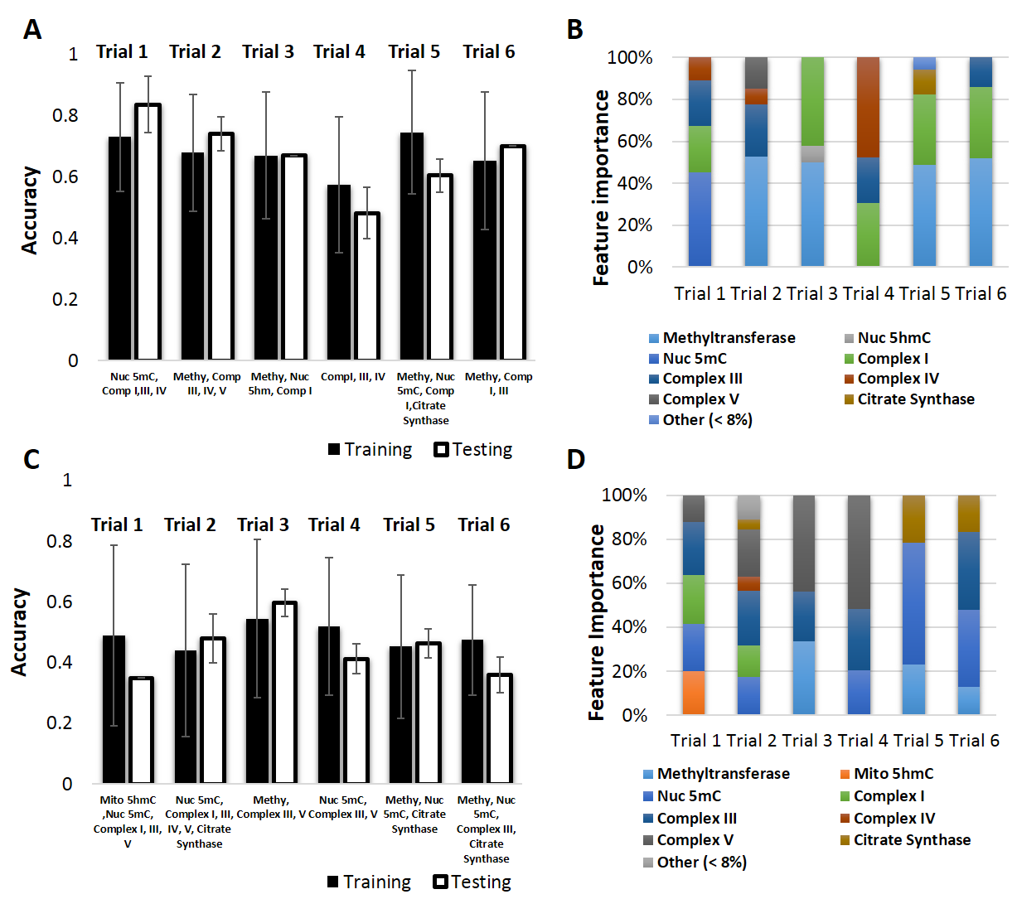

Figure S1: Feature importance using CART for physiological and biochemical characteristics from patients. (A) Training and testing accuracies for combinations of parameters that gave the most predictive outcomes in binary classification. (B) Percentage of individual feature importance by trial for binary classification. (C) Training and testing accuracies for combinations of parameters that gave the most predictive outcomes in multiple classification. (D) Percentage of individual feature importance by trial for multiple classification. Nuc = nuclear, Mito = mitochondrial, 5mC = 5-methylcytosine, 5hmC, 5-hydroxymethylcytosine, Methyl = S-adenosyl methionine methyltransferase activity, binary = non-diabetic and type 2 diabetic, multiple = non-diabetic, prediabetic, and type 2 diabetic.
Figure S2
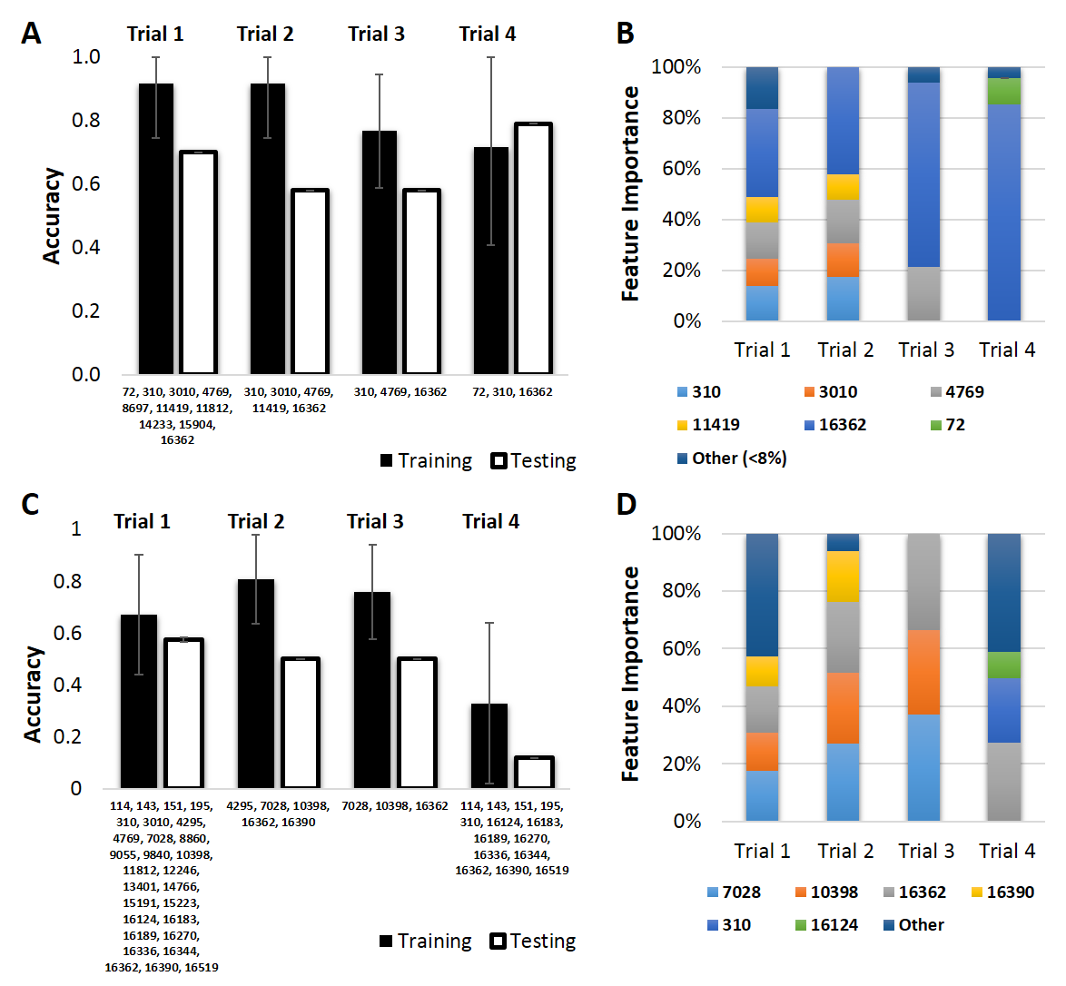

Figure S2: Feature importance using CART for mitochondrial DNA SNPs from patients. (A) Training and testing accuracies for combinations of parameters that gave the most predictive outcomes in binary classification. (B) Percentage of individual feature importance by trial for binary classification. (C) Training and testing accuracies for combinations of parameters that gave the most predictive outcomes in multiple classification. (D) Percentage of individual feature importance by trial for multiple classification. Numbers are indicative of the single nucleotide polymorphism (SNP) found in the mitochondrial DNA. Binary = non-diabetic and type 2 diabetic, multiple = non-diabetic, prediabetic, and type 2 diabetic.
Figure S3
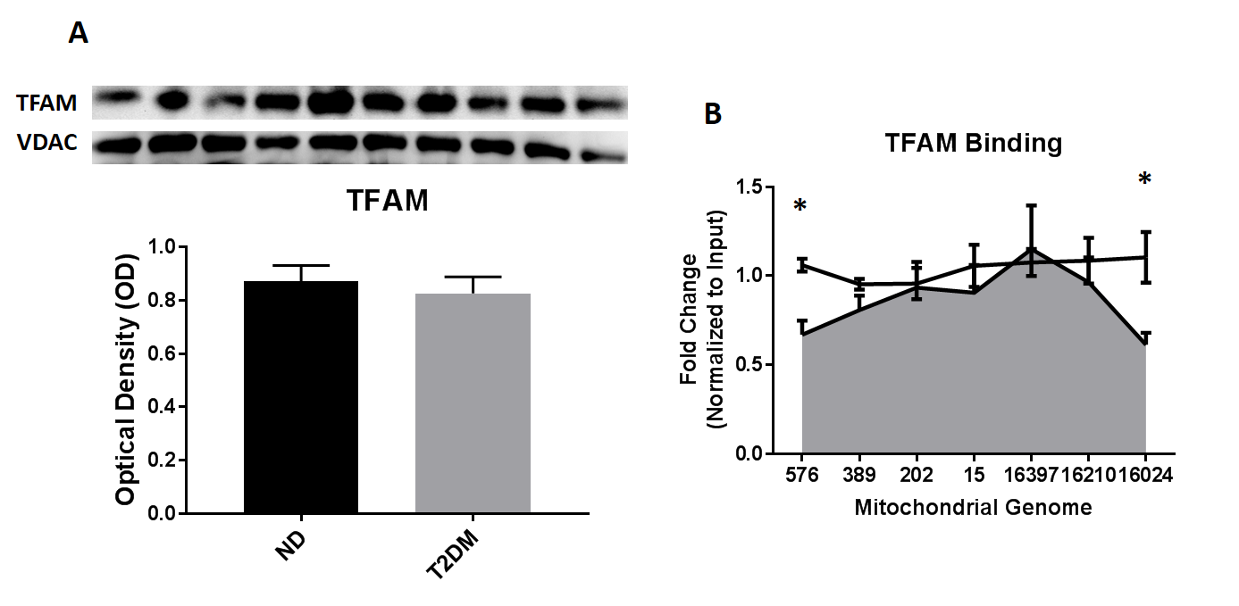

Figure S3: Expression and binding affinity of TFAM. (A) Expression of TFAM in isolated mitochondria from non-diabetic (n = 5, left) and type 2 diabetic (n = 5, right) patients. (B) Binding affinity of TFAM to the D-Loop region of mitochondrial DNA using chromatin immunoprecipitation. Groups are considered significantly different if P ≤ 0.05 = * compared to non-diabetic. All data are presented as the mean ± standard error of the mean (SEM). TFAM = transcription factor A, mitochondrial.
Figure S4
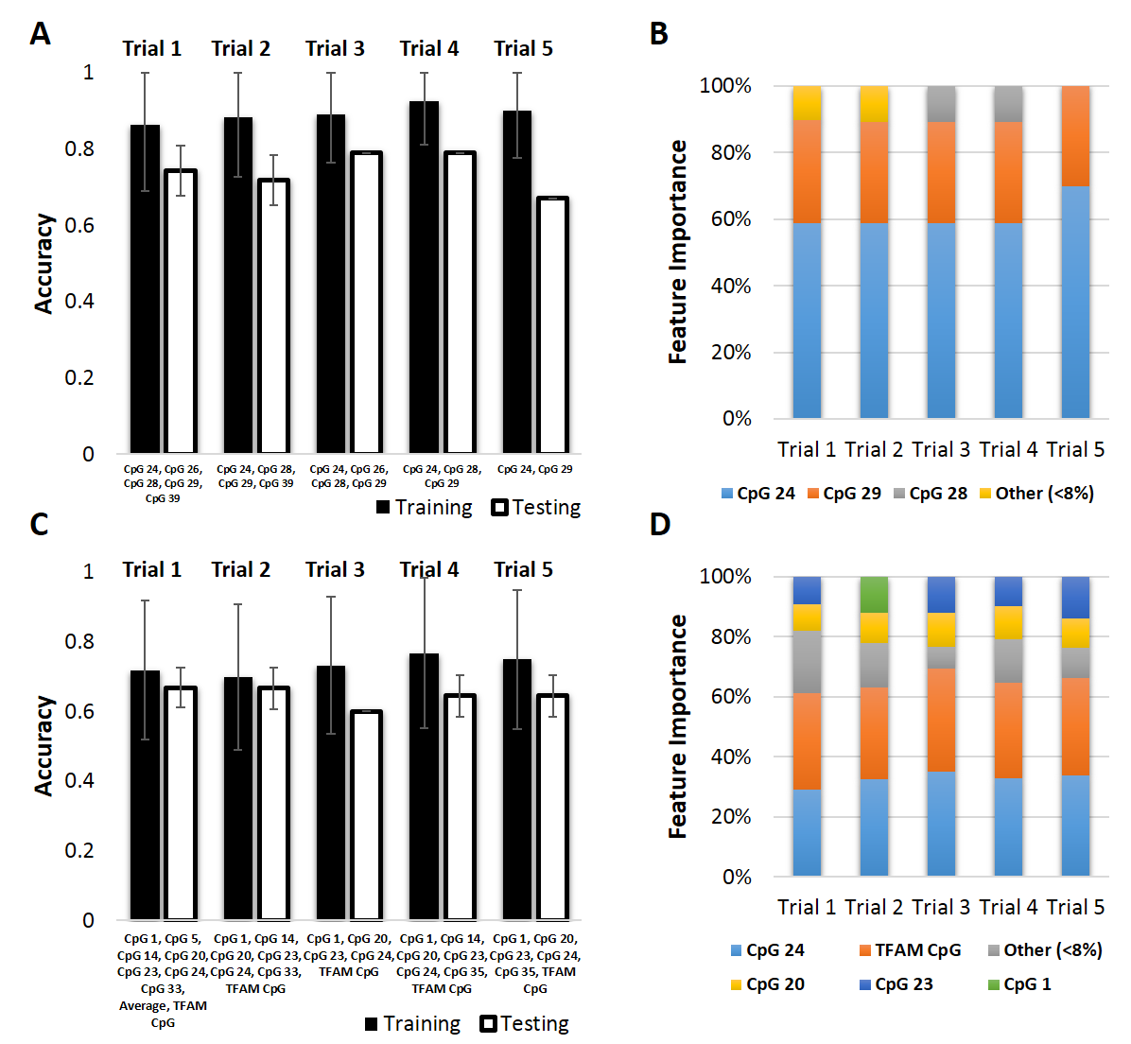

Figure S4: Feature importance using CART for CpG island methylation of TFAM from patients. (A) Training and testing accuracies for combinations of parameters that gave the most predictive outcomes in binary classification. (B) Percentage of individual feature importance by trial for binary classification. (C) Training and testing accuracies for combinations of parameters that gave the most predictive outcomes in multiple classification. (D) Percentage of individual feature importance by trial for multiple classification. CpG = cytosine nucleotide followed by a guanine nucleotide, TFAM CpG = total CpG methylation of the TFAM promoter region, TFAM = transcription factor A, mitochondrial, binary = non-diabetic and type 2 diabetic, multiple = non-diabetic, prediabetic, and type 2 diabetic.
Figure S5
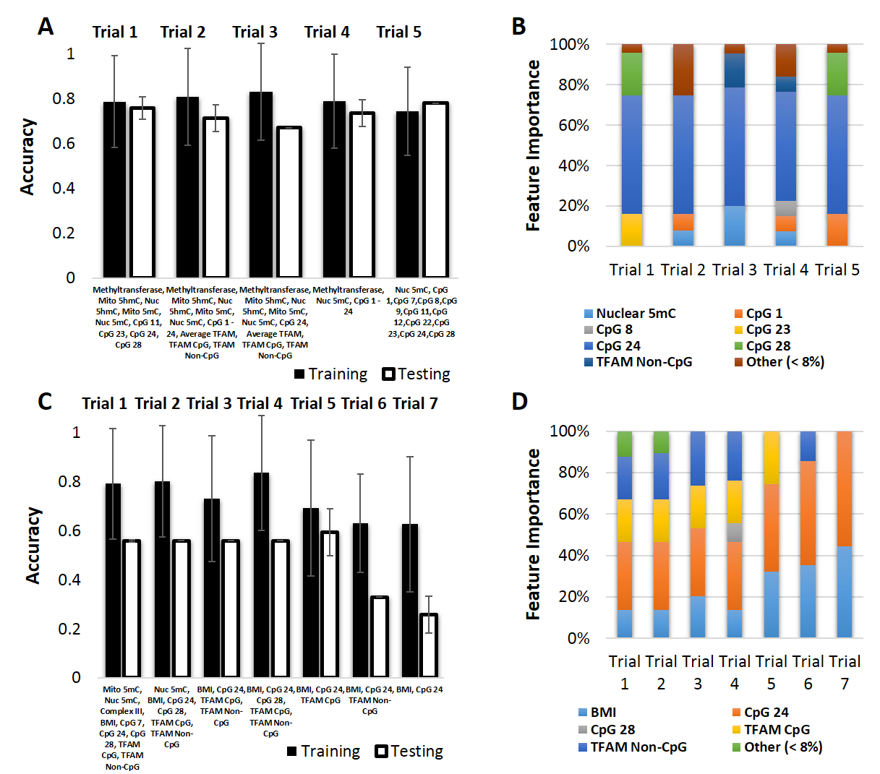

Figure S5: Feature importance using CART for all factors combined from patients. (A) Training and testing accuracies for combinations of parameters that gave the most predictive outcomes in binary classification. (B) Percentage of individual feature importance by trial for binary classification. (C) Training and testing accuracies for combinations of parameters that gave the most predictive outcomes in multiple classification. (D) Percentage of individual feature importance by trial for multiple classification. Nuc = nuclear, Mito = mitochondrial, 5mC = 5-methylcytosine, 5hmC, 5-hydroxymethylcytosine, Methylytransferase = S-adenosyl methionine methyltransferase activity, CpG = cytosine nucleotide followed by a guanine nucleotide, TFAM CpG = total CpG methylation of the TFAM promoter region, TFAM Non-CpG = total methylation of the TFAM promoter region not at CpG sites, TFAM = transcription factor A, mitochondrial, binary = non-diabetic and type 2 diabetic, multiple = non-diabetic, prediabetic, and type 2 diabetic.

