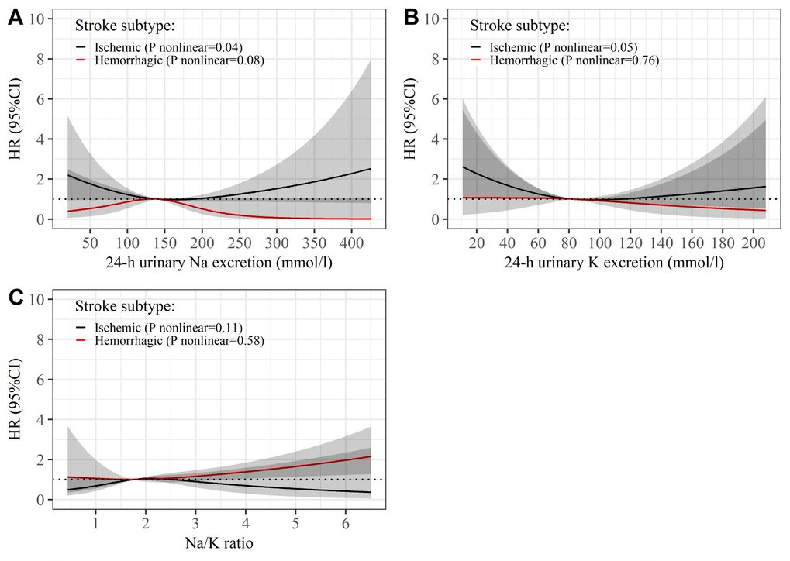
Additional Figure 3. Restricted cubic spline models for ischemic and hemorrhagic stroke and 24-h Na, 24-h K, and Na/K ratio. Risk of ischemic and hemorrhagic stroke in relation to A. 24-hour urinary sodium excretion (24-h Na), B. 24-hour urinary potassium excretion (24-h K) C. Sodium/potassium ratio (Na/K ratio), estimated using restricted cubic spline models with three knots. The age- and sex-adjusted hazard ratios (HR) are represented by the solid line and the 95% confidence interval (CI) by the shaded area.

