Additional material

Additional Table S1. Platelet function at enrolment (receiving standard-of-care aspirin 75 mg OD) and after 14 days of study aspirin 75 mg OD, compared by paired t-tests. Data shown are mean ± SD.

 | Enrolment | End of study aspirin period | p
Maximum aggregation responses (%)
Agonist
AA 1mM | 5.1 ± 16.7 | 6.5 ± 18.8 | 0.63
ADP 20 μmol/L | 75.7 ± 10.1 | 77.8 ± 8.4 | 0.17
Collagen 2 μg/mL | 59.8 ± 21.0 | 62.3 ± 19.3 | 0.39
P selectin expression after ADP 30 μmol/L (%) | 45.1 ± 24.7 | 45.7 ± 21.6 | 0.85

Additional Table S2. Proportions of patients with high- (HRPR) and low-residual platelet reactivity (LRPR) compared between the three treatments. P values generated using chi-squared tests.

 | Aspirin (n=56) | Clopidogrel (n=56) | Prasugrel (n=56)
HRPR | 56 (100%) | 30 (54%) | 3 (5%)
LRPR | 0 (0%) | 26 (46%) | 53 (95%)

 | Clopidogrel vs. Aspirin | Prasugrel vs. Aspirin | Prasugrel vs. Clopidogrel
Chi-squared | 33.9 | 100.6 | 31.3
Relative risk of HRPR (95% CI) | 0.54 (0.41 – 0.66) | 0.05 (0.02 – 0.15) | 0.1 (0.03 – 0.28)
p value | <0.0001 | <0.0001 | <0.0001

Additional Table S3. Assessments of correlation between miRNA expression and variables relating to platelet function, coagulation and diabetes, generated using Pearson correlation coefficient tests. miRNA values were log-transformed prior to analysis. Significant correlations are highlighted in bold.

 | Relative quantification
vs. | miR-21 |  | miR-24 |  | miR-126 |  | miR-191 |  | miR-197 |  | miR-223
 | R | P | R | p | R | p | R | p | R | p | R | p
MA to ADP 20 μmol/L | 0.1 | 0.19 | 0.03 | 0.75 | 0.03 | 0.75 | 0.09 | 0.23 | 0.07 | 0.35 | 0.09 | 0.24
MA to Collagen 2 μg/mL | -0.08 | 0.30 | -0.09 | 0.23 | -0.09 | 0.23 | -0.13 | 0.11 | -0.12 | 0.12 | -0.13 | 0.1
MA to AA 1 mmol/L | -0.08 | 0.30 | -0.08 | 0.31 | -0.08 | 0.31 | -0.20 | 0.010 | -0.23 | 0.002 | -0.16 | 0.04
P selectin expression to ADP 30 μmol/L | 0.23 | 0.003 | 0.27 | 0.0004 | 0.27 | 0.0004 | 0.2 | 0.008 | 0.12 | 0.13 | 0.24 | 0.002
Maximum absorbance | 0.22 | 0.006 | 0.061 | 0.44 | 0.061 | 0.44 | -0.016 | 0.84 | 0.088 | 0.27 | 0.013 | 0.87
Lag time | -0.05 | 0.53 | 0.033 | 0.67 | 0.033 | 0.67 | -0.017 | 0.83 | 0.065 | 0.41 | -0.007 | 0.93
Lysis time | 0.094 | 0.23 | 0.14 | 0.067 | 0.14 | 0.067 | -0.015 | 0.85 | 0.008 | 0.92 | 0.013 | 0.87

AA, arachidonic acid; MA, maximum aggregation

Additional Table S4. Relative quantification of miRNAs, maximum platelet aggregation responses and platelet P-selectin expression during periods of high- (HRPR) or low-residual platelet reactivity (LRPR). Data shown are mean ± SD. p values were generated with paired t-tests. AA, arachidonic acid.
 | HRPR (n=89) | LRPR (n=78) | p
Relative quantification of miRNAs
miR-21 | 1.16 ± 0.59 | 1.04 ± 0.50 | 0.16
miR-24 | 0.97 ± 0.59 | 0.83 ± 0.62 | 0.14
miR-191 | 0.80 ± 0.63 | 0.63 ± 0.55 | 0.065
miR-197 | 1.02 ± 0.63 | 0.94 ± 0.72 | 0.43
miR-223 | 0.87 ± 0.52 | 0.75 ± 0.46 | 0.1
Maximum aggregation responses (%)
Agonist
ADP 20 μmol/L | 74.6 ± 9.7 | 35.8 ± 13.5 | <2.2 x10⁻¹⁶
Collagen 2 μg/mL | 67.7 ± 20.4 | 61.7 ± 17.4 | 0.043
AA 1 mmol/L | 29.8 ± 39.3 | 52.5 ± 32.7 | 7.3 x10⁻⁵
ADP-induced (30 μmol/L) P-selectin expression (%) | 40.9 ± 22.2 | 15.6 ± 14.2 | 1.86 x 10⁻¹⁵

Additional Table S5. Relative quantification of miRNAs, maximum platelet aggregation responses and platelet P-selectin expression in participants with and without a history of cardiovascular disease. Data shown are mean ± SD. p values were generated with paired t-tests. AA, arachidonic acid.

 | Drug
 | Aspirin |  |  | Clopidogrel |  |  | Prasugrel
 | Cardiovascular disease |  |  | Cardiovascular disease |  |  | Cardiovascular disease
 | Present (n=32) | Absent (n=24) | p | Present  (n=32) | Absent  (n=24) | p | Present  (n=32) | Absent  (n=24) | p
Relative quantification of miRNAs
miR-21 | 1.29 ± 0.80 | 1.13 ± 0.43 | 0.34 | 0.97 ± 0.52 | 1.18 ± 0.51 | 0.14 | 0.92 ± 0.28 | 1.12 ± 0.59 | 0.14
miR-24 | 1.00 ± 0.71 | 1.15 ± 0.54 | 0.36 | 0.88 ± 0.84 | 0.92 ± 0.52 | 0.81 | 0.73 ± 0.32 | 0.77 ± 0.43 | 0.76
miR-191 | 0.78 ± 0.68 | 1.01 ± 0.62 | 0.19 | 0.68 ± 0.75 | 0.68 ± 0.43 | 0.99 | 0.58 ± 0.39 | 0.60 ± 0.55 | 0.89
miR-197 | 0.97 ± 0.63 | 1.35 ± 0.69 | 0.04 | 0.85 ± 0.78 | 1.15 ± 0.89 | 0.2 | 0.68 ± 0.33 | 0.99 ± 0.46 | 0.008
miR-223 | 0.86 ± 0.55 | 1.06 ± 0.57 | 0.19 | 0.75 ± 0.57 | 0.85 ± 0.47 | 0.51 | 0.67 ± 0.32 | 0.74 ± 0.43 | 0.53
Maximum aggregation responses (%)
Agonist
ADP 20 μmol/L | 77.5 ± 8.4 | 78.1 ± 8.6 | 0.79 | 55.0 ± 17.5 | 60.4 ± 17.6 | 0.27 | 34.2 ± 15.1 | 33.8 ± 12.9 | 0.92
Collagen 2 μg/mL | 61.6 ± 18.6 | 63.1 ± 20.4 | 0.77 | 71.6 ± 17.9 | 73.0 ± 18.6 | 0.77 | 59.9 ± 20.6 | 60.6 ± 15.9 | 0.89
AA 1 mmol/L | 4.84 ± 14.7 | 8.67 ± 23.4 | 0.49 | 55.5 ± 37.9 | 71.5 ± 29.5 | 0.08 | 52.2 ± 32.5 | 53.1 ± 29.8 | 0.91
ADP-induced (30 μmol/L) P-selectin expression (%) | 47.6 ± 21.9 | 43.2 ± 21.6 | 0.46 | 27.3 ± 17.5 | 27.0 ± 21.0 | 0.95 | 14.0 ± 18.3 | 14.2 ± 9.1 | 0.97

Additional Figure S1. Recruitment and follow up of study participants.

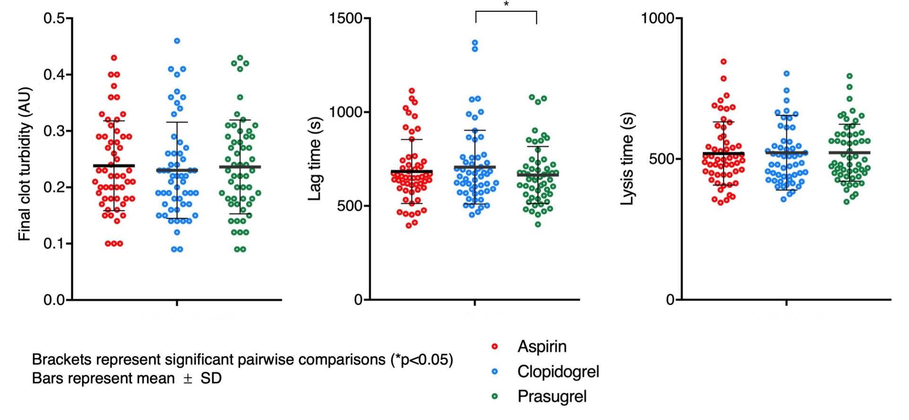

Additional Figure S2. Parameters of fibrin clot formation and lysis (A, final clot turbidity; B, lag time; C, lysis₂ time; D, lysis₃ time; E, lysis area under the curve) when receiving aspirin, clopidogrel or prasugrel. AU, absorbance units.

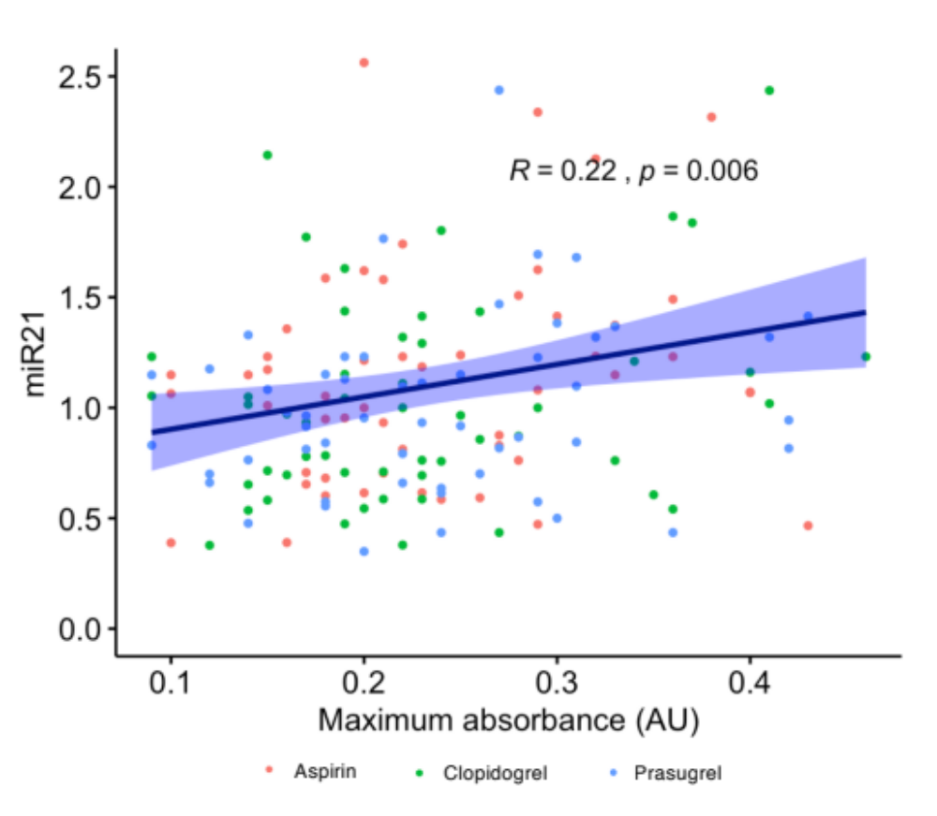
miR-21
Final clot turbidity (AU)

Additional Figure S3. Correlation of relative quantification of miR-21 with final clot turbidity. Dark blue line indicates that of best linear fit, light blue shading indicates 95% confidence interval. R and p values were produced by Pearson correlation analysis.

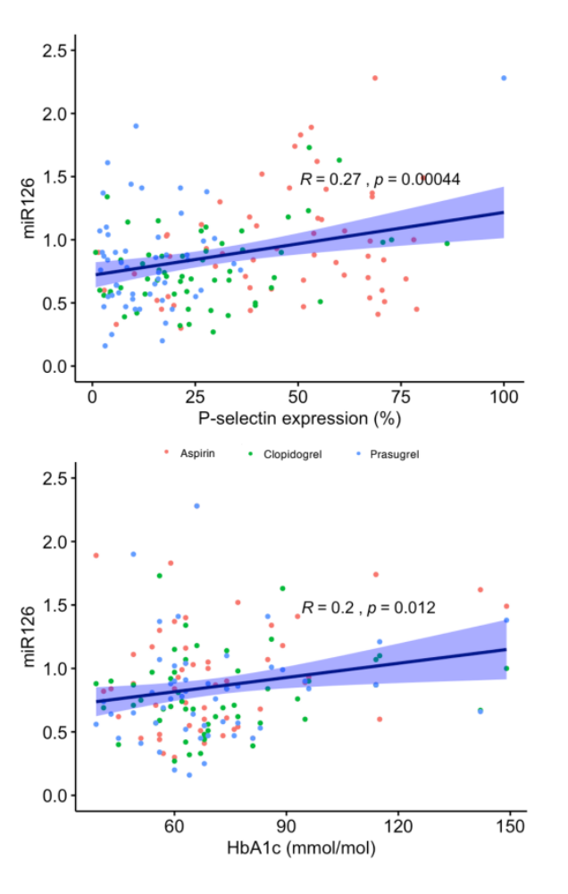
miR-126

Additional Figure S 4. Correlation of relative quantification of miR-126 with glycated haemoglobin A1c (HbA1c). Dark blue line indicates best linear fit, light blue shading indicates 95% confidence interval. R and p values were produced by Pearson correlation analysis.

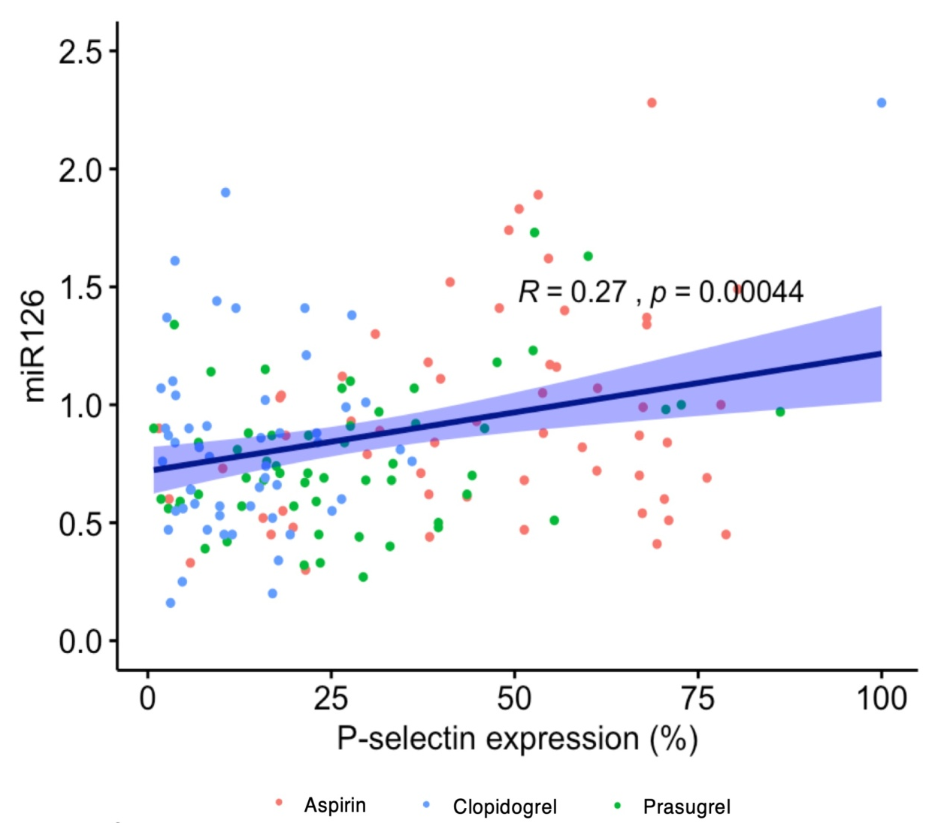

Additional Figure S5. Correlation of relative quantification of miR-126 with platelet P-selectin expression, after stimulation with 30 μmol/L ADP.

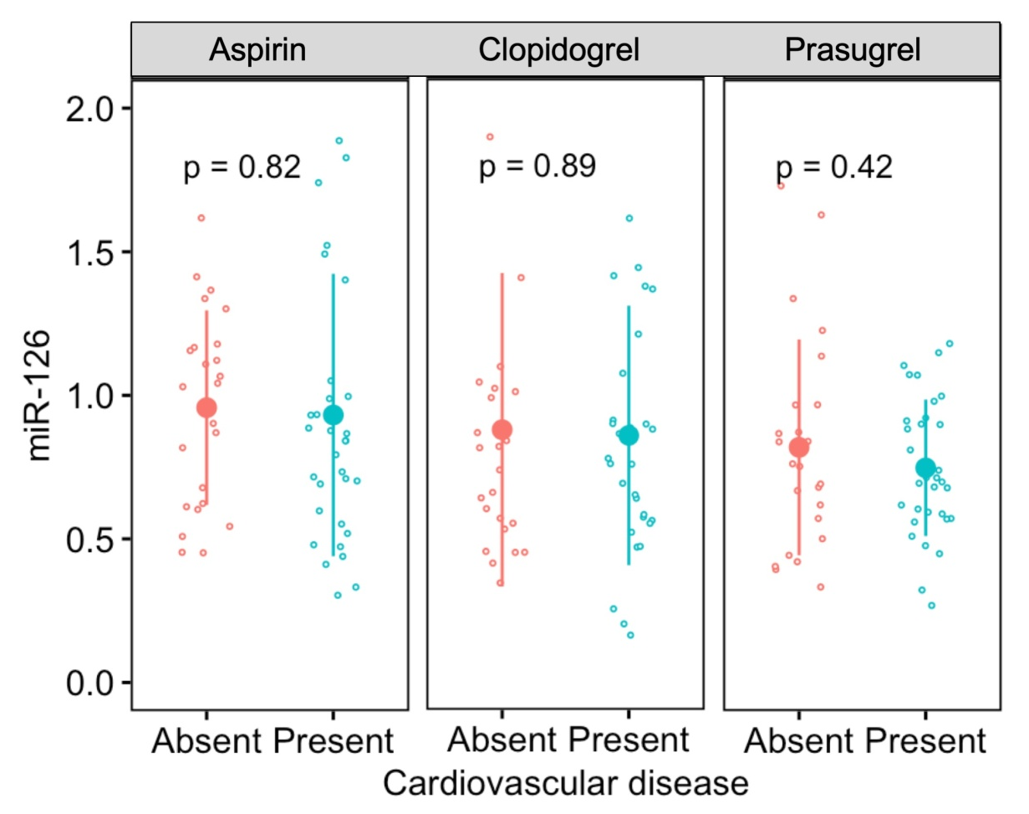

Additional Figure S6. Relative quantity of miR-126 in patients with diabetes mellitus when receiving aspirin, clopidogrel or prasugrel, stratified by presence or absence of known cardiovascular disease. P-values generated by t-tests.

