Supplementary

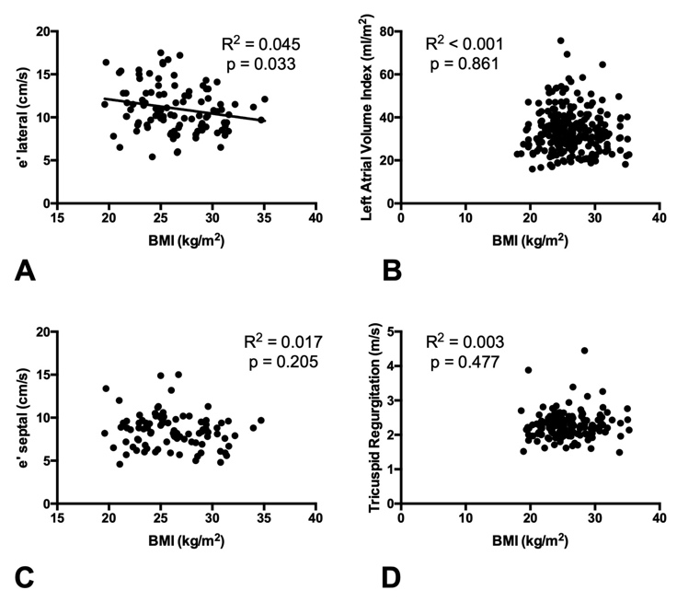
Fig. S1. Associations between BMI and diastolic function parameters in a healthy population. BMI is negatively associated with e’ lateral (A), but not with LAVI (B), e’ septal (C) or TR (D) in a healthy population.

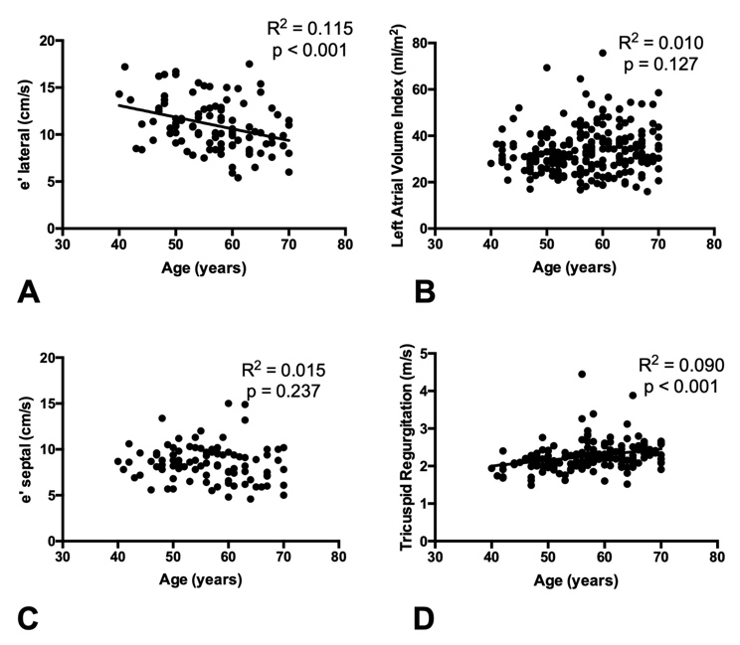
Fig. S2. Associations between age and diastolic function parameters in a healthy population. Age is negatively associated with e’ lateral (A), and positively associated with TR (D) in healthy population. Age is not with LAVI (B), or e’ septal (C).

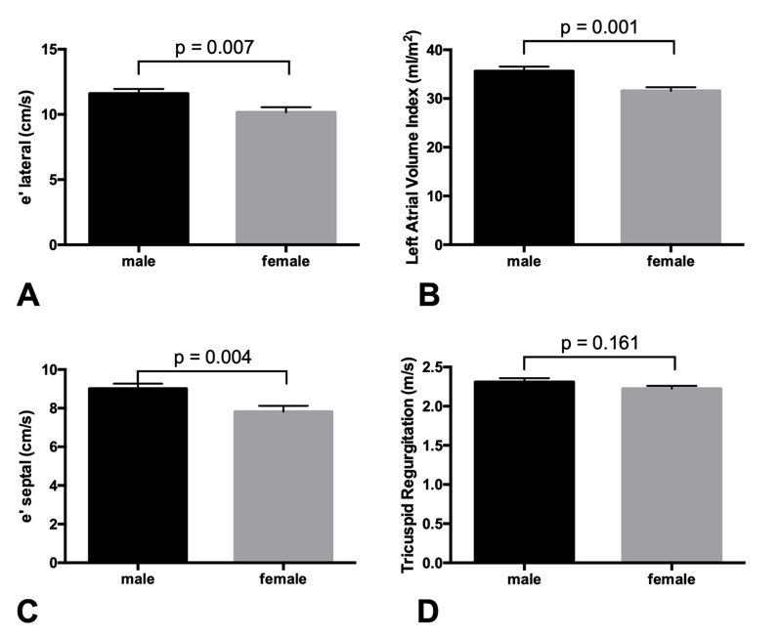
Fig. S3. Associations between sex and diastolic function parameters in a healthy population. Males are associated with higher e’ lateral (A), higher LAVI (B), and higher e’ septal (C), compared to females. No sex difference is observed in TR (D).

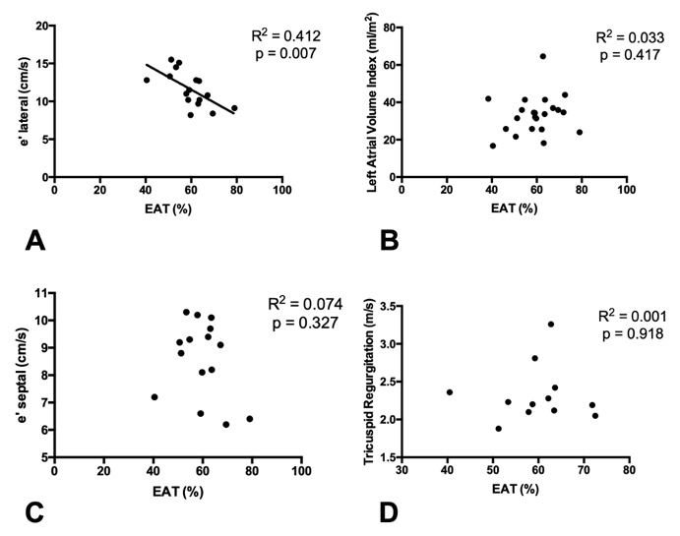
Fig. S4. Associations between EAT volume (as % of PF volume) and diastolic function parameters in subjects with low or high PF volume within a healthy population. Only e’ lateral (B) was associated with the relative amount of EAT volume; no associations were found for LAVI (B), e’ septal (C), nor TR (D).

