Supplementary Appendix Figure S1. Forest plots for semaglutide vs comparators across the quartiles of CV risk scores (and its components)
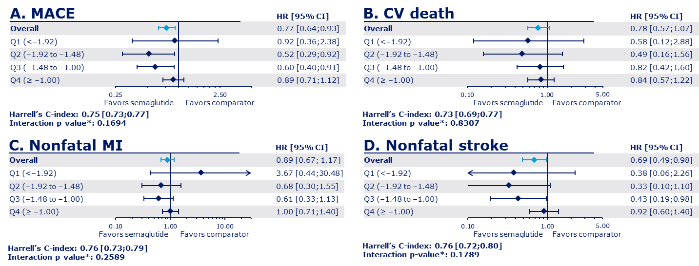
*p-value for interaction between treatment and CV risk quantile. Data in parentheses are the risk scores included in each quartile. CI, confidence interval; CV cardiovascular; HR, hazard ratio; MACE, major adverse cardiovascular events; MI, myocardial infarction; Q, quartile.

