Supplementary Appendix Figure S3. Sensitivity analysis of relative (A) and absolute (B) MACE risk estimates for semaglutide vs placebo (excluding active comparators)
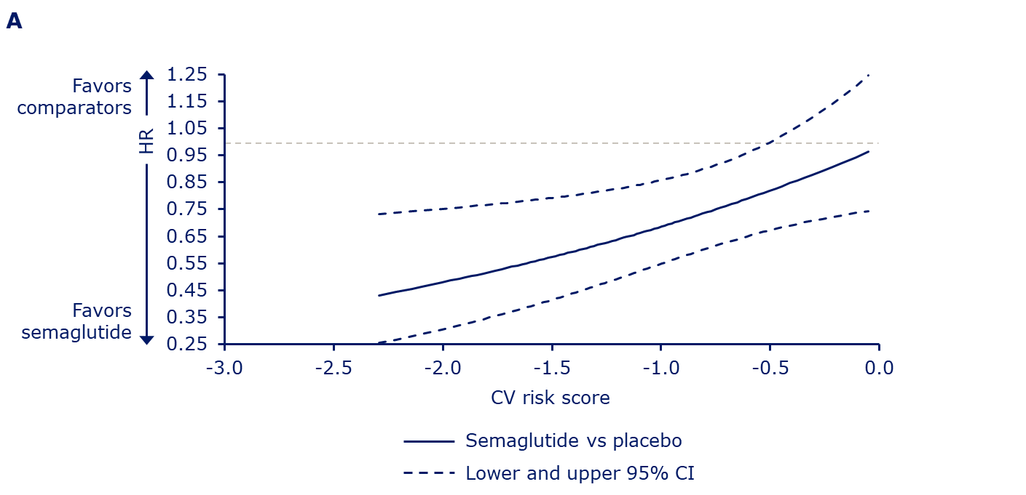
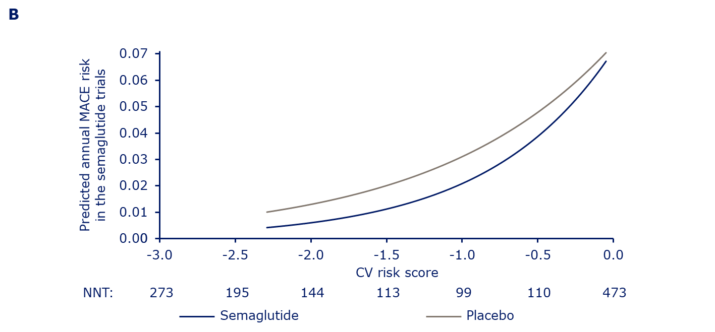
Absolute yearly MACE probabilities, estimated using a stratified Cox proportional hazards model including effects of treatment, CV risk score and interaction between both. Includes placebo data from SUSTAIN 1, SUSTAIN 5, PIONEER 1, PIONEER 4, PIONEER 5, PIONEER 6, PIONEER 8 and PIONEER 9. Hazard ratio value of 1.00 is indicated by horizontal dashed line. For panel B the model was without the stratification. The x-axis shows the CV risk score derived from subjects’ baseline characteristics in the semaglutide trials. Data on graph cut off at the 5th and 95th percentile of whole dataset. CI, confidence interval; CV, cardiovascular; CVOT, cardiovascular outcomes trial; HR, hazard ratio; MACE, major adverse cardiovascular events; NNT, number needed to treat to avoid one MACE during 1 year.

