Glycated ACE2 receptor in diabetes: open door for SARS-COV-2 entry in cardiomyocyte
¹Nunzia D’Onofrio*, PhD; ²Lucia Scisciola*, PhD; ²Celestino Sardu, MD, PhD^{Ŧ}; ³Maria Consiglia Trotta, PhD; ⁴Marisa De Feo, MD; ⁵Ciro Maiello, MD; ⁶Pasquale Mascolo, MD; ⁶Francesco De Micco, MD; ²Fabrizio Turriziani, MD; ⁷Emilia Municinò, MD; ⁷Pasquale Monetti, MD; ⁷Antonio Lombardi, MD; ⁷Maria Gaetana Napolitano, MD; ⁸Federica Zito Marino, MD; ⁸Andrea Ronchi, MD; ²Vincenzo Grimaldi, MD; ⁹Anca Hermenean, MD; ²Maria Rosaria Rizzo, MD, PhD; ²Michelangela Barbieri, MD, PhD; ⁸Renato Franco, MD; ⁶Carlo Pietro Campobasso, MD; ²Claudio Napoli, MD, PhD; ⁷Maurizio Municinò, MD; ^{2, 10}Giuseppe Paolisso, MD; ¹Maria Luisa Balestrieri, PhD; ^{2, 10}Raffaele Marfella, MD PhD.

¹Department of Precision Medicine, University of Campania L. Vanvitelli, Italy; ²Department of Advanced Medical and Surgical Sciences, University of Campania L. Vanvitelli, Italy; ³Department of Experimental Medicine, University of Campania "Luigi Vanvitelli", Naples, Italy; ⁴Department of Cardio-Thoracic Sciences, University of Campania “Luigi Vanvitelli”, Naples, Italy; ⁵Unit of Cardiac Surgery and Transplants, AORN Ospedali dei Colli-Monaldi Hospital, 80131 Naples, Italy; ⁶Department of Experimental Medicine Forensic Pathology Service University of Campania L. Vanvitelli, Italy; ⁷Department of Forensic, Evaluative and Necroscopic Medicine ASL Napoli 2 NORD, Italy; ⁸Department of Mental and Physical Health and Preventive Medicine University of Campania L. Vanvitelli, Italy; ⁹Institute of Life Science, Vasile Goldis Western University, Arad, Romania; 10. Mediterranea Cardiocentro, Naples, Italy.

*Authors equally contributed as first author

Short title: Diabetes-induced glycation of ACE2 and SARS-COV-2;
Word count: 1286;
Subject code: ACE2, Receptors; Diabetes, Type 2; Cardiomyopathy;.

ŦCorresponding author:

Prof. Celestino Sardu,
Piazza Miraglia, 2. 80138 Napoli, Italy
Tel. +39 081 5665110
Fax+39 081 5665303
Email: celestino.sardu@unicampania.it
DATA SUPPLEMENT
Figure I.

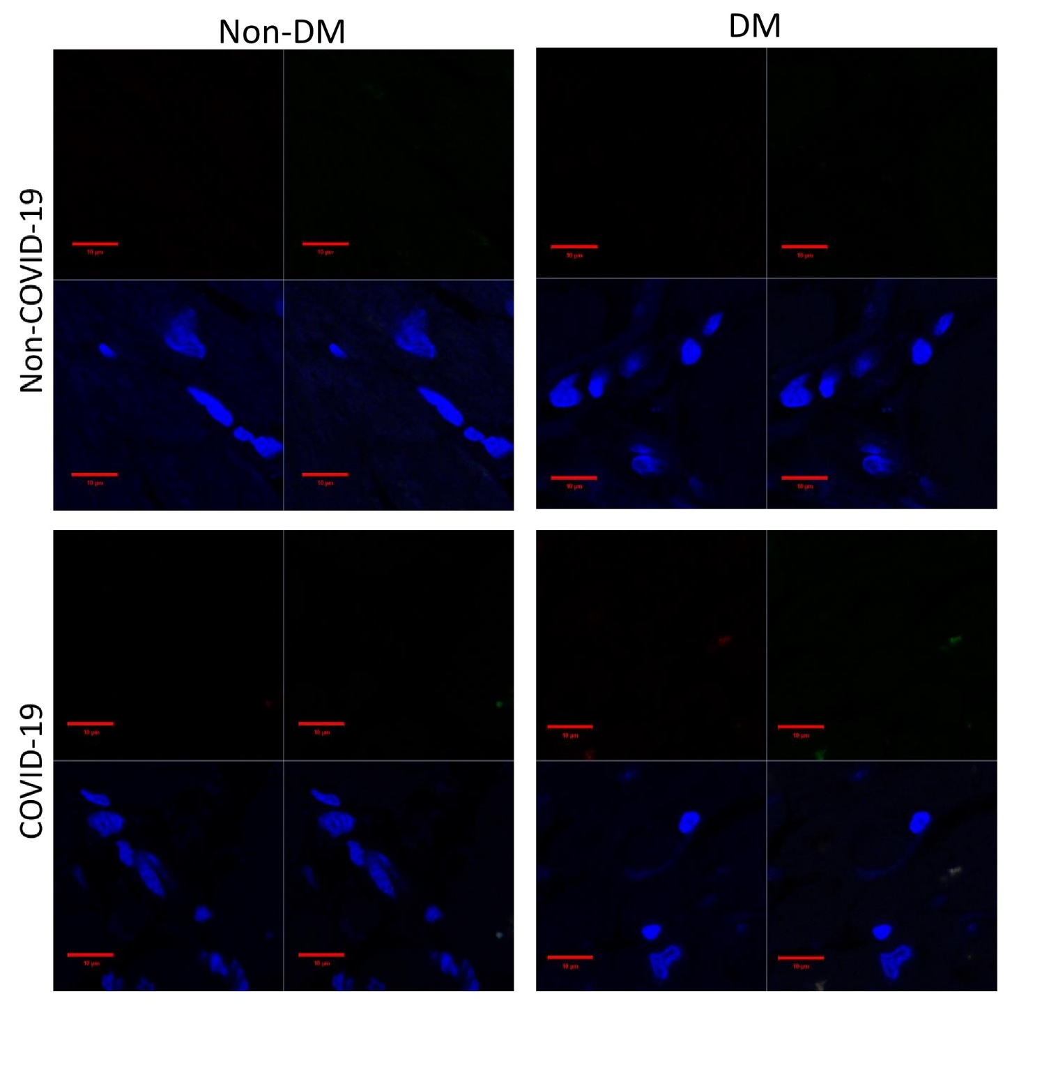

Online Figure I: Immunofluorescence negative control. Sections from diabetic and non-diabetic patients were performed with blocking solution, supplemented with a non-immune immunoglobulin IgG antibody, following by secondary antibody Alexa Fluor 488 or 633 incubation for 1 hour at RT. All samples were stained with DAPI (5 μg/ml) for 10 min before mounting in Vectashield Mounting Medium (Vector Laboratories, Burlingame, CA, USA). All slides were imaged using a Zeiss LSM 710 confocal microscope (Zeiss, Oberkochen, Germany) with a plan apochromat X63 (NA1.4) oil immersion objective. DM: diabetes mellitus; Non-DM: without diabetes mellitus.

Sequence | Accuracy  (ppm) | Accuracy glycated  (ppm) | RT  (min) | RT glycated (min) | Sequence Span
Glucose-12 mM
AVCHPTAWDLGKGDFR | 8.44 | 0.00 | 16.62 | 18.54 | 342-357
NSFVGWSTDWSPYADQSIKVR | 0.38 | 0.08 | 26.53 | 26,58 | 601-621
SALGDKAYEWNDNEMYLFR | 0.04 | 0.04 | 26.39 | 26.18 | 626-644
VKNQMILFGEEDVR | 1.03 | 1.13 | 20,77 | 20,65 | 658-671
ISFNFFVTAPKNVSDIIPR | 0.56 | 0.60 | 30.80 | 30.60 | 679-697
Glucose-60 mM
AVCHPTAWDLGKGDFR | -10.55 | 0.82 | 21.28 | 21.3 | 342-357
GEIPKDQWMK | -1,44 | -0.24 | 16.78 | 16.9 | 466-475
LGKSEPWTLALENVVGAK | -1.25 | 0.31 | 30.70 | 30.47 | 560-577
NSFVGWSTDWSPYADQSIKVR | -0.61 | 1.23 | 29,44 | 29.27 | 601-621
SALGDKAYEWNDNEMYLFR | 0,00 | 0,13 | 29,43 | 29,14 | 626-644
VKNQMILFGEEDVR | -3.32 | 0.36 | 23.79 | 23.56 | 658-671
ISFNFFVTAPKNVSDIIPR | -1.98 | 1.39 | 33.64 | 33.4 | 679-697
Glucose-120 mM
AVCHPTAWDLGKGDFR | -3.26 | -3.55 | 21.27 | 21.12 | 342-357
GEIPKDQWMK | -2.73 | -1.14 | 16.78 | 16.67 | 466-475
LGKSEPWTLALENVVGAK | 0.14 | -1.10 | 30.7 | 30.47 | 560-577
NSFVGWSTDWSPYADQSIKVR | -0.61 | -0.41 | 29.47 | 29.37 | 601-621
SALGDKAYEWNDNEMYLFR | -0.93 | 0.17 | 29.43 | 29.27 | 626-644
VKNQMILFGEEDVR | -1.36 | -3.28 | 23.73 | 23.56 | 658-671
ISFNFFVTAPKNVSDIIPR | -1.25 | -1.89 | 33.63 | 33.4 | 679-697

Online Table I: Mass accuracy and retention time (RT) of hACE2 tryptic peptides targeted by glycation. The measurement accuracies were reported in parts per million (ppm) and the chromatographic retention times in minutes (mins).

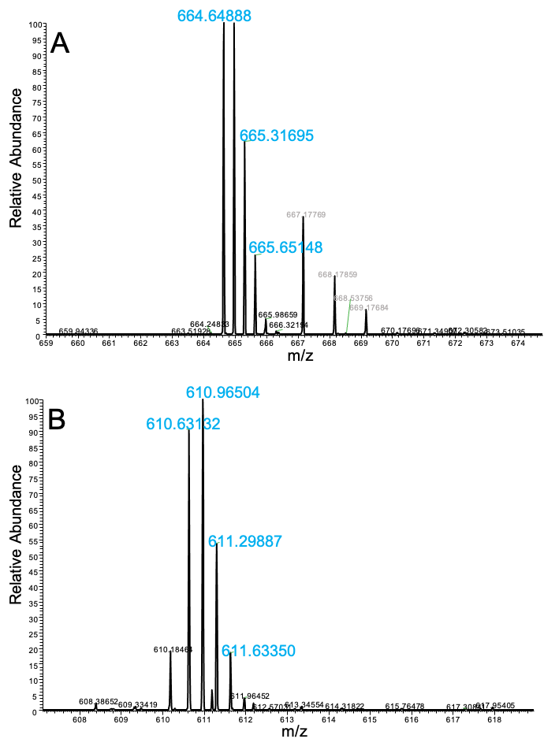

Online Figure II: Mass spectra of the triply charged hACE2 tryptic peptide 342-357 in the glycated (panel A) and non-glycated (panel B) form.

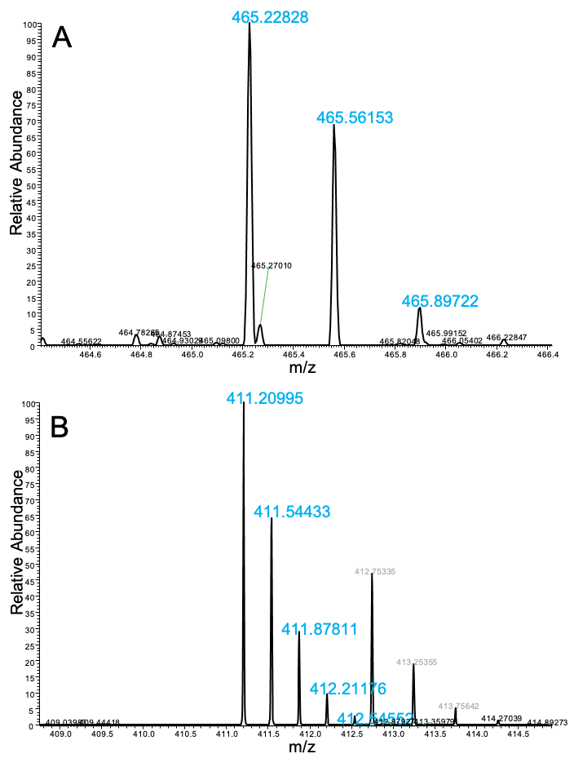

Online Figure III: Mass spectra of the triply charged hACE2 tryptic peptide 466-475 in the glycated (panel A) and non-glycated (panel B) form.

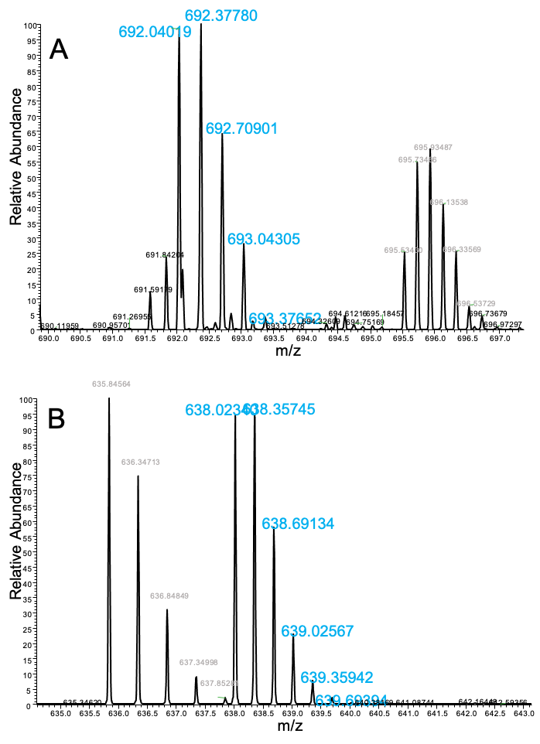

Online Figure IV: Mass spectra of the triply charged hACE2 tryptic peptide 560-577 in the glycated (panel A) and non-glycated (panel B) form.

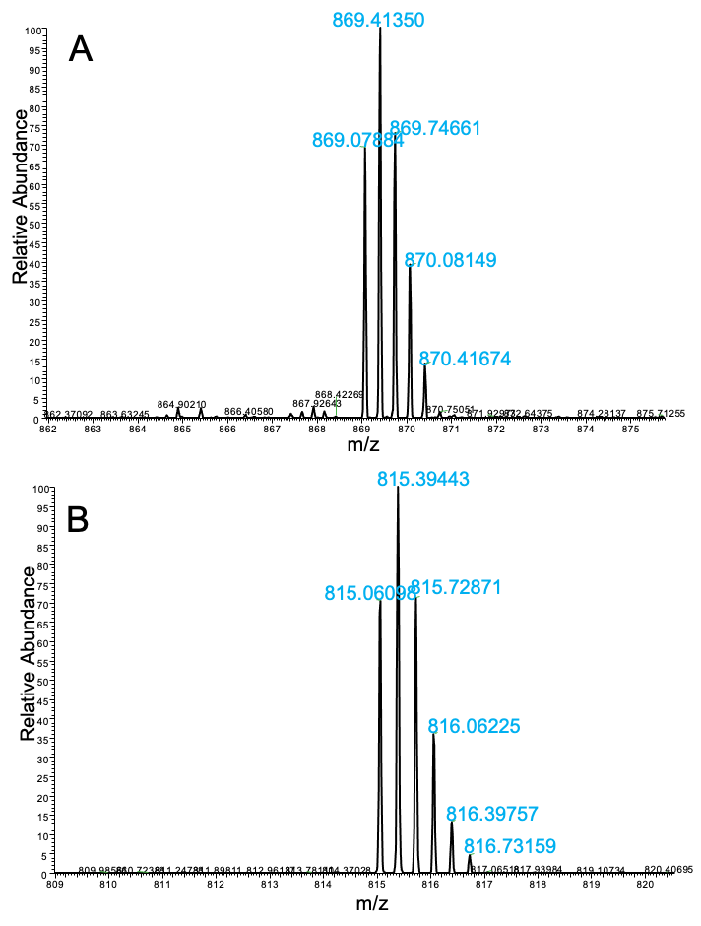

Online Figure V: Mass spectra of the triply charged hACE2 tryptic peptide 601-621 in the glycated (panel A) and non-glycated (panel B) form.

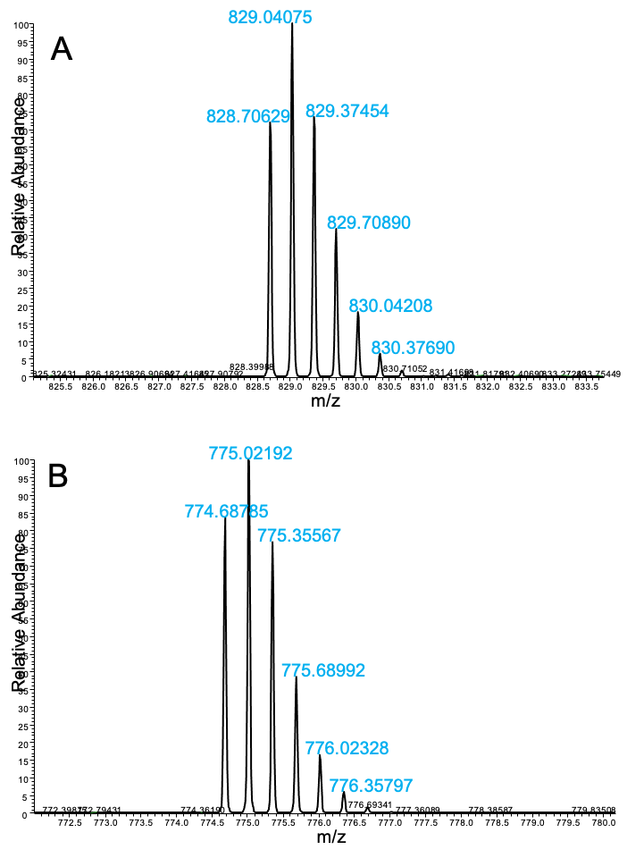

Online Figure VI: Mass spectra of the triply charged hACE2 tryptic peptide 626-644 in the glycated (panel A) and non-glycated (panel B) form.

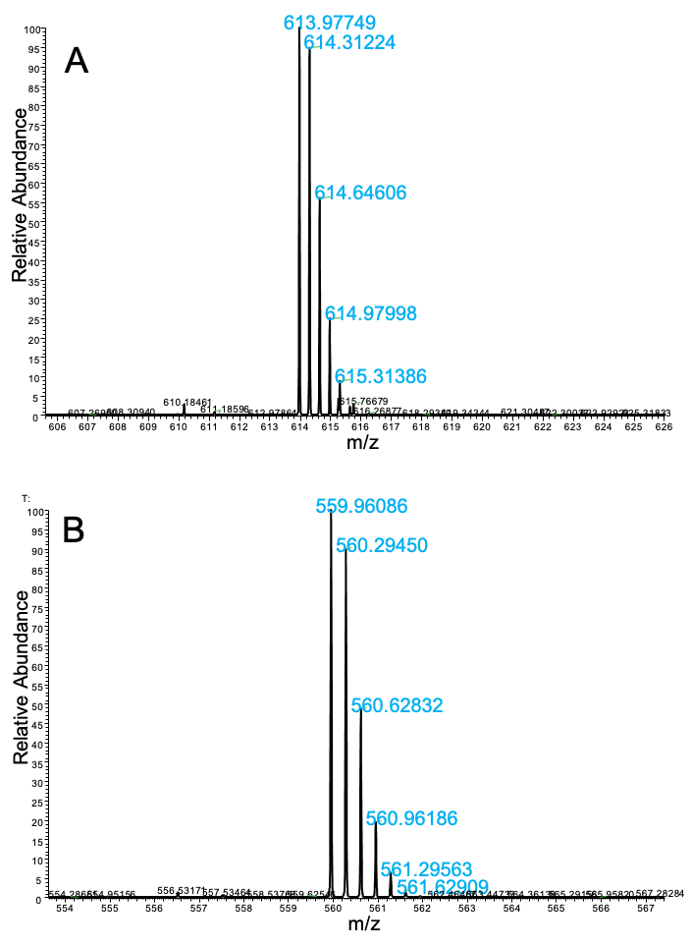

Online Figure VII: Mass spectra of the triply charged hACE2 tryptic peptide 658-671 in the glycated (panel A) and non-glycated (panel B) form.

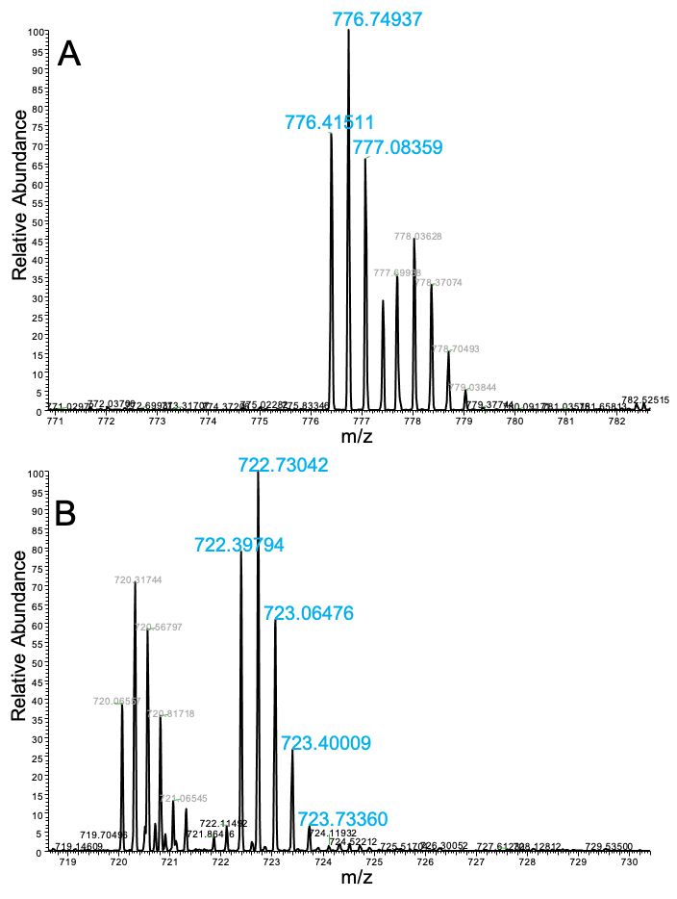

Online Figure VIII: Mass spectra of the triply charged hACE2 tryptic peptide 679-697 in the glycated (panel A) and non-glycated (panel B) form.

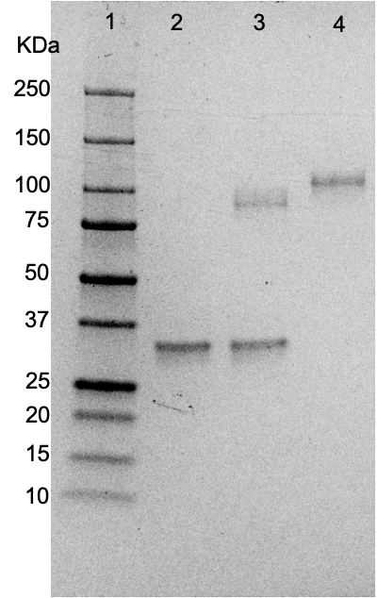

Online Figure IX: hACE2 PNGase F deglycosylation.
SDS-PAGE performed on 500 nanograms of hACE2 digested with five units of PNGase F (Promega, catalog n. V4831) overnight at 37 °C and then analyzed on a NuPAGE 4-12 Bis-Tris gel (Thermo, catalog no. NP326) using a NuPAGE MES running buffer (Thermo, catalog no. NP0002). Lane 1=Bio-Rad Precision Standard (catalog no. 161-0373); lane 2=deglycosylation blank; lane 3=PNGase-digested hACE2; lane 4= undigested hACE2. The band at about 35 KDa in lanes 2 and 3 is the PNGase F.

Online Figure X. Glycated hACE binding to SARS-CoV-2 Spike protein. A, hACE2 control, B, hACE2 at 12 days incubation time with 60 mM and C, 120 mM of glucose. D, Values of kinetic binding parameters of hACE2-SARS-CoV-2 Spike protein obtained from SPR measurement. Binding sensorgrams for SARS-CoV-2 Spike protein and several analyte concentrations of 1 µg of immobilized Spike protein and ACE2. Samples of ACE2 were diluted in HBS-EP+ at different concentration (64 µg/ml, 32µg/ml, 16 µg/ml, 8 µg/ml, and 4 µg/ml) and injected for 120s at a flow rate of 30µl/min on flow cell 3 and 4. Formulation buffer was run as a control. Dissociation was followed for 300sec; regeneration was achieved with a 60-sec pulse of 3M MgCl2. ACE2 concentrations were listed on the right side and were expressed in µg/ml. Ligand-analyte affinity (KD) and kinetic parameters (Association rate, Ka; Dissociation rate, Kd) of Originator and Biosimilar Rituximab was calculated with the Biacore T200 Evaluation Software (version 2.0; GE Healthcare)

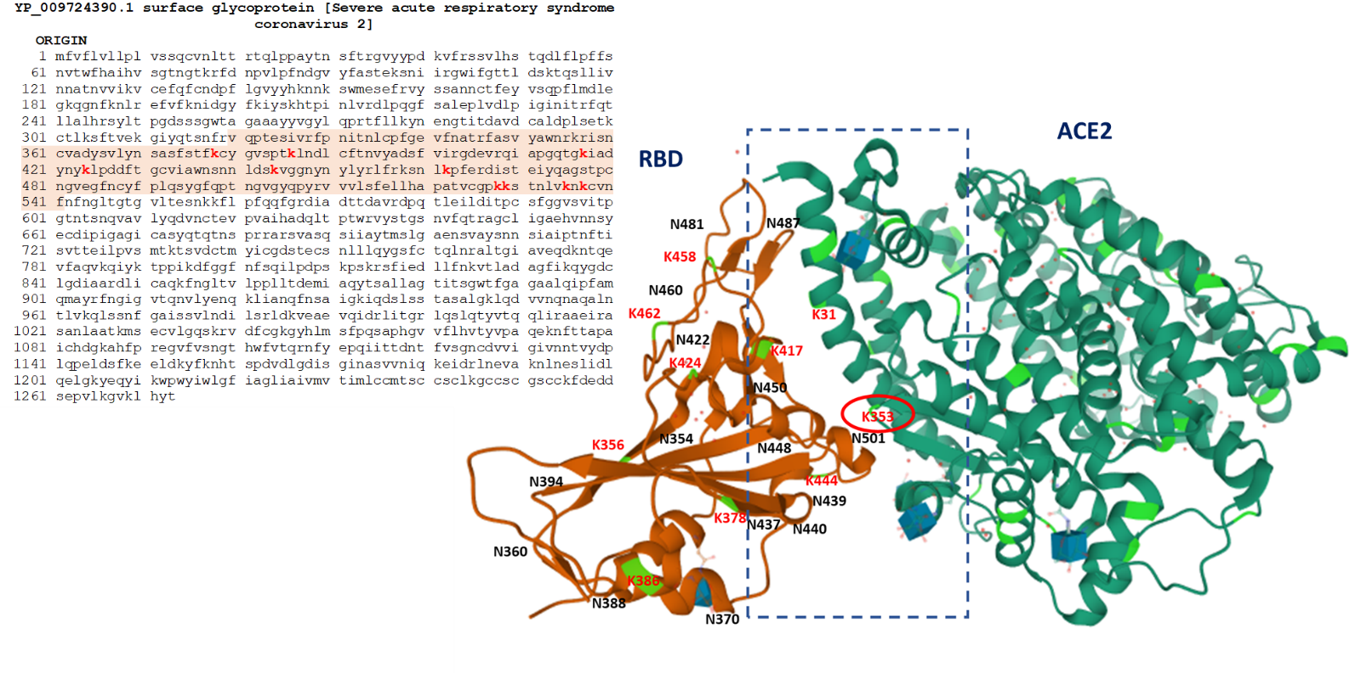

Online Figure XI: RBD amino acid sequence; 319–541 residues and crystal structure of SARS-CoV-2 Spike receptor-binding domain (RBD) bound with ACE2 (PDB ID: 6M0J). Lysine 353 (K353) undergoes mild glycation by high-glucose (12 mM) exposure. Asparagine (N).

