Additional file to Morieri et al. “Improving statin treatment strategies to reduce LDL-cholesterol: factors associated with targets' attainment in subjects with and without type 2 diabetes.”

Additional file 1: Figure S1. study flow-chart and design
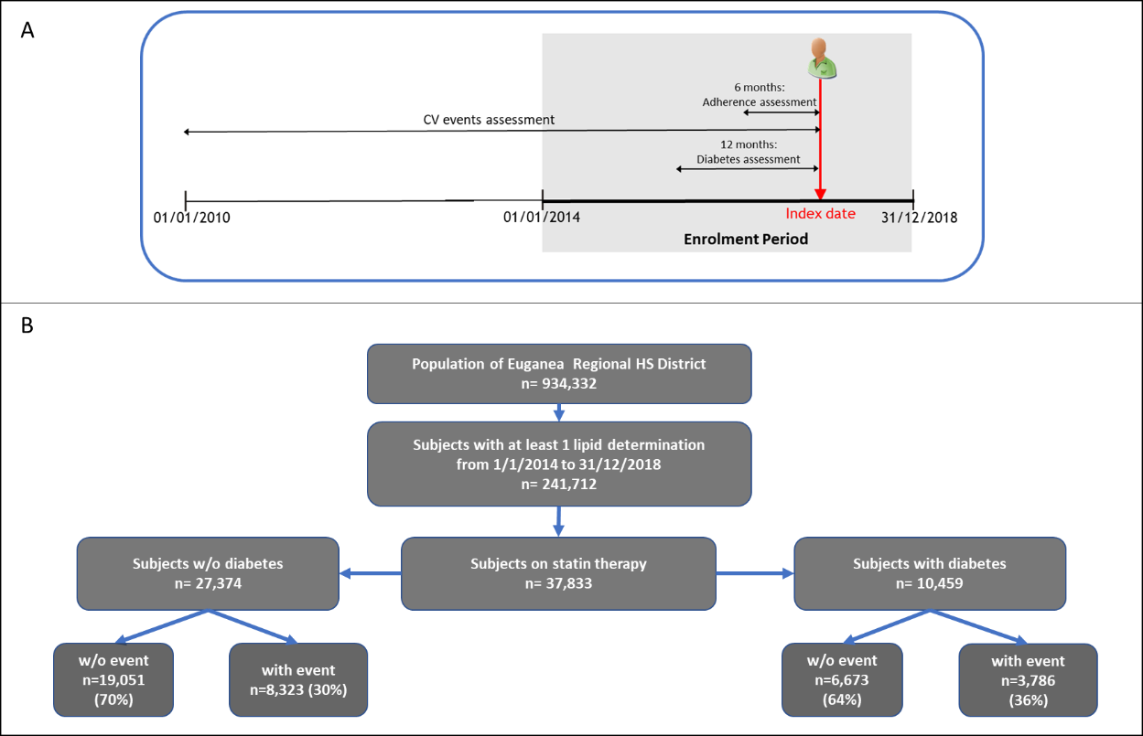

Additional file 1: Figure S2. LDL-cholesterol levels in patients with events according to event site and lipid-lowering treatments
