Supplementary Materials

CVD-REAL Investigator and Study Group
Executive Scientific Committee (Academic Members and Investigators):
Mikhail Kosiborod, MD, Saint Luke's Mid America Heart Institute and University of Missouri-Kansas City, Kansas City, MO, United States; Matthew A. Cavender, MD MPH, University of North Carolina, Chapel Hill, NC, United States; John P. Wilding MD, PhD, University of Liverpool, Liverpool, United; Kingdom; Kamlesh Khunti, MD PhD, University of Leicester, Leicester, United Kingdom; Anna Norhammar, MD, Cardiology Unit, Department of Medicine, Karolinska Institutet, Stockhom, Sweden; Kåre Birkeland, MD PhD, Department of Endocrinology, University of Oslo, Norway; Marit Eika Jørgensen, MD PhD, Cand.med, Steno Diabetes Center, Gentofte, Denmark; Reinhard W. Holl MD PhD, Institute of Epidemiology, University of Ulm, Ulm, Germany; Carolyn SP Lam, MD, National Heart Centre, Singapore and SingHealth Duke-NUS, Singapore.

Extended publications committee
Hanne Løvdal Gulseth, MD, PhD, Department of Endocrinology, Oslo University Hospital, Aker, Norway; Bendix Carstensen, PhD, Diabetes Center, Gentofte, Denmark; Esther Bollow, Institute of Epidemiology and Medical Biometry, University of Ulm, Ulm, Germany; Josep Franch-Nadal, MD, PhD, Researcher at the IDIAP - Unitad de Suport a la Recerca - Jordi Gol Fundation - EAP Rabal Sud, Barcelona, Spain - Catalunya Registry; Luis Alberto García Rodríguez, MD, CEIFE - Centro Español de Investigación Farmacoepidemiológica, Madrid, Spain; Avraham Karasik, MD PhD, Institute of Endocrinology, Tel Aviv University, Ramat Aviv, Israel - Maccabi Healthcare Services; Navdeep Tangri MD PhD, University of Manitoba, Winnipeg MB, Canada- Manitoba Centre for Health Policy (MCHP); Shun Kohsaka MD, Keio University School of Medicine, Tokyo, Japan; Dae Jung Kim MD, Professor at Ajou University School of Medicine, Korea; Jonathan Shaw MD, Professor, Baker IDI Heart and Diabetes Institute – Australia; Suzanne Arnold, MD, MHA. Research Assistant Professor, University of Missouri–Kansas City School of Medicine, Kansas City, MO; Su-Yen Goh MD, Singapore General Hospital, Singapore; Chern-En Chiang MD, Taipei Veterans General Hospital, Taipei, Taiwan; Johan G Eriksson, University of Helsinki and Helsinki University Hospital, Helsinki, Finland; Francesco Zaccardi MD PhD, University of Leicester, Leicester, United Kingdom

Executive Scientific Committee (AstraZeneca Members):
Peter Fenici, MD, PhD, Global Medical Affairs Senior Leader, AZ, Academy House, Cambridge, United Kingdom (Study Leader); Johan Bodegård, MD PhD, Medical Evidence Scientific Lead Nordics/Baltic, AZ Oslo, Norway; Hungta Chen PhD, Principal Statistician, Biometrics and Information Sciences, AZ Gaithersburg, MD, USA; Filip Surmont MD, Medical Director CVMD International, AZ Luton, United Kingdom; Rachel Kendrick, PhD, Publications Lead, AZ Cambridge, United Kingdom; Wesley Belli, PhD, Publications Lead, AZ Gaithersburg, MD, USA;

Study Core Team (AstraZeneca Members):
Eric T. Wittbrodt, PharmD, MPH, HEOR Director, AZ Wilmington, DE, United States; Matthias Saathoff, Dr, Clinical Project Leader, ERP, AZ, Wedel, Germany; Yusuke Noguchi, BS, MBA, Associate Medical Affairs Manager in AZKK, Japan, Donna Tan, Brand Manager, COM, AZ Singapore, Maro Williams, Senior Medical Manager, EMA, AZ Australia, Hye Won Lee, Medical Science Liaison, COO, AZ South Korea, Maya Greenbloom, Manager Medical Liaison, Medical Affairs, AZ Israel, Oksana Kaidanovich-Beilin, Medical Evidence Lead, COO, AZ Canada; Karolina Andersson-Sundell, MSc PhD, Assoc .Dir. Epidemiology, MEOR, AZ Gothenburg, Sweden;.

External Investigators and Analysts:
Khung Keong Yeo MBBS, National Heart Centre, Singapore; Yong Mong Bee MBBS, Singapore General Hospital, Singapore; Joan Khoo MBBS, Changi General Hospital, Singapore; Agnes Koong MBBS, SingHealth Polyclinics, Singapore; Yee How Lau, Singapore Cardiac Data Bank, Singapore; Fei Gao, National Heart Centre, Singapore; Wee Boon Tan MBBS, Singapore General Hospital, Singapore; Hanis Abdul Kadir BSc, Singapore General Hospital, Singapore; Kyoung Hwa Ha, PhD, Department of Endocrinology and Metabolism, Ajou University School of Medicine, Republic of Korea; Jinhee Lee, MS, Department of Endocrinology and Metabolism, Ajou University School of Medicine, Republic of Korea; Gabriel Chodick, PhD, Faculty of Medicine, Tel Aviv University, Medical division, Maccabi Healthcare Services, Israel; Cheli Melzer Cohen, MSc, Medical division, Maccabi Healthcare Services, Israel; Reid Whitlock, BEd, BSc, MSc, Biostatistician, Seven Oaks Hospital Chronic Disease Innovation Centre, Canada; Lucia Cea Soriano, PharmD, PhD, CEIFE – Centro Español de Investigación Farmacoepidemiológica; Oscar Fernándex Cantero, CEIFE – Centro Español de Investigación Farmacoepidemiológica; Jordan A. Menzin, BA, Chief Technology Officer, Boston Health Economics, Inc, Waltham, MA; Matthew Guthrie, MA, Analyst II, Boston Health Economics, Inc, Waltham, MA; Jennie Ilomaki PhD, Monash University, Australia; Dianna Magliano, PhD, Monash University, Australia; Fabian Hoti, StatFinn & EPID Research, Espoo, Finland; Solomon Christopher, StatFinn & EPID Research, Espoo, Finland; Minna Vehkala, StatFinn & EPID Research, Espoo, Finland

Data Sources
Data from Finland utilised the DAHLIA study database, which includes T2D patient information from four linked national Finnish registries with full coverage of the population: the Finnish Prescription Register for years 1998 to 2015, covering all filled drug prescriptions using ATC-codes; the Finnish Cause of Death Registry for years until 2015; the Finnish Care Register for Health Care covering all open patient clinic visit diagnoses and all hospital discharge diagnoses for the years 1996 to 2015; and the Finnish Register for Primary Health Care visits for the years 2011-2015. Diagnoses are recorded according to the ICD-10 and the NOMESCO Classification of Surgical Procedure (NCSP) codes. Data linkage was performed by Finnish Social Insurance Institution based on the study identification numbers provided by the Prescription Register.

Table S1. ICD and Read codes for Type 2 diabetes, Type 1 diabetes and gestational diabetes
Type 2 diabetes
ICD codes
ICD-9 250.X0, 250.X2
ICD-10 codes E11 and 024.1
Read codes
66A4.00 | Diabetic on oral treatment
66Ao.00 | Diabetes type 2 review
66At100 | Type II diabetic dietary review
66At111 | Type 2 diabetic dietary review
66AV.00 | Diabetic on insulin and oral treatment
C100100 | Diabetes mellitus, adult onset, no mention of complication
C100111 | Maturity onset diabetes
C100112 | Non-insulin dependent diabetes mellitus
C101100 | Diabetes mellitus, adult onset, with ketoacidosis
C102100 | Diabetes mellitus, adult onset, with hyperosmolar coma
C103100 | Diabetes mellitus, adult onset, with ketoacidotic coma
C104100 | Diabetes mellitus, adult onset, with renal manifestation
C105100 | Diabetes mellitus, adult onset, + ophthalmic manifestation
C106100 | Diabetes mellitus, adult onset, + neurological manifestation
C107100 | Diabetes mellitus, adult, + peripheral circulatory disorder
C107200 | Diabetes mellitus, adult with gangrene
C107400 | NIDDM with peripheral circulatory disorder
C109.00 | Non-insulin dependent diabetes mellitus
C109.11 | NIDDM - Non-insulin dependent diabetes mellitus
C109.12 | Type 2 diabetes mellitus
C109.13 | Type II diabetes mellitus
C109000 | Non-insulin-dependent diabetes mellitus with renal comps
C109011 | Type II diabetes mellitus with renal complications
C109012 | Type 2 diabetes mellitus with renal complications
C109100 | Non-insulin-dependent diabetes mellitus with ophthalm comps
C109111 | Type II diabetes mellitus with ophthalmic complications
C109112 | Type 2 diabetes mellitus with ophthalmic complications
C109200 | Non-insulin-dependent diabetes mellitus with neuro comps
C109211 | Type II diabetes mellitus with neurological complications
C109212 | Type 2 diabetes mellitus with neurological complications
C109300 | Non-insulin-dependent diabetes mellitus with multiple comps
C109400 | Non-insulin dependent diabetes mellitus with ulcer
C109411 | Type II diabetes mellitus with ulcer
C109412 | Type 2 diabetes mellitus with ulcer
C109500 | Non-insulin dependent diabetes mellitus with gangrene
C109511 | Type II diabetes mellitus with gangrene
C109512 | Type 2 diabetes mellitus with gangrene
C109600 | Non-insulin-dependent diabetes mellitus with retinopathy
C109611 | Type II diabetes mellitus with retinopathy
C109612 | Type 2 diabetes mellitus with retinopathy
C109700 | Non-insulin dependent diabetes mellitus - poor control
C109711 | Type II diabetes mellitus - poor control
C109712 | Type 2 diabetes mellitus - poor control
C109900 | Non-insulin-dependent diabetes mellitus without complication
C109A00 | Non-insulin dependent diabetes mellitus with mononeuropathy
C109A11 | Type II diabetes mellitus with mononeuropathy
C109B00 | Non-insulin dependent diabetes mellitus with polyneuropathy
C109B11 | Type II diabetes mellitus with polyneuropathy
C109C00 | Non-insulin dependent diabetes mellitus with nephropathy
C109C11 | Type II diabetes mellitus with nephropathy
C109C12 | Type 2 diabetes mellitus with nephropathy
C109D00 | Non-insulin dependent diabetes mellitus with hypoglyca coma
C109D11 | Type II diabetes mellitus with hypoglycaemic coma
C109D12 | Type 2 diabetes mellitus with hypoglycaemic coma
C109E00 | Non-insulin depend diabetes mellitus with diabetic cataract
C109E11 | Type II diabetes mellitus with diabetic cataract
C109E12 | Type 2 diabetes mellitus with diabetic cataract
C109F00 | Non-insulin-dependent d m with peripheral angiopath
C109F11 | Type II diabetes mellitus with peripheral angiopathy
C109F12 | Type 2 diabetes mellitus with peripheral angiopathy
C109G00 | Non-insulin dependent diabetes mellitus with arthropathy
C109G11 | Type II diabetes mellitus with arthropathy
C109G12 | Type 2 diabetes mellitus with arthropathy
C109H00 | Non-insulin dependent d m with neuropathic arthropathy
C109H11 | Type II diabetes mellitus with neuropathic arthropathy
C109H12 | Type 2 diabetes mellitus with neuropathic arthropathy
C109J00 | Insulin treated Type 2 diabetes mellitus
C109J11 | Insulin treated non-insulin dependent diabetes mellitus
C109J12 | Insulin treated Type II diabetes mellitus
C109K00 | Hyperosmolar non-ketotic state in type 2 diabetes mellitus
C10C.11 | Maturity onset diabetes in youth
C10D.00 | Diabetes mellitus autosomal dominant type 2
C10D.11 | Maturity onset diabetes in youth type 2
C10F.00 | Type 2 diabetes mellitus
C10F.11 | Type II diabetes mellitus
C10F000 | Type 2 diabetes mellitus with renal complications
C10F011 | Type II diabetes mellitus with renal complications
C10F100 | Type 2 diabetes mellitus with ophthalmic complications
C10F111 | Type II diabetes mellitus with ophthalmic complications
C10F200 | Type 2 diabetes mellitus with neurological complications
C10F211 | Type II diabetes mellitus with neurological complications
C10F300 | Type 2 diabetes mellitus with multiple complications
C10F311 | Type II diabetes mellitus with multiple complications
C10F400 | Type 2 diabetes mellitus with ulcer
C10F411 | Type II diabetes mellitus with ulcer
C10F500 | Type 2 diabetes mellitus with gangrene
C10F511 | Type II diabetes mellitus with gangrene
C10F600 | Type 2 diabetes mellitus with retinopathy
C10F611 | Type II diabetes mellitus with retinopathy
C10F700 | Type 2 diabetes mellitus - poor control
C10F711 | Type II diabetes mellitus - poor control
C10F900 | Type 2 diabetes mellitus without complication
C10F911 | Type II diabetes mellitus without complication
C10FA00 | Type 2 diabetes mellitus with mononeuropathy
C10FA11 | Type II diabetes mellitus with mononeuropathy
C10FB00 | Type 2 diabetes mellitus with polyneuropathy
C10FB11 | Type II diabetes mellitus with polyneuropathy
C10FC00 | Type 2 diabetes mellitus with nephropathy
C10FC11 | Type II diabetes mellitus with nephropathy
C10FD00 | Type 2 diabetes mellitus with hypoglycaemic coma
C10FD11 | Type II diabetes mellitus with hypoglycaemic coma
C10FE00 | Type 2 diabetes mellitus with diabetic cataract
C10FE11 | Type II diabetes mellitus with diabetic cataract
C10FF00 | Type 2 diabetes mellitus with peripheral angiopathy
C10FF11 | Type II diabetes mellitus with peripheral angiopathy
C10FG00 | Type 2 diabetes mellitus with arthropathy
C10FG11 | Type II diabetes mellitus with arthropathy
C10FH00 | Type 2 diabetes mellitus with neuropathic arthropathy
C10FJ00 | Insulin treated Type 2 diabetes mellitus
C10FJ11 | Insulin treated Type II diabetes mellitus
C10FK00 | Hyperosmolar non-ketotic state in type 2 diabetes mellitus
C10FL00 | Type 2 diabetes mellitus with persistent proteinuria
C10FL11 | Type II diabetes mellitus with persistent proteinuria
C10FM00 | Type 2 diabetes mellitus with persistent microalbuminuria
C10FM11 | Type II diabetes mellitus with persistent microalbuminuria
C10FN00 | Type 2 diabetes mellitus with ketoacidosis
C10FP00 | Type 2 diabetes mellitus with ketoacidotic coma
C10FQ00 | Type 2 diabetes mellitus with exudative maculopathy
C10FR00 | Type 2 diabetes mellitus with gastroparesis
C10K.00 | Type A insulin resistance
C10K000 | Type A insulin resistance without complication
C10z100 | Diabetes mellitus, adult onset, + unspecified complication
L180600 | Pre-existing diabetes mellitus, non-insulin-dependent
Type 1 diabetes
ICD codes
ICD-9 codes 250.x1, 250.X3
ICD-10 codes E10 and O24
Read codes
66An.00 | Diabetes type 1 review
C108D11 | Type I diabetes mellitus with nephropathy
66An.00 | Diabetes type 1 review
66At000 | Type I diabetic dietary review
66At011 | Type 1 diabetic dietary review
C100011 | Insulin dependent diabetes mellitus
C101000 | Diabetes mellitus, juvenile type, with ketoacidosis
C102000 | Diabetes mellitus, juvenile type, with hyperosmolar coma
C103000 | Diabetes mellitus, juvenile type, with ketoacidotic coma
C104000 | Diabetes mellitus, juvenile type, with renal manifestation
C105000 | Diabetes mellitus, juvenile type, + ophthalmic manifestation
C106000 | Diabetes mellitus, juvenile, + neurological manifestation
C107000 | Diabetes mellitus, juvenile +peripheral circulatory disorder
C107300 | IDDM with peripheral circulatory disorder
C108.00 | Insulin dependent diabetes mellitus
C108.11 | IDDM-Insulin dependent diabetes mellitus
C108.12 | Type 1 diabetes mellitus
C108.13 | Type I diabetes mellitus
C108000 | Insulin-dependent diabetes mellitus with renal complications
C108011 | Type I diabetes mellitus with renal complications
C108012 | Type 1 diabetes mellitus with renal complications
C108100 | Insulin-dependent diabetes mellitus with ophthalmic comps
C108112 | Type 1 diabetes mellitus with ophthalmic complications
C108200 | Insulin-dependent diabetes mellitus with neurological comps
C108211 | Type I diabetes mellitus with neurological complications
C108212 | Type 1 diabetes mellitus with neurological complications
C108300 | Insulin dependent diabetes mellitus with multiple complicatn
C108400 | Unstable insulin dependent diabetes mellitus
C108411 | Unstable type I diabetes mellitus
C108412 | Unstable type 1 diabetes mellitus
C108500 | Insulin dependent diabetes mellitus with ulcer
C108511 | Type I diabetes mellitus with ulcer
C108512 | Type 1 diabetes mellitus with ulcer
C108600 | Insulin dependent diabetes mellitus with gangrene
C108700 | Insulin dependent diabetes mellitus with retinopathy
C108711 | Type I diabetes mellitus with retinopathy
C108712 | Type 1 diabetes mellitus with retinopathy
C108800 | Insulin dependent diabetes mellitus - poor control
C108811 | Type I diabetes mellitus - poor control
C108812 | Type 1 diabetes mellitus - poor control
C108900 | Insulin dependent diabetes maturity onset
C108911 | Type I diabetes mellitus maturity onset
C108912 | Type 1 diabetes mellitus maturity onset
C108A00 | Insulin-dependent diabetes without complication
C108A11 | Type I diabetes mellitus without complication
C108B00 | Insulin dependent diabetes mellitus with mononeuropathy
C108B11 | Type I diabetes mellitus with mononeuropathy
C108C00 | Insulin dependent diabetes mellitus with polyneuropathy
C108D00 | Insulin dependent diabetes mellitus with nephropathy
C108D11 | Type I diabetes mellitus with nephropathy
C108E00 | Insulin dependent diabetes mellitus with hypoglycaemic coma
C108E11 | Type I diabetes mellitus with hypoglycaemic coma
C108E12 | Type 1 diabetes mellitus with hypoglycaemic coma
C108F00 | Insulin dependent diabetes mellitus with diabetic cataract
C108F11 | Type I diabetes mellitus with diabetic cataract
C108G00 | Insulin dependent diab mell with peripheral angiopathy
C108H00 | Insulin dependent diabetes mellitus with arthropathy
C108H11 | Type I diabetes mellitus with arthropathy
C108J00 | Insulin dependent diab mell with neuropathic arthropathy
C108J11 | Type I diabetes mellitus with neuropathic arthropathy
C108J12 | Type 1 diabetes mellitus with neuropathic arthropathy
C10C.12 | Maturity onset diabetes in youth type 1
C10E.00 | Type 1 diabetes mellitus
C10E.11 | Type I diabetes mellitus
C10E.12 | Insulin dependent diabetes mellitus
C10E000 | Type 1 diabetes mellitus with renal complications
C10E012 | Insulin-dependent diabetes mellitus with renal complications
C10E100 | Type 1 diabetes mellitus with ophthalmic complications
C10E111 | Type I diabetes mellitus with ophthalmic complications
C10E112 | Insulin-dependent diabetes mellitus with ophthalmic comps
C10E200 | Type 1 diabetes mellitus with neurological complications
C10E212 | Insulin-dependent diabetes mellitus with neurological comps
C10E300 | Type 1 diabetes mellitus with multiple complications
C10E311 | Type I diabetes mellitus with multiple complications
C10E312 | Insulin dependent diabetes mellitus with multiple complicat
C10E400 | Unstable type 1 diabetes mellitus
C10E411 | Unstable type I diabetes mellitus
C10E412 | Unstable insulin dependent diabetes mellitus
C10E500 | Type 1 diabetes mellitus with ulcer
C10E511 | Type I diabetes mellitus with ulcer
C10E512 | Insulin dependent diabetes mellitus with ulcer
C10E600 | Type 1 diabetes mellitus with gangrene
C10E611 | Type I diabetes mellitus with gangrene
C10E700 | Type 1 diabetes mellitus with retinopathy
C10E711 | Type I diabetes mellitus with retinopathy
C10E712 | Insulin dependent diabetes mellitus with retinopathy
C10E800 | Type 1 diabetes mellitus - poor control
C10E812 | Insulin dependent diabetes mellitus - poor control
C10E900 | Type 1 diabetes mellitus maturity onset
C10E911 | Type I diabetes mellitus maturity onset
C10E912 | Insulin dependent diabetes maturity onset
C10EA00 | Type 1 diabetes mellitus without complication
C10EA11 | Type I diabetes mellitus without complication
C10EA12 | Insulin-dependent diabetes without complication
C10EB00 | Type 1 diabetes mellitus with mononeuropathy
C10EC00 | Type 1 diabetes mellitus with polyneuropathy
C10EC11 | Type I diabetes mellitus with polyneuropathy
C10EC12 | Insulin dependent diabetes mellitus with polyneuropathy
C10ED00 | Type 1 diabetes mellitus with nephropathy
C10ED12 | Insulin dependent diabetes mellitus with nephropathy
C10EE00 | Type 1 diabetes mellitus with hypoglycaemic coma
C10EE12 | Insulin dependent diabetes mellitus with hypoglycaemic coma
C10EF00 | Type 1 diabetes mellitus with diabetic cataract
C10EF12 | Insulin dependent diabetes mellitus with diabetic cataract
C10EG00 | Type 1 diabetes mellitus with peripheral angiopathy
C10EH00 | Type 1 diabetes mellitus with arthropathy
C10EJ00 | Type 1 diabetes mellitus with neuropathic arthropathy
C10EK00 | Type 1 diabetes mellitus with persistent proteinuria
C10EL00 | Type 1 diabetes mellitus with persistent microalbuminuria
C10EL11 | Type I diabetes mellitus with persistent microalbuminuria
C10EM00 | Type 1 diabetes mellitus with ketoacidosis
C10EM11 | Type I diabetes mellitus with ketoacidosis
C10EN00 | Type 1 diabetes mellitus with ketoacidotic coma
C10EN11 | Type I diabetes mellitus with ketoacidotic coma
C10EP00 | Type 1 diabetes mellitus with exudative maculopathy
C10EP11 | Type I diabetes mellitus with exudative maculopathy
C10EQ00 | Type 1 diabetes mellitus with gastroparesis
C10z000 | Diabetes mellitus, juvenile type, + unspecified complication
L180500 | Pre-existing diabetes mellitus, insulin-dependent
8Hj3.00 | Referral to DAFNE diabetes structured education programme
8Hj4.00 | Referral to DESMOND diabetes structured education programme
8Hj5.00 | Referral to XPERT diabetes structured education programme
8I82.00 | Did not complete DAFNE diabetes structured education program
8I83.00 | Did not complete DESMOND diabetes structured educat program
8I84.00 | Did not complete XPERT diabetes structured education program
9NiC.00 | Did not attend DAFNE diabetes structured education programme
9NiD.00 | Did not attend DESMOND diabetes structured education program
9NiE.00 | Did not attend XPERT diabetes structured education programme
9OLG.00 | Attended XPERT diabetes structured education programme
9OLH.00 | Attended DAFNE diabetes structured education programme
9OLJ.00 | DAFNE diabetes structured education programme completed
9OLK.00 | DESMOND diabetes structured education programme completed
9OLL.00 | XPERT diabetes structured education programme completed
Gestational Diabetes
ICD codes
ICD-9 codes 648.8
ICD-10:O24.4
Read codes
ZC2CB00 | Dietary advice for gestational diabetes
ZV13F00 | [V]Personal history of gestational diabetes mellitus
L180900 | Gestational diabetes mellitus
L180811 | Gestational diabetes mellitus
8CE0000 | Gestational diabetes information leaflet given
66Ay.00 | Gestational diabetes mellitus annual review
8CE0000 | Gestational diabetes information leaflet given
Q44B.00 | Syndrome of infant of mother with gestational diabetes
66AX.00 | Diabetes: shared care in pregnancy - diabetol and obstet
6761.00 | Diabetic pre-pregnancy counselling
L180.00 | Diabetes mellitus during pregnancy/childbirth/puerperium
L180000 | Diabetes mellitus - unspec whether in pregnancy/puerperium
L180100 | Diabetes mellitus during pregnancy - baby delivered
L180300 | Diabetes mellitus during pregnancy - baby not yet delivered
L180800 | Diabetes mellitus arising in pregnancy
L180z00 | Diabetes mellitus in pregnancy/childbirth/puerperium NOS

Table S2. Start and stop dates per country
Country | Start | Stop
South Korea | 2014 – September | 2016 – December
Japan | 2014 – April | 2017 – July
Singapore | 2014 – September | 2017 – November
Australia | 2013 – December | 2014 – December
USA | 2013 – April | 2017 – September
Canada | 2014 – June | 2017 – March
Denmark | 2012 – December | 2016 – December
Sweden | 2013 – July | 2016 – December
Spain | 2013 – Spain | 2016 – December
Germany | 2013 – January | 2016 – December
Israel | 2015 – April | 2017 – June
Taiwan | 2016 – May | 2016 – December
Finland | 2013 – August | 2015 – December

Table S3. Hospital discharge diagnosis codes
 | Definition
Heart failure | Hospitalization with a main diagnosis of heart failure (ICD10: I50, or equivalent)
All-cause death | Date of death
Cardiovascular death | Death with CV underlying cause of death: ICD10: I, or equivalent
Myocardial infarction | Hospitalization with a main diagnosis of myocardial infarction (ICD10: I21, or equivalent)
Stroke | Hospitalization with a main diagnosis of stroke (ICD10: I60-I64, or equivalent)
Ischemic stroke | Hospitalization with a main diagnosis of ischemic stroke (ICD10: I63-I64, or equivalent)
CV, cardiovascular

Table S4. Variables included in the propensity score*
Women
Age in years
Frailty
CV history
Smoker
HbA1c >7%
BMI ≥30 kg/m²
Duration of type 2 diabetes
eGFR <60
Chronic kidney disease
Microvascular disease
Nephropathy
Peripheral neuropathy
Retinopathy
Acute myocardial infarction
Stroke
Heart failure
Unstable angina
Atrial fibrillation
Peripheral artery disease
Hypertension
Coronary revascularization
Coronary artery bypass graft
Percutaneous coronary intervention
Carotid intervention
Metformin
Sulfonylurea
GLP-1 receptor agonists
Meglitinide
Thiazolidinedione
Acarbose
Insulins
Short-acting
Intermediate-acting (isophane)
Premixed
Long-acting
Statin therapy
Anti-hypertensive therapy
P2Y12 inhibitors
Antiplatelets
Warfarin
Anticoagulants
Low dose aspirin
Beta-blocker
Loop diuretics
Low ceiling diuretics
Aldosterone antagonists
Weight loss drugs
Bariatric surgery
Index date

CV, cardiovascular; dipeptidylpeptidase; eGFR, estimated glomerular filtration rate; GLP-1, glucagon-like peptide-1
*Baseline comorbidity information was not available in Australia; laboratory variables were only available in Israel, Singapore and Canada; BMI was only available in Japan, Israel, Singapore and Canada; treatment duration was only available in Japan and Israel.

Table S5. Baseline characteristics for all 13 countries combined (pre-match)
 | SGLT-2 inhibitor (N=477,894) | oGLD (N=9,153,603) | std diff
Age, years | 57.9 (11.7) | 63.0 (12.9) | 41.7 %
Women | 210,807 (44.1) | 4,090,539 (44.7) | 1.2 %
CV-history | 146,813 (31.6) | 3,360,740 (37.8) | 12.9 %
Myocardial infarction | 21,773 (4.7) | 389,070 (4.4) | 1.5 %
Unstable angina | 24,861 (5.4) | 439,384 (4.9) | 1.9 %
Heart failure | 35,309 (7.6) | 856,951 (9.6) | 7.2 %
Atrial fibrillation | 19,433 (4.2) | 458,860 (5.2) | 4.6 %
Stroke | 51,633 (11.1) | 1,518,552 (17.1) | 17.2 %
PAD | 24,059 (5.2) | 555,212 (6.2) | 4.6 %
Microvascular disease | 238,231 (51.3) | 4,122,796 (46.3) | 10.0 %
CKD | 26,135 (5.6) | 870,594 (9.8) | 15.6 %
Frailty* (yes) | 40,339 (8.9) | 1,084,273 (12.5) | 11.5 %
Metformin | 371,489 (77.7) | 4,089,779 (44.7) | 72.1 %
SU | 226,351 (47.4) | 3,013,375 (32.9) | 29.8 %
DPP-4i | 235,147 (49.2) | 2,488,956 (27.2) | 46.5 %
TZD | 56,960 (11.9) | 687,003 (7.5) | 14.9 %
GLP-1RA | 42,334 (8.9) | 143,012 (1.6) | 33.3 %
Insulin | 123,337 (25.8) | 1,558,294 (17.0) | 21.5 %
Anti hypertensive therapy | 337,210 (70.6) | 6,104,116 (66.7) | 8.4 %
Loop diuretics | 41,339 (8.7) | 1,037,777 (11.3) | 9.0 %
Low ceiling diuretics† | 57,170 (12.0) | 794,409 (8.7) | 10.8 %
ACE Inhibitors | 104,170 (21.8) | 1,414,670 (15.5) | 16.3 %
ARBs | 202,558 (42.4) | 3,677,650 (40.2) | 4.5 %
Statin therapy | 316,349 (66.2) | 4,883,923 (53.4) | 26.4 %
Beta blockers | 126,598 (26.5) | 2,445,812 (26.7) | 0.5 %
Aldosterone antagonists | 15,693 (3.3) | 320,714 (3.5) | 1.2 %
Index year
2012 | 20 (0.0) | 4,468 (0.2) | 5.6 %
2013 | 12,024 (5.3) | 399,571 (13.3) | 28.1 %
2014 | 64,655 (15.8) | 1,247,057 (21.1) | 13.7 %
2015 | 123,910 (30.3) | 2,012,810 (35.3) | 10.8 %
2016 | 234,035 (51.3) | 5,169,578 (58.9) | 15.3 %
2017 | 43,250 (22.6) | 331,268 (14.8) | 20.1 %
All values are n (%) unless otherwise stated; *≥1 hospitalization of ≥3 consecutive days during the year prior to index. †, thiazides
ACE, angiotensin converting enzyme; ARB, angiotensin receptor blockers; CKD, chronic kidney disease; CV, cardiovascular; DPP-4i, dipeptidyl peptidase-4 inhibitor; GLP-1RA, glucagon-like peptide-1receptor agonist; oGLD, other glucose-lowering drug; PAD, peripheral artery disease; SGLT-2i, sodium-glucose cotransporter-2 inhibitor; std Diff, standardized difference; SU, sulfonylureas; TZD, thiazolidinediones.

Table S6. Distribution of follow-up time among different SGLT-2i agents, as a percentage of time within each country
 | Dapagliflozin | Empagliflozin | Canagliflozin | Ipragliflozin | Luseogliflozin | Tofogliflozin
South Korea | 91.3 | 4.3 | 0.0 | 4.4 | 0.0 | 0.0
Japan | 26.1 | 13.6 | 10.6 | 29.8 | 6.3 | 13.7
Taiwan | 59.7 | 40.3 | 0.0 | 0.0 | 0.0 | 0.0
Singapore | 68.5 | 17.9 | 13.7 | 0.0 | 0.0 | 0.0
Australia | 80.8 | 0.0 | 19.2 | 0.0 | 0.0 | 0.0
USA | 12.9 | 15.9 | 71.2 | 0.0 | 0.0 | 0.0
Canada | 52.0 | 7.7 | 40.2 | 0.0 | 0.0 | 0.0
Spain | 62.1 | 13.7 | 24.2 | 0.0 | 0.0 | 0.0
Germany | 79.7 | 18.2 | 2.1 | 0.0 | 0.0 | 0.0
Denmark | 79.9 | 17.5 | 2.7 | 0.0 | 0.0 | 0.0
Sweden | 75.9 | 23.8 | 0.3 | 0.0 | 0.0 | 0.0
Finland | 97.5 | 2.5 | 0.0 | 0.0 | 0.0 | 0.0
Israel | 50.9 | 49.1 | 0.0 | 0.0 | 0.0 | 0.0
Total | 60.4 | 14.1 | 20.1 | 3.7 | 0.5 | 1.1

Table S7. Distribution of follow-up time for each oGLD class, as percentage of time within each country
 | Metformin | SU | DPP-4i | TZD | GLP-1i | Insulin | Acarbose | Metiglinides
South Korea | 11.5 | 19.2 | 36.2 | 22.0 | 0.4 | 7.3 | 2.6 | 0.6
Japan | 20.6 | 13.4 | 23.5 | 10.2 | 3.5 | 7.5 | 11.7 | 9.6
Taiwan | 9.5 | 24.6 | 19.8 | 0.6 | 0.8 | 16.6 | 20.5 | 7.6
Singapore | 11.3 | 8.8 | 26.7 | 0.0 | 0.4 | 36.9 | 15.8 | 0.1
Australia | 26.5 | 15.5 | 30.7 | 1.4 | 6.9 | 18.0 | 1.0 | 0.0
USA | 12.6 | 24.0 | 17.6 | 10.3 | 14.9 | 18.5 | 0.7 | 1.5
Canada | 9.5 | 29.6 | 32.1 | 2.0 | 1.5 | 20.8 | 2.3 | 2.3
Spain | 21.0 | 15.6 | 20.4 | 2.7 | 11.3 | 19.1 | 0.3 | 9.6
Germany | 23.1 | 12.1 | 23.2 | 0.3 | 11.7 | 24.1 | 0.8 | 4.7
Denmark | 10.5 | 12.8 | 20.1 | 0.2 | 14.8 | 41.5 | 0.1 | 0.0
Sweden | 8.4 | 12.2 | 16.9 | 0.9 | 13.2 | 44.1 | 0.3 | 4.1
Finland | 5.0 | 5.6 | 14.2 | 6.0 | 23.0 | 43.8 | 0.0 | 2.2
Israel | 5.3 | 12.4 | 18.9 | 11.4 | 19.6 | 17.1 | 1.8 | 13.5
Total | 13.3 | 18.0 | 25.4 | 10.9 | 8.2 | 18.2 | 3.0 | 3.0
DPP-4i, dipeptyl peptidase-4 inhibitor; GLP-1i, glucagon-like peptide-1 inhibitor; oGLD, other glucose-lowering drug; SU, sulfonylurea; TZD, thiazolidinediones

Table S8. Mean follow-up times (days) for the SGLT-2i and oGLD groups for the intent-to-treat and on-treatment analyses
 | On treatment |  | ITT
 | SGLT-2i | oGLD | SGLT-2i | oGLD
Korea | 216 | 228 | 348 | 373
Japan | 287 | 247 | 375 | 378
Taiwan | 110 | 115 | 144 | 144
Singapore | 319 | 361 | 405 | 464
Australia | 127 | 116 | 652 | 643
USA | 299 | 269 | 500 | 498
Canada | 299 | 242 | 463 | 459
Spain |  |  | 333 | 337
Germany | 364 | 399 | 513 | 515
Denmark | 393 | 411 | 512 | 505
Sweden | 329 | 342 | 447 | 462
Finland | 254 | 320 | 340 | 367
Israel | 219 | 177 | 364 | 352
Total | 243 | 240 | 396 | 406
ITT, intent-to-treat; oGLD, other glucose-lowering drug; SGLT-2i, Sodium-glucose cotransporter-2 inhibitor

Table S9. Events and event rates (per 100 patient-years) for each outcome per country (ITT, unadjusted)
 |  | HHF |  | ACD |  | HHF or ACD |  | MI |  | Stroke
 | N | SGLT-2 | oGLD | SGLT-2 | oGLD | SGLT-2 | oGLD | SGLT-2 | oGLD | SGLT-2 | oGLD
Korea | 336644 | 2310 (1.45) | 2839 (1.67) | 1386 (0.86) | 2059 (1.20) | 3451 (2.17) | 4539 (2.66) | 821 (0.51) | 1080 (0.63) | 2608 (1.64) | 3364 (1.98)
Japan | 67780 | 242 (0.70) | 323 (0.93) | 200 (0.57) | 357 (1.02) | 419 (1.21) | 642 (1.84) | 39 (0.11) | 52 (0.15) | 108 (0.31) | 164 (0.47)
Taiwan | 68754 | 28 (0.21) | 77 (0.57) | 142 (1.05) | 263 (1.94) | 169 (1.25) | 333 (2.46) | 24 (0.18) | 57 (0.42) | 78 (0.58) | 118 (0.87)
Singapore | 2726 | 24 (1.60) | 43 (2.55) | 14 (0.93) | 22 (1.27) | 33 (2.21) | 60 (3.56) | 29 (1.95) | 41 (2.42) | 8 (0.53) | 26 (1.53)
Australia | 27442 |  |  | 177 (0.72) | 541 (2.24)
USA | 189420 | 231 (0.18) | 404 (0.31) | 564 (0.43) | 901 (0.70) | 769 (0.59) | 1244 (0.97) | 609 (0.47) | 685 (0.53) | 412 (0.32) | 541 (0.42)
Canada | 16064 | 25 (0.25) | 63 (0.63) | 94 (0.92) | 167 (1.65) | 115 (1.13) | 216 (2.15) | 53 (0.52) | 75 (0.75) | 20 (0.20) | 25 (0.25)
Spain | 25834 | 164 (1.41) | 244 (2.08) | 112 (0.95) | 270 (2.26) | 263 (2.26) | 485 (4.13) | 56 (0.48) | 54 (0.45) | 96 (0.82) | 123 (1.04)
Germany | 40564 | 274 (0.96) | 365 (1.28) | 351 (1.23) | 540 (1.89) | 587 (2.06) | 830 (2.90) | 177 (0.62) | 190 (0.66) | 204 (0.72) | 209 (0.73)
Denmark | 35220 | 219 (0.90) | 288 (1.20) | 300 (1.22) | 657 (2.70) | 508 (2.08) | 889 (3.69) | 139 (0.57) | 165 (0.68) | 146 (0.60) | 180 (0.74)
Sweden | 35330 | 288 (1.35) | 378 (1.72) | 260 (1.20) | 497 (2.22) | 518 (2.42) | 824 (3.74) | 187 (0.87) | 201 (0.91) | 181 (0.84) | 222 (1.00)
Finland | 15948 | 63 (0.85) | 101 (1.27) | 53 (0.71) | 126 (1.57) |  |  | 38 (0.51) | 49 (0.61) | 73 (0.99) | 89 (1.12)
Israel | 19472 | 45 (0.47) | 83 (0.89) | 59 (0.61) | 140 (1.49) | 100 (1.03) | 213 (2.28) | 31 (0.32) | 28 (0.30) | 47 (0.49) | 69 (0.74)
Total | 881198 | 3913 (0.87) | 5208 (1.13) | 3712 (0.78) | 6540 (1.33) | 6932 (1.56) | 10275 (2.26) | 2203 (0.49) | 2677 (0.58) | 3981 (0.88) | 5130 (1.11)
ACD, all-cause death; HHF, hospitalization for heart failure; ITT, intent-to-treat; MI, myocardial infarction; oGLD, other glucose-lowering drug; SGLT-2i, Sodium-glucose cotransporter-2 inhibitor

Figure S1. Flow chart for all countries combined
oGLD, other glucose-lowering drug; SGLT-2i, sodium-glucose cotransporter-2 inhibitors
Figure S2. Pooled hazard ratios for the outcomes of (A) hospitalization for heart failure, (B) all-cause death, (C) composite of all-cause death or hospitalization for heart failure, (D) myocardial infarction, and (E) stroke (ITT, unadjusted)
A.
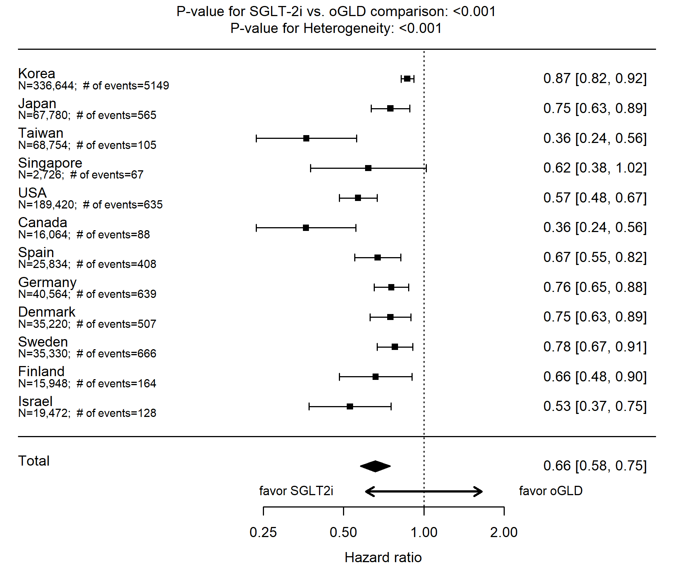
B.
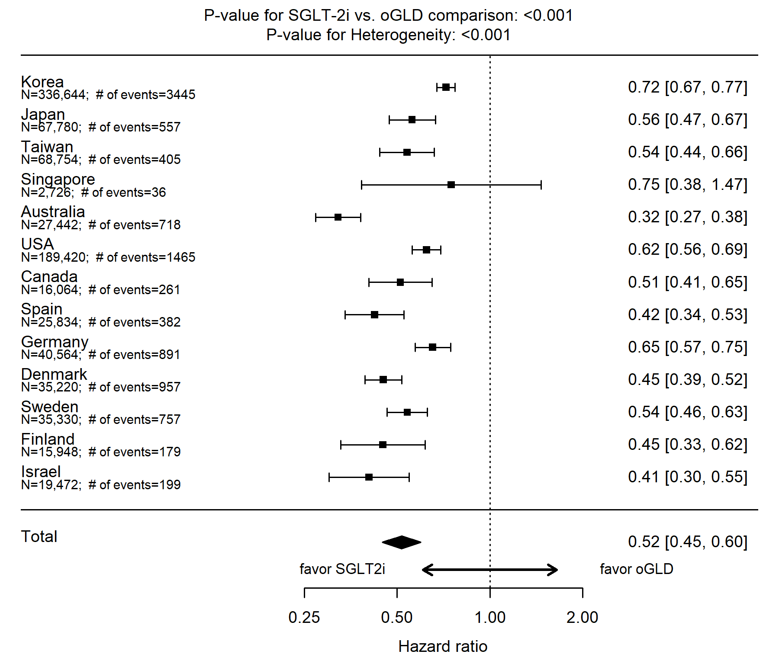
C.
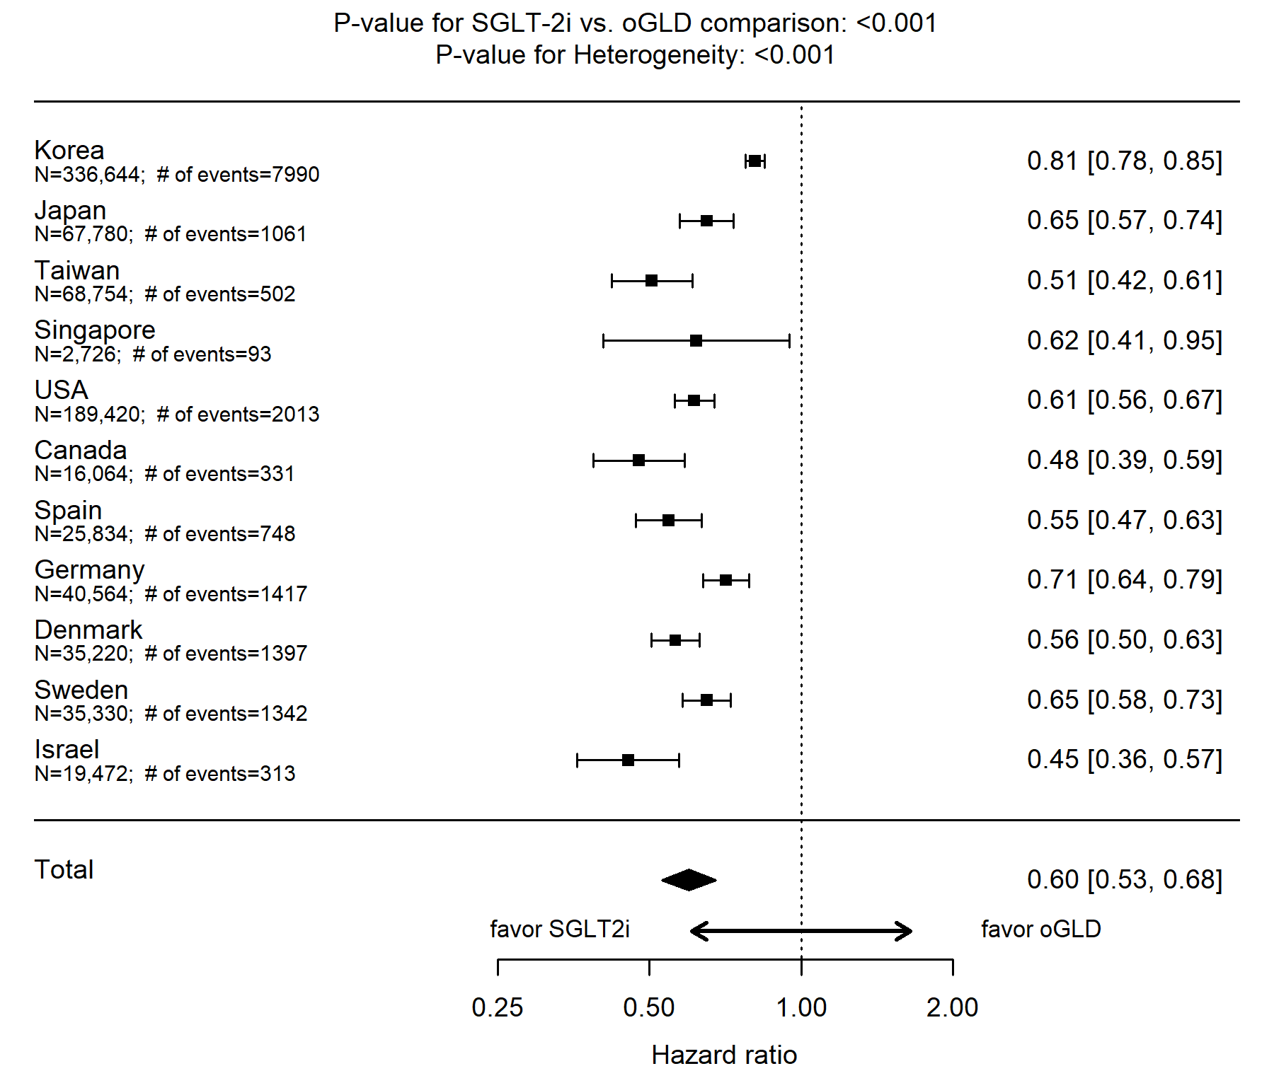
D.
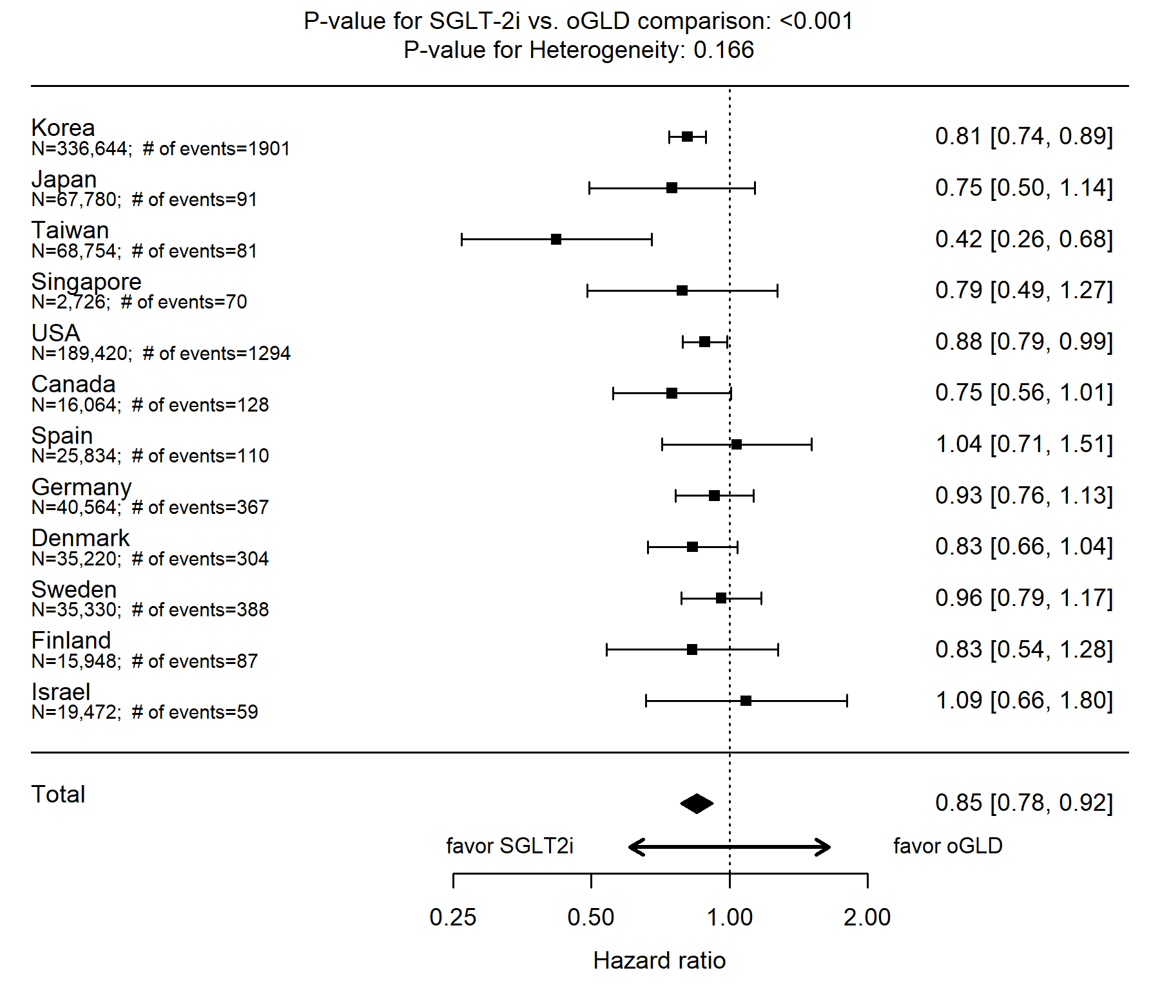
E.
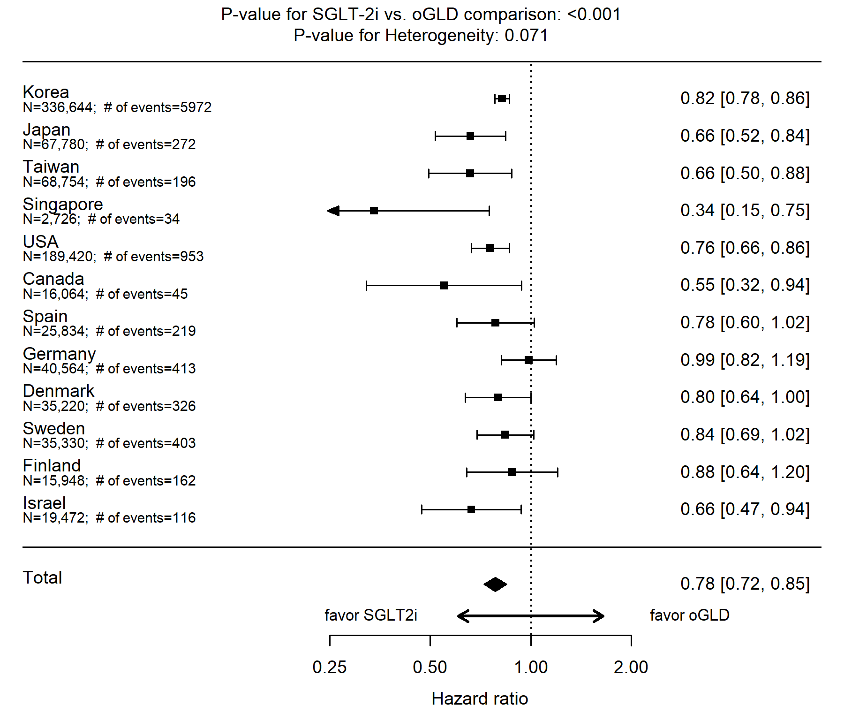
ITT, intent-to-treat; oGLD, other glucose-lowering drug; SGLT-2i, Sodium-glucose cotransporter-2 inhibitor

Figure S3. Pooled hazard ratios for the outcomes of hospitalization for heart failure, all-cause death, composite of all-cause death or hospitalization for heart failure, myocardial infarction, and stroke (ITT, adjusted)
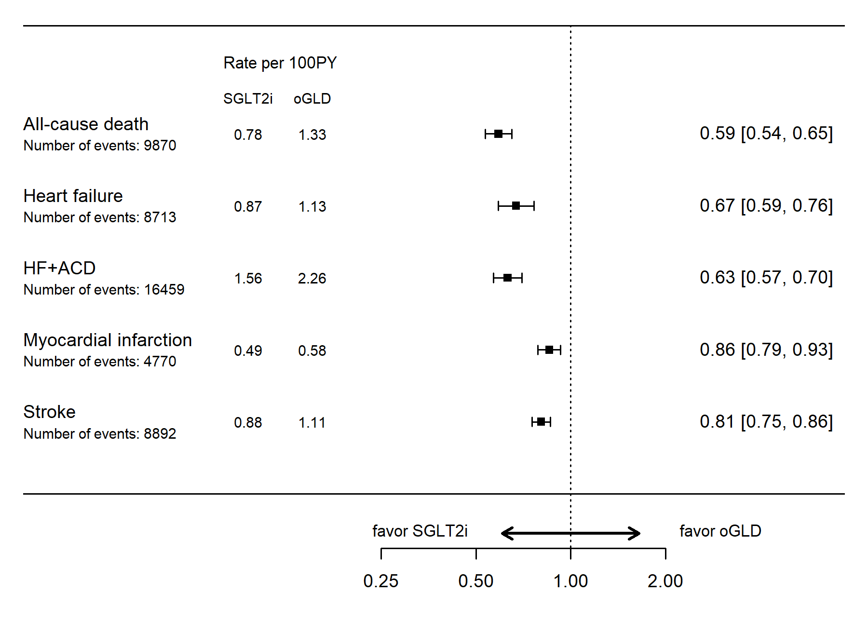
ACD, all-cause death; HF, heart failure; ITT, intent-to-treat; oGLD, other glucose-lowering drug; SGLT-2i, Sodium-glucose cotransporter-2 inhibitor
Figure S4. Pooled hazard ratios for the outcomes of hospitalization for heart failure, all-cause death, composite of all-cause death or hospitalization for heart failure, myocardial infarction, and stroke (on treatment, unadjusted)
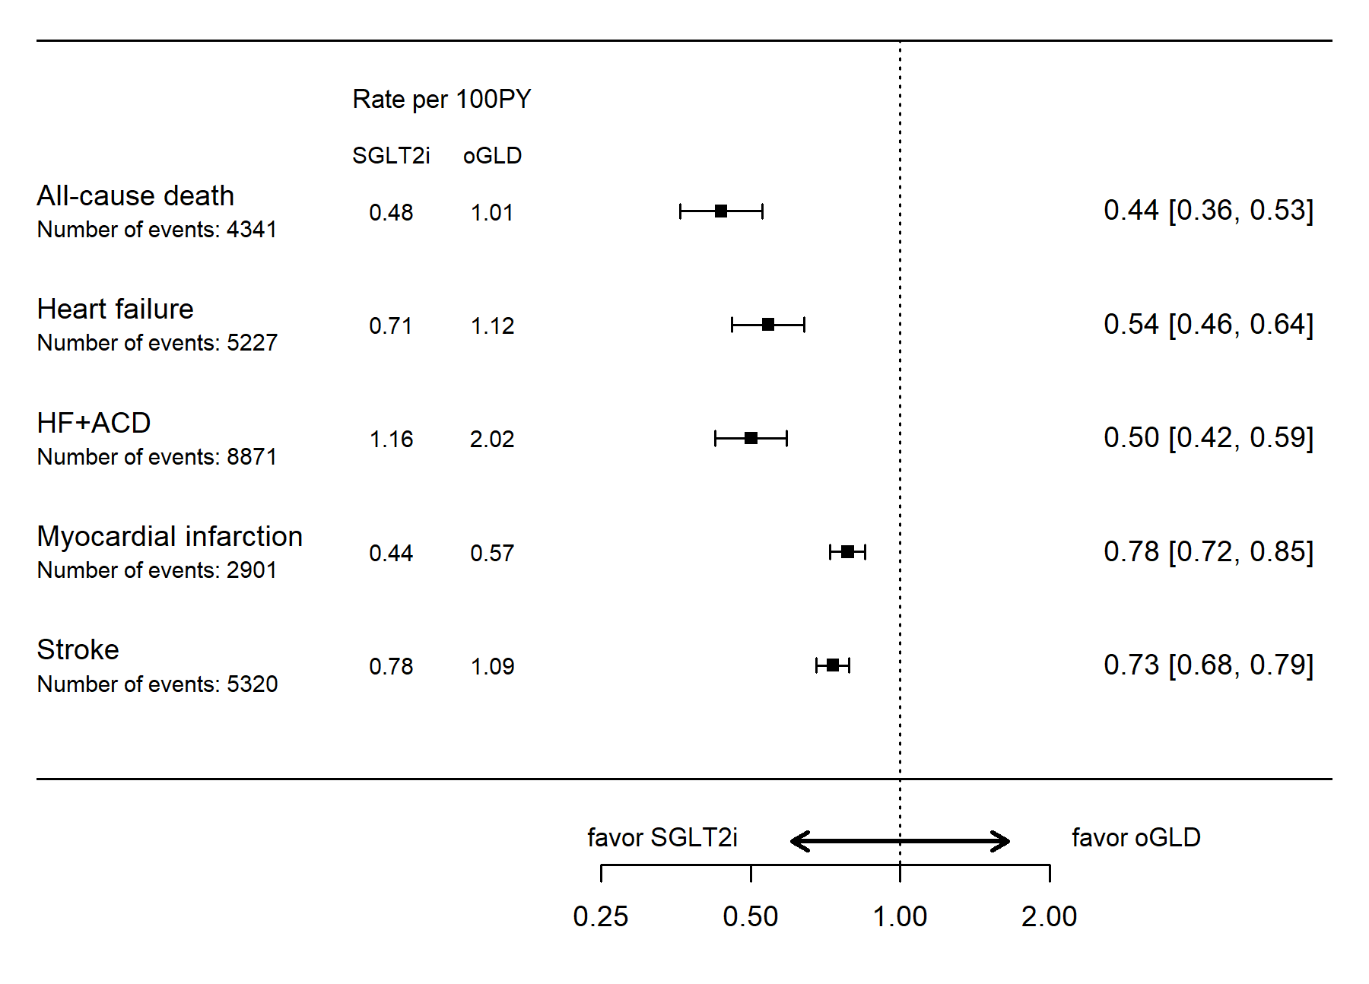

ACD, all-cause death; HF, heart failure; ITT, intent-to-treat; oGLD, other glucose-lowering drug; SGLT-2i, Sodium-glucose cotransporter-2 inhibitor
Figure S5. Pooled hazard ratios for the outcomes of hospitalization for heart failure, all-cause death, composite of all-cause death or hospitalization for heart failure, myocardial infarction, and stroke (on treatment, adjusted)
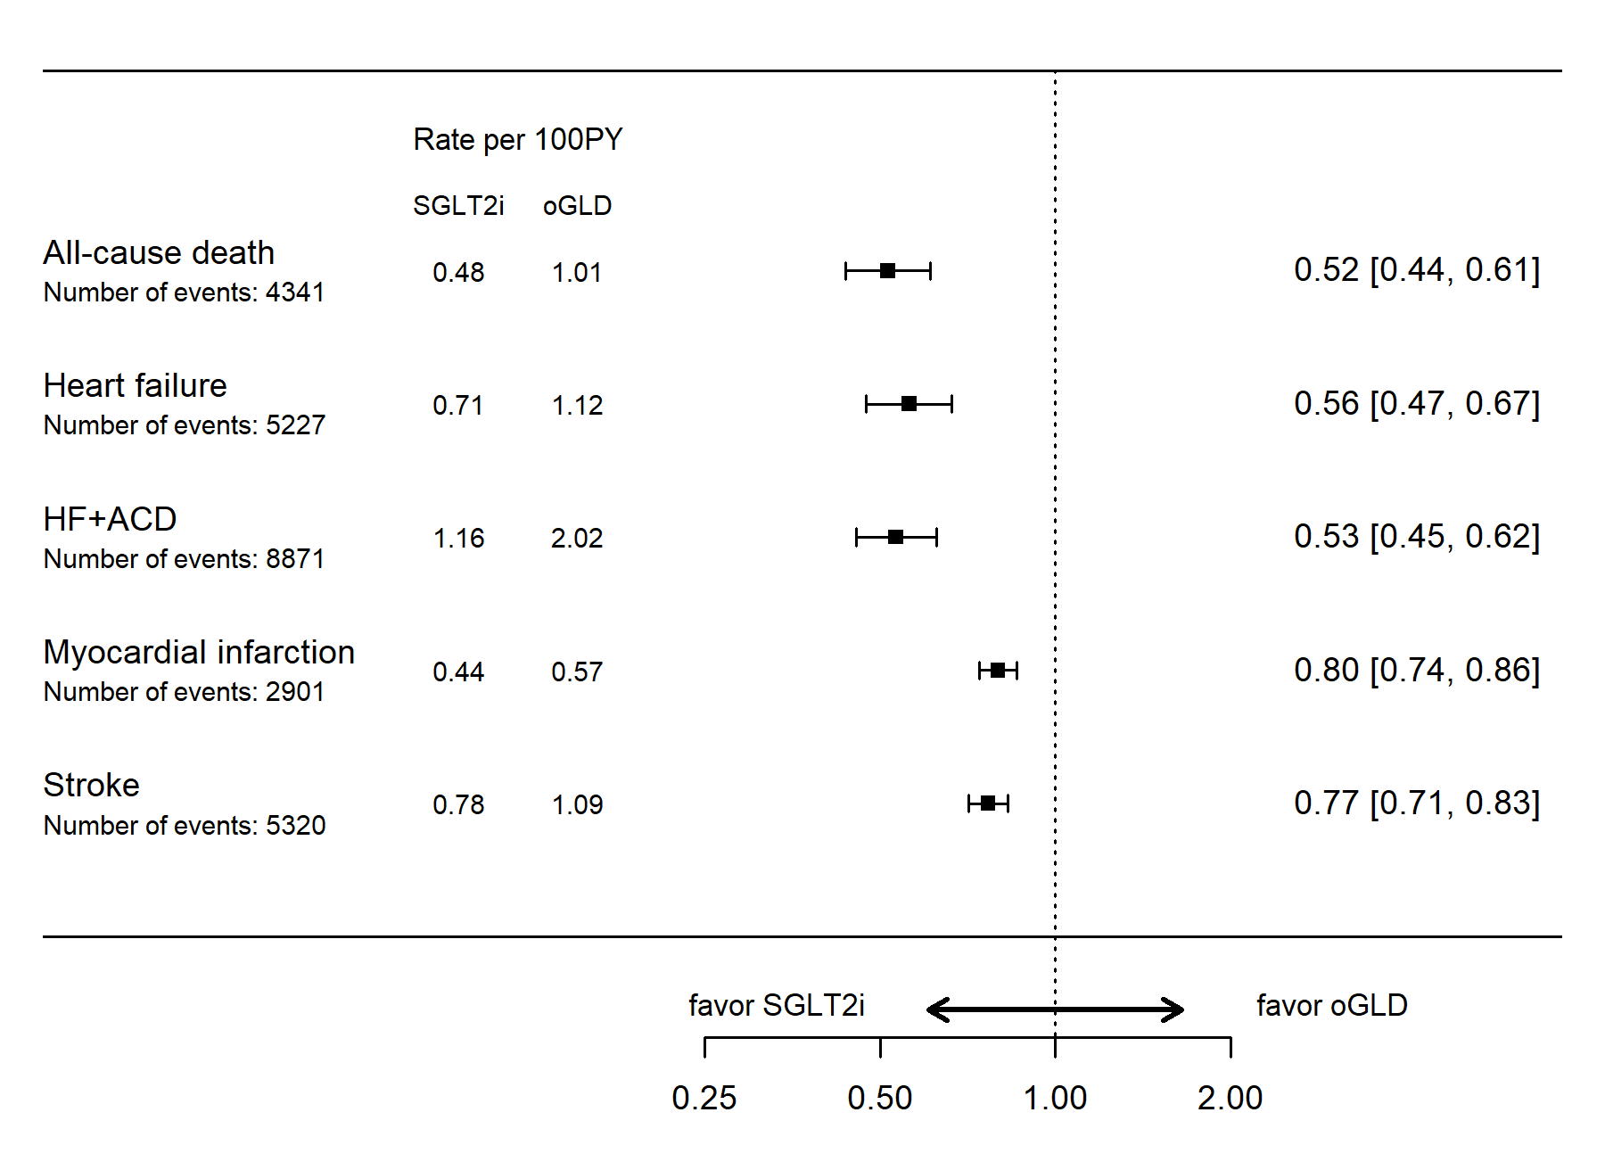
ACD, all-cause death; HF, heart failure; ITT, intent-to-treat; oGLD, other glucose-lowering drug; SGLT-2i, Sodium-glucose cotransporter-2 inhibitor

