Additional file 1:
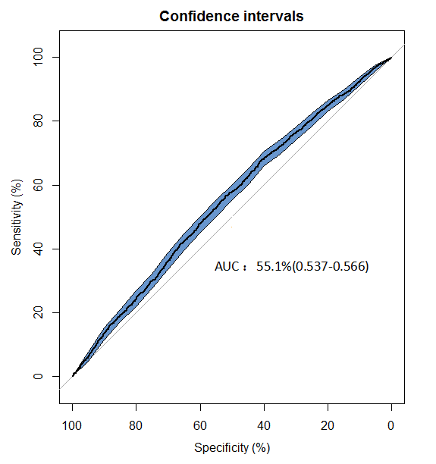
Figure S1. Area Under the Curve (AUC) for AIP in differentiating MACEs outcome in the cohort.

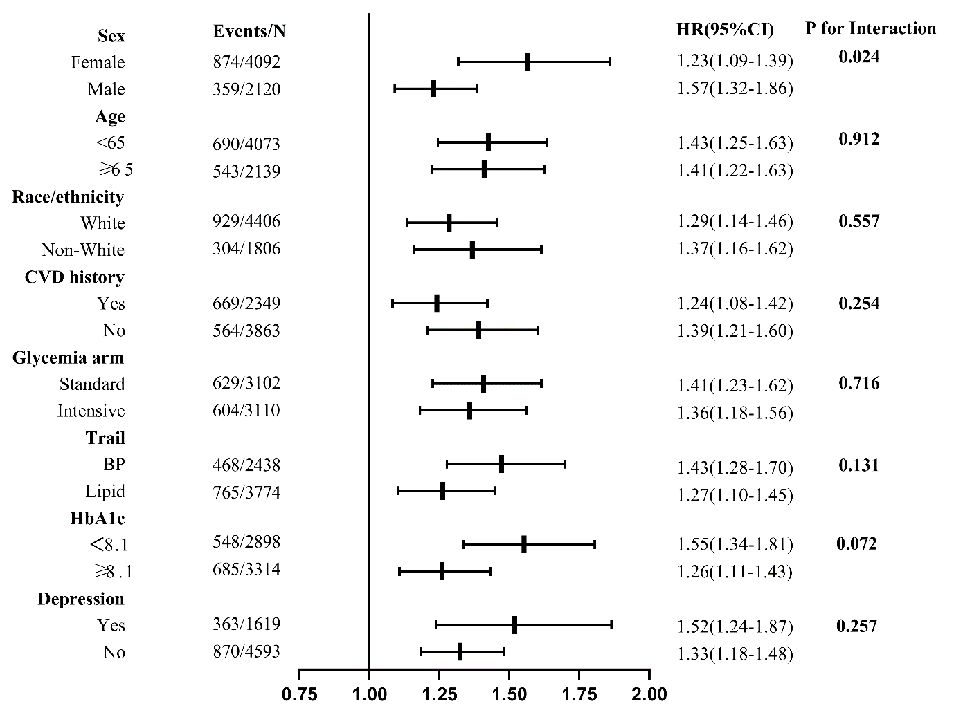
Figure S2. Risk of major adverse events.
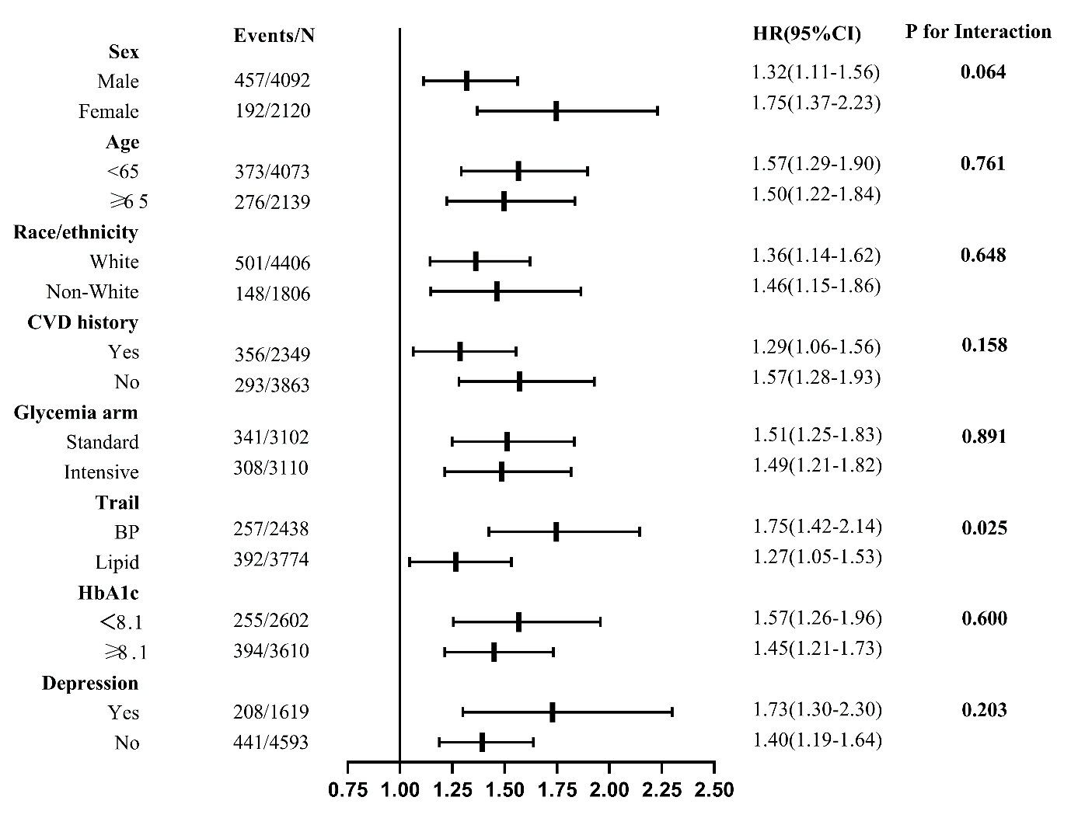
Figure S3. Risk of Nonfatal myocardial infarction.

