Table S1. Pre- and post-treatment lipid profiles with statin therapy
 |  |  | Matched control (1:1–27) |  | P- value*
 | Low-intensity group |  | Moderate- or high-intensity group |  | P- value*
 | (n = 383) |  | (n = 8554) |  | P- value*
LDL-C (mmol/L)
Pre-treatment | 3.23 | (0.92) | 3.29 | (0.92) | 0.754
Post-treatment | 2.03 | (0.67) | 1.93 | (0.66)
Change | -1.13 | (1.03) | -1.35 | (0.89) | 0.004
HDL-C (mmol/L)
Pre-treatment | 1.26 | (0.38) | 1.31 | (0.35) | 0.017
Post-treatment | 1.28 | (0.31) | 1.30 | (0.33)
Change | -0.00 | (0.41) | -0.02 | (0.34) | 0.553
Triglyceride (mmol/L)
Pre-treatment | 2.00 | (1.21) | 2.01 | (1.24) | 0.776
Post-treatment | 1.55 | (0.89) | 1.48 | (0.86)
Change | -0.44 | (1.06) | -0.51 | (1.11) | 0.352
Total cholesterol (mmol/L)
Pre-treatment | 5.40 | (1.02) | 5.52 | (1.02) | 0.096
Post-treatment | 3.98 | (0.80) | 3.90 | (0.79)
Change | -1.36 | (1.08) | -1.61 | (0.96) | 0.001
Non-HDL-C (mmol/L)
Pre-treatment | 4.14 | (0.98) | 4.21 | (0.97) | 0.453
Post-treatment | 2.71 | (0.74) | 2.61 | (0.73)
Change | -1.36 | (1.10) | -1.59 | (0.94) | 0.001
Data are presented as mean (standard deviation).
*P value calculated using the generalized estimating equation method.
LDL-C, low-density lipoprotein cholesterol; HDL-C, high-density lipoprotein cholesterol.

Table S2. Relative importance of predictors for MACE by estimating the log-likelihood explained by each predictor
Order  of importance | Variables | Proportion of explainable log-likelihood (%)
1 | Pre-existing IHD | 12.14
2 | Insulin | 4.65
3 | Sex | 4.57
4 | Pre-existing IS | 4.28
5 | Statin therapy duration* | 2.55
6 | Age | 2.39
7 | Achieved LDL-C level | 2.18
8 | Anti-thrombotic agent | 1.82
9 | Sulfonylurea | 1.45
10 | Statin intensity | 0.95
11 | Pre-existing heart failure | 0.80
12 | Smoking | 0.72
13 | Alcohol consumption | 0.56
14 | Systolic blood pressure | 0.47
15 | Vasodilator | 0.44
16 | α-glucosidase inhibitor | 0.42
17 | Body mass index | 0.39
18 | Duration of diabetes* | 0.37
19 | α-blocker | 0.37
20 | Calcium channel blocker | 0.33
21 | RAS inhibitor | 0.31
22 | Metformin | 0.22
23 | Socioeconomic status | 0.18
24 | Regular exercise | 0.17
25 | DPP4-inhibitor | 0.10
26 | β-blocker | 0.06
27 | Diuretic | 0.03
28 | Thiazolidinedione | 0.01
29 | Glinide | 0.01
30 | Fasting blood glucose | 0.01
31 | Creatinine | <0.01
The relative contributions of predictors for MACE were quantified by calculating the proportion of explainable log-likelihood explained by each risk factor.
*The statin therapy and diabetes durations were included as time-dependent variables.
MACE, major adverse cardiovascular event; IHD, ischemic heart disease; IS, ischemic stroke; LDL-C, low-density lipoprotein cholesterol; RAS, renin–angiotensin–aldosterone; DPP4, Dipeptidyl Peptidase-4.

Figure S1. Flow diagram of the study subject selection process.

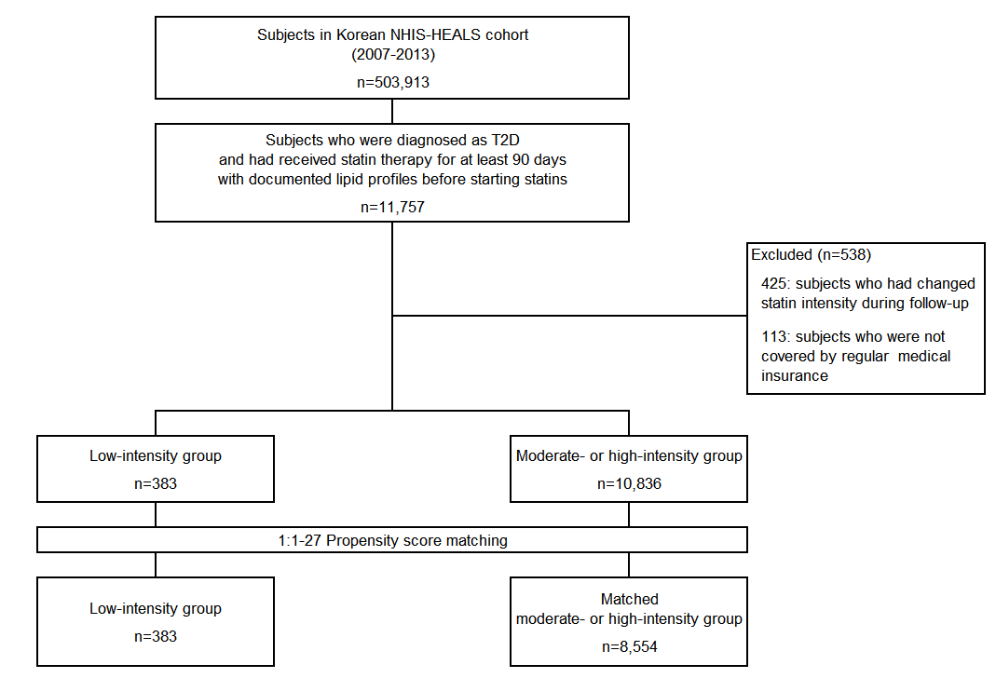
Figure S2. Cumulative incidence of major cardiovascular events by statin intensity
