Heterogeneous treatment effects of intensive glycemic control on major adverse cardiovascular events in the ACCORD and VADT trials: a machine-learning analysis

Justin A. Edward, Kevin Josey, Gideon Bahn, Liron Caplan, Jane E.B. Reusch, Peter Reaven, Debashis Ghosh, Sridharan Raghavan

Online Supplementary Material
Supplemental Table 1. Baseline predictor variables common to VADT and ACCORD studies included in causal forest analysis.

Supplemental Table 2. Variable importance ranks for cardiovascular disease events and heterogeneous treatment effects across ACCORD, VADT, and pooled samples.

Supplemental Figure 1. Correlation of variable importance rank from causal forest in the VADT and ACCORD studies.

Supplemental Figure 2. Comparison of subgroup effects based on subgroup-specific rates of major adverse cardiovascular events (MACE) stratified by study.

Supplemental Table 3. Risk differences of mortality between intensive and standard glycemic control arms in in eight subgroups.

List of Contributors to VADT Study.
Supplemental Table 1. Baseline predictor variables common to VADT and ACCORD studies included in causal forest analysis.
Demographics
Age
Sex
Race – Black
Race – Hispanic
Blood pressure
Systolic blood pressure
Diastolic blood pressure
Laboratory values
ALT
Creatinine
Estimated GFR
Glucose
HbA1c
HDL
LDL
Triglycerides
Total cholesterol
Cardiovascular risk factors and history
History of amputation
History of angina
History of myocardial infarction
History of stroke
History of congestive heart failure
History of coronary revascularization
History of percutaneous revascularization
BMI
Smoker
Diabetes history
Diabetes duration
History of eye surgery
Diabetes medications
Metformin use
Sulfonylurea use
Thiazolidinedione use
Insulin use
Acarbose use
Glinide use
Blood pressure medications
ACE inhibitor use
ARB use
Antiadrenergic medication use
Beta blocker use
Calcium channel blocker use
Loop diuretic use
Potassium-sparing diuretic use
Thiazide diuretic use
Other hypertension medication use
Other medications
Antiplatelet agent use
Statin use
Fibrates use
Other variables
Hemoglobin glycation index (HGI)
Treatment arm
Study (VADT or ACCORD)

Supplemental Table 2. Variable importance ranks for cardiovascular disease events and heterogeneous treatment effects across ACCORD, VADT, and pooled samples.
Variable | ACCORD + VADT |  | ACCORD |  | VADT
Variable | Score | Rank | Score | Rank | Score | Rank
HGI | 0.14 | 1 | 0.195 | 1 | 0.038 | 9
Fasting glucose | 0.102 | 2 | 0.064 | 6 | 0.079 | 4
Duration of diabetes (yrs) | 0.09 | 3 | 0.031 | 14 | 0.163 | 1
Total cholesterol | 0.072 | 4 | 0.043 | 11 | 0.082 | 3
eGFR | 0.068 | 5 | 0.065 | 5 | 0.056 | 8
BMI | 0.059 | 6 | 0.070 | 4 | 0.019 | 16
HDL cholesterol | 0.058 | 7 | 0.082 | 2 | 0.028 | 15
Age | 0.054 | 8 | 0.080 | 3 | 0.079 | 5
LDL cholesterol | 0.050 | 9 | 0.048 | 10 | 0.063 | 7
HbA1c | 0.050 | 10 | 0.054 | 8 | 0.029 | 13
Abbreviations: ACCORD, Action to Control Cardiovascular Risk in Diabetes Study; VADT, Veterans Affairs Diabetes Trial; HGI, hemoglobin glycation index; eGFR, estimated glomerular filtration rate; BMI, body mass index; HDL, high-density lipoprotein; LDL, low-density lipoprotein; HbA1c, hemoglobin A1c

Supplemental Figure 1. Correlation of variable importance rank from causal forest in the VADT and ACCORD studies.
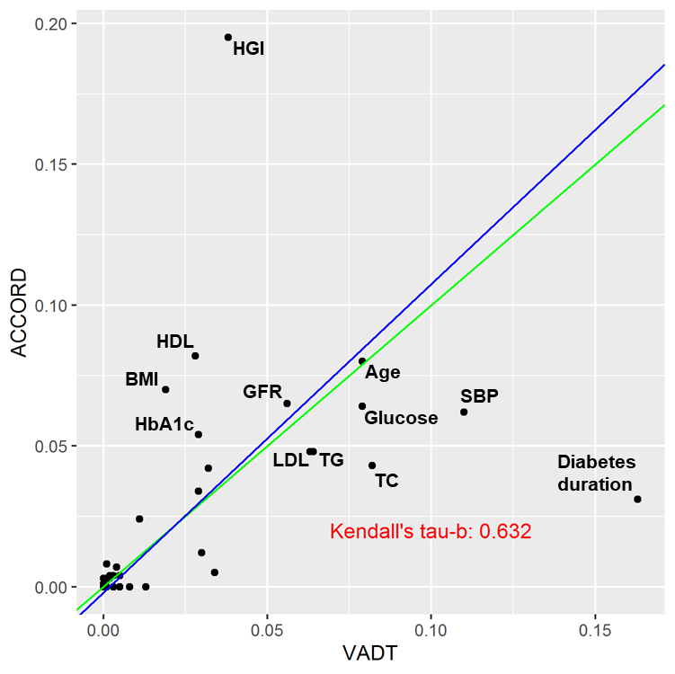

Supplemental Figure 1. Correlation of variable importance rank from causal forest in the VADT and ACCORD studies. Variable importance score in VADT study on x-axis and in ACCORD study on y-axis. Perfect correlation represented by green line; actual correlation represented by blue line. Key variables indicated (HGI, hemoglobin glycation index; HDL, high-density lipoprotein cholesterol; BMI, body mass index; HbA1c, hemoglobin A1c; eGFR, estimated glomerular filtration rate; LDL, low-density lipoprotein cholesterol; TG, triglycerides; age; glucose; TC, total cholesterol; SBP, systolic blood pressure; diabetes duration).

Supplemental Figure 2. Comparison of subgroup effects based on subgroup-specific rates of major adverse cardiovascular events (MACE) stratified by study.
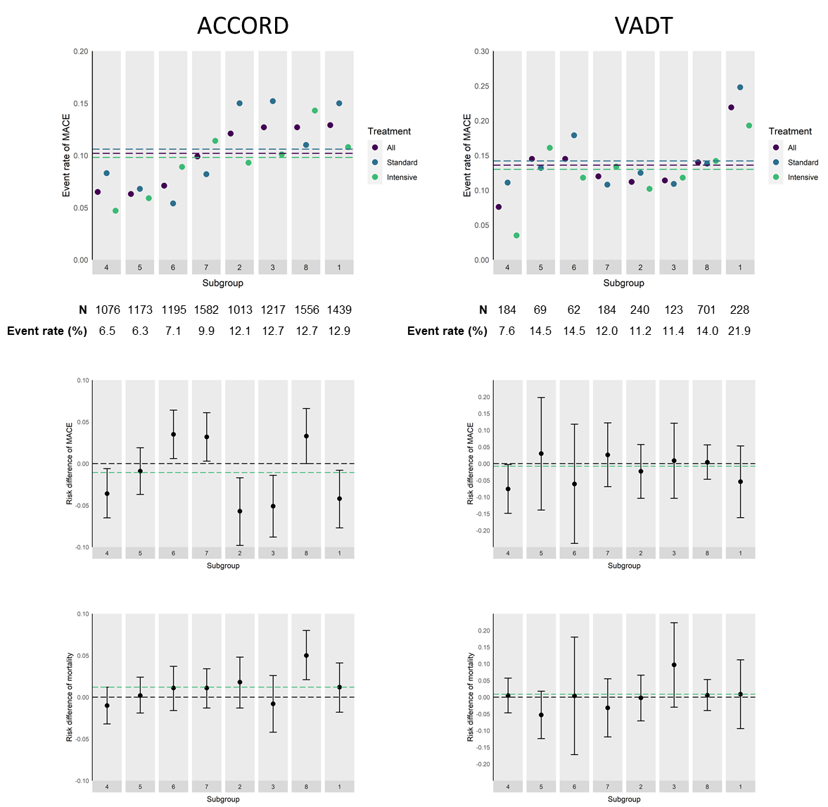
Supplemental Figure 2. Comparison of subgroup effects based on subgroup-specific rates of major adverse cardiovascular events (MACE) stratified by study (ACCORD on the left, VADT on the right). Subgroups were ordered from left to right by event rates in pooled data including both ACCORD and VADT studies. Top panels show event rates in each subgroup across both treatment arms (“All”, purple), among those randomized to standard glycemic control (“Standard”, blue), and among those randomized to intensive glycemic control (“Intensive”, green). Dotted lines show the event rates of MACE in the full sample (purple), in those randomized to standard glycemic control (blue), and in those randomized to intensive glycemic control (green). Middle panels show risk differences of MACE associated with standard versus intensive glycemic control with subgroups ordered from left to right by increasing MACE event rates in the full sample including pooled data from both studies. Positive risk differences reflect higher MACE and negative risk differences reflect lower MACE in intensive glycemic control compared to standard glycemic control. Bottom panels show risk differences of all-cause mortality associated with standard versus intensive glycemic control with subgroups ordered from left to right by increasing MACE event rates in the full sample including pooled data from both studies. Positive risk differences reflect higher mortality and negative risk differences reflect lower mortality in intensive glycemic control compared to standard glycemic control. Green dotted lines in the middle and bottom panels show the average treatment effect of intensive versus standard glycemic control in each study – risk difference of MACE (middle panels) and of all-cause mortality (bottom panels).

Supplemental Table 3. Risk differences of mortality between intensive and standard glycemic control arms in in eight subgroups.
 |  | Subgroup 1 | Subgroup 2 | Subgroup 3 | Subgroup 4 | Subgroup 5 |  | Subgroup 6 | Subgroup 7 | Subgroup 8
Mortality | ACCORD + VADT  Risk difference  (95% CI) | 1.2%  (-1.7, 4.1) | 1.4%  (-1.4, 4.2) | 0.3%  (-3.1, 3.6) | -0.8%  (-2.8, 1.2) | -0.1%  (-2.1, 2.0) |  | 1.2%  (-1.5, 3.8) | 0.5%  (-1.8, 2.8) | 3.6%  (1.1, 6.1)
Mortality | ACCORD  Risk difference  (95% CI) | 1.2%  (-1.8, 4.1) | 1.8%  (-1.3, 4.8) | -0.8%  (-4.2, 2.6) | -1.0%  (-3.2, 1.2) | 0.2%  (-1.9, 2.4) |  | 1.1%  (-1.6, 3.7) | 1.1%  (-1.3, 3.4) | 5.0%  (2.1, 8.0)
Mortality | VADT  Risk difference  (95% CI) | 0.9%  (-9.4, 11.2) | -0.2%  (-7.1, 6.6) | 9.7%  (-3.0, 22.3) | 0.5%  (-4.7, 5.7) | -5.3%  (-12.4, 1.8) |  | 0.4%  (-17.2, 18.0) | -3.2%  (-11.9, 5.5) | 0.6%  (-4.0, 5.3)

Contributors to the VADT Study
Study Co-chairs:
C. Abraira, Miami Veterans Affairs (VA) Medical Center, Miami.
W.C. Duckworth, Carl T. Hayden VA Medical Center, Phoenix, AZ.

Miami Study Co-chair’s Office: C. Paul, D. Arca, L. Cason, R. Martinez Zolotor, L. Williams.
Phoenix Study Co-chair’s Office: S.L. Collier, N. Ahmed, A. Boyd.

Hines VA Cooperative Studies Program (CSP) Coordinating Center:
D. Reda, Director
T. Moritz, study biostatistician
R. Anderson, subprotocol biostatistician
M.E. Vitek, quality assurance specialist
T. Paine, national study coordinator
L. Thottapurathu, statistical programmer
P. Luo, subprotocol statistical programmer
K. Bukowski, database programmer
D. Motyka, database programmer
V. Barillas, statistical assistant
R. Brown, statistical assistant
B. Christine, statistical assistant
L. Anfinsen, statistical programmer
M. Biondic, database programmer
R. Havlicek, statistical assistant
J. Kubal, national study coordinator, statistical assistant
M. McAuliffe, statistical assistant
M. McCarren, study biostatistician
M. Rachelle, statistical assistant
L. Rose, national study coordinator
J. Sacks, subprotocol biostatistician
T. Sindowski, statistical assistant
J.Thomas, national study coordinator
C. Zahora, national study coordinator

CSP Coordinating Center, Albuquerque, NM:
M.R. Sather, Director
S. Warren, study pharmacist
J. Day, pharmaceutical project manager
J. Haroldson, study pharmacist.

Executive Committee:
C. Abraira, W. Duckworth, S.N. Davis, N. Emanuele, S. Goldman, R. Hayward, J. Marks, T. Moritz, P. Reaven, D. Reda, S. Warren, F. Zieve, W. Wendell, J. Haroldson, P. Harper, W.G. Henderson, R.R. Henry, M.S. Kirkman, M. McCarren, J. Sacks.

Data and Safety Monitoring Committee: J. Gavin, E. Chew, B. Howard, T. Karrison, I.V. Pacold, D. Seigel, F. Vinicor, B. Massie, consultant.

End-Points Committee: S. Goldman, S. Rapcsak, G. Sethi, M. Sharon, H. Thai, K. Zadina, J. Christensen, D. Morrison, P. Spooner, A. Westerband.

Consultants: B. Materson, E. Brinton, R. Klein, J.A. Colwell, E.J. Schaefer, C.S. Gass.

Central Laboratories:
C-peptide: D.A. Ehrmann, P. Rue
Biochemistry: E.J. Schaefer, J.R. McNamara
MAVERIC Core Laboratory: M. Brophy, D. Humphries, D. Govan, L. McDonnell, L. Carlton, Y. Weng
Cost-Effectiveness: R.A. Hayward, S. Krein
Electrocardiography: S. Goldman, K. Zadina
Fundus Photograph Reading Center: M. Davis, Director; K. Glander, project coordinator.

The following investigators and sites participated in the study:
Charleston, SC: J. Soule, S. Caulder, C. Pittman, O. Alston, R.K. Mayfield, G. Moffitt, J. Sagel, F. Sanacor, E. Ganaway
Miami: J. Marks, L. Okur, L. Jones, H. Florez, D. Pfeifer, L. Samos, A.L. Taylor
Lyons/East Orange, NJ: M.B. Zimering, A. Sama, F. Rosenberg, H. Garcia, N. Ertel, L. Pogach, J.J. Shin, F. Caldarella, C. Carseli, M. Shah
Fresno, CA: P. Ginier, G. Arakel, Y. Fu, D. Tayloe, J.E. Allen, E. Fox, P.G. Hensley
Hines, IL: N. Emanuele, K. Kahsen, P. Linnerud, L. Agrawal, N. Azad
Houston: M. Marcelli, G.R. Cunningham, N.M. Nichols, E. Cordero, R. Hijazi, F. Roman, P. Datta, M. Garcia Touza
Indianapolis: A. Lteif, K.L. Moore, C. Lazar-Robinson, S. Gupta, M.S. Kirkman, M. Mendez, Z. Haider, L. Risley
Lexington, KY: D. Karounos, L. Barber, J. Hibbard, J.W. Anderson, L.R. Reynolds, J. Carlsen, R.W. Collins, A. Ehtisham
Long Beach, CA: M.L. Kashyap, B. Matheus, T. Rahbarnia, A.N. Vo, N. Downey, L. Fox, R.M. Gonzales, C.D. Meyers, S. Tavintharan
Minneapolis: F.Q. Nuttall, L. Cupersmith, K. Dardick, L. Kollman, A. Georgopoulos, C. Niewoehner; N ashville: S.N. Davis, P. Harper, D. Davis, J. Devin, A. Marney, J. Passyn-Dunn, J. Perkins, J. Stafford, A. Powers, L. Balch, P. Harris
Omaha, NE: R.J. Anderson, D. Dunning, S. Ludwig, M. Vogel, C. DeSouza, R. Ecklund, S. Doran, C. Korolchuk, M. McElmeel, S. Wagstaff; Phoenix, AZ: P. Reaven, B. Solie, J. Matchette, C. Meyer, S. Vela, N. Aslam, E. Brinton, J. Clark, A. Domb, L. McDonald, L. Shurtz; Pittsburgh: R.H. Rao, J.N. Beattie, C. Franko, F.R. DeRubertis, D. Kelly, M. Maser, J. Paul
Richmond, VA: F. Zieve, S.J. Clark, A. Grimsdale, S. Fredrickson, J. Levy, D. Schroeder
Salem, VA: A. Iranmanesh, B. Dunn, D. Arsura, C. Kovesdy, S. Hanna, A. Iranmanesh, C. Florow, F. Remandaban, E. Smith; San Diego, CA: R.R. Henry, M. Keller, V. Aroda, C. Choe, S. Edelman, A. Gasper, D. MaFong, S. Mudaliar, D. Oh, R. Bandukwala, A. Chang, S. Chaudhary, S. Chinnapongse, L. Christiansen, N. Chu, D. Kim, M. Lupo, C. Manju, R. Plodkowski, R. Sathyaprakash, J. Wilson, J. Yu, G. Macaraeg, S. Tornes
San Antonio, TX: R. DeFronzo, L. Johnson, K. Cusi, D. Tripathy, M. Bajaj, J. Blodgett, S. Kayshup, M.H. Vasquez, B. Walz, T. Weaver
San Juan, Puerto Rico: J. Benabe, Z. Mercado, B. Padilla, J. Serrano-Rodriguez, C. Rosado, E. Mejias, T. Tejera, C. Geldrez, E. Gonzalez-Melendez, M. Natal, M. Rios Jimenez
Tucson, AZ: J.H. Shah, W.S. Wendel, L. Scott, L.A. Gurnsey, F.A. Kwiecinski, T. Boyden, M.G. Goldschmid, V. Easton.

