Supplemental e-material
Table S1: Search Strategy
Figure S1: Study selection flowchart of randomized controlled trials
Figure S2: Risk of bias summary
Figure S3: Risk of bias graph

Table S1: Search Strategy:
OVID Medline (adapted for other databases)
1 | exp PCSK9 Inhibitors/
2 | (Alirocumab or SAR236553 or Evolocumab or AMG 145 or Inclisiran). ab,kw,ti
3 | #1 or #2
4 | exp hypercholesterolemia/ or exp familial hypercholesterolemia/
5 | (Hyperlipidemia or Dyslipidemia).ab,kw,ti
6 | #4 or #5
7 | #3 and #6
8 | exp randomized controlled trial/
9 | (random* or blind* or placebo or trial*).ab,kw,ti.
10 | 11 or 12
11 | exp human/
12 | 10 and 11
13 | 7 and 12

Figure S1: Study selection flowchart of randomized controlled trials
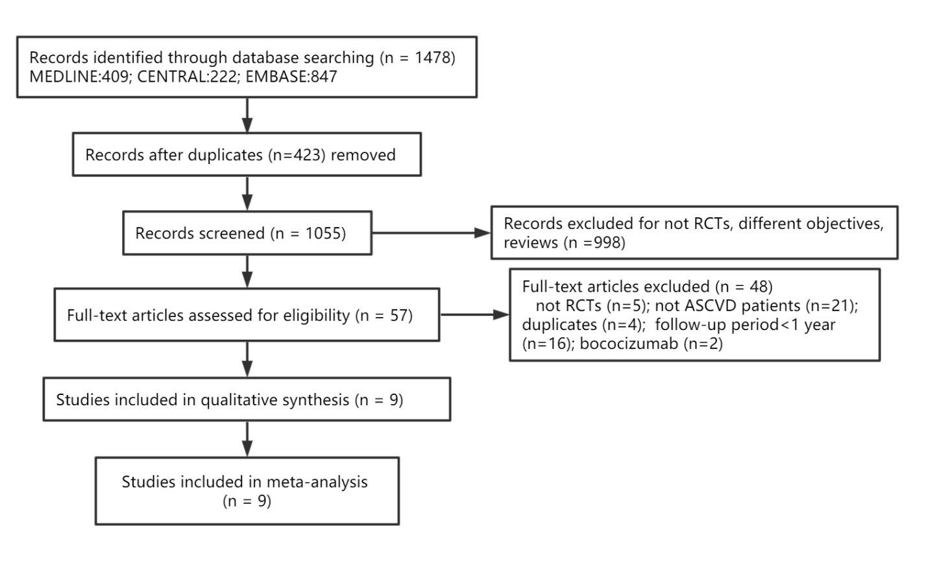

Figure S2: Risk of bias summary: review authors' judgements about each risk of bias item for each included study.
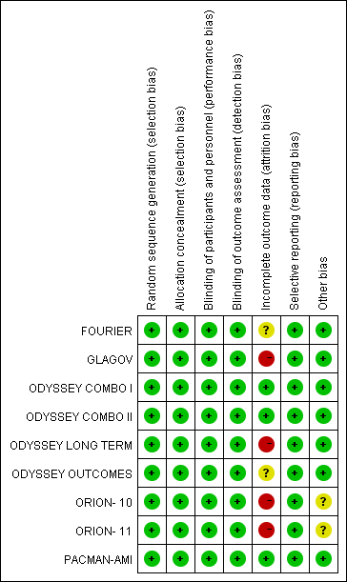

Figure S3: Risk of bias graph: review authors' judgements about each risk of bias item presented as percentages across all included studies
