A B
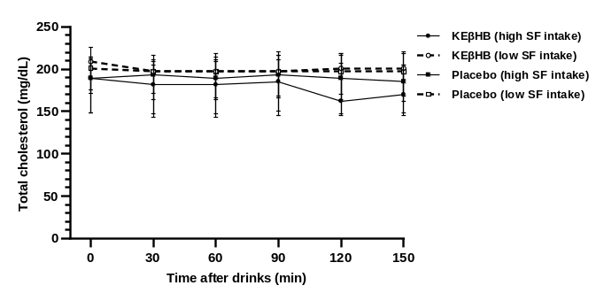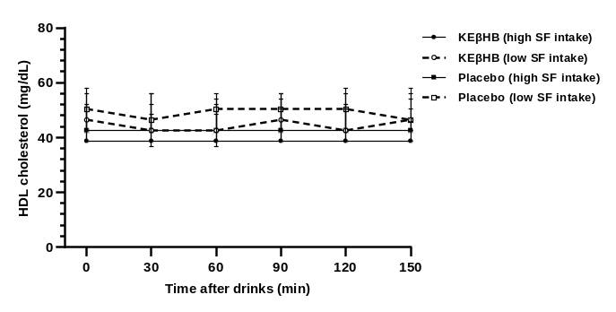

C D
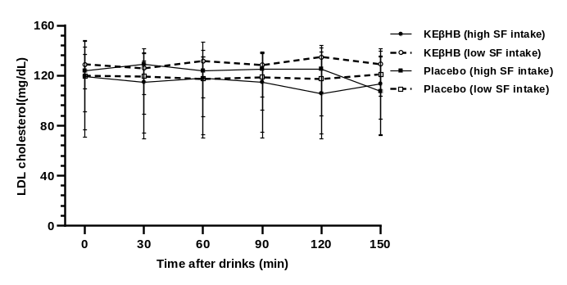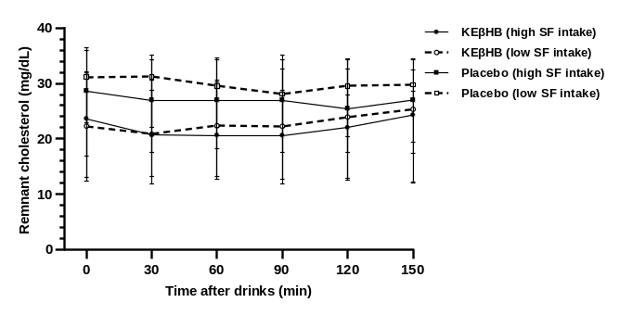

E F
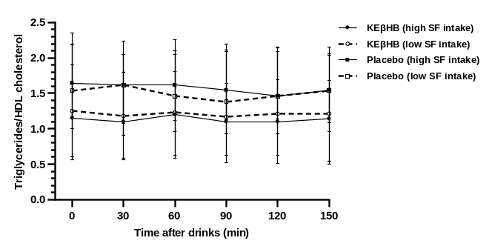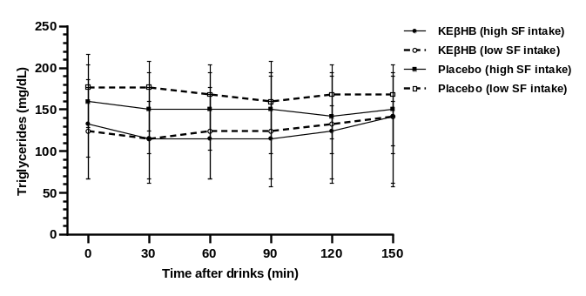

Supplementary figure 1. Effect of the KEβHB versus placebo drinks on lipid profile at individual time points
Footnotes: Participants were stratified according to the median value of habitual dietary saturated fat intake. Data are presented as median and interquartile range at 0 (fasted), 30, 60, 90, 120, and 150 minutes.
Abbreviations: HDL, high-density lipoprotein; KEβHB, ketone monoester (β-hydroxybutyrate); LDL, low-density lipoprotein; SF, saturated fat.

