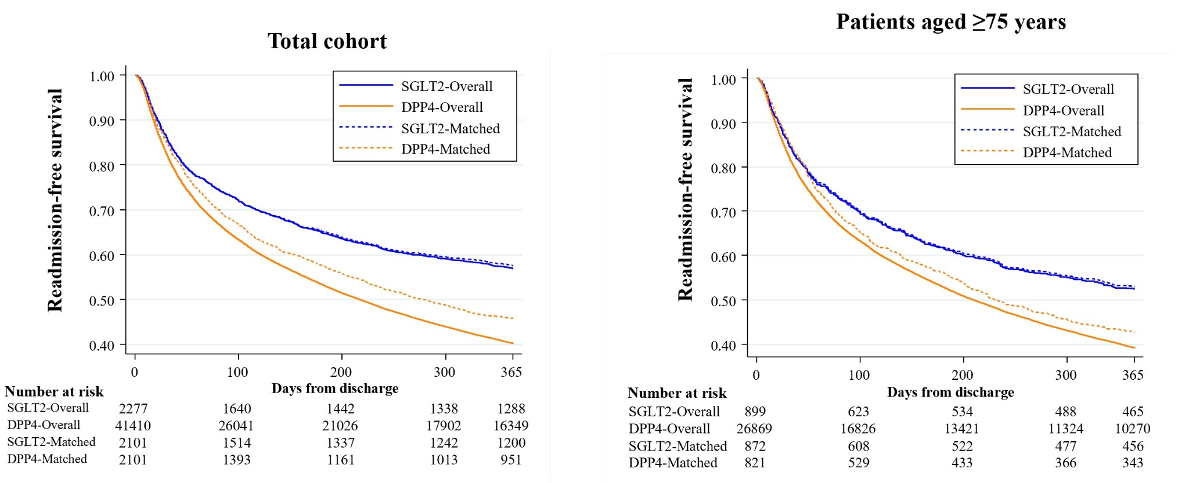
Figure S1. Kaplan–Meier analysis of all-cause readmission for SGLT2 and DPP4 inhibitor use at discharge in overall patients and in patients aged ≥75 years
DPP4-I, dipeptidyl peptidase-4 inhibitor; SGLT2-I, sodium-glucose cotransporter-2 inhibitor

Figure S2. Stratified analysis for all-cause readmission in the propensity-matched cohort
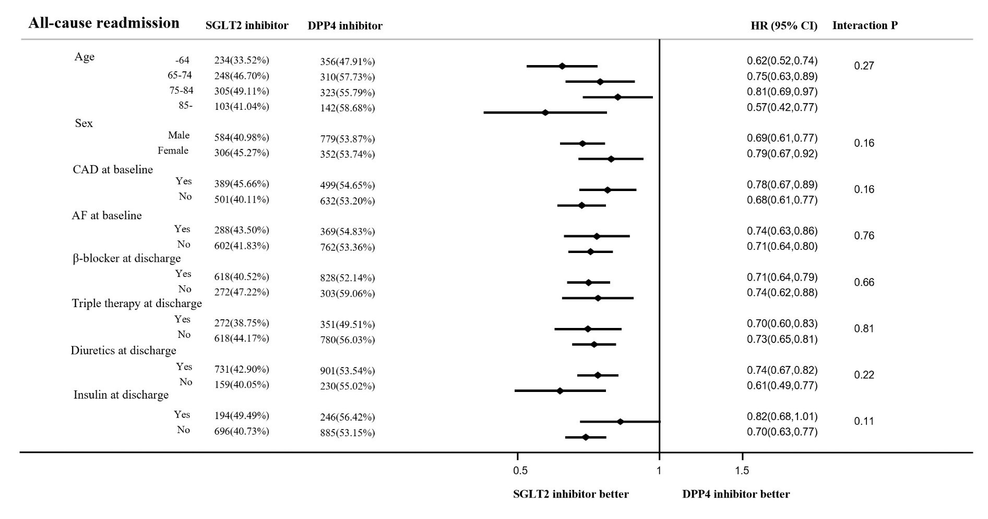
AF, atrial fibrillation or atrial flutter; CAD, coronary artery disease; CI, confidence interval; DPP4, dipeptidyl peptidase-4; HF, heart failure; SGLT2, sodium-glucose cotransporter-2

Table S1. Definition and codes used in baseline characteristics

Key condition | Definitions | ICD10 code
Discharged medicine
diuretics | Loop diuretics, tolvaptan
Anti-platelets | Aspirin, clopidogrel, cilostazol, ticlopidine, prasugrel
Anti-coagulants | Warfarin, dabigatran, rivaroxaban, apixaban, edoxaban
Anti-arrhythmic agents | Quinidine, disopyramide, cibenzoline, pilsicainide, pilmenol, flecainide, procainamide, propafenone, mexiletine, lidocaine, amiodarone, sotalol, nifekalant, bepridil
Anti-hypertensive agents | Calcium channel blocker, thiazide
Anti-diabetic agents | Dipeptidyl peptidase-4 inhibitor, sodium–glucose cotransporter 2 inhibitor, sulfonylurea, alpha-glucosidase, glipizide, thiazolidine, metformin, insulin, glucagon-like peptide-1 receptor agonist
Comorbidities
Valvular disease | Defined from diagnosis codes | I05-I08, I34-I37
Cardiomyopathy | Defined from diagnosis codes | I42
Atrial fibrillation/flutter | Defined from diagnosis codes | I48
Coronary artery disease | Defined from diagnosis codes | I20, I25 (excluding I25.4)
Pulmonary hypertension | Defined from diagnosis codes | I27
Diabetes mellitus | Defined from diagnosis codes or anti-diabetic medications | E10-E14
COPD | Defined from diagnosis codes | J43, J44
Dementia | Defined from diagnosis codes | G10, G30, G238, G310, G318, F01, F03, F050, F051, F107, B220, E756
Peripheral artery disease | Defined from diagnosis codes | I70, I743, I744, I745, I749
Chronic kidney disease | Defined from diagnosis codes | N17-N19, N391, R80, E112

COPD, chronic obstructive pulmonary disease; ICD10, International Classification of Diseases,10th revision
Table S2. Univariate/multivariable multilevel logistic analysis for mortality and readmissions
 | Univariate | Model 1 | Model 2
 | HR (95% CI) | HR (95% CI) | HR (95% CI)
Mortality
Total patients
DM/non-DM | 0.89 (0.87,0.91) | 1.03 (1.01,1.06) | 1.03 (1.01,1.06)
Patients ≥75 years
DM/non-DM | 0.96 (0.94,0.98) | 1.02 (1.00,1.05) | 1.03 (1.00,1.06)
Patients ≥85 years
DM/non-DM | 1.01 (0.98,1.04) | 1.00 (0.97,1.03) | 1.01 (0.98,1.04)
HF readmission
Total patients
DM/non-DM | 1.20 (1.19,1.22) | 1.27 (1.25,1.29) | 1.14 (1.12,1.16)
Patients ≥75 years
DM/non-DM | 1.17 (1.15,1.19) | 1.17 (1.15,1.19) | 1.10 (1.07,1.12)
Patients ≥85 years
DM/non-DM | 1.10 (1.07,1.13) | 1.09 (1.06,1.12) | 1.04 (1.01,1.07)
All-cause readmission
Total patients
DM/non-DM | 1.15 (1.14,1.16) | 1.17 (1.16,1.18) | 1.07 (1.06,1.09)
Patients ≥75 years
DM/non-DM | 1.13 (1.11,1.14) | 1.11 (1.10,1.13) | 1.05 (1.04,1.07)
Patients ≥85 years
DM/non-DM | 1.08 (1.06,1.10) | 1.07 (1.05,1.09) | 1.03 (1.01,1.05)

CI, confidence interval; DM, diabetes mellitus; HF, heart failure; HR, hazard ratio
In Model 1, HR was adjusted for age category and sex. In Model 2, HR was adjusted for age category, sex, and other 22 factors.

Table S3. Baseline characteristics after propensity matching

 | SGLT2-I | DPP4-I | Standardized difference
N | 2101 | 2101
Sex, male | 1425 (67.82%) | 1446 (68.82%) | 0.021
Age category |  |  | 0.039
-54 | 369 (17.56%) | 370 (17.61%)
55-64 | 329 (15.66%) | 373 (17.75%)
65-74 | 531 (25.27%) | 537 (25.56%)
75-84 | 621 (29.56%) | 579 (27.56%)
85- | 251 (11.95%) | 242 (11.52%)
Age at 75 years or older | 872 (41.50%) | 821 (39.08%) | 0.049
Medications at discharge
Diuretics | 1704 (81.10%) | 1683 (80.10%) | 0.025
β-Blockers | 1525 (72.58%) | 1588 (75.58%) | 0.068
ACEI/ARB | 1496 (71.20%) | 1496 (71.20%) | 0.000
MRA | 1161 (55.26%) | 1192 (56.73%) | 0.029
Digoxin | 84 (4.00%) | 95 (4.52%) | 0.025
Triple therapy | 702 (33.41%) | 709 (33.75%) | 0.007
Anti-platelets | 862 (41.03%) | 875 (41.65%) | 0.012
Anti-coagulants | 885 (42.12%) | 898 (42.74%) | 0.012
Anti-arrhythmic agents | 194 (9.23%) | 234 (11.14%) | 0.062
Anti-hypertensive agents | 713 (33.94%) | 700 (33.32%) | 0.013
Anti-diabetic agents
Sulfonylurea | 126 (6.00%) | 141 (6.71%) | 0.029
Metformin | 219 (10.42%) | 228 (10.85%) | 0.013
Insulin | 392 (18.66%) | 436 (20.75%) | 0.052
GLP1 agonist | 24 (1.14%) | 20 (0.95%) | 0.018
Others | 174 (8.28%) | 191 (9.09%) | 0.028
Statin | 973 (46.31%) | 991 (47.17%) | 0.017
Procedures during hospitalization
Inotropic agents | 455 (21.66%) | 494 (23.51%) | 0.044
Ventilator use* | 606 (28.84%) | 666 (31.70%) | 0.062
Cardiac rehabilitation | 1195 (56.88%) | 1241 (59.07%) | 0.044
Comorbidities
Valvular disease | 191 (9.09%) | 205 (9.76%) | 0.022
Cardiomyopathy | 182 (8.66%) | 209 (9.95%) | 0.044
Atrial fibrillation/flutter | 662 (31.51%) | 673 (32.03%) | 0.011
Coronary artery disease | 852 (40.55%) | 913 (43.46%) | 0.058
Pulmonary hypertension | 28 (1.33%) | 33 (1.57%) | 0.019
Peripheral artery disease | 60 (2.86%) | 62 (2.95%) | 0.005
Chronic kidney disease | 306 (14.56%) | 310 (14.75%) | 0.005
COPD | 46 (2.19%) | 54 (2.57%) | 0.024
Dementia | 41 (1.95%) | 55 (2.62%) | 0.044
Clinical Outcomes
Hospitalization period | 17.0 (12.0, 25.0) | 19.0 (13.0, 28.0) | 0.119
All-cause mortality | 125 (5.95%) | 175 (8.33%) | 0.092
HF readmission | 269 (12.80%) | 472 (22.47%) | 0.255
All-cause readmission | 890 (42.36%) | 1131 (53.83%) | 0.231

ACEI/ARB, angiotensin-converting enzyme inhibitor/angiotensin II receptor blocker; DM, diabetes mellitus; DPP4-I, dipeptidyl peptidase-4 inhibitor; GLP1, glucagon-like peptide-1; HF, heart failure; MRA, mineralocorticoid receptor antagonist; SGLT2-I, sodium–glucose cotransporter-2 inhibitor; COPD, chronic obstructive pulmonary disease
*Ventilator use includes noninvasive positive pressure ventilation.

