Additional file Table S1. ICD-9 and ICD-10 codes for disease definition for gestational diabetes, congenital heart disease (for exclusion) and cardiovascular outcomes
Disease | ICD codes
Gestational diabetes | ICD 9: 6480, 6488  ICD 10: O244
Congenital heart disease | ICD 9: 745, 7450, 74500, 74501, 7451, 74510, 74511, 74512, 74518, 74519, 7452, 74520, 74521, 7453, 7454, 74540, 74541, 74542, 74548, 74549, 7455, 74550, 74551, 74552, 74558, 74559, 7456, 74560, 74561, 74562, 74563, 74568, 74569, 7457, 7458, 7459, 746, 7460, 74600, 74601, 74602, 74608, 74609, 7461, 7462, 7463, 7464, 7465, 7466, 7467, 7468, 74680, 74681, 74682, 74683, 74684, 74685, 74686, 74687, 74688, 7469, 74690, 74691, 74692, 74693, 74699, 747, 7470, 7471, 74710, 74711, 74719, 7472, 74720, 74721, 74722, 74723, 74724, 74725, 74726, 74727, 74728, 74729, 7473, 74730, 74731, 74732, 74733, 74734, 74738, 74739, 7474, 74740, 74741, 74742, 74743, 74744, 74745, 74748, 74749  ICD 10: Q20, Q200, Q201, Q202, Q203, Q204, Q205, Q206, Q208, Q209, Q21, Q210, Q211, Q212, Q213, Q214, Q218, Q219, Q22, Q220, Q221, Q222, Q223, Q224, Q225, Q226, Q228, Q229, Q23, Q230, Q231, Q232, Q233, Q234, Q238, Q239, Q24, Q240, Q241, Q242, Q243, Q244, Q245, Q246, Q248, Q249, Q25, Q250, Q251, Q252, Q253, Q254, Q255, Q256, Q257, Q258, Q259, Q26, Q260, Q261, Q262, Q263, Q264, Q265, Q266, Q268, Q269
Hypertension | ICD 9: 401, 4010, 4011, 4019, 402, 4020, 4021, 4029, 403, 4030, 4031, 4039, 404, 4040, 4041, 4049, 405, 4050, 4051, 4059  ICD 10: I10, I11, I110, I119, I12, I120, I129, I13, I130, I131, I132, I139, I15, I150, I151, I152, I158, I159
Dyslipidemia | ICD 10: E780, E781, E782, E784, E785
Diabetes mellitus | ICD 9: 250, 2500, 25000, 25001, 25009, 2501, 25010, 25011, 25019, 2502, 25020, 25021, 25029, 2503, 2504, 2505, 2506, 2507, 2509, 25090, 25091, 25099  ICD 10: E10, E100, E101, E102, E103, E104, E105, E106, E107, E108, E109, E11, E110, E111, E112, E113, E114, E115, E116, E117, E118, E119, E14, E140, E141, E142, E143, E144, E145, E146, E147, E148, E149
Coronary artery disease | ICD 9: 410, 4109, 411, 4119, 412, 4129, 4140, 4148, 4149  ICD 10: I21, I210, I211, I212, I213, I214, I219, I22, I220, I221, I228, I229, I23, I230, I231, I232, I233, I234, I235, I236, I238, I24, I240, I241, I248, I249, I251, I252, I255, I256, I258, I259
Peripheral arterial disease | ICD 9: 4400, 4402, 4438, 4439  ICD 10: I70, I700, I7000, I7001, I702, I7020, I7021, I708, I7080, I709, I7090, I738, I739
Heart failure | ICD 9: 4254, 4280, 4281, 4289  ICD 10: I110, I130, I132, I255, I420, I421, I422, I425, I428, I429, I50, I500, I501, I509
Aortic stenosis | ICD 10: I060, I062, I350, I352
Mitral regurgitation | ICD 9: 3942  ICD 10: I051, I052, I340
Atrial fibrillation or flutter | ICD 9: 4273  ICD 10: I48, I480, I481, I482, I483, I484, I489
Venous thromboembolism | ICD 9: 4151, 4511  ICD 10: I26, I260, I269, I80, I800, I801, I802, I803, I808, I809, I81, I820, I822, D68, D680, D681, D682, D683, D684, D685, D686, D688, D689

Additional file Table S2. Frequency of prevalent cardiovascular diseases at enrollment
Outcomes | No history of GDM | History of GDM
Outcomes | (n = 217,940) | (n = 1,390)
Total cardiovascular outcome | 14,691 (6.7) | 114 (8.2)
Coronary artery disease | 4,118 (1.9) | 52 (3.7)
Myocardial infarction | 2,031 (0.9) | 32 (2.3)
Ischemic stroke | 462 (0.2) | 3 (0.2)
Peripheral artery disease | 388 (0.2) | 5 (0.4)
Heart failure | 618 (0.3) | 13 (0.9)
Aortic stenosis | 183 (0.1) | 0 (0.0)
Mitral regurgitation | 347 (0.2) | 4 (0.3)
Atrial fibrillation/ flutter | 2153 (1.0) | 7 (0.5)
Venous thromboembolism | 8,397 (3.9) | 48 (3.5)
Data are presented as proportion (%).
Abbreviations: GDM, gestational diabetes mellitus

Additional file Table S3. Baseline clinical features and prevalent diseases after propensity score matching. Control group was selected after matching for age, race, BMI, smoking history, alcohol consumption, prevalent morbidities (diabetes, hypertension, dyslipidemia), and medications (aspirin, anti-hypertensives, cholesterol lowering agent).
Characteristics | No history of GDM | History of GDM
Characteristics | (n = 6,900) | (n = 1,380)
Age (years) | 52.2 ± 8.1 | 52.1 ± 8.1
Caucasian | 5,761 (83.5) | 1,146 (83.0)
BMI (kg/m²) | 29.2 ± 6.6 | 29.2 ± 6.0
Obesity (BMI >30 kg/m²) | 2,580 (37.4) | 521 (37.8)
Early menopause <40 years | 221 (3.2) | 46 (3.3)
Hysterectomy | 440 (6.4) | 91 (6.6)
Ever smoking | 2,561 (37.1) | 498 (36.1)
Prevalent comorbidity at baseline
Type 2 diabetes | 2,076 (30.1) | 411 (29.8)
Hypertension | 2,484 (36.0) | 497 (36.0)
Dyslipidemia | 1,455 (21.1) | 300 (21.7)
Use of medication
Aspirin | 1,191 (17.3) | 232 (16.8)
Anti-hypertensive agent | 1,916 (27.8) | 384 (27.8)
Lipid-lowering agent | 1,942 (28.1) | 392 (28.4)
Data are presented as proportion (%) or mean ± standard deviation.
Abbreviations: BMI, body mass index; GDM, gestational diabetes mellitus

Additional file Table S4. The risk incident cardiovascular outcomes in women without prevalent cardiovascular disease
Outcomes | Hazard ratio§
Total cardiovascular outcome | 1.36 (1.18-1.55)***
Coronary artery disease | 1.36 (1.11-1.66)**
Myocardial infarction | 1.58 (1.15-2.17)**
Ischemic stroke | 1.72 (1.14-2.59)**
Peripheral artery disease | 1.91 (1.22-3.00)**
Heart failure | 1.15 (0.77-1.73)
Aortic stenosis | 0.81 (0.30-2.17)
Mitral regurgitation | 2.23 (1.39-3.59)***
Atrial fibrillation/ flutter | 1.38 (1.06-1.80)*
Venous thromboembolism | 1.05 (0.75-1.46)
Significant codes: ‘***’ <0.001; ‘**’ <0.01 ;‘*’ < 0.05
§ Adjusted for age, race, BMI, smoking, alcohol consumption, early menopause, hysterectomy, prevalent diseases (hypertension, diabetes, or hypercholesterolemia), and medication (aspirin, Anti-hypertensive, and cholesterol-lowering agent) by cox proportional hazards regression analysis

Additional file Table S5. The risk incident cardiovascular outcomes in women without any prior cardiovascular disease
Outcomes | Hazard ratio§
Coronary artery disease | 3.29 (2.53-4.29)***
Myocardial infarction | 2.17 (1.28-3.67)**
Ischemic stroke | 1.48 (0.90-2.43)
Peripheral artery disease | 1.96 (1.18-3.24)**
Heart failure | 0.96 (0.57-1.63)
Aortic stenosis | 0.98 (0.37-2.65)
Mitral regurgitation | 2.33 (1.36-3.99)**
Atrial fibrillation/ flutter | 1.44 (1.09-1.91)*
Venous thromboembolism | 1.01 (0.71-1.43)
Significant codes: ‘***’ <0.001; ‘**’ <0.01 ;‘*’ < 0.05
§ Adjusted for age, race, BMI, smoking, alcohol consumption, early menopause, hysterectomy, prevalent diseases (hypertension, diabetes, or hypercholesterolemia), and medication (aspirin, Anti-hypertensive, and cholesterol-lowering agent) by cox proportional hazards regression analysis

Additional file Figure S1. Survival analysis of each cardiovascular outcome
(A) Coronary artery disease (B) Myocardial infarction
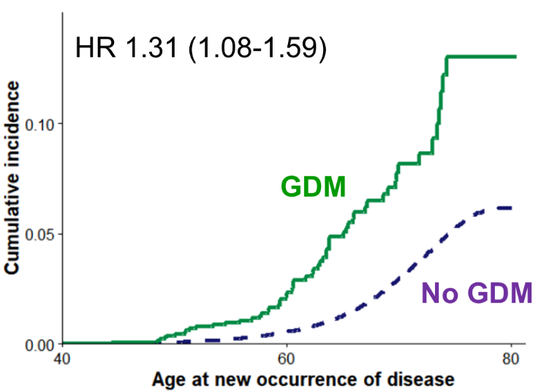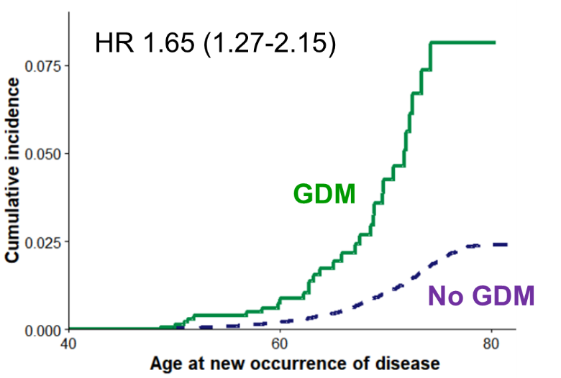

(C) Ischemic stroke (D) Peripheral artery disease
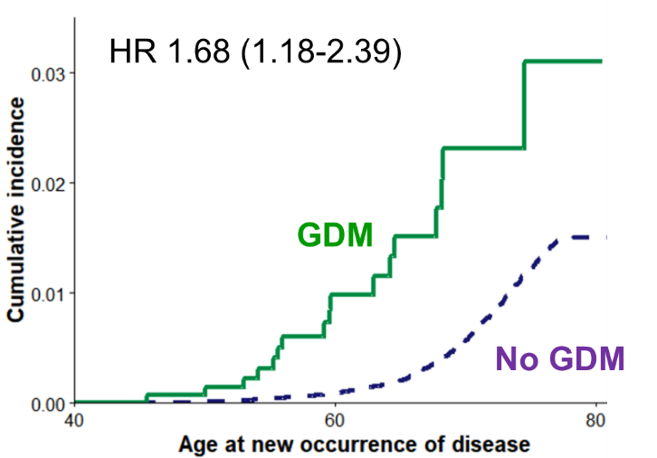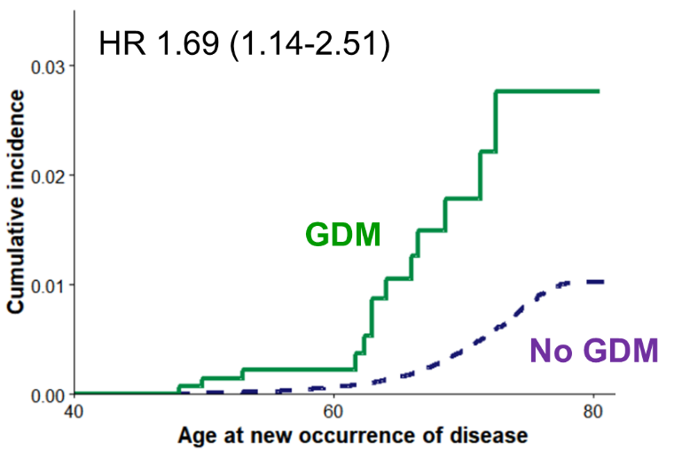

(E) Heart failure (F) Mitral regurgitation
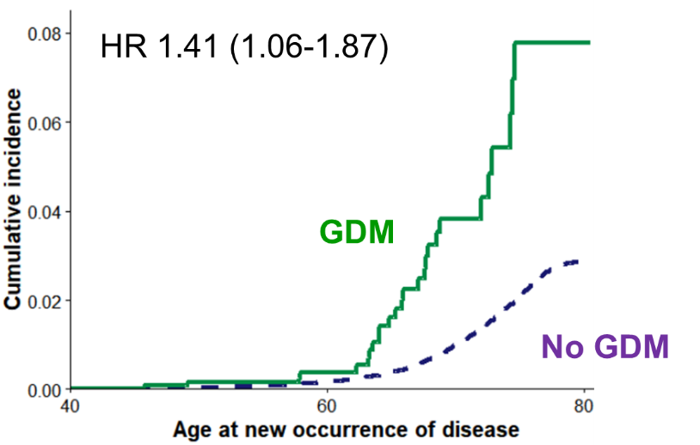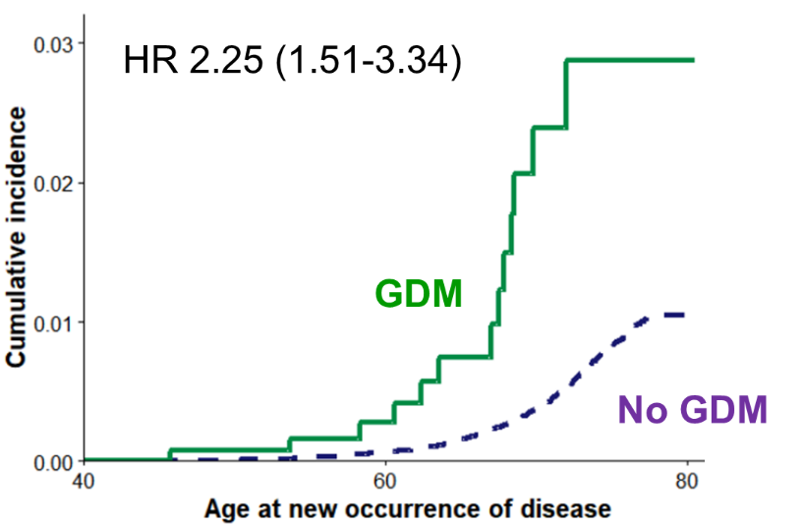

(G) Atrial fibrillation/ flutter
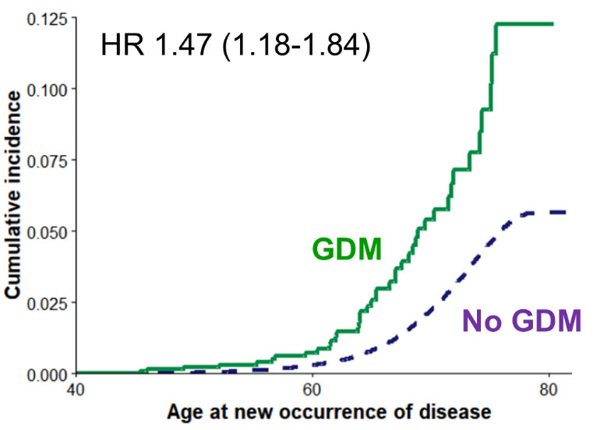
* adjusted for age, race, BMI, smoking, alcohol consumption, early menopause, hysterectomy, prevalent diseases (hypertension, diabetes, or hypercholesterolemia), and medication (aspirin, Anti-hypertensive, and cholesterol-lowering agent) by cox proportional hazards regression analysis

Additional file Figure S2. Survival analysis of each cardiovascular outcome from the index pregnancy
(a) Atherosclerotic cardiovascular disease §
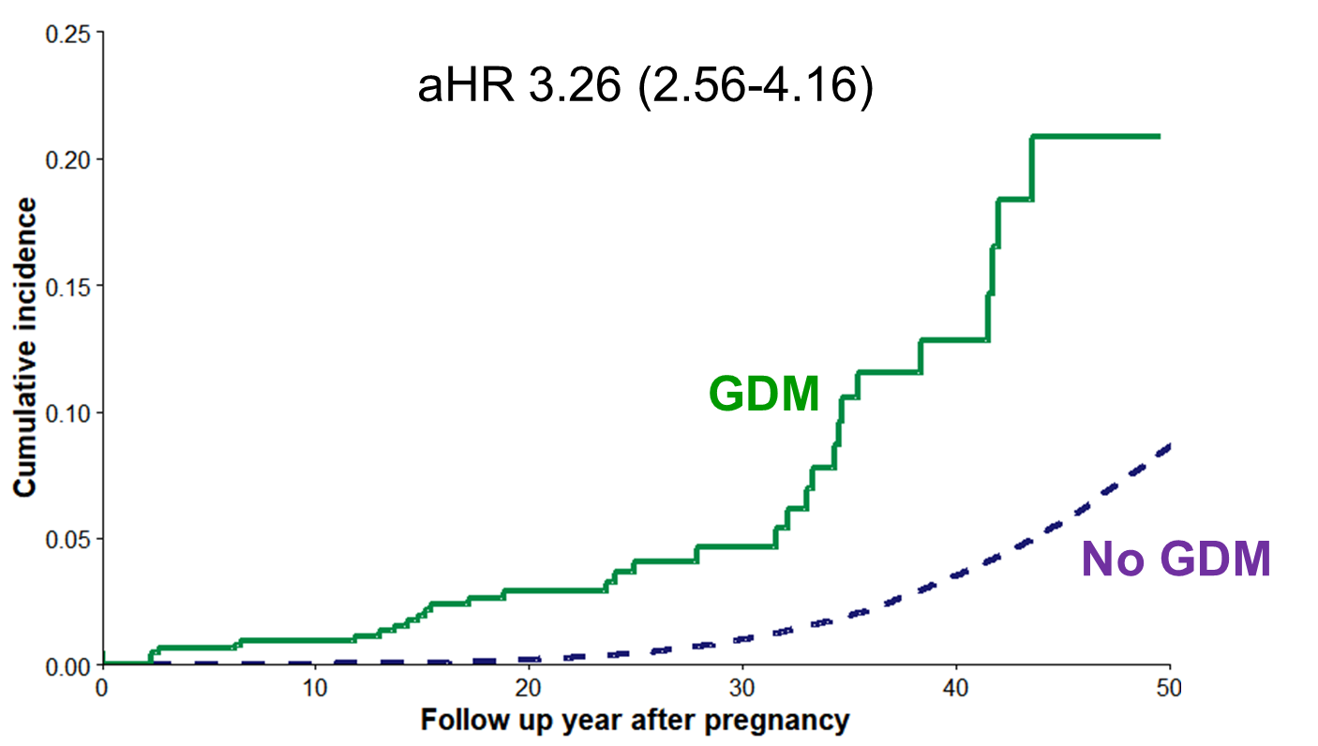
(b) Non-atherosclerotic cardiovascular disease ¶
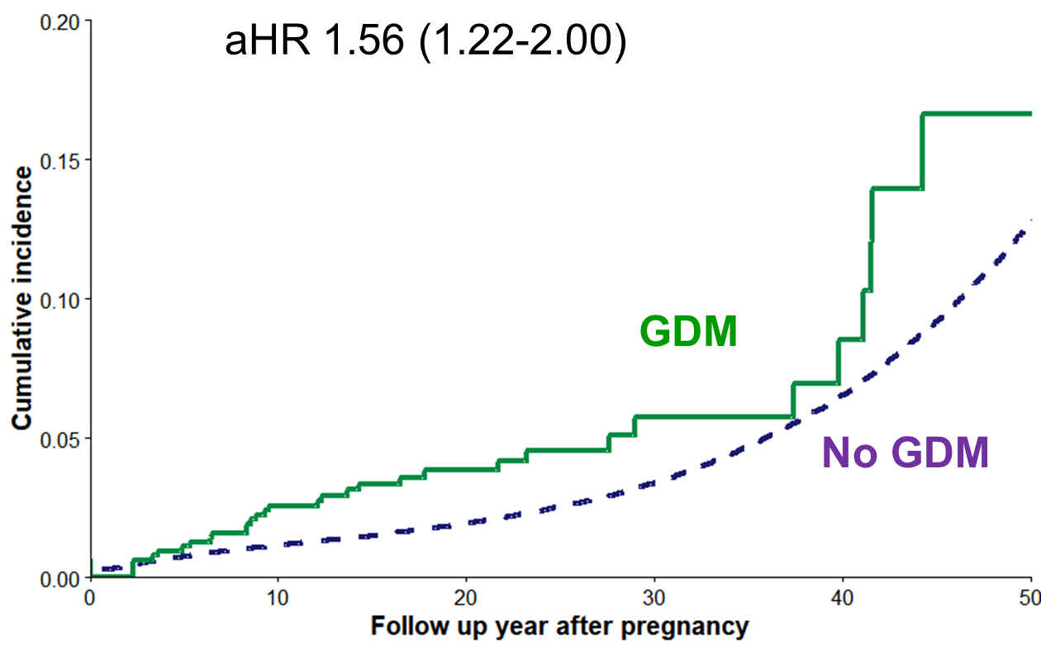
§ a composite of coronary artery disease, myocardial infarction (MI), ischemic stroke, and peripheral artery disease
¶ a composite of heart failure, aortic stenosis, mitral regurgitation, atrial fibrillation/ flutter, and venous thromboembolism
aHR: adjusted hazard ratio [adjusted for age at delivery, race, and prevalent diseases before pregnancy (hypertension, diabetes, or hypercholesterolemia) by Cox proportional hazards regression analysis]

