Supplemental tables and figures

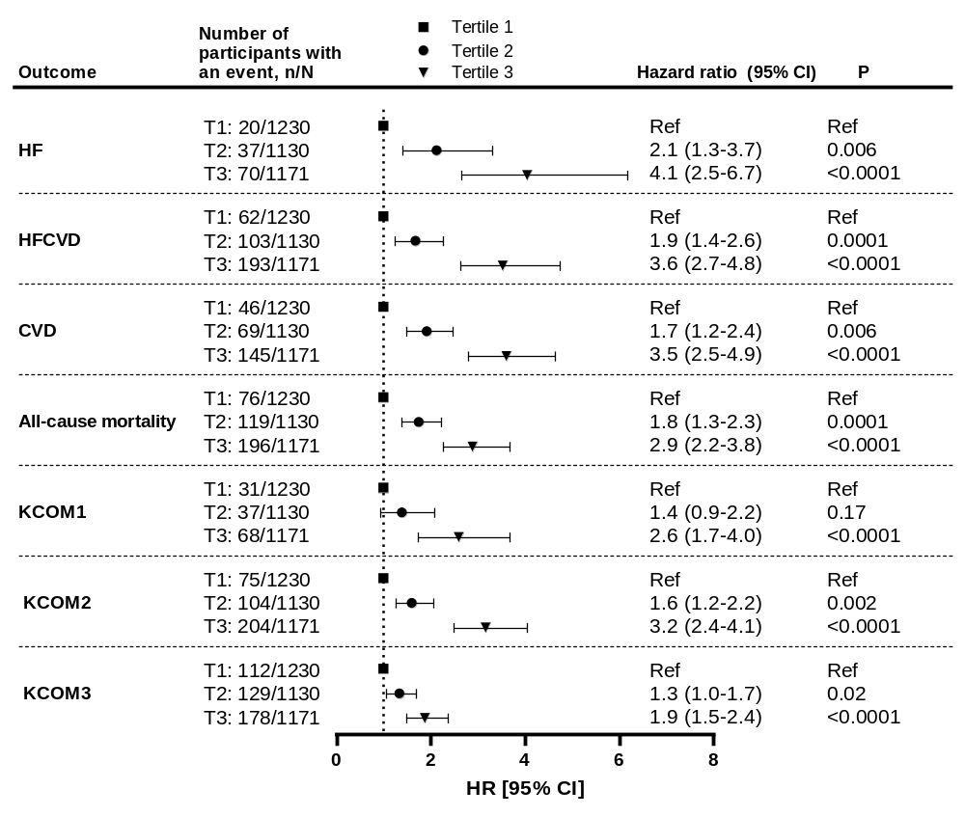
Supplemental Figure 1. Hazard ratios for tertiles of P-ETP at baseline. Patients were stratified into tertiles based on P-ETP levels at baseline. Unadjusted associations of P-ETP tertiles with outcome are depicted as HR [95% CI].

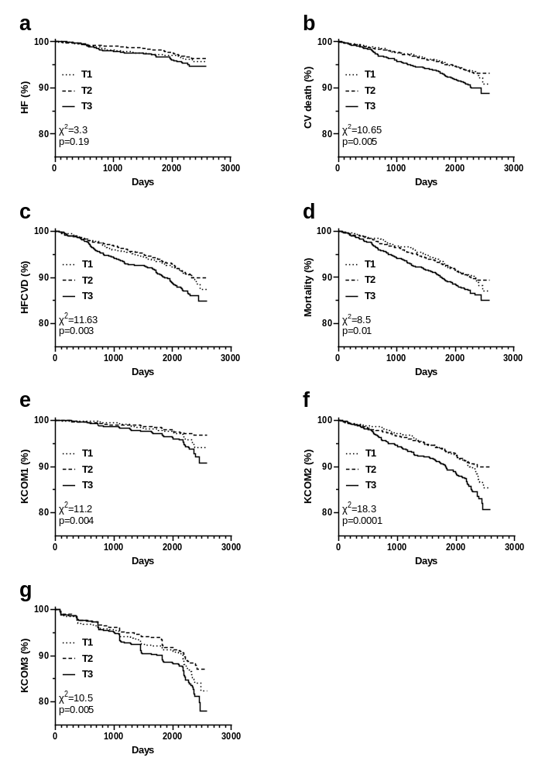
Supplemental Figure 2. Association of U-ETP with outcome. Patients were stratified based on baseline U-ETP into tertiles and Kaplan-Meier curves were plotted for each tertile. Risk was assessed with reference to tertile 1 for A) heart failure (HF), B) CV death, C) the composite of HF and CV death, D) all-cause mortality, E) the kidney composite endpoint 1 (KCOM1; 40% decrease in eGFR, kidney death, or ESKD), F) -2 (KCOM2; KCOM1 and CVD), and G) -3 (KCOM3; KCOM1 and conversion to severely increased albuminuria).

