Additional file Materials

Additional file 2: Figure S1. Discriminative ability for NTpBNP to detect abnormal echocardiographic parameters.
- GLS ≥-16%  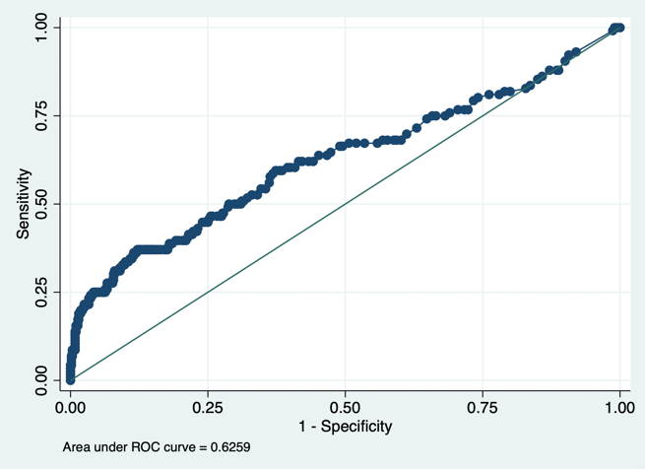 | - E/e’ >14  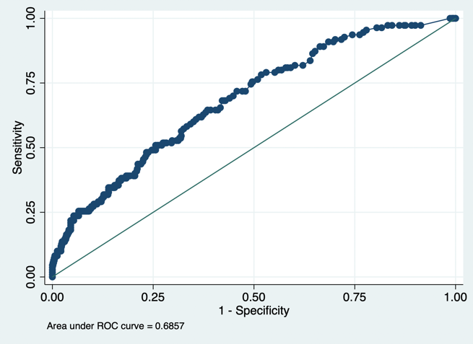
- e’ <8cm/s  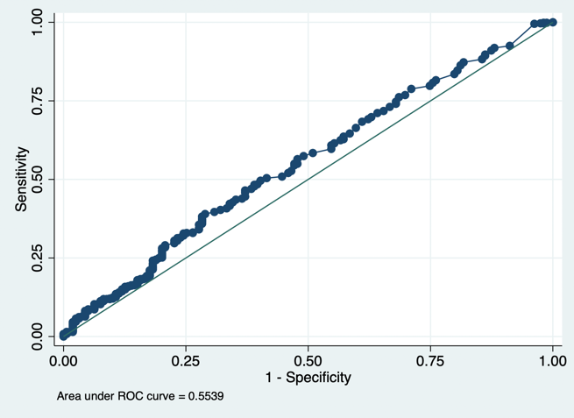 | - LAVi >34ml/m²  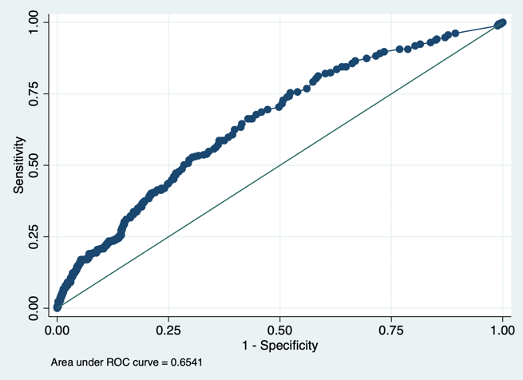
- LVMi >88g/m² (F) or 102g/m² (M)
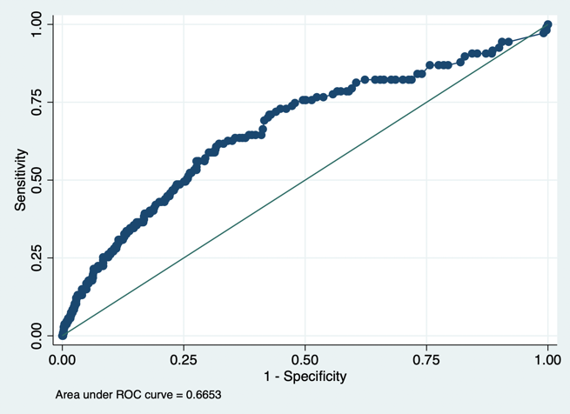
GLS = global longitudinal strain; LAVi = left atrial volume indexed to body surface area; LVMi = left ventricular mass indexed to body surface area; NTpBNP = N-terminal pro-brain natriuretic peptide.

Additional file 2: Figure S2. Discriminative ability for hs-TnT to detect abnormal echocardiographic parameters.
- GLS ≥-16%  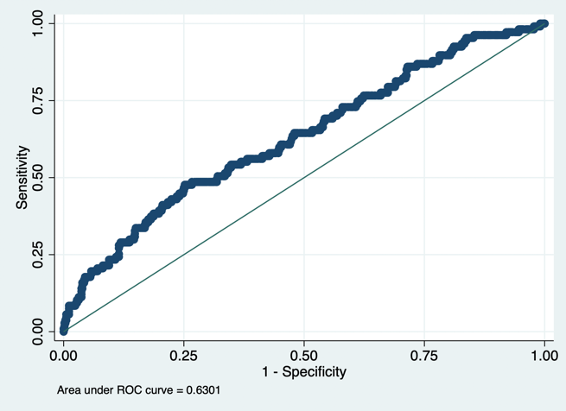 | - E/e’ >14  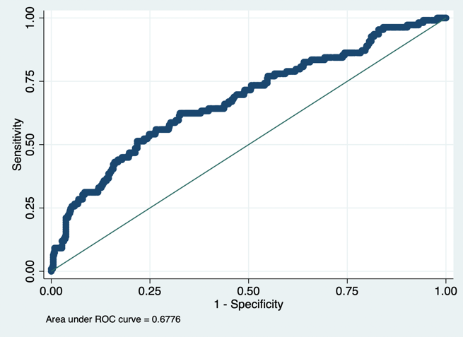
- e’ <8cm/s  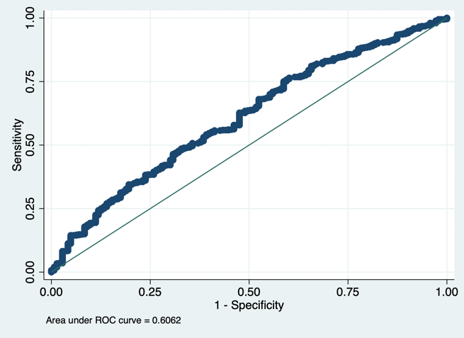 | - LAVi >34ml/m²  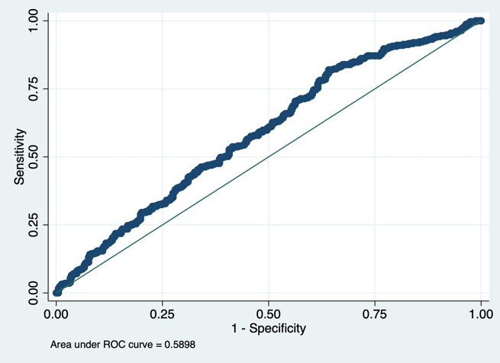
- LVMi >88g/m² (F) or 102g/m² (M)
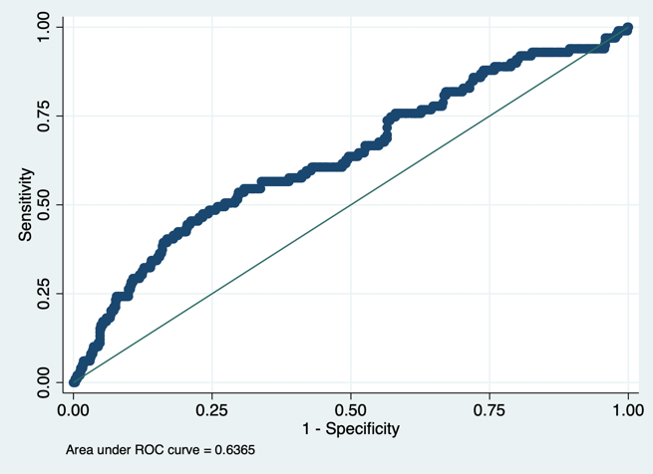
GLS = global longitudinal strain; LAVi = left atrial volume indexed to body surface area; LVMi = left ventricular mass indexed to body surface area; hs-TnT = high sensitivity troponin-T.

Additional file 2: Figure S3. Discriminative ability for the ARIC-HF score to detect abnormal echocardiographic parameters.
- GLS ≥-16%  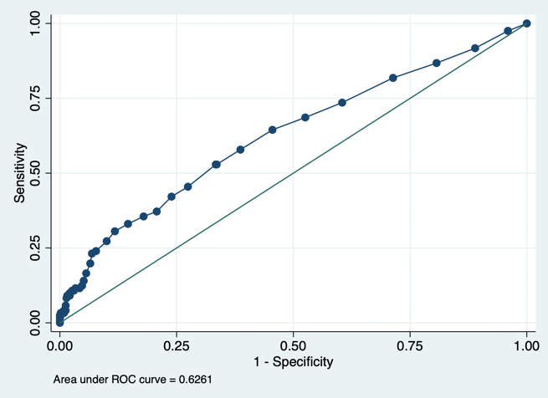 | - E/e’ >14  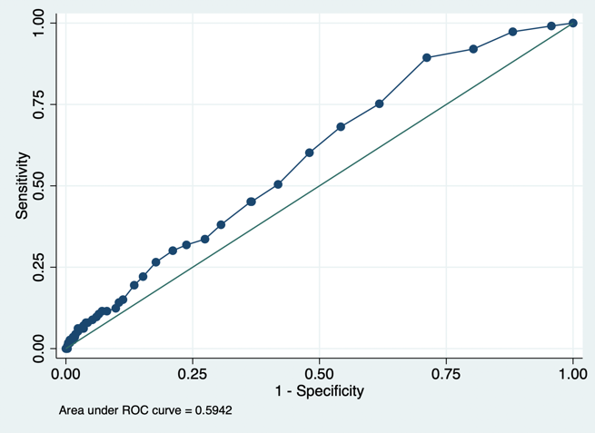
- e’ <8cm/s  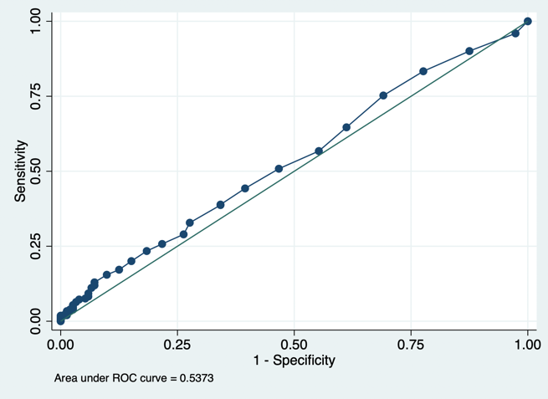 | - LAVi >34ml/m²  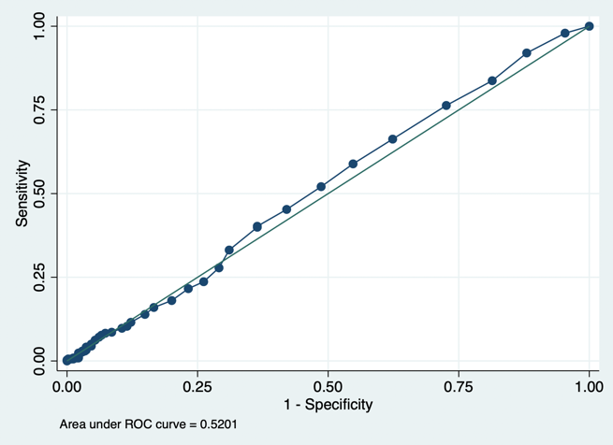
- LVMi >88g/m² (F) or 102g/m² (M)
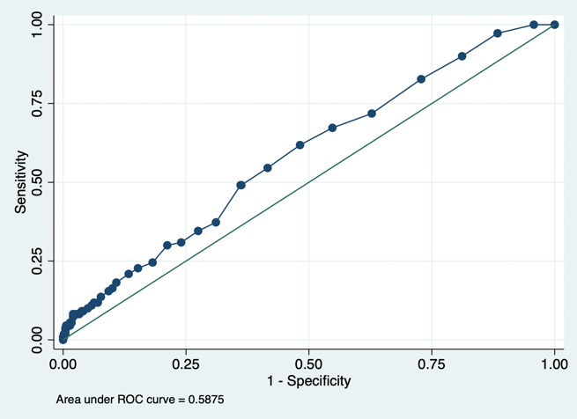
GLS = global longitudinal strain; LAVi = left atrial volume indexed to body surface area; LVMi = left ventricular mass indexed to body surface area.

Additional file 2: Figure S4. Discriminative ability for the WATCH-DM score to detect abnormal echocardiographic parameters.
- GLS ≥-16%  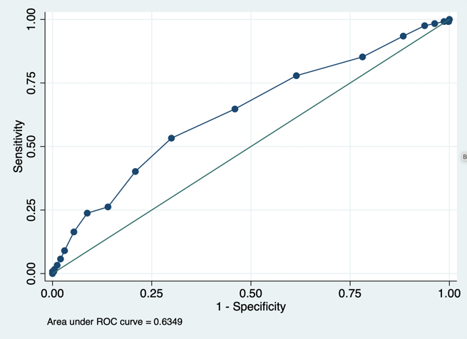 | - E/e’ >14  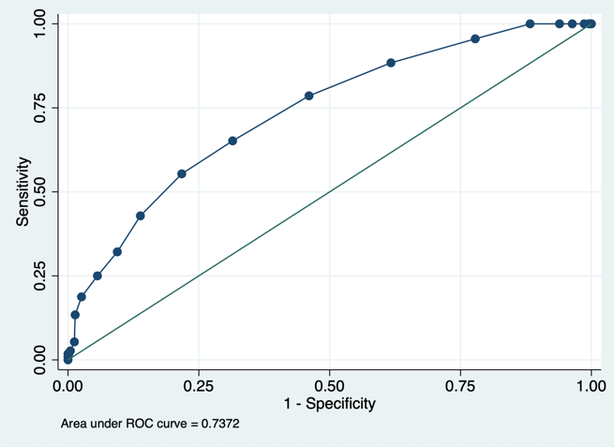
- e’ <8cm/s  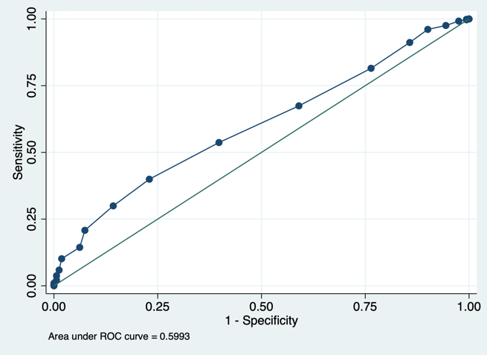 | - LAVi >34ml/m²  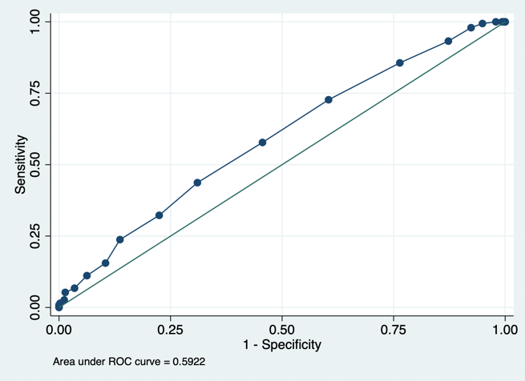
- LVMi >88g/m² (F) or 102g/m² (M)
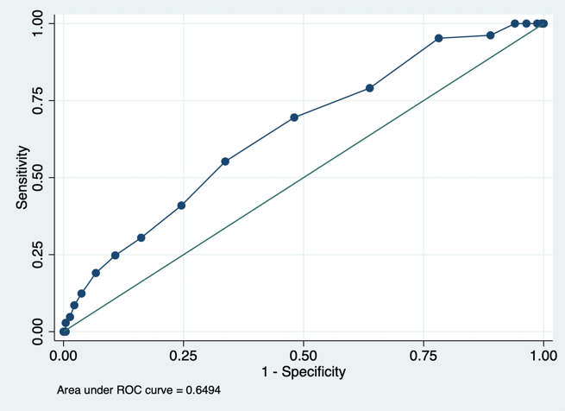
GLS = global longitudinal strain; LAVi = left atrial volume indexed to body surface area; LVMi = left ventricular mass indexed to body surface area.

