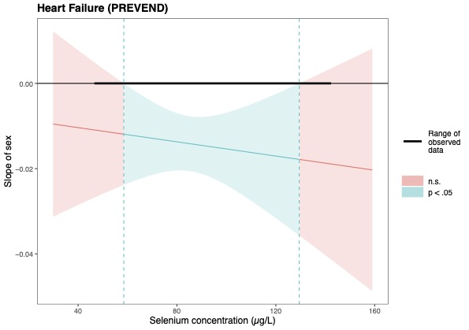
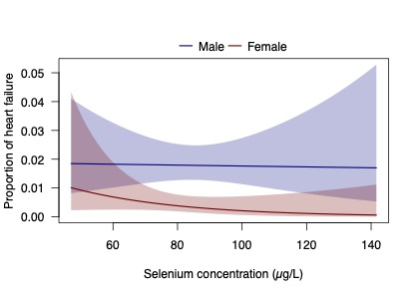
Additional file 1 Figures And Tables
Supplementary figure S1: Interaction results and simple slope analysis (Johnson-Neyman plot) for heart failure (p_{interaction}=0.086) (PREVEND). With selenium concentrations between ~60-130 μg/L, females significantly associated to lower prevalent heart failure with increasing selenium as compared to males.

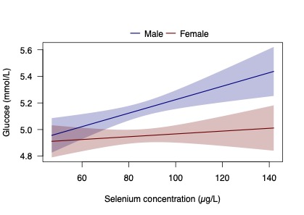
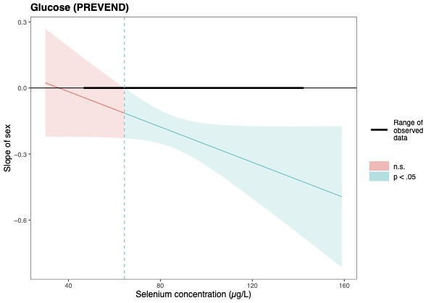
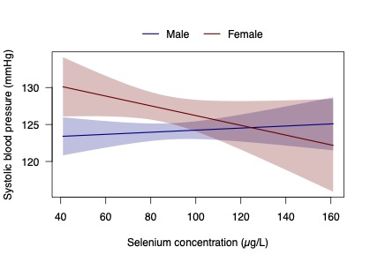
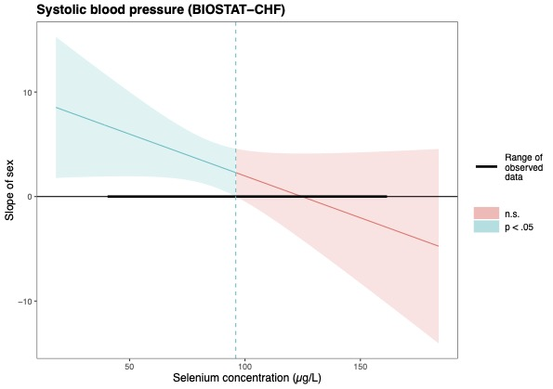
Supplementary figure S2: Interaction results and simple slope analysis (Johnson-Neyman plot) for glucose concentration (p_{interaction}=0.018) (PREVEND). With selenium levels above ~65μg/L, the relative difference between both sexes became statistically significant, with especially males associating to increased glucose.
Supplementary figure S3: Interaction results and simple slope analysis (Johnson-Neyman plot) for systolic blood pressure (p_{interaction}=0.094) (BIOSTAT-CHF). With selenium concentrations below ~95 μg/L, females significantly associated to a higher systolic blood pressure as compared to males.
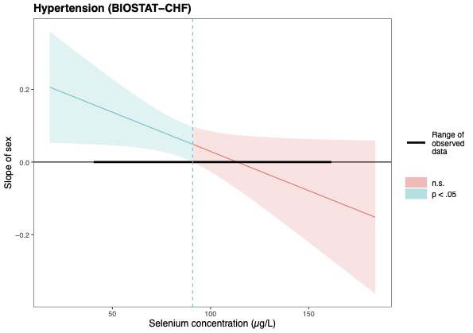
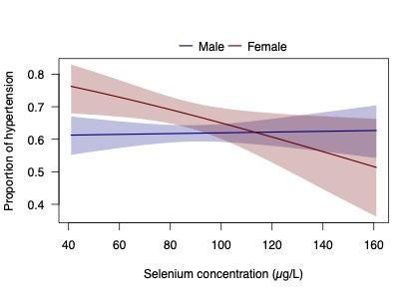
Supplementary figure S4: Interaction results and simple slope analysis (Johnson-Neyman plot) for hypertension (p_{interaction}=0.045) (BIOSTAT-CHF). With selenium concentrations below ~90 μg/L, females significantly associated to higher prevalent hypertension as compared to males.

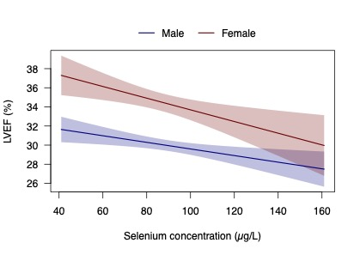
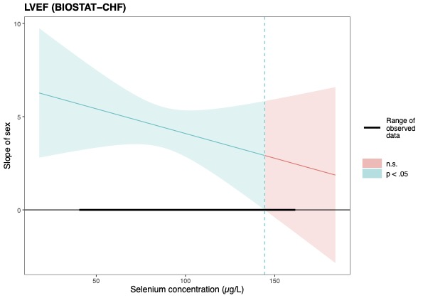
Supplementary figure S5: Interaction results and simple slope analysis (Johnson-Neyman plot) for LVEF (p_{interaction}=0.094) (BIOSTAT-CHF). With selenium concentrations below ~145 μg/L, females significantly associated to a higher LVEF as compared to males.

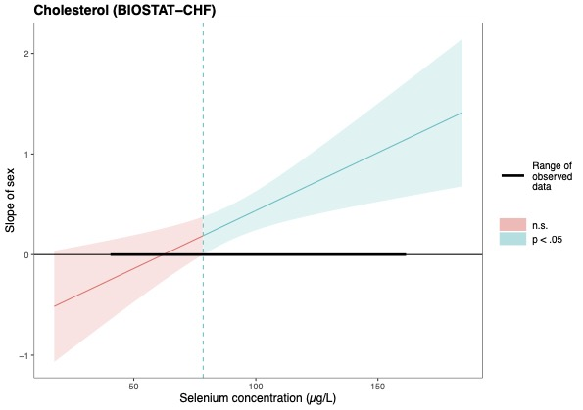
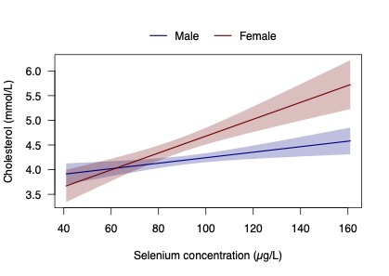
Supplementary figure S6: Interaction results and simple slope analysis (Johnson-Neyman plot) for cholesterol concentration (p_{interaction}=0.001) (BIOSTAT-CHF). With selenium concentrations above ~75 μg/L, especially females associated significantly to increased cholesterol.
Additional file 1: Table S1: Cardiovascular parameters from BIOSTAT-CHF, based on sex and selenium status. P-values are depicted in the table below. Total counts (%) or mean values (SD) of all parameters of the total cohort are added in a separate column.
 | Total cohort | Selenium deficient (<70μg/L ) |  |  | Selenium non-deficient (≥70μg/L) |  |  | P-value  interaction
Factor |  | Males | Females | P-value | Males | Females | P-value | P-value  interaction
N | 1994 | 280 | 137 |  | 1175 | 402
Cardiovascular parameters
Ischemic etiology (%) | 903 (45.3%) | 136 (49.5%) | 50 (36.8%) | 0.015 | 583 (50.6%) | 134 (33.8%) | <0.001 | 0.163
LVEF (%) | 31.3 (10.6) | 30.0 (25.0, 40.0) | 35.0 (30.0, 45.0) | <0.001 | 30.0 (25.0, 35.0) | 32.0 (27.0, 40.0) | <0.001 | 0.094
NYHA functional class |  |  |  | 0.27 |  |  | 0.55 | 0.622
Class I | 173 (8.7%) | 13 (5.1%) | 11 (9.2%) |  | 118 (11.3%) | 31 (9.1%)
Class II | 925 (46.4%) | 121 (47.6%) | 52 (43.3%) |  | 567 (54.3%) | 185 (54.3%)
Class III | 596 (29.9%) | 107 (42.1%) | 47 (39.2%) |  | 326 (31.2%) | 116 (34.0%)
Class IV | 66 (11.7%) | 13 (5.1%) | 10 (8.3%) |  | 34 (3.3%) | 9 (2.6%)
Previous HF hospitalization (%) | 655 (32.9%) | 103 (36.8%) | 50 (36.5%) | 0.95 | 396 (33.7%) | 106 (26.4%) | 0.006 | 0.594
Signs and symptoms
Extent of peripheral edema (%) |  |  |  | 0.43 |  |  | 1.00 | 0.195
Not Present | 663 (33.3%) | 57 (24.4%) | 23 (20.9%) |  | 433 (44.4%) | 150 (44.6%)
Ankle | 499 (25.0%) | 75 (32.1%) | 33 (30.0%) |  | 292 (29.9%) | 99 (29.5%)
Below Knee | 366 (18.4%) | 71 (30.3%) | 32 (29.1%) |  | 195 (20.0%) | 68 (20.2%)
Above Knee | 128 (6.4%) | 31 (13.2%) | 22 (20.0%) |  | 56 (5.7%) | 19 (5.7%)
Elevated JVP (%) | 436 (21.9%) | 85 (43.4%) | 39 (52.7%) | 0.28 | 238 (28.4%) | 74 (26.9%) | 0.18 | 0.262
Hepatomegaly (%) | 283 (14.2%) | 59 (21.2%) | 17 (12.5%) | 0.031 | 173 (14.7%) | 34 (8.5%) | 0.001 | 0.377
Orthopnea (%) | 667 (34.0%) | 114 (40.9%) | 69 (50.4%) | 0.066 | 351 (29.9%) | 143 (35.8%) | 0.029 | 0.222
Pulmonary congestion/edema with rales/crackles (%) | 1030 (51.7%) | 166 (60.1%) | 89 (66.9%) | 0.19 | 565 (49.6%) | 210 (54.4%) | 0.100 | 0.596
Peripheral arterial disease (%) | 208 (10.4%) | 33 (11.8%) | 14 (10.2%) | 0.63 | 135 (11.5%) | 26 (6.5%) | 0.004 | 0.322
Laboratory
NTproBNP (pg/mL) | 4916.1 (6347.3) | 4510.0 (1979.0, 10371.0) | 4455.0 (2271.0, 10123.0) | 0.87 | 2374.0 (1064.0, 4871.0) | 2620.0 (1130.0, 4825.0) | 0.55 | 0.757
JVP, jugular venous pressure; LVEF, left ventricular ejection fraction; NT-proBNP, N-terminal pro-B-type natriuretic peptide; NYHA, New York Heart Association.

PREVEND | Males | Females
BMI | β_{selenium} = -.09 (-.18 to -.01) | β_{selenium} = .14 (.04 to .24)
Glucose | β_{selenium} = -.05 (-.08 to -.02) | β_{selenium} = -.00 (-.03 to .02)
Heart failure | OR_{selenium} = 1.01 (.85 to 1.20) | OR_{selenium} = 1.49 (1.00 to 2.22)
Myocardial infarction | OR_{selenium} = 1.02 (.94 to 1.11) | OR_{selenium} = 1.20 (1.08 to 1.35)
Diabetes mellitus | OR_{selenium} = .89 (.82 to .97) | OR_{selenium} = 1.02 (.93 to 1.11)
BIOSTAT-CHF
BMI | β_{selenium} = -.10 (-.20 to .01) | β_{selenium} = .16 (-.04 to .37)
Cholesterol | β_{selenium} = -.05 (-.08 to -.02) | β_{selenium} = -.17 (-.23 to -.11)
Systolic blood pressure | β_{selenium} = -.04 (-.46 to .38) | β_{selenium} = .69 (-.12 to 1.50)
Left ventricular ejection fraction | β_{selenium} = .34 (.13 to .55) | β_{selenium} = .72 (.29 to 1.14)
Myocardial infarction | OR_{selenium} = .98 (.94 to 1.03) | OR_{selenium} = 1.06 (.98 to 1.15)
Hypertension | OR_{selenium} = 1.01 (.97 to 1.05) | OR_{selenium} = 1.10 (1.02 to 1.19)
Diabetes mellitus | OR_{selenium} = .99 (.95 to 1.04) | OR_{selenium} = 1.10 (1.02 to 1.19)
Additional file 1: Table S2: Effect of selenium on significant interaction results from PREVEND and BIOSTAT-CHF, stratified by sex. Beta coefficients, odds ratio’s as well as 95% confidence intervals are depicted per 10 μg/L decrease in selenium concentration.

Additional file 1: Table S3: Effect of selenium on parameters of interest stratified by sex, corrected for continuous age. Beta coefficients, odds ratio’s as well as 95% confidence intervals are depicted in the table below, showing the effect of selenium in males and females separately, per 10 μg/L decrease in selenium concentration.
Variable (continuous) |  | PREVEND | p-value interaction | BIOSTAT-CHF | p-value interaction
BMI | Males | β_{selenium} = -.09 (-.18 to -.01) | <0.001 | β_{selenium} = -.00 (-.11 to .10) | 0.012
 | Females | β_{selenium} = .17 (.08 to .27) |  | β_{selenium} = .28 (.08 to .48)
Systolic blood pressure | Males | β_{selenium} = -.13 (-.51 to .24) | 0.203 | β_{selenium} = -.17 (-.60 to .25) | 0.102
 | Females | β_{selenium} = .24 (-.10 to .58) |  | β_{selenium} = .50 (-.33 to 1.33)
Glucose | Males | β_{selenium} = -.05 (-.08 to -.02) | 0.005 | β_{selenium} = -.03 (-.10 to .05) | 0.913
 | Females | β_{selenium} = .00 (-.02 to .03) |  | β_{selenium} = -.01 (.16 to -.14)
Cholesterol | Males | β_{selenium} = -.07 (-.09 to -.05) | 0.492 | β_{selenium} = -.04 (-.07 to -.00) | 0.001
 | Females | β_{selenium} = -.05 (-.07 to -.03) |  | β_{selenium} = -.14 (-.21 to -.08)
CRP | Males | β_{selenium} = .02 (-.00 to .05) | 0.079 | β_{selenium} = .08 (.05 to .10) | 0.860
 | Females | β_{selenium} = .05 (.03 to .08) |  | β_{selenium} = .07 (.03 to .11)
LVEF | Males |  | - | β_{selenium} = .15 (-.06 to .37) | 0.107
 | Females |  |  | β_{selenium} = .50 (.07 to .92)
NTproBNP (pg/mL) | Males |  | - | β_{selenium} = 546.90 (417.10 to 676.71) | 0.708
 | Females |  |  | β_{selenium} = 517.09 (301.06 to 733.13)
Variable (categorical/binary)
Heart failure | Males | OR_{selenium} = .99 (.83 to 1.18) | 0.056 |  | -
 | Females | OR_{selenium} = 1.52 (1.02 to 2.27)
Myocardial infarction | Males | OR_{selenium} = 1.01 (.93 to 1.10) | 0.008 | OR_{selenium} = .96 (.92 to 1.00) | 0.095
 | Females | OR_{selenium} = 1.22 (1.08 to 1.37) |  | OR_{selenium} = 1.05 (.97 to 1.14)
Cerebrovascular accident | Males | OR_{selenium} = .98 (.79 to 1.23) | 0.539 | OR_{selenium} = 1.04 (.97 to 1.12) | 0.507
 | Females | OR_{selenium} = 1.09 (.86 to 1.37) |  | OR_{selenium} = 1.10 (.96 to 1.25)
Atrial fibrillation | Males | OR_{selenium} = .96 (.81 to 1.14) | 0.632 | OR_{selenium} = 1.02 (.97 to 1.06) | 0.169
 | Females | OR_{selenium} = 1.04 (.81 to 1.35) |  | OR_{selenium} = 1.08 (1.00 to 1.16)
Hypertension | Males | OR_{selenium} = 1.01 (.95 to 1.08) | 0.756 | OR_{selenium} = .98 (.94 to 1.03) | 0.052
 | Females | OR_{selenium} = 1.02 (.96 to 1.09) |  | OR_{selenium} = 1.08 (.99 to 1.16)
Diabetes mellitus | Males | OR_{selenium} = .88 (.81 to .95) | 0.013 | OR_{selenium} = .99 (.94 to 1.03) | 0.025
 | Females | OR_{selenium} = 1.03 (.93 to 1.14) |  | OR_{selenium} = 1.09 (1.01 to 1.18)
Ischemic etiology | Males |  | - | OR_{selenium} = .95 (.91 to .99) | 0.184
 | Females |  |  | OR_{selenium} = 1.02 (.94 to 1.10)
Previous HF hospitalization | Males |  | - | OR_{selenium} = 1.03 (.99 to 1.08) | 0.600
 | Females |  |  | OR_{selenium} = 1.06 (.98 to 1.15)
Elevated JVP | Males |  | - | OR_{selenium} = 1.16 (1.10 to 1.23) | 0.264
 | Females |  |  | OR_{selenium} = 1.23 (1.11 to 1.37)
Hepatomegaly | Males |  | - | OR_{selenium} = 1.03 (.97 to 1.09) | 0.365
 | Females |  |  | OR_{selenium} = 1.10 (.96 to 1.25)
Orthopnea | Males |  | - | OR_{selenium} = 1.11 (1.06 to 1.16) | 0.224
 | Females |  |  | OR_{selenium} = 1.20 (1.11 to 1.32)
Pulmonary congestion | Males |  | - | OR_{selenium} = 1.03 (.98 to 1.08) | 0.629
 | Females |  |  | OR_{selenium} = 1.04 (.97 to 1.12)
Peripheral arterial disease | Males |  | - | OR_{selenium} = .97 (.90 to 1.04) | 0.347
 | Females |  |  | OR_{selenium} = 1.02 (.88 to 1.18)
Extent of peripheral edema | Males |  | - | OR_{selenium} = 1.18 (1.12 to 1.23) | 0.205
 | Females |  |  | OR_{selenium} = 1.27 (1.16 to 1.38)
NYHA classification | Males |  | - | OR_{selenium} = 1.08 (1.00 to 1.15) | 0.615
 | Females |  |  | OR_{selenium} = 1.06 (.93 to 1.20)
Additional file 1: Table S4: Effect of selenium on binary parameters of interest stratified by sex, calculated with Poisson regression with robust variance and log-binomial test. Prevalence ratio’s (PRs) as well as 95% confidence intervals are described for males and females separately, per 10 μg/L decrease in selenium.
PREVEND |  |  | Poisson regression with robust variance | p-value interaction | Log-binomial model | p-value interaction
Heart failure | Males |  | PR_{selenium} = 1.01 (.85 to 1.20) | 0.050 | PR_{selenium} = 1.01 (.85 to 1.20) | 0.056
 | Females |  | PR_{selenium} = 1.49 (1.05 to 2.08) |  | PR_{selenium} = 1.49 (1.00 to 2.22)
Myocardial infarction | Males |  | PR_{selenium} = 1.02 (.94 to 1.11) | 0.042 | PR_{selenium} = 1.02 (.94 to 1.10) | 0.003
 | Females |  | PR_{selenium} = 1.19 (1.05 to 1.37) |  | PR_{selenium} = 1.20 (1.08 to 1.33)
Cerebrovascular accident | Males |  | PR_{selenium} = 1.00 (.70 to 1.43) | 0.709 | PR_{selenium} = 1.00 (.79 to 1.25) | 0.648
 | Females |  | PR_{selenium} = 1.08 (.91 to 1.27) |  | PR_{selenium} = 1.08 (.85 to 1.35)
Hypertension | Males |  | PR_{selenium} = 1.01 (.97 to 1.05) | 0.695 | PR_{selenium} = 1.06 (1.06 to 1.06) | 0.629
 | Females |  | PR_{selenium} = 1.00 (.96 to 1.04) |  | PR_{selenium} = 1.00 (.95 to 1.04)
Atrial fibrillation | Males |  | PR_{selenium} = .99 (.80 to 1.23) | 0.822 | PR_{selenium} = .99 (.84 to 1.18) | 0.860
 | Females |  | PR_{selenium} = 1.02 (.90 to 1.16) |  | PR_{selenium} = 1.02 (0.80 to 1.32)
Diabetes mellitus | Males |  | PR_{selenium} = .90 (.84 to .97) | 0.039 | PR_{selenium} = .94 (.94 to .94) | 0.077
 | Females |  | PR_{selenium} = 1.02 (1.11 to .93) |  | PR_{selenium} = 1.01 (1.01 to 1.01)
BIOSTAT-CHF
Myocardial infarction | Males |  | PR_{selenium} = .99 (.97 to 1.01) | 0.082 | PR_{selenium} = .99 (.97 to 1.01) | 0.087
 | Females |  | PR_{selenium} = 1.05 (.99 to 1.11) |  | PR_{selenium} = 1.05 (.99 to 1.11)
Cerebrovascular accident | Males |  | PR_{selenium} = 1.05 (.99 to 1.12) | 0.464 | PR_{selenium} = 1.05 (.99 to 1.12) | 0.479
 | Females |  | PR_{selenium} = 1.11 (.99 to 1.23) |  | PR_{selenium} = 1.11 (.99 to 1.25)
Hypertension | Males |  | PR_{selenium} = 1.00 (.99 to 1.02) | 0.060 | PR_{selenium} = 1.00 (.99 to 1.02) | 0.037
 | Females |  | PR_{selenium} = 1.03 (1.01 to 1.05) |  | PR_{selenium} = 1.04 (1.01 to 1.06)
Diabetes mellitus | Males |  | PR_{selenium} = 1.00 (.97 to 1.02) | 0.026 | PR_{selenium} = 1.00 (.97 to 1.02) | 0.021
 | Females |  | PR_{selenium} = 1.06 (1.01 to 1.12) |  | PR_{selenium} = 1.08 (1.01 to 1.14)
Ischemic etiology | Males |  | PR_{selenium} = .99 (.97 to 1.01) | 0.177 | PR_{selenium} = .99 (.97 to 1.01) | 0.178
 | Females |  | PR_{selenium} = 1.03 (.98 to 1.09) |  | PR_{selenium} = 1.03 (.98 to 1.08)
Previous HF hospitalization | Males |  | PR_{selenium} = 1.02 (.99 to 1.06) | 0.547 | PR_{selenium} = 1.02 (.99 to 1.05) | 0.575
 | Females |  | PR_{selenium} = 1.04 (.99 to 1.10) |  | PR_{selenium} = 1.04 (.99 to 1.10)
Elevated JVP | Males |  | PR_{selenium} = 1.11 (1.08 to 1.15) | 0.821 | PR_{selenium} = 1.16 (1.10 to 1.23) | 0.179
 | Females |  | PR_{selenium} = 1.12 (1.05 to 1.20) |  | PR_{selenium} = 1.27 (1.14 to 1.43)
Hepatomegaly | Males |  | PR_{selenium} = 1.02 (.96 to 1.08) | 0.314 | PR_{selenium} = 1.02 (.97 to 1.06) | 0.377
 | Females |  | PR_{selenium} = 1.08 (.97 to 1.19) |  | PR_{selenium} = 1.08 (.96 to 1.20)
Orthopnea | Males |  | PR_{selenium} = 1.09 (1.04 to 1.11) | 0.374 | PR_{selenium} = 1.09 (1.05 to 1.11) | 0.408
 | Females |  | PR_{selenium} = 1.11 (1.06 to 1.16) |  | PR_{selenium} = 1.11 (1.05 to 1.16)
Pulmonary congestion with rales/crackles | Males |  | PR_{selenium} = 1.02 (1.00 to 1.04) | 0.722 | PR_{selenium} = 1.03 (1.01 to 1.05) | 0.780
 | Females |  | PR_{selenium} = 1.03 (1.00 to 1.06) |  | PR_{selenium} = 1.03 (1.00 to 1.06)
Atrial fibrillation | Males |  | PR_{selenium} = 1.03 (1.00 to 1.05) | 0.097 | PR_{selenium} = 1.03 (1.01 to 1.05) | 0.115
 | Females |  | PR_{selenium} = 1.06 to (1.02 to 1.11) |  | PR_{selenium} = 1.06 (1.02 to 1.11)
Peripheral arterial disease | Males |  | PR_{selenium} = .99 (.94 to 1.05) | 0.354 | PR_{selenium} = .99 (.93 to 1.05) | 0.318
 | Females |  | PR_{selenium} = 1.06 (.93 to 1.22) |  | PR_{selenium} = 1.06 (.93 to 1.22)

