Table S1: Pooled odds ratio effects based on meta-analysis incorporating generalized linear mixed effect model
Outcome | 1 year follow-up |  | 3 years follow-up |  | 4 years follow-up |  | 5 years follow-up |  | Heterogeneity statistics
Outcome | OR (95% CI) | p | OR (95% CI) | p | OR (95% CI) | p | OR (95% CI) | p | Heterogeneity statistics
MACE | 1.09 (0.72 – 1.68) | 0.67 | 1.75 (1.12 – 2.72) | .01 | 1.84 (1.32 – 2.56) | <.01 | 2.08 (1.34 – 3.22) | <0.01 | Q = χ² (6) = 5.48, p = .48, I² = 5.57%
MI | 0.60 (0.20 - 1.82) | 0.36 | -- | -- | 2.46 (1.36 – 4.39) | <.01 | 4.81 (0.22 – 105.64) | 0.320 | Q = χ² (4) = 4.33, p = .36, I² = 9.57%
Unplanned Revascularisation | 1.08 (0.65 – 1.80) | 0.76 | -- | -- | 1.80 (1.16 – 2.80) | <.01 | 7.03 (0.34 – 142.59) | 0.210 | Q = χ² (4) = 3.51, p = .48, I² = 0.05%
All-cause Mortality | 1.13 (0.52 – 2.44) | 0.76 | -- | -- | 2.10 (1.35 – 3.22) | <.01 | 0.88 (0.16 – 4.81) | 0.880 | Q = χ² (4) = 2.66, p = .66, I² = 0.00%
Cardiovascular Mortality | 2.27 (0.04 – 114.43) | 0.68 | -- | -- | 2.08 (1.05 – 4.10) | 0.03 | -- | -- | Q = χ² (2) = 0.06, p = .97, I² = 0.00%
Note: OR = odds ratio, CI: confidence interval, Q (.) = Cochran’s Q statistic for test of between study heterogeneity.

Figure S1: ROBINS-E assessment for included studies.
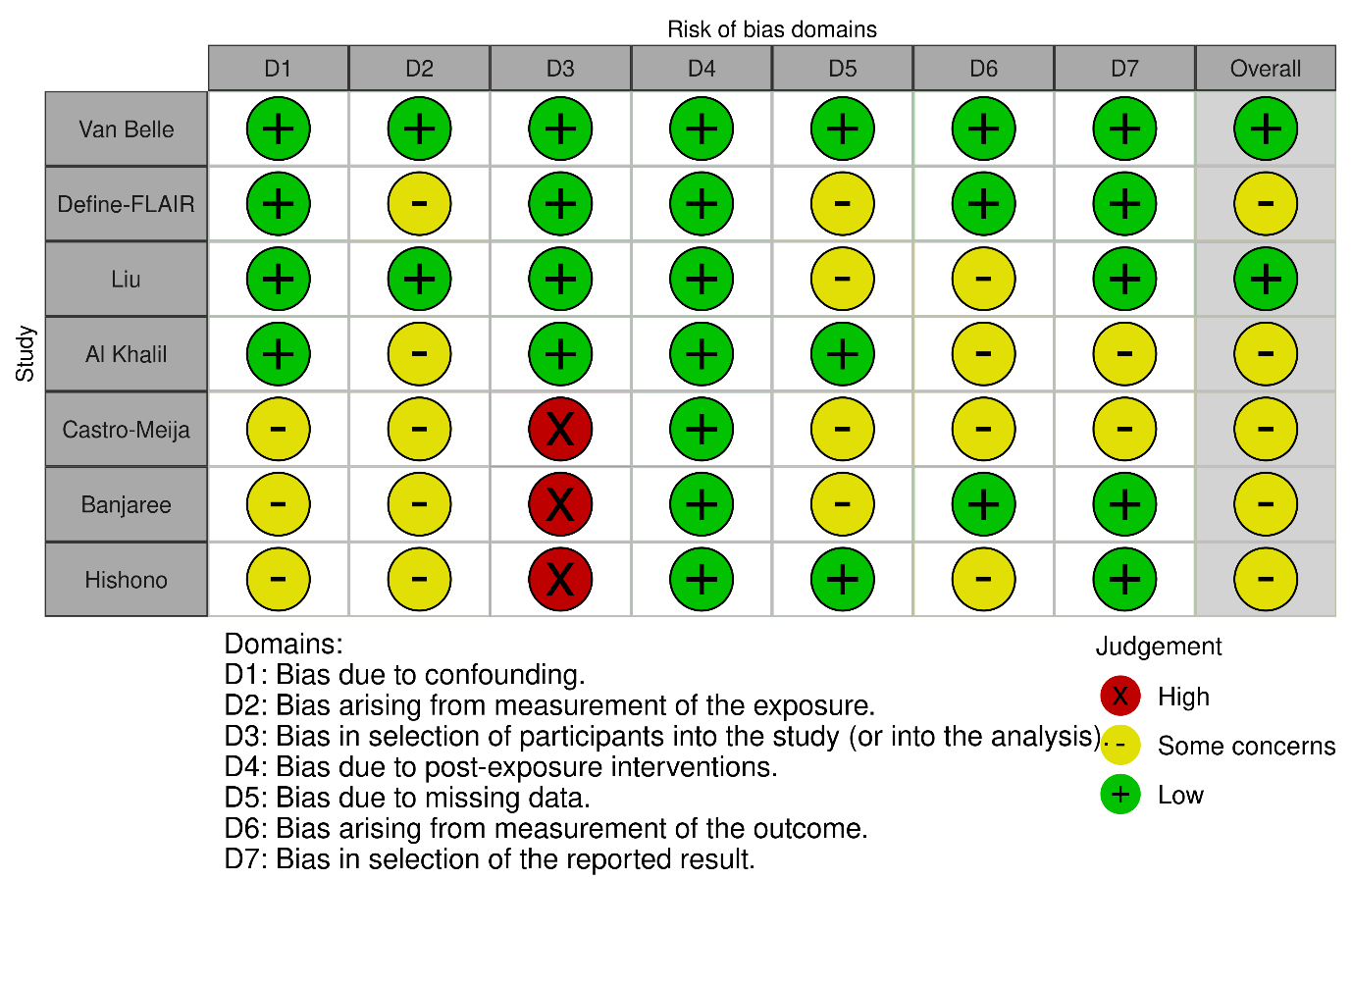

Figure S2: The Preferred Reporting Items for Systematic Review and Meta-analysis (PRISMA).

Identification of studies via databases and registers

Records removed before screening:
Duplicate records removed (n = 2634)
Records removed due to publication date before 2012 (n =2195)
Records identified from:
Databases (n = 13408)
Additional records through screening reference lists (n = 15)

Identification

Records screened
(n = 8594)
Records excluded based on title
(n = 8495)

Reports not retrieved
(n = 0)
Abstracts excluded on screening (n=75)
Reports sought for retrieval
(n = 99)

Screening

Reports excluded:
Event numbers not reported (n = 9)
FFR threshold of 0.75 (n = 2)
Time to events not reported, only mean follow up (n=4)
Included patients exclusively with acute coronary syndromes (n=2)
Full manuscripts assessed for eligibility
(n = 24)

Studies included in review
(n = 7)
Reports of included studies
(n = 7)
Included

Figure S3: Funnel plot of MACE between diabetic and non-diabetic groups.

Figure S4: Funnel plot of meta-analysis of MI between diabetic and non-diabetic groups.

Figure S5: Funnel plot of unplanned revascularisations between diabetic and non-diabetic groups.

Figure S6: Funnel plot of all-cause mortality between diabetic and non-diabetic groups.

Figure S7: Funnel plot of cardiovascular mortality between diabetic and non-diabetic groups.

