Additional material

Additional Figure 1. Kaplan-Meier curves for MACCEs, all-cause mortality, cardiovascular mortality, non-fatal MI, non-fatal stroke, and revascularization according to NT-proBNP categories
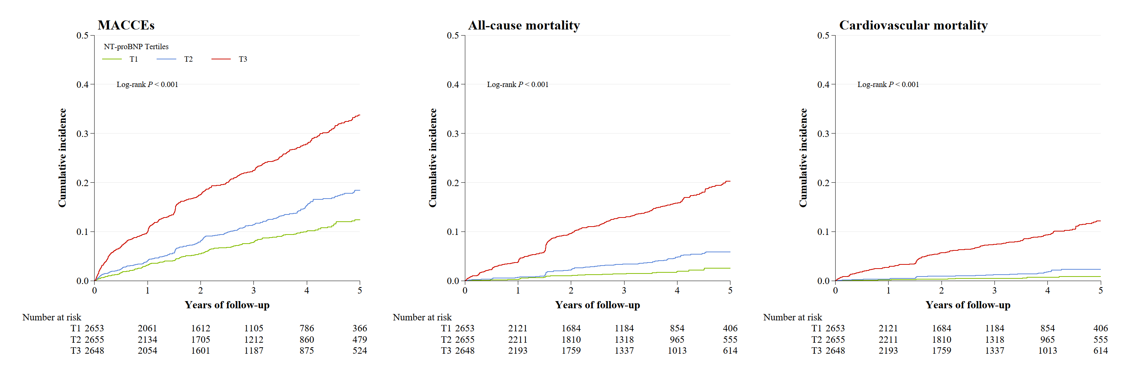
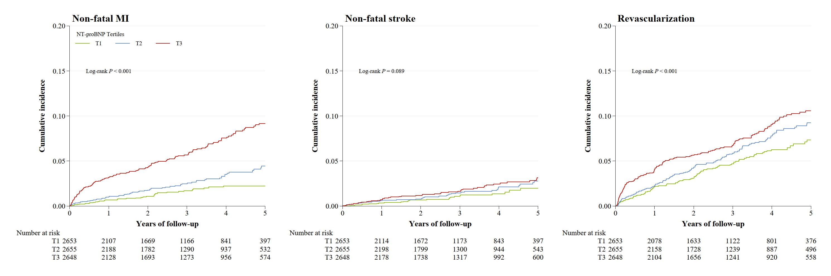
Abbreviations: MACCEs, major adverse cardio-cerebral events; MI, myocardial infarction; NT-proBNP, N-terminal pro-B-type natriuretic peptide.

Additional Table 1. P-value of the interaction of glycemic and NT-proBNP categories in the prediction of incident MACCEs and all-cause mortality
NT-proBNP categories × diabetes status | MACCEs | 0.1852
NT-proBNP categories × diabetes status | All-cause mortality | 0.2250
NT-proBNP risk categories × HbA1c categories | MACCEs | 0.0685
NT-proBNP risk categories × HbA1c categories | All-cause mortality | 0.0780
NT-proBNP risk categories × FPG categories | MACCEs | 0.0484
NT-proBNP risk categories × FPG categories | All-cause mortality | 0.1184
Abbreviations: FPG, fasting plasma glucose; HbA1c, glycosylated hemoglobin; MACCEs, major adverse cardio-cerebral events; NT-proBNP, N-terminal pro-B-type natriuretic peptide.

Additional Table 2. Adjusted HRs of incident MACCE across the spectrum of diabetes status and NT-proBNP categories for different subgroups
 | NT-proBNP
 | T1  < 92 pg/ml | T2  92-335 pg/ml | T3  ≥ 336 pg/ml | P value for trend | T1  < 92 pg/ml | T2  92-335 pg/ml | T3  ≥ 336 pg/ml | P value for trend
Diabetes status | HR (95% CI) * |  |  |  | HR (95% CI) *
 | Male (n = 4986) |  |  |  | Female (n = 2970)
Normoglycemia | Ref. | 1.62 (0.99-2.66) | 2.11 (1.29-3.43) | 0.116 | Ref. | 0.59 (0.22-1.53) | 1.91 (0.87-4.20) | < 0.001
Prediabetes | 1.97 (1.23-3.16) | 1.54 (0.94-2.52) | 2.47 (1.55-3.94) | 0.008 | 0.55 (0.21-1.47) | 1.05 (0.47-2.37) | 1.70 (0.79-3.69) | < 0.001
Diabetes | 1.81 (1.15-2.84) | 2.54 (1.64-3.94) | 2.64 (1.69-4.12) | < 0.001 | 0.75 (0.32-1.77) | 1.40 (0.66-2.95) | 2.21 (1.05-4.66) | < 0.001
P value for trend | 0.183 | 0.003 | < 0.001 |  | 0.045 | 0.487 | < 0.001
 | Age < 60 y (n = 2288) |  |  |  | Age ≥ 60 y (n = 5668)
Normoglycemia | Ref. | 2.12 (1.08-4.17) | 1.32 (0.59-2.95) | 0.325 | Ref. | 1.17 (0.65-2.09) | 2.92 (1.74-4.89) | < 0.001
Prediabetes | 1.41 (0.74-2.70) | 1.55 (0.77-3.13) | 1.94 (0.95-3.97) | 0.125 | 1.65 (0.94-2.89) | 1.58 (0.92-2.71) | 3.03 (1.83-5.03) | < 0.001
Diabetes | 1.68 (0.93-3.02) | 1.91 (1.03-3.54) | 3.13 (1.66-5.88) | 0.002 | 1.42 (0.83-2.46) | 2.59 (1.58-4.25) | 3.33 (2.03-5.44) | < 0.001
P value for trend | 0.323 | 0.133 | < 0.001 |  | 0.183 | 0.020 | < 0.001
 | BMI < 25 kg/m² (n = 3398) |  |  |  | BMI ≥ 25 kg/m² (n = 4558)
Normoglycemia | Ref. | 1.37 (0.75-2.48) | 1.80 (1.01-3.19) | 0.024 | Ref. | 1.15 (0.60-2.20) | 2.50 (1.40-4.47) | 0.008
Prediabetes | 1.32 (0.69-2.50) | 1.23 (0.67-2.28) | 2.29 (1.31-4.00) | 0.002 | 1.66 (0.94-2.93) | 1.49 (0.84-2.64) | 2.10 (1.20-3.67) | 0.004
Diabetes | 1.34 (0.74-2.44) | 2.23 (1.30-3.84) | 2.32 (1.35-3.99) | < 0.001 | 1.60 (0.93-2.76) | 2.13 (1.26-3.59) | 2.89 (1.71-4.90) | < 0.001
P value for trend | 0.757 | 0.031 | 0.001 |  | 0.491 | 0.034 | < 0.001
*Estimates were adjusted for age, sex, BMI, NSTE-ACS status, previous hypertension, previous dyslipidemia, previous myocardial infarction, systolic blood pressure, heart rate, LVEF, eGFR, hs-CRP, LDL-C, smoking status, and in-hospital treatments (PCI, antiplatelet therapy, β-blocker, ACEI or ARB, and statins).
Abbreviations see Table 1.

Additional Table 3. Adjusted HR of cardiovascular outcomes across the spectrum of glycemic control and NT-proBNP categories
 | NT-proBNP
 | HR (95% CI) * |  |  | P value for trend
Diabetes status | T1  < 92pg/ml | T2  92-335 pg/ml | T3  ≥ 336 pg/ml | P value for trend
MACCEs
Normoglycemia | Ref. | 1.28 (0.83-1.98) | 2.12 (1.41-3.18) | 0.001
Prediabetes | 1.52 (1.00-2.32) | 1.40 (0.92-2.12) | 2.24 (1.51-3.33) | < 0.001
Diabetes
HbA1c < 7.0% | 1.06 (0.64-1.75) | 1.90 (1.26-2.88) | 2.62 (1.77-3.89) | < 0.001
HbA1c ≥ 7.0% | 1.90 (1.24-2.90) | 2.39 (1.60-3.56) | 2.72 (1.84-4.02) | < 0.001
P value for trend | 0.470 | 0.001 | < 0.001
All-cause mortality
Normoglycemia | Ref. | 0.78 (0.32-1.89) | 2.41 (1.16-4.98) | < 0.001
Prediabetes | 0.90 (0.36-2.21) | 0.98 (0.43-2.21) | 2.32 (1.13-4.75) | < 0.001
Diabetes
HbA1c < 7.0% | 0.67 (0.22-2.01) | 1.73 (0.80-3.71) | 2.95 (1.44-6.03) | < 0.001
HbA1c ≥ 7.0% | 1.11 (0.45-2.73) | 2.10 (0.99-4.45) | 3.02 (1.48-6.16) | < 0.001
P value for trend | 0.072 | 0.386 | < 0.001
*Estimates were adjusted for age, sex, BMI, NSTE-ACS status, previous hypertension, previous dyslipidemia, previous myocardial infarction, systolic blood pressure, heart rate, LVEF, eGFR, hs-CRP, LDL-C, smoking status, and in-hospital treatments (PCI, antiplatelet therapy, β-blocker, ACEI or ARB, and statins).
Abbreviations see Table 1.

