Figure S1. Time to Dialysis Distribution and Causes of Death
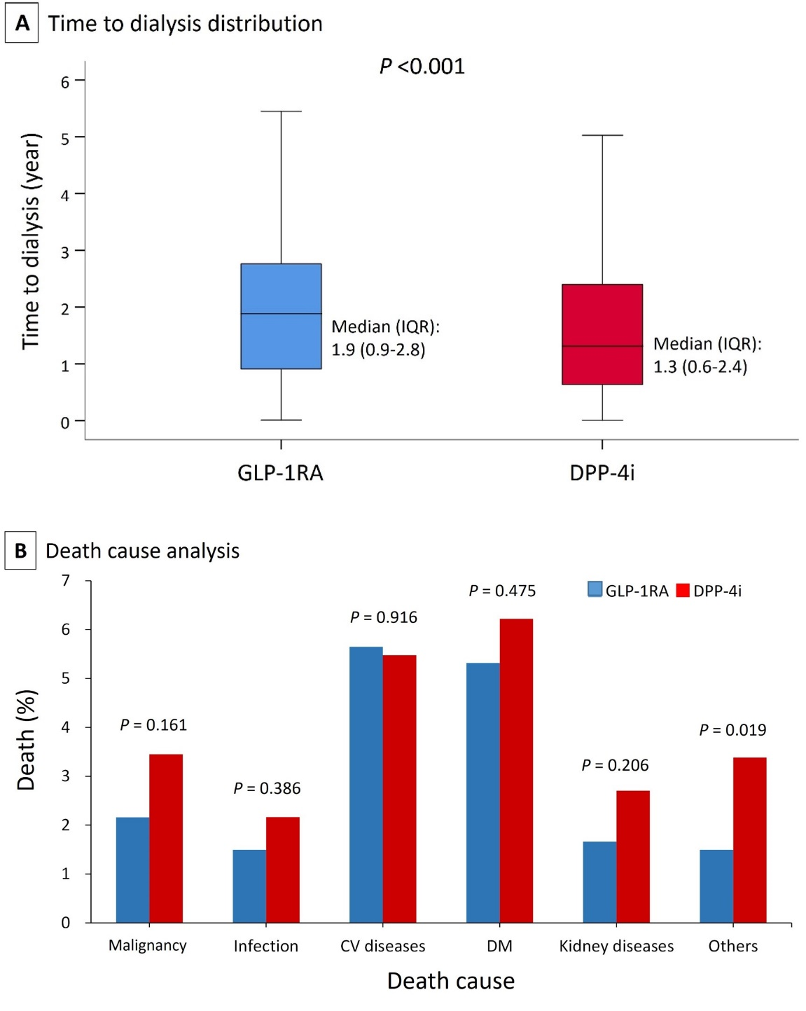
Time to dialysis was significantly reduced in the GLP-1RA group, with a 6-month delay compared to the DDP-4i group. Common causes death in the advanced DKD patients included malignancy, infection, CV diseases, DM, and kidney disease. There were no significant differences between the GLP-1RA and DPP-4i groups. The other causes of death were significantly lower in the GLP-1RA group.
Abbreviations: GLP-1RA, glucagon-like peptide 1 receptor agonist; DPP-4i, dipeptidyl peptidase 4 inhibitor; CV, cardiovascular; DM, diabetes mellitus.

Table S1. Number of patients with advanced chronic kidney disease with prescription of GLP1RA and DPP4i
Class / agent | 2012 | 2013 | 2014 | 2015 | 2016 | 2017 | 2018 | 2019 | 2020 | 2021
DPP4i | 11,570 | 9,280 | 10,903 | 14,651 | 14,447 | 12,774 | 12,721 | 11,465 | 10,718 | 11,525
Sitagliptin | 11,570 | 9,280 | 10,267 | 10,363 | 7,471 | 4,564 | 5,214 | 4,545 | 4,464 | 4,789
Vildagliptin | 0 | 0 | 0 | 987 | 2,453 | 2,799 | 2,486 | 1,730 | 1,456 | 1,633
Saxagliptin | 0 | 0 | 636 | 3,301 | 3,021 | 2,685 | 2,177 | 1,452 | 913 | 806
Linagliptin | 0 | 0 | 0 | 0 | 1,502 | 2,726 | 2,844 | 3,526 | 3,590 | 3,855
Alogliptin | 0 | 0 | 0 | 0 | 0 | 0 | 0 | 0 | 0 | 0
GLP1RA | 0 | 0 | 20 | 204 | 375 | 231 | 244 | 660 | 1,118 | 1,532
Exenatide | 0 | 0 | 20 | 204 | 35 | 8 | 8 | 0 | 0 | 0
Liraglutide | 0 | 0 | 0 | 0 | 340 | 223 | 236 | 407 | 681 | 585
Lixisenatide | 0 | 0 | 0 | 0 | 0 | 0 | 0 | 0 | 0 | 0
Dulaglutide | 0 | 0 | 0 | 0 | 0 | 0 | 0 | 253 | 437 | 947
Semaglutide | 0 | 0 | 0 | 0 | 0 | 0 | 0 | 0 | 0 | 0
Abbreviations: GLP1RA, glucagon-like peptide-1 receptor agonist; DPP4i, dipeptidyl peptidase 4 inhibitors;
Data were presented as frequency.

Table S2. Number of patients receiving dialysis with prescription of GLP1RA and DPP4i
Class / agent | 2012 | 2013 | 2014 | 2015 | 2016 | 2017 | 2018 | 2019 | 2020 | 2021
DPP4i | 1,885 | 1,465 | 1,593 | 1,884 | 1,849 | 1,680 | 1,568 | 1,327 | 1,227 | 1,353
Sitagliptin | 1,885 | 1,465 | 1,514 | 1,285 | 841 | 369 | 410 | 270 | 259 | 259
Vildagliptin | 0 | 0 | 0 | 75 | 195 | 319 | 265 | 173 | 130 | 154
Saxagliptin | 0 | 0 | 79 | 524 | 466 | 273 | 174 | 95 | 63 | 48
Linagliptin | 0 | 0 | 0 | 0 | 347 | 719 | 719 | 774 | 758 | 873
Alogliptin | 0 | 0 | 0 | 0 | 0 | 0 | 0 | 0 | 0 | 0
GLP1RA | 0 | 0 | 2 | 30 | 29 | 27 | 17 | 56 | 121 | 174
Exenatide | 0 | 0 | 2 | 30 | 6 | 1 | 1 | 0 | 0 | 0
Liraglutide | 0 | 0 | 0 | 0 | 23 | 26 | 16 | 33 | 71 | 72
Lixisenatide | 0 | 0 | 0 | 0 | 0 | 0 | 0 | 0 | 0 | 0
Dulaglutide | 0 | 0 | 0 | 0 | 0 | 0 | 0 | 23 | 50 | 102
Semaglutide | 0 | 0 | 0 | 0 | 0 | 0 | 0 | 0 | 0 | 0
Abbreviations: GLP1RA, glucagon-like peptide-1 receptor agonist; DPP4i, dipeptidyl peptidase 4 inhibitors;
Data were presented as frequency.

