Additional File 3. Mediation analyses for systolic blood pressure using weight loss as a factor at Week 40/42 (SURPASS 1-5, pooled data for TZP dose)
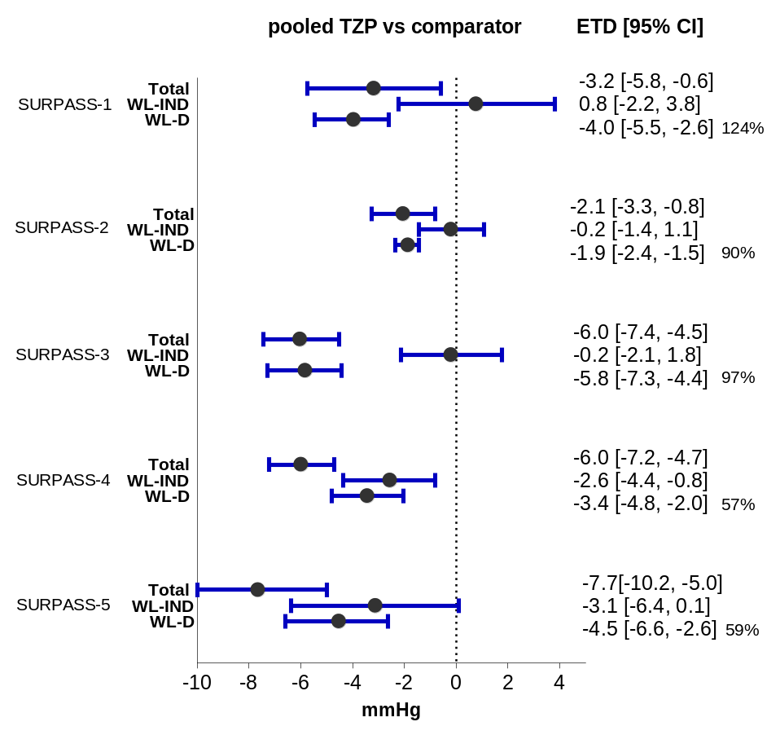
Data are least-squares mean ETD (95% CI). Data are taken from the safety population of each study. Percentage values represent the percent of blood pressure reduction mediated by weight loss.
CI confidence interval; ETD estimated treatment difference; TZP tirzepatide; WL-D weight-loss dependent; WL-IND weight-loss independent.

