SUPPLEMENTARY MATERIAL
Rapid kidney function decline and increased risk of heart failure in patients with type 2 diabetes: findings from the ACCORD cohort.
Short Title: Rapid kidney function decline and heart failure in T2D
Carlos Roberto Bueno Junior^{1,2,3}*, Arjola Bano^{1,2,4,5}*, Yaling Tang^{1,2}, Xuqin Sun^{1,2,6}, Alex Abate¹, Elizabeth Hall^{1,2}, Joanna Mitri^{1,2}, Mario Luca Morieri⁷, Hetal Shah^{1,2}, Alessandro Doria^{1,2}
*These authors contributed equally to this study.
¹Research Division, Joslin Diabetes Center, Boston, Massachusetts, USA
²Department of Medicine, Harvard Medical School, Boston, Massachusetts, USA
³ School of Physical Education and Sport, Medical School, and College of Nursing of Ribeirao Preto, University of Sao Paulo (USP), Ribeirao Preto, Sao Paulo, Brazil
⁴Institute of Social and Preventive Medicine (ISPM), University of Bern, Bern, Switzerland
⁵Department of Cardiology, Bern University Hospital, University of Bern, Bern, Switzerland
⁶Department of Endocrine and Metabolism, Anzhen Hospital Affiliated to Capital Medical University, Beijing, China
⁷Department of Medicine, University of Padova, and Metabolic Disease Unit, University Hospital of Padova, Padova, Italy.
Corresponding Author:
Alessandro Doria, M.D., Ph.D., M.P.H.,
Research Division,
Joslin Diabetes Center,
One Joslin Place,
Boston, MA 02215
Contents
Supplementary Table 1. Prevalence of rapid kidney function decline according to CVD history at baseline and occurrence of HF events during the first 4 years of follow-up. 3
Supplementary Table 2. Association of rapid kidney function decline and other clinical characteristics with odds of HF within 4 years from baseline. 4
Supplementary Table 3. Association of rapid kidney function decline during follow-up (vs no/slow kidney function decline) with odds of HF within 5 years from baseline. 5
Supplementary Table 4. Odds of HF according to baseline eGFR and UACR classes. 6
Supplemental Figure 1. Measurements performed at baseline and follow-up. 7
Supplemental Figure 2. Flow chart for the selection of study participants 8
Supplemental Figure 3. Distributions of the number of eGFR measurements (A) and years spanned by them (B) 9

Supplementary Table 1. Prevalence of rapid kidney function decline according to CVD history at baseline and occurrence of HF events during the first 4 years of follow-up.
 | All Participants |  |  | No CVD History |  |  | CVD History
 | All | No HF | HF | All | No HF | HF | All | No HF | HF
No/slow kidney function decline (n [%]) | 5,966 (79.1) | 5,825 (80.0) | 141  (55.3) | 3,929 (79.8) | 3,867 (80.3) | 62  (59.1) | 2037  (77.9) | 1958 (79.4) | 79  (52.7)
Rapid kidney function decline (n [%]) | 1,573 (20.9) | 1,459 (20.0) | 114  (44.7) | 994  (20.2) | 951  (19.7) | 43  (40.9) | 579  (22.1) | 508  (20.6) | 71  (47.3)
All (n [%]) | 7,539 (100) | 7,284 (100) | 255  (100) | 4,923 (100) | 4,818 (100) | 105  (100) | 2,616  (100) | 2,466 (100) | 150  (100)
Abbreviations: HF, heart failure, CVD cardiovascular disease

Supplementary Table 2. Association of rapid kidney function decline and other clinical characteristics with odds of HF within 4 years from baseline.

 | Model 1  Rapid kidney function decline |  |  | Model 2  Model 1 + ACCORD trial assignments and ACCORD clinical centers |  |  | Model 3  Model 2 + sex, age, duration of diabetes, BMI, WC, HbA1c, SBP, DBP, HDL, log triglycerides, smoking history, CVD history at baseline (All participants) |  |  | Model 4  Model 3 + eGFR and log UACR at baseline |  |  | Model 5  Model 4 + eGFR and log UACR before event or at censoring
Predictors | OR | 95% CI | p-value | OR | 95% CI | p-value | OR | 95% CI | p-value | OR | 95% CI | p-value | OR | 95% CI | p-value
Rapid kidney function decline | 3.23 | 2.51-4.16 | <0.0001 | 3.39 | 2.62-4.39 | <0.0001 | 3.27 | 2.44-4.37 | <0.0001 | 2.81 | 2.08-3.78 | <0.0001 | 3.73 | 2.63-5.31 | <0.0001
Intensive glycemic control | - | - | - | 1.12 | 0.87-1.44 | 0.39 | 1.27 | 0.89-1.82 | 0.19 | 1.21 | 0.85-1.74 | 0.29 | 1.24 | 0.867-1.78 | 0.24
Intensive BP control | - | - | - | 0.83 | 0.56-1.23 | 0.34 | 0.95 | 0.61-1.48 | 0.82 | 1.00 | 0.64-1.57 | 0.99 | 1.17 | 0.74-1.85 | 0.50
Fenofibrate vs. placebo | - | - | - | 0.84 | 0.60-1.18 | 0.31 | 1.10 | 0.76-1.59 | 0.61 | 1.15 | 0.79-1.67 | 0.47 | 1.44 | 0.97-2.12 | 0.07
Female | - | - | - | - | - | - | 0.98 | 0.66-1.45 | 0.92 | 1.05 | 0.70-1.56 | 0.81 | 1.09 | 0.73-1.63 | 0.67
Age | - | - | - | - | - | - | 1.06 | 1.03-1.08 | <0.0001 | 1.06 | 1.03-1.09 | <0.0001 | 1.06 | 1.04-1.09 | <0.0001
Diabetes duration | - | - | - | - | - | - | 1.02 | 1.00-1.04 | 0.03 | 1.01 | 0.99-1.03 | 0.21 | 1.01 | 0.99-1.09 | 0.18
BMI | - | - | - | - | - | - | 1.03 | 0.98-1.08 | 0.29 | 1.03 | 0.98-1.08 | 0.29 | 1.03 | 0.98-1.09 | 0.26
WC | - | - | - | - | - | - | 1.02 | 1.00-1.04 | 0.05 | 1.02 | 1.00-1.04 | 0.08 | 1.02 | 1.00-1.04 | 0.11
Baseline HbA1c | - | - | - | - | - | - | 1.24 | 1.06-1.44 | 0.006 | 1.19 | 1.02-1.37 | 0.03 | 1.19 | 1.02-1.39 | 0.03
Mean HbA1c during follow-up | - | - | - | - | - | - | 1.16 | 0.93-1.43 | 0.19 | 1.10 | 0.89-1.37 | 0.38 | 1.08 | 0.87-1.34 | 0.49
SBP | - | - | - | - | - | - | 1.01 | 1.00-1.02 | 0.08 | 1.00 | 0.99-1.01 | 0.48 | 1.00 | 0.99-1.01 | 0.71
DBP | - | - | - | - | - | - | 0.97 | 0.95-0.99 | 0.0009 | 0.98 | 0.96-0.99 | 0.006 | 0.99 | 0.96-0.99 | 0.006
HDL | - | - | - | - | - | - | 0.99 | 0.97-1.01 | 0.40 | 0.99 | 0.97-1.01 | 0.41 | 0.99 | 0.97-1.01 | 0.39
Log Triglycerides | - | - | - | - | - | - | 1.07 | 0.87-1.45 | 0.66 | 0.98 | 0.72-1.33 | 0.88 | 0.97 | 0.71-1.33 | 0.86
Smoking history | - | - | - | - | - | - | 1.17 | 0.87-1.59 | 0.30 | 1.13 | 0.83-1.53 | 0.43 | 1.14 | 0.84-1.55 | 0.40
CVD history at baseline | - | - | - | - | - | - | 1.96 | 1.44-2.67 | <0.0001 | 1.87 | 1.36-2.56 | <0.0001 | 1.84 | 1.34-2.53 | 0.0002
Diuretic therapy at baseline | - | - | - | - | - | - | 1.59 | 2.28-2.14 | 0.002 | 1.56 | 1.15-2.11 | 0.005 | 1.53 | 1.13-2.08 | 0.006
Beta blocker therapy at baseline | - | - | - | - | - | - | 1.27 | 0.93-1.73 | 0.13 | 1.25 | 0.92-1.71 | 0.16 | 1.28 | 0.93-1.75 | 0.13
RASB therapy at baseline | - | - | - | - | - | - | 1.03 | 0.74-1.43 | 0.87 | 0.97 | 0.69-1.36 | 0.85 | 0.98 | 0.70-1.37 | 0.89
eGFR at baseline† | - | - | - | - | - | - | - | - | - | 0.99 | 0.99-1.01 | 0.50 | 0.99 | 0.97-0.99 | 0.01
Log UACR at baseline‡ | - | - | - | - | - | - | - | - | - | 1.43 | 1.31-1.57 | <0.0001 | 1.28 | 1.12-1.47 | 0.0003
eGFR at event/censoring | - | - | - | - | - | - | - | - | - | - | - | - | 1.02 | 1.01-1.03 | 0.0008
Log UACR at event/censoring | - | - | - | - | - | - | - | - | - | - | - | - | 1.20 | 1.06-1.35 | 0.004
†ORs are per 10 ml/min/1.73 m2 increment in eGFR
‡ORs are per 1 natural log mg/g increment in UACR
Abbreviations: HF, heart failure; BMI, body mass index; WC, waist circumference; HbA1c, glycated hemoglobin; SBP, systolic blood pressure; DBP, diastolic blood pressure; LDL, low density lipoprotein; HDL, high density lipoprotein; CVD, cardiovascular disease; eGFR, estimated glomerular filtration rate; UACR, urinary albumin/creatinine ratio.

Supplementary Table 3. Association of rapid kidney function decline during follow-up (vs no/slow kidney function decline) with odds of HF within 5 years from baseline.
 | All Participants |  | No CVD History |  | CVD History
Models | OR (95% CI) | P value | OR (95% CI) | P value | OR (95% CI) | P value
Model 1: Rapid kidney function decline | 3.84 (3.01-4.89) | <0.0001 | 3.31 (2.27-4.82) | <0.0001 | 4.13 (2.48-4.84) | <0.0001
Model 2: Model 1 + ACCORD trial treatment assignments and ACCORD clinical centers | 4.06 (3.16-5.20) | <0.0001 | 3.58 (2.43-5.27) | <0.0001 | 4.28 (3.02-5.91) | <0.0001
Model 3: Model 2 + sex, age, duration of diabetes, BMI, WC, baseline HbA1c, SBP, DBP, HDL, log triglycerides, smoking history, diuretic therapy, beta blocker therapy, RASB therapy, CVD history at baseline (All participants), mean Hba1c during follow-up | 3.99 (3.00-5.30) | <0.0001 | 2.98 (1.93-4.62) | <0.0001 | 4.88 (3.31-7.12) | <0.0001
Model 4: Model 3 + eGFR and log UACR at baseline | 3.36 (2.50-4.51) | <0.0001 | 2.58 (1.65-4.04) | <0.0001 | 4.17 (2.78-6.24) | <0.0001
Model 5: Model 4 + last eGFR and log UACR before censoring or event | 4.90 (3.44-6.99) | <0.0001 | 3.76 (2.19-6.47) | <0.0001 | 6.20 (3.82-10.0) | <0.0001
Data are based on the analysis of 4,758 participants who completed 5 years of follow-up and/or had an HF events within that time interval. Included were 832 participants with rapid kidney function decline and 303 participants with an HF event.
Abbreviations: OR, odds ratio; 95% CI, 95% confidence interval; BMI, body mass index; WC, waist circumference; HbA1c, glycated hemoglobin; SBP, systolic blood pressure; RASB, renin-angiotensin blockers; CVD, cardiovascular disease; eGFR, estimated glomerular filtration rate; UACR, urine albumin-creatinine ratio

Supplementary Table 4. Odds of HF within 4 years from baseline according to baseline eGFR and UACR classes.
Baseline eGFR  (ml/min/1.73 m²) | Baseline UACR  (mg/g) | No HF  N (%) | HF  N (%) | Adjusted  OR (95% CI)
≥90 | <30 | 2,452 (33.8) | 33 (13.0) | 1 (ref)
≥90 | ≥30 | 1,009 (13.9) | 56 (22.1) | 3.51 (2.15-5.74)
60-89 | <30 | 2,172 (30.0) | 46 (18.1) | 1.17 (0.71-1.94)
60-89 | ≥30 | 948 (13.1) | 72 (28.4) | 3.53 (2.18-5.71)
<60 | <30 | 390 (5.4) | 20 (7.9) | 2.12 (1.11-4.03)
<60 | ≥30 | 280 (3.9) | 27 (10.6) | 3.98 (2.19-7.23)
All | All | 7,251 (100) | 255 (100)
Abbreviations: HF, heart failure; eGFR, estimated glomerular filtration rate; UACR, urinary albumin/creatinine ratio; OR, odds ratio; CI, confidence interval.

Supplemental Figure 1. Measurements performed at baseline and follow-up.

Randomization and start of follow-up
4 months

UACR
eGFR
WATCH_DM
At least 3 eGFR measures or more were used to calculate the GRF slope
HF status after 4 years of follow-up

Supplemental Figure 2. Flow chart for the selection of study participants

Abbreviations: eGFR, estimated glomerular filtration rate; UACR, urinary albumin/creatinine ratio

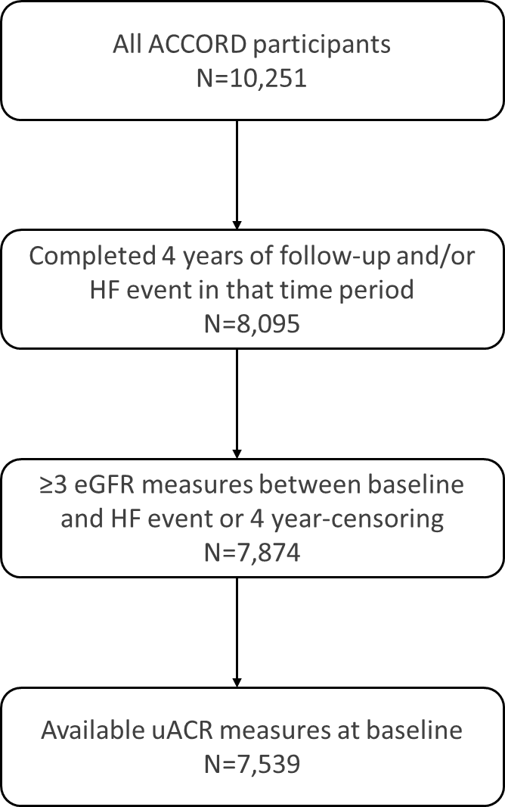

Supplemental Figure 3. Distributions of the number of eGFR measurements (A) and years spanned by them (B)

A
B
