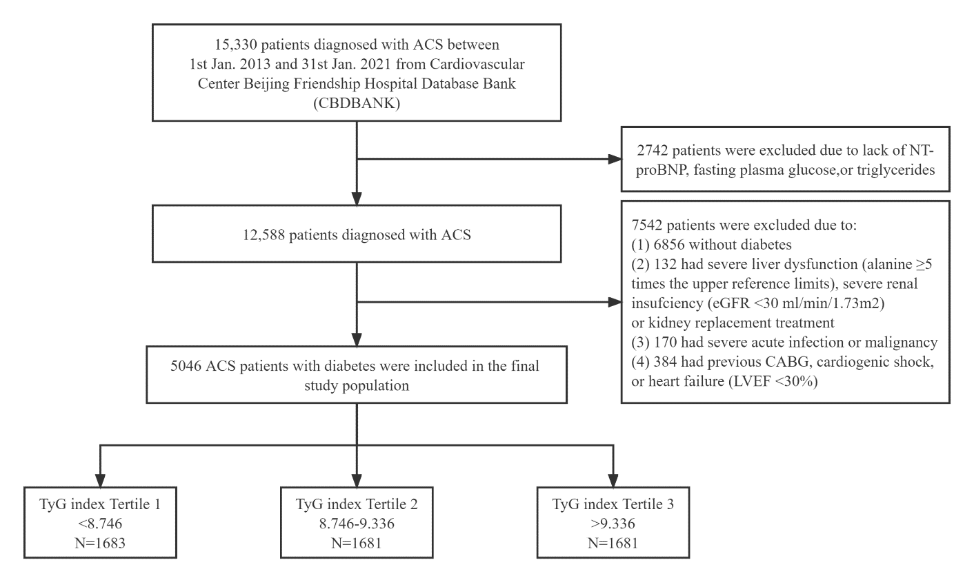
Supplemental Figure 1. Flowchart of the participants selection

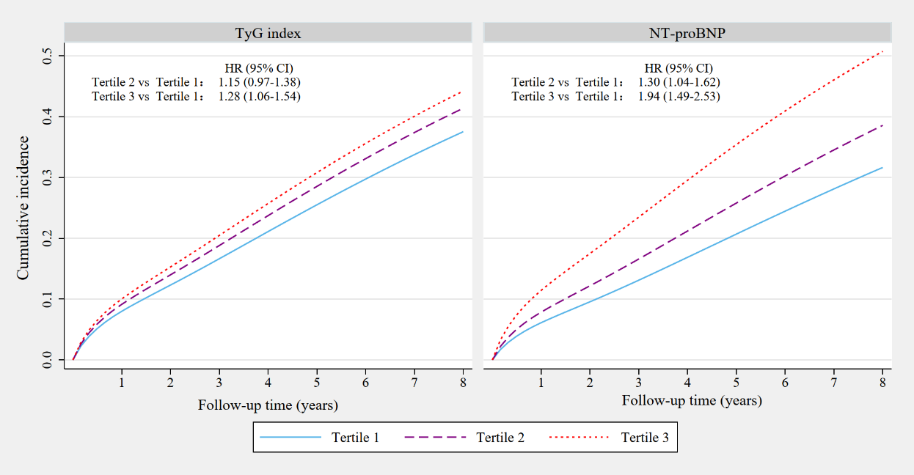
Additional Figure 2. Standardized cumulative incidence curves for MACCEs by the TyG index (left) and NT-proBNP (right) categories in the fully adjusted model (including the TyG index, NT-proBNP, age, sex, BMI, diagnosis of AMI, history of hypertension, history of dyslipidemia, history of myocardial infarction, history of arrhythmia, SBP, LVEF, eGFR, hs-CRP, LDL-C, smoking status, and in-hospital treatments (PCI, antiplatelet therapy, β-blocker, ACEI or ARB, and statins).

Additional Figure 3. Association between TyG index and NT-proBNP in men and women. Abbreviations: NT-proBNP, N-terminal pro-B-type natriuretic peptide; TyG, triglyceride-glucose.

Additional Figure 4. Association between TyG index and NT-proBNP stratified by age subgroups. Abbreviations: NT-proBNP, N-terminal pro-B-type natriuretic peptide; TyG, triglyceride-glucose.

Additional Figure 5. E-value for MACCEs according to the TyG index for the adjusted model. Abbreviations: TyG, triglyceride-glucose; MACCEs, major adverse cardio-cerebral events.

Additional Figure 6. E-value for MACCEs according to NT-proBNP for the adjusted model. Abbreviations: NT-proBNP, N-terminal pro-B-type natriuretic peptide; MACCEs, major adverse cardio-cerebral events.

Additional Table 1. Baseline and clinical characteristics by triglyceride-glucose index categories
 | Total (n=5046) | Triglyceride-glucose index |  |  | P value
 | Total (n=5046) | Tertile 1 (n=1683) | Tertile 2 (n=1681) | Tertile 3 (n=1682) | P value
Triglyceride-glucose index | 9.1 ± 0.7 | 8.4 ± 0.3 | 9.0 ± 0.2 | 9.9 ± 0.5 | < 0.001
Clinical characteristics
Age, year | 65.6 ± 10.6 | 68.3 ± 9.7 | 65.9 ± 10.3 | 62.4 ± 11.1 | < 0.001
Male, n (%) | 3127 (62.0) | 1035 (61.5) | 1029 (61.2) | 1063 (63.2) | 0.44
BMI, kg/m² | 26.1 ± 3.5 | 25.4 ± 3.5 | 26.2 ± 3.5 | 26.6 ± 3.5 | < 0.001
Heart rate, bpm | 73.6 ± 13.4 | 71.9 ± 13.1 | 73.6 ± 13.2 | 75.4 ± 13.5 | < 0.001
SBP, mm Hg | 132.9 ± 19.0 | 132.3 ± 18.1 | 132.0 ± 18.7 | 134.6 ± 20.1 | < 0.001
Previous hypertension, n (%) | 3783 (75.0) | 1309 (77.8) | 1253 (74.5) | 1221 (72.6) | 0.002
Previous dyslipidemia, n (%) | 2494 (49.4) | 802 (47.7) | 826 (49.1) | 866 (51.5) | 0.081
Previous MI, n (%) | 469 (9.3) | 170 (10.1) | 154 (9.2) | 145 (8.6) | 0.33
Previous arrhythmia | 499 (9.9) | 209 (12.4) | 165 (9.8) | 125 (7.4) | <0.001
Current smoker, n (%) | 1668 (33.1) | 445 (26.4) | 544 (32.4) | 679 (40.4) | < 0.001
LVEF, % | 62.8 ± 9.1 | 63.4 ± 9.2 | 62.8 ± 9.2 | 62.3 ± 8.8 | 0.002
ACS status, n (%) |  |  |  |  | < 0.001
UA | 3247 (64.3) | 1230 (73.1) | 1075 (64.0) | 942 (56.0)
NSTEMI | 930 (18.4) | 267 (15.9) | 320 (19.0) | 343 (20.4)
STEMI | 869 (17.2) | 186 (11.1) | 286 (17.0) | 397 (23.6)
Laboratory examinations
Peak value of NT-proBNP, pg/mL | 279.0 (90.0, 1331.0) | 252.0 (88.4, 1335.0) | 283.0 (90.5, 1402.0) | 304.5 (92.6, 1272.0) | 0.50
FPG, mmol/L | 7.7 ± 2.8 | 5.9 ± 1.4 | 7.4 ± 1.9 | 9.8 ± 3.1 | < 0.001
HbA1c, % | 7.5 ± 1.5 | 6.9 ± 1.1 | 7.3 ± 1.3 | 8.3 ± 1.7 | < 0.001
eGFR, ml/min/1.73m² | 111.7 ± 33.5 | 110.4 ± 31.9 | 111.6 ± 33.5 | 113.2 ± 35.2 | 0.065
Hs-CRP, mg/L | 2.4 (0.9, 8.8) | 1.6 (0.6, 6.6) | 2.5 (0.9, 9.2) | 3.1 (1.3, 10.2) | < 0.001
Total cholesterol, mmol/L | 4.2 ± 1.1 | 3.8 ± 0.9 | 4.2 ± 1.0 | 4.8 ± 1.2 | < 0.001
LDL-C, mmol/L | 2.4 ± 0.8 | 2.1 ± 0.6 | 2.4 ± 0.7 | 2.7 ± 0.8 | < 0.001
HDL-C, mmol/L | 1.0 ± 0.3 | 1.1 ± 0.3 | 1.0 ± 0.2 | 1.0 ± 0.2 | < 0.001
Triglycerides, mmol/L | 1.4 (1.1, 2.1) | 1.0 (0.8, 1.2) | 1.5 (1.3, 1.8) | 2.4 (1.9, 3.3) | < 0.001
In-hospital treatment, n (%)
Aspirin | 4558 (90.3) | 1491 (88.6) | 1524 (90.7) | 1543 (91.7) | 0.007
Clopidogrel/Ticagrelor | 3235 (64.1) | 1017 (60.4) | 1060 (63.1) | 1158 (68.8) | < 0.001
β-Blocker | 3554 (70.4) | 1125 (66.8) | 1181 (70.3) | 1248 (74.2) | < 0.001
ACEI/ARB | 2960 (58.7) | 962 (57.2) | 941 (56.0) | 1057 (62.8) | < 0.001
Statins | 4453 (88.2) | 1474 (87.6) | 1487 (88.5) | 1492 (88.7) | 0.57
PCI status, n (%) |  |  |  |  | < 0.001
No PCI performed | 2100 (41.6) | 814 (48.4) | 702 (41.8) | 584 (34.7)
Timely PCI | 557 (11.0) | 100 (5.9) | 187 (11.1) | 270 (16.1)
Other PCI | 2389 (47.3) | 769 (45.7) | 792 (47.1) | 828 (49.2)
Values are mean ± SD, n (%), or median (interquartile interval).
Abbreviations: BMI, body mass index; SBP, systolic blood pressure; MI, myocardial infarction; LVEF, left ventricular ejection fraction; ACS, acute coronary syndrome; UA, unstable angina; NSTEMI, non-ST-segment elevation myocardial infarction; STEMI, ST-segment elevation myocardial infarction; NT-proBNP, N-terminal pro-B-type natriuretic peptide; FPG, fasting plasma glucose; HbA1c, glycosylated hemoglobin; eGFR, estimated glomerular filtration rate; hs-CRP, high sensitivity C-reactive protein; LDL-C, low-density lipoprotein cholesterol; HDL-C, high-density lipoprotein cholesterol; ACEI, angiotensin-converting enzyme inhibitor; ARB, angiotensin receptor blocker; PCI, percutaneous coronary intervention.

Additional Table 2. Estimated hazard ratios for all-cause mortality, non-fatal myocardial infarction, non-fatal stroke, and revascularization
 | Base Model† |  | Adjusted Model††
 | Hazard Ratio (95% CI) | P Value | Hazard Ratio (95% CI) | P Value
All-cause mortality
NT-proBNP |  | < 0.001 |  | < 0.001
Tertile 1 | 1.00 (Reference) |  | 1.00 (Reference)
Tertile 2 | 1.79 (1.23-2.59) | 0.002 | 1.74 (1.13-2.69) | 0.012
Tertile 3 | 4.81 (3.42-6.77) | < 0.001 | 3.26 (2.04-5.19) | < 0.001
TyG index, per 1 unit* | 1.09 (0.95-1.26) | 0.232 | 1.23 (1.04-1.46) | 0.015
Non-fatal myocardial infarction
NT-proBNP |  | < 0.001 |  | 0.001
Tertile 1 | 1.00 (Reference) |  | 1.00 (Reference)
Tertile 2 | 2.13 (1.40-3.24) | < 0.001 | 1.45 (0.92-2.28) | 0.108
Tertile 3 | 4.34 (2.94-6.41) | < 0.001 | 2.50 (1.49-4.21) | 0.001
TyG index, per 1 unit* | 1.35 (1.13-1.62) | 0.001 | 1.23 (1.00-1.52) | 0.051
Non-fatal stroke
NT-proBNP |  | 0.101 |  | 0.488
Tertile 1 | 1.00 (Reference) |  | 1.00 (Reference)
Tertile 2 | 1.34 (0.79-2.28) | 0.273 | 1.46 (0.78-2.76) | 0.241
Tertile 3 | 1.74 (1.04-2.92) | 0.035 | 1.50 (0.66-3.38) | 0.334
TyG index, per 1 unit* | 0.79 (0.59-1.07) | 0.125 | 0.81 (0.56-1.16) | 0.249
Revascularization
NT-proBNP |  | < 0.001 |  | 0.038
Tertile 1 | 1.00 (Reference) |  | 1.00 (Reference)
Tertile 2 | 1.47 (1.13-1.92) | 0.005 | 1.26 (0.92-1.73) | 0.156
Tertile 3 | 1.78 (1.36-2.31) | < 0.001 | 1.69 (1.13-2.54) | 0.011
TyG index, per 1 unit* | 1.21 (1.05-1.40) | 0.008 | 1.19 (1.00-1.41) | 0.044
*Modeled as linear effects.
†Base model included the TyG index, NT-proBNP, age, and sex.
††Adjusted model included base model plus BMI, diagnosis of AMI, history of hypertension, history of dyslipidemia, history of myocardial infarction, history of arrhythmia, SBP, LVEF, eGFR, hs-CRP, LDL-C, smoking status, and in-hospital treatments (PCI, antiplatelet therapy, β-blocker, ACEI or ARB, and statins).
Abbreviations: CI, confidence interval; NT-proBNP, N-terminal pro-B-type natriuretic peptide; TyG, triglyceride-glucose; BMI, body mass index; AMI, acute myocardial infarction; SBP, systolic blood pressure; LVEF, left ventricular ejection fraction; eGFR, estimated glomerular filtration rate; hs-CRP, high sensitivity C-reactive protein; LDL-C, low-density lipoprotein cholesterol; PCI, percutaneous coronary intervention; ACEI, angiotensin-converting enzyme inhibitor; ARB, angiotensin receptor blocker.

Additional Table 3. Estimated hazard ratios for MACCEs stratified by sex
 |  | Base Model |  | Adjusted Model†
 |  | Hazard Ratio (95% CI) | P Value | Hazard Ratio (95% CI) | P Value
Men | NT-proBNP |  | < 0.001 |  | 0.011
Men | Tertile 1 | 1.00 (Reference) |  | 1.00 (Reference)
Men | Tertile 2 | 1.46 (1.16-1.83) | 0.001 | 1.20 (0.92-1.57) | 0.179
Men | Tertile 3 | 2.48 (2.00-3.06) | < 0.001 | 1.62 (1.17-2.24) | 0.004
Men | TyG index, per 1 unit* | 1.08 (0.96-1.21) | 0.193 | 1.08 (0.94-1.24) | 0.284
Women | NT-proBNP |  | < 0.001 |  | < 0.001
Women | Tertile 1 | 1.00 (Reference) |  | 1.00 (Reference)
Women | Tertile 2 | 1.86 (1.27-2.72) | 0.001 | 1.71 (1.10-2.66) | 0.017
Women | Tertile 3 | 4.02 (2.80-5.76) | < 0.001 | 3.09 (1.89-5.03) | < 0.001
Women | TyG index, per 1 unit* | 1.28 (1.10-1.50) | 0.002 | 1.32 (1.09-1.59) | 0.004
*Modeled as linear effects.
†Base model included the TyG index, NT-proBNP, and age.
††Adjusted model included base model plus BMI, diagnosis of AMI, history of hypertension, history of dyslipidemia, history of myocardial infarction, history of arrhythmia, SBP, LVEF, eGFR, hs-CRP, LDL-C, smoking status, and in-hospital treatments (PCI, antiplatelet therapy, β-blocker, ACEI or ARB, and statins).
Abbreviations: MACCEs, major adverse cardio-cerebral events; CI, confidence interval; NT-proBNP, N-terminal pro-B-type natriuretic peptide; TyG, triglyceride-glucose; BMI, body mass index; AMI, acute myocardial infarction; SBP, systolic blood pressure; LVEF, left ventricular ejection fraction; eGFR, estimated glomerular filtration rate; hs-CRP, high sensitivity C-reactive protein; LDL-C, low-density lipoprotein cholesterol; PCI, percutaneous coronary intervention; ACEI, angiotensin-converting enzyme inhibitor; ARB, angiotensin receptor blocker.

Additional Table 4. Estimated hazard ratios for MACCEs stratified by age subgroups
 |  | Base Model |  | Adjusted Model†
 |  | Hazard Ratio (95% CI) | P Value | Hazard Ratio (95% CI) | P Value
< 65 years | NT-proBNP |  | < 0.001 |  | 0.005
< 65 years | Tertile 1 | 1.00 (Reference) |  | 1.00 (Reference)
< 65 years | Tertile 2 | 1.59 (1.21-2.09) | 0.001 | 1.33 (0.95-1.85) | 0.095
< 65 years | Tertile 3 | 2.74 (2.13-3.53) | < 0.001 | 1.96 (1.30-2.96) | 0.001
< 65 years | TyG index, per 1 unit* | 1.10 (0.95-1.27) | 0.203 | 1.08 (0.91-1.29) | 0.358
≥ 65 years | NT-proBNP |  | < 0.001 |  | 0.001
≥ 65 years | Tertile 1 | 1.00 (Reference) |  | 1.00 (Reference)
≥ 65 years | Tertile 2 | 1.46 (1.10-1.94) | 0.009 | 1.28 (0.93-1.77) | 0.128
≥ 65 years | Tertile 3 | 2.78 (2.13-3.63) | < 0.001 | 1.87 (1.30-2.69) | 0.001
≥ 65 years | TyG index, per 1 unit* | 1.16 (1.03-1.32) | 0.016 | 1.24 (1.07-1.43) | 0.005
*Modeled as linear effects.
†Base model included the TyG index, NT-proBNP, age, and sex.
††Adjusted model included base model plus BMI, diagnosis of AMI, history of hypertension, history of dyslipidemia, history of myocardial infarction, history of arrhythmia, SBP, LVEF, eGFR, hs-CRP, LDL-C, smoking status, and in-hospital treatments (PCI, antiplatelet therapy, β-blocker, ACEI or ARB, and statins).
Abbreviations: MACCEs, major adverse cardio-cerebral events; CI, confidence interval; NT-proBNP, N-terminal pro-B-type natriuretic peptide; TyG, triglyceride-glucose; BMI, body mass index; AMI, acute myocardial infarction; SBP, systolic blood pressure; LVEF, left ventricular ejection fraction; eGFR, estimated glomerular filtration rate; hs-CRP, high sensitivity C-reactive protein; LDL-C, low-density lipoprotein cholesterol; PCI, percutaneous coronary intervention; ACEI, angiotensin-converting enzyme inhibitor; ARB, angiotensin receptor blocker.

Additional Table 5. Sensitivity analyses for the independent association of triglyceride-glucose index and NT-proBNP categories with incident MACCEs
 | Sensitivity analysis 1† |  | Sensitivity analysis 2† |  | Sensitivity analysis 3†
 | Hazard Ratio  (95% CI) | P Value | Hazard Ratio  (95% CI) | P Value | Hazard Ratio  (95% CI) | P Value
NT-proBNP |  | < 0.001 |  | < 0.001 |  | < 0.001
Tertile 1 | 1.00 (Reference) |  | 1.00 (Reference) |  | 1.00 (Reference)
Tertile 2 | 1.23 (0.93-1.61) | 0.145 | 1.25 (0.99-1.57) | 0.060 | 1.25 (1.00-1.57) | 0.055
Tertile 3 | 1.94 (1.40-2.70) | < 0.001 | 2.16 (1.63-2.86) | < 0.001 | 1.90 (1.46-2.49) | < 0.001
TyG index, per 1 unit* | 1.19 (1.03-1.37) | 0.017 | 1.17 (1.03-1.32) | 0.015 | 1.14 (1.01-1.28) | 0.040
*Modeled as linear effects.
†Adjusted model included the TyG index, NT-proBNP, age, sex, BMI, diagnosis of AMI, history of hypertension, history of dyslipidemia, history of myocardial infarction, history of arrhythmia, SBP, LVEF, eGFR, hs-CRP, LDL-C, smoking status, and in-hospital treatments (PCI, antiplatelet therapy, β-blocker, ACEI or ARB, and statins).
Abbreviations: NT-proBNP, N-terminal pro-B-type natriuretic peptide; MACCEs, major adverse cardio-cerebral events; CI, confidence interval; TyG, triglyceride-glucose; BMI, body mass index; AMI, acute myocardial infarction; SBP, systolic blood pressure; LVEF, left ventricular ejection fraction; eGFR, estimated glomerular filtration rate; hs-CRP, high sensitivity C-reactive protein; LDL-C, low-density lipoprotein cholesterol; PCI, percutaneous coronary intervention; ACEI, angiotensin-converting enzyme inhibitor; ARB, angiotensin receptor blocker.

Additional Table 6. Sensitivity analysis 4 for the independent association of triglyceride-glucose index and NT-proBNP categories divided by the optimal cutoff value with incident MACCEs
 | Hazard Ratio (95% CI) † | P Value
NT-proBNP
< 354 pg/ml | 1.00 (Reference)
354‒4240 pg/ml | 1.41 (1.16-1.71) | < 0.001
> 4240 pg/ml | 2.03 (1.52-2.71) | < 0.001
TyG index
< 8.52 | 1.00 (Reference)
8.52‒9.97 | 1.15 (0.95-1.39) | 0.144
> 9.97 | 1.45 (1.09-1.92) | 0.010
†Adjusted model included the TyG index, NT-proBNP, age, sex, BMI, diagnosis of AMI, history of hypertension, history of dyslipidemia, history of myocardial infarction, history of arrhythmia, SBP, LVEF, eGFR, hs-CRP, LDL-C, smoking status, and in-hospital treatments (PCI, antiplatelet therapy, β-blocker, ACEI or ARB, and statins).
Abbreviations: NT-proBNP, N-terminal pro-B-type natriuretic peptide; MACCEs, major adverse cardio-cerebral events; CI, confidence interval; TyG, triglyceride-glucose; BMI, body mass index; AMI, acute myocardial infarction; SBP, systolic blood pressure; LVEF, left ventricular ejection fraction; eGFR, estimated glomerular filtration rate; hs-CRP, high sensitivity C-reactive protein; LDL-C, low-density lipoprotein cholesterol; PCI, percutaneous coronary intervention; ACEI, angiotensin-converting enzyme inhibitor; ARB, angiotensin receptor blocker.

Additional Table 7. Sensitivity analyses for the joint association of triglyceride-glucose index and NT-proBNP categories with MACCEs risk in the fully adjusted model
 |  | Sensitivity analysis 1†* |  | Sensitivity analysis 2†* |  | Sensitivity analysis 3†* |  | Sensitivity analysis 4†※
TyG index group | NT-proBNP group | HR (95% CI) | P Value | HR (95% CI) | P Value | HR (95% CI) | P Value | HR (95% CI) | P Value
Group 1 | Group 1 | 1.00 (Reference) |  | 1.00 (Reference) |  | 1.00 (Reference) |  | 1.00 (Reference)
Group 1 | Group 2 | 1.02 (0.62-1.67) | 0.932 | 1.15 (0.76-1.73) | 0.503 | 1.13 (0.75-1.70) | 0.553 | 2.03 (1.36-3.03) | 0.001
Group 1 | Group 3 | 2.04 (1.25-3.31) | 0.004 | 2.33 (1.54-3.52) | < 0.001 | 2.03 (1.36-3.02) | < 0.001 | 2.72 (1.67-4.42) | < 0.001
Group 2 | Group 1 | 1.09 (0.64-1.86) | 0.756 | 1.24 (0.81-1.91) | 0.323 | 1.28 (0.84-1.96) | 0.255 | 1.44 (1.02-2.03) | 0.036
Group 2 | Group 2 | 1.39 (0.86-2.24) | 0.182 | 1.42 (0.95-2.12) | 0.089 | 1.51 (1.02-2.24) | 0.039 | 2.02 (1.42-2.89) | < 0.001
Group 2 | Group 3 | 2.29 (1.40-3.74) | 0.001 | 2.24 (1.47-3.41) | < 0.001 | 2.12 (1.42-3.17) | < 0.001 | 2.99 (1.98-4.52) | < 0.001
Group 3 | Group 1 | 1.30 (0.79-2.15) | 0.307 | 1.18 (0.77-1.82) | 0.450 | 1.15 (0.74-1.79) | 0.526 | 2.30 (1.50-3.52) | < 0.001
Group 3 | Group 2 | 1.77 (1.11-2.81) | 0.016 | 1.69 (1.14-2.52) | 0.009 | 1.65 (1.12-2.45) | 0.012 | 2.19 (1.36-3.50) | 0.001
Group 3 | Group 3 | 2.31 (1.41-3.79) | 0.001 | 2.82 (1.84-4.32) | < 0.001 | 2.41 (1.61-3.61) | < 0.001 | 2.63 (1.28-5.39) | 0.008
†Adjusted for age, sex, BMI, diagnosis of AMI, history of hypertension, history of dyslipidemia, history of myocardial infarction, history of arrhythmia, SBP, LVEF, eGFR, hs-CRP, LDL-C, smoking status, and in-hospital treatments (PCI, antiplatelet therapy, β-blocker, ACEI or ARB, and statins).
* Grouped by tertiles of the TyG index and NT-proBNP.
※ Grouped by the optimal cutoff value of the TyG index (< 8.52, 8.52‒9.97, and > 9.97) and NT-proBNP (< 354 pg/ml, 354‒4240 pg/ml, and > 4240 pg/ml).
Abbreviations: NT-proBNP, N-terminal pro-B-type natriuretic peptide; MACCEs, major adverse cardio-cerebral events; TyG, triglyceride-glucose; CI, confidence interval; BMI, body mass index; AMI, acute myocardial infarction; SBP, systolic blood pressure; LVEF, left ventricular ejection fraction; eGFR, estimated glomerular filtration rate; hs-CRP, high sensitivity C-reactive protein; LDL-C, low-density lipoprotein cholesterol; PCI, percutaneous coronary intervention; ACEI, angiotensin-converting enzyme inhibitor; ARB, angiotensin receptor blocker.

