Additional file
Search strategies
1.Embase（94）
#1 'coronary artery disease':ab,ti OR 'coronary heart disease':ab,ti OR 'atherosclerotic cardiovascular diseases':ab,ti OR 'CAD':ab,ti OR 'CHD':ab,ti OR 'ASCVD':ab,ti
#2 'triglyceride glucose index':ab,ti OR 'tyg index':ab,ti
#1 AND #2

2.PubMed （83）
("triglyceride glucose index"[Title/Abstract] OR "tyg index"[Title/Abstract]) AND ("Coronary Artery Disease"[MeSH Terms] OR "Coronary Disease"[MeSH Terms] OR ("Coronary Artery Disease"[Title/Abstract] OR "coronary heart disease"[Title/Abstract] OR "atherosclerotic cardiovascular diseases"[Title/Abstract] OR "CAD"[Title/Abstract] OR "CHD"[Title/Abstract] OR "ASCVD"[Title/Abstract]))

3.Cochrane（92）
#1 MeSH descriptor: [Coronary Artery Disease] explode all trees
#2 MeSH descriptor: [Coronary Disease] explode all trees
#3 (coronary artery disease):ti,ab,kw OR (coronary heart disease):ti,ab,kw OR (atherosclerotic cardiovascular diseases):ti,ab,kw OR (CAD):ti,ab,kw OR (CHD):ti,ab,kw
#4 (ASCVD):ti,ab,kw
#5 #1 OR #2 OR #3 OR #4
#6 (triglyceride glucose index):ti,ab,kw OR (tyg index):ti,ab,kw
#7 #5 AND #6

4.Web of science（112）
#1 TS=("coronary artery disease") OR TS=("coronary heart disease") OR TS=("atherosclerotic cardiovascular diseases") OR TS=(CAD) OR TS=(CHD) OR TS=(ascvd)
#2 (TS=("triglyceride glucose index")) OR TS=("tyg index")
#3 #1 AND #2
Table S1. NOS of the included studies.
Study | Selection |  |  |  | Comparability | Outcome |  |  | Overall
Study | 1 | 2 | 3 | 4 | 1 | 1 | 2 | 3 | Overall
da Silva2019 [12] | 0 | 0 | 1 | 0 | 2 | 1 | 0 | 0 | 4
Si2021 [13] | 0 | 0 | 1 | 0 | 2 | 1 | 0 | 0 | 4
Liu2022 [14] | 0 | 0 | 1 | 0 | 2 | 1 | 0 | 0 | 4
Zhao2022 [15] | 0 | 1 | 1 | 0 | 2 | 1 | 0 | 0 | 5
Pan2023 [16] | 1 | 1 | 1 | 1 | 2 | 1 | 0 | 0 | 7
Lee2016 [17] | 0 | 1 | 1 | 0 | 2 | 1 | 0 | 0 | 5
Kim2017 [18] | 1 | 1 | 1 | 1 | 2 | 1 | 0 | 0 | 7
Thai2020 [19] | 0 | 1 | 1 | 1 | 2 | 1 | 0 | 0 | 6
Ding2023 [20] | 0 | 0 | 1 | 1 | 2 | 1 | 0 | 0 | 5
Park2019 [21] | 1 | 1 | 1 | 1 | 2 | 1 | 1 | 1 | 9
Won2020 [22] | 0 | 1 | 1 | 1 | 2 | 1 | 1 | 1 | 8
Park2020 [23] | 1 | 1 | 1 | 1 | 2 | 1 | 0 | 0 | 7
Wang2022 [24] | 1 | 1 | 1 | 1 | 2 | 1 | 0 | 0 | 7
Su2022 [25] | 0 | 1 | 1 | 0 | 2 | 1 | 0 | 0 | 5
Wang2022[26] | 0 | 0 | 1 | 1 | 2 | 1 | 1 | 1 | 7
Xiong2023 [27] | 0 | 1 | 1 | 0 | 2 | 1 | 0 | 0 | 5
Zhu2021 [28] | 0 | 1 | 1 | 1 | 2 | 1 | 1 | 1 | 8
Guo2023 [29] | 0 | 1 | 1 | 0 | 2 | 1 | 1 | 1 | 7
Mao2019 [30] | 0 | 1 | 1 | 1 | 2 | 1 | 1 | 1 | 8
Luo2019 [31] | 0 | 1 | 1 | 1 | 2 | 1 | 1 | 1 | 8
Hu2020 [32] | 0 | 1 | 1 | 1 | 2 | 1 | 1 | 1 | 8
Ma2020 [33] | 0 | 1 | 1 | 1 | 2 | 1 | 1 | 1 | 8
Zhang2020 [34] | 0 | 1 | 1 | 1 | 2 | 1 | 1 | 1 | 8
Zhao2020 [35] | 0 | 1 | 1 | 1 | 2 | 1 | 1 | 1 | 8
Wang2020 [36] | 0 | 1 | 1 | 1 | 2 | 1 | 1 | 1 | 8
Zhao2021 [37] | 0 | 1 | 1 | 1 | 2 | 1 | 1 | 1 | 8
Zhang2022 [38] | 0 | 1 | 1 | 1 | 2 | 1 | 1 | 1 | 8
Jiao2022 [39] | 0 | 1 | 1 | 1 | 2 | 1 | 1 | 1 | 8
Karadeniz2022 [40] | 0 | 1 | 1 | 1 | 2 | 1 | 1 | 1 | 8
Guo2022 [41] | 0 | 1 | 1 | 1 | 2 | 1 | 1 | 1 | 8
Qin2022 [42] | 0 | 1 | 1 | 1 | 2 | 1 | 1 | 1 | 8
Pang2022 [43] | 0 | 1 | 1 | 1 | 2 | 1 | 1 | 1 | 8
Shen2023 [44] | 0 | 1 | 1 | 1 | 2 | 1 | 1 | 1 | 8
Jin2018a [45] | 0 | 1 | 1 | 1 | 2 | 1 | 1 | 1 | 8
Jin2018b [46] | 0 | 1 | 1 | 1 | 2 | 1 | 1 | 1 | 8
Neglia2021 [47] | 0 | 1 | 1 | 1 | 2 | 1 | 1 | 1 | 8
Yang2021 [48] | 0 | 1 | 1 | 1 | 2 | 1 | 1 | 1 | 8
Chen2022 [49] | 0 | 1 | 1 | 1 | 2 | 1 | 1 | 1 | 8
Lin2023 [50] | 0 | 1 | 1 | 1 | 2 | 1 | 1 | 1 | 8
Gao2021 [51] | 0 | 1 | 1 | 1 | 2 | 1 | 1 | 1 | 8
Selection
1.Representativeness of the exposed cohort;
2.Selection of the non exposed cohort;
3.Ascertainment of exposure;
4.Demonstration that outcome of interest was not present at start of study;
Comparability
1.Comparability of cohorts on the basis of the design or analysis;
Outcome
1.Assessment of outcome;
2.Was follow-up long enough for outcomes to occur;
3.Adequacy of follow up of cohort
Table S2. Definition of the primary endpoint.
Study | Definition
Mao2019 [30] | The composite of cardiac death, non-fatal myocardial infarction, target vessel revascularization, congestive heart failure, and non-fatal stroke.
Luo2019 [31] | The composite of all-cause death, target vessel revascularization, myocardial infarction during follow-up, unstable angina pectoris requiring hospitalization, heart failure, stroke or transient cerebral ischaemia.
Hu2020 [32] | The composite of death, non-fatal myocardial infarction, non-fatal stroke or unplanned repeat revascularization.
Ma2020 [33] | The composite of overall death, non-fatal stroke, non-fatal myocardial infarction, or unplanned repeat revascularization.
Zhang2020 [34] | The composite of all-cause death, non-fatal myocardial infarction, revascularization, and cardiac rehospitalization (admission because of angina or heart failure).
Zhao2020 [35] | The composite of all-cause death, non-fatal myocardial infarction and ischemia-driven revascularization.
Wang2020 [36] | The composite of all-cause death, non-fatal MI and non-fatal stroke.
Zhao2021 [37] | The composite of all-cause death, non-fatal myocardial infarction, non-fatal ischemic stroke, and ischemia-driven revascularization.
Zhang2022 [38] | The composite of all-cause death, non-fatal myocardial infarction, nonfatal stroke, revascularization, and cardiac rehospitalization (admission because of angina or heart failure).
Jiao2022 [39] | The composite of acute myocardial infarction, coronary artery revascularization and all-cause mortality (cardiac or non-cardiac mortalities).
Karadeniz2022 [40] | The composite of all-cause mortality, non-fatal re-infarction, and repeat target vessel revascularization.
Guo2022 [41] | The composite of cardiac death, non-fatal myocardial infarction, ischemia-driven revascularization, and stroke.
Qin2022 [42] | The composite of all-cause death, malignant arrhythmia, non-fatal myocardial infarction, target vessel reconstruction, angina pectoris requiring hospitalization, and acute heart failure.
Pang2022 [43] | The composite of all-cause death, non-fatal myocardial infarction, non-fatal ischemic stroke, and ischemia driven revascularization.
Jin2018a [45] | The composite of cardiovascular mortality, non-fatal myocardial infarction, stroke, post-discharge revascularization and hospitalized unstable angina.
Jin2018b [46] | The composite of death, non-fatal myocardial infarction, stroke and post-discharge revascularization.
Yang2021 [48] | The composite of all-cause mortality, non-fatal myocardial infarction, non-fatal stroke, and target vessel revascularization.
Chen2022 [49] | The composite of all-cause death, non-fatal myocardial infarction, nonfatal stroke and symptomatic graft failure.
Lin2023 [50] | The composite of overall death, non-fatal myocardial infarction, and unplanned revascularization.
Gao2021 [51] | The composite of death, non-fatal myocardial infarction, revascularization, and nonfatal stroke.

Table S3. Results of the secondary outcomes.
Secondary outcomes | Studies | Heterogeneity |  | Effects model | Meta-analysis
Secondary outcomes | Studies | P value | I² value | Effects model | HR (95%CI) | P value
ACS
All-cause mortality (Categorized) | 7 [34-39,44] | 0.52 | 0% | Fixed | 1.43 (1.18-1.73) | 0.0003
All-cause mortality (Continuous) | 4 [35,37,39,44] | 0.25 | 27% | Fixed | 1.31 (1.13-1.52) | 0.0003
Cardiac mortality (Categorized) | 4 [30,34,38,41] | 0.18 | 39% | Fixed | 1.51 (1.12-2.02) | 0.0006
Revasculation (Categorized) | 6 [30,34-38,41] | <0.0001 | 82% | Randomized | 2.42 (1.64-3.57) | <0.00001
Revasculation (Continuous) | 2 [35,37] | 0.25 | 23% | Fixed | 2.64 (2.08-3.35) | <0.00001
Cardiac rehospitalization (Categorized) | 2 [34,38] | 0.34 | 0% | Fixed | 1.19 (1.03-1.38) | 0.02
MI (Categorized) | 7 [30,34-38,41] | 0.65 | 0% | Fixed | 1.58 (1.28-1.96) | <0.0001
MI (Continuous) | 2 [35,37] | 0.89 | 0% | Fixed | 3.44 (2.20-5.39) | <0.00001
Stroke (Categorized) | 5 [30,36-38,41] | 0.62 | 0% | Fixed | 2.03 (1.39-2.97) | 0.0003
Stroke (Continuous) | 1 [35] | - | - | - | 1.86 (0.69-5.04) | 0.22
CCS
All-cause mortality (Categorized) | 3 [47,49,50] | 0.02 | 73% | Randomized | 1.69 (0.52-5.54) | 0.39
All-cause mortality (Continuous) | 1 [50] | - | - | - | 1.96 (0.61-6.26) | 0.26
Revasculation (Categorized) | 2 [47,50] | 0.71 | 0% | Fixed | 1.30 (1.07-1.59) | 0.01
Revasculation (Continuous) | 1 [50] | - | - | - | 1.42 (1.00-2.01) | 0.05
MI (Categorized) | 2 [47,50] | 0.77 | 0% | Fixed | 3.80 (1.95-7.40) | <0.0001
MI (Continuous) | 1 [50] | - | - | - | 3.18 (1.73-5.83) | 0.0002
Stroke (Categorized) | 1 [49] | - | - | - | 2.08 (0.81-5.33) | 0.13

Figure S1. The flow chart of the process (*83 from PubMed, 94 from EMbase, 92 from The Cochrane Library and 112 from Web of Science).

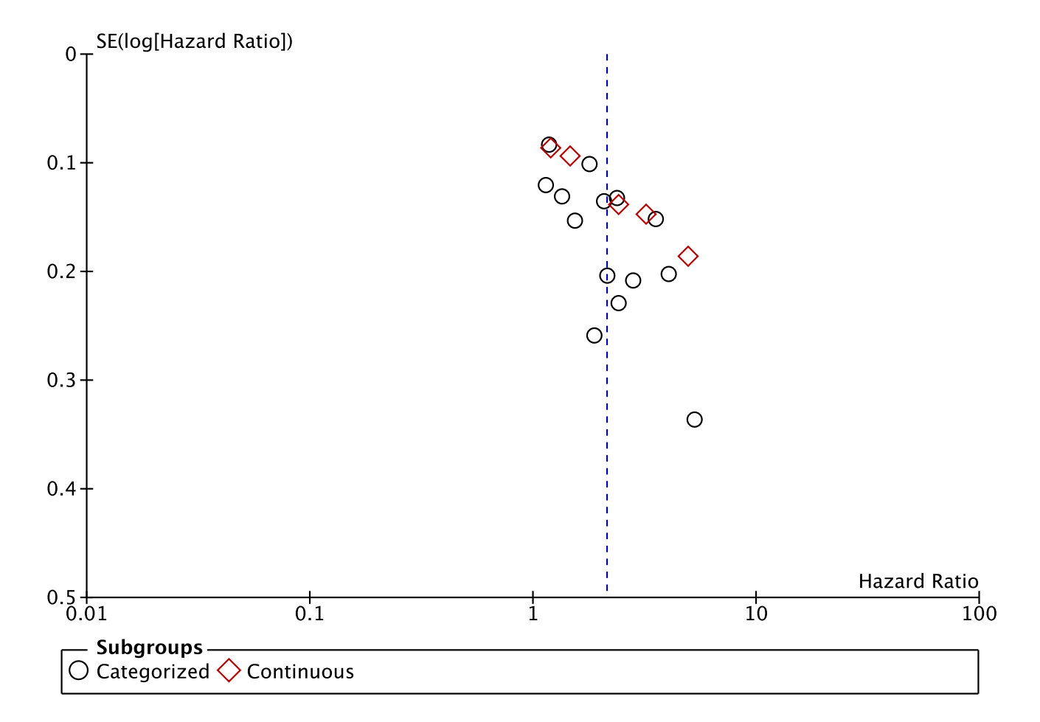
Figure S2. Results of the secondary outcomes.

