Supplement figure 1: Restricted cubic spline illustrates the relationship between uACR and the risk of cardiovascular and all-cause mortality among CAD patients combined with CHF
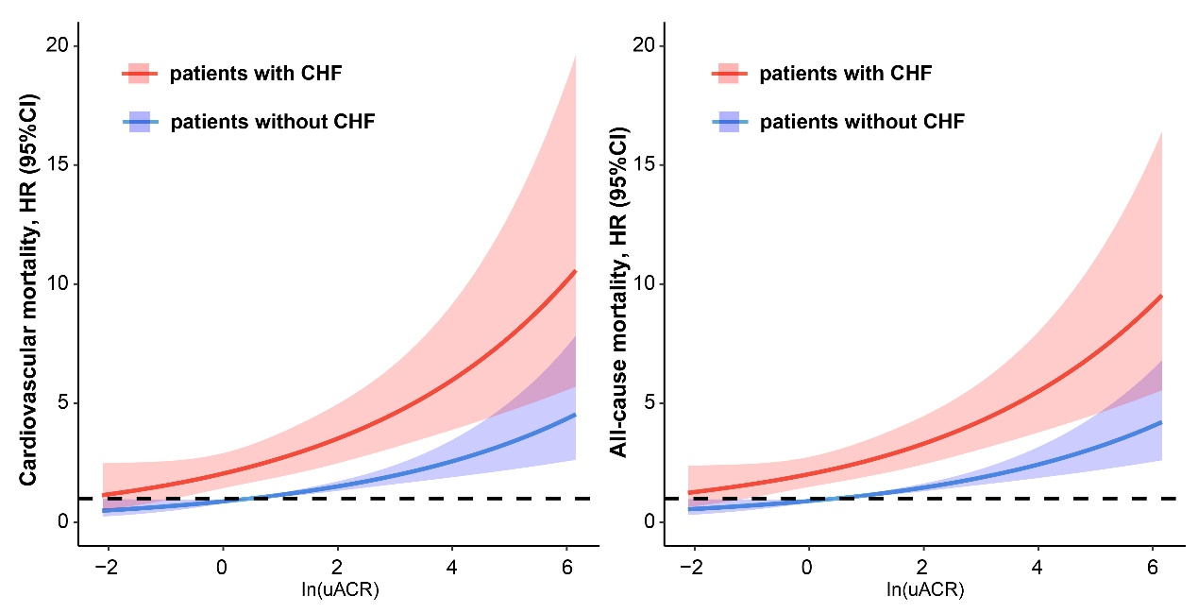
Abbreviation: uACR: urinary albumin creatinine ratio; CHF: congestive heart failure
Adjusted for age, gender, smoking history, acute myocardial infarction, hypertension, chronic kidney disease, anemia, type 2 diabetes mellitus, low density lipoprotein cholesterol, high density lipoprotein cholesterol and ACEI/ARB.

