Additional file 1
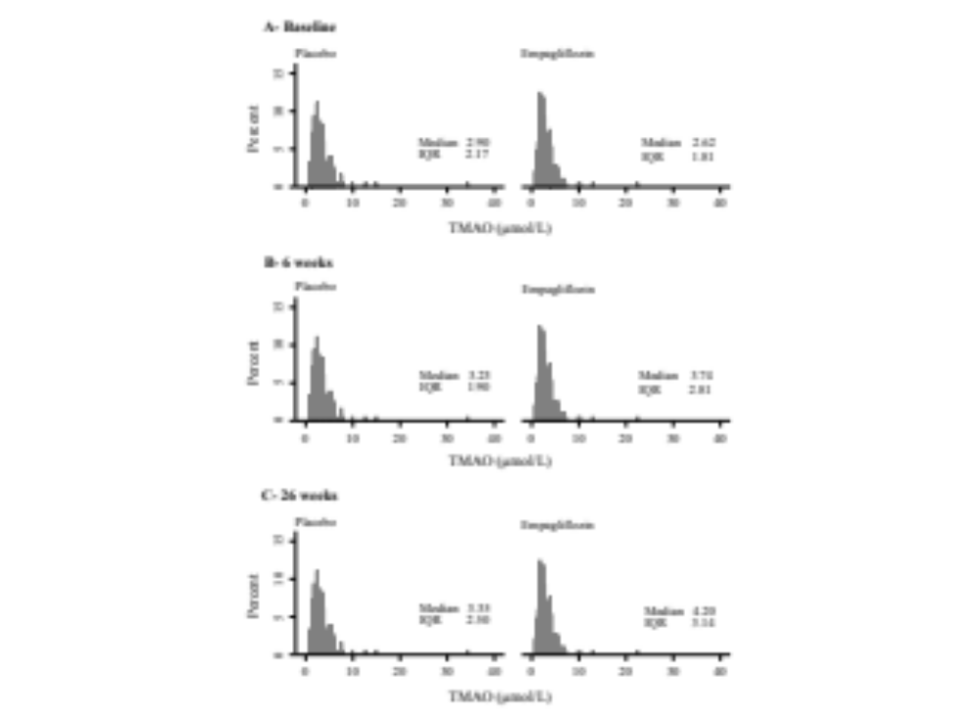
Fig. S1. Distribution of untransformed TMAO concentration (µmol/L) by treatment groups at A–baseline, B–6 weeks, and C–26 weeks.
IQR: Interquartile range
Table S1. LDL-C levels over visits by treatment groups.
LDL-C | Visit 1 | 6 weeks | 26 weeks | P-value | P-interaction
Empagliflozin | 123.2 ±37.9 | 62.7 ±26.4 | 61.0 ±28.6 | <0.001 | 0.579
Placebo | 122.6 ±42.5 | 60.3 ±25.3 | 56.0 ±23.8 | <0.001 | 0.579
LDL-C: Low density lipoprotein cholesterol
P-values are derived from the linear mixed

