Supplementary Table S1. Description of the Mediterranean Lifestyle (MEDLIFE) index, adapted to the UK Biobank (N = 112,493).
Index items | Components (serving size) | Criteria for 1 point | % scoring 1 point
Block 1: Mediterranean food consumption
1. Sweets | Cookies, chocolate cookies, pastries, donuts, homemade baked goods, store-bought baked goods, muffins (50 g), chocolates (30 g). | ≤ 2 serv/wk | 20.37
2. Red meat | Beef, pork, lamb (125 g). | ≤ 2 serv/wk | 53.63
3. Processed meat | Sausage, soft spicy sausage, bacon, cured ham, cooked ham, hamburger, liver, organ meats, pâté (42.5 g). | ≤ 1 serv/wk | 44.56
4. Eggs | Eggs (1 unit = 65 g). | ≥ 2 to ≤ 4 serv/wk | 14.45
5. Legumes | Lentils, beans, chickpeas, peas (150 g cooked). | ≥ 2 serv/wk | 16.96
6. White meat | Chicken/turkey with skin, chicken/turkey without skin, rabbit (125 g). | ≤ 2 serv/wk | 60.39
7. Fish/seafood | White fish, fatty fish, codfish, salted or smoked fish, shrimp, octopus, calamari, oysters and shellfish (125 g). | ≥ 2 serv/wk | 38.63
8. Potatoes | Baked or boiled potatoes (150 g). | ≤ 3 serv/wk | 37.97
9. Low-fat dairy products | Skim milk, low-fat milk (200 ml), low fat yogurt (125 g), fresh soft cheese (50 g). | 2 serv/d | 28.56
10. Nuts | Almonds, peanuts, hazelnuts, walnuts (30 g). | ≥ 3 serv/wk | 20.26
11. Sofrito | Sauce of olive oil with onion, pepper, other vegetables (250 g) and tomato (150 g). | > 2/4 ingredients  above the median | ---
12. Fruit | Orange, banana, apple, pear, kiwi, mango, avocado, peach, apricot, nectarine, clementine, strawberry, cherries, plums, figs, grapes, watermelon, melon (160 g), dates and dried fruits (30 g). | ≥ 3 serv/d | 9.29
13. Vegetables | Spinach, cauliflower, broccoli, lettuce, carrot, squash, green beans, eggplant, zucchini, cucumber, pepper, asparagus, gazpacho, garden salad, tomato, other vegetables (236.59 g for green leafy, half for others) (excluding potatoes). | ≥ 2 serv/d | 24.09
14. Olive oil | Olive oil (1 Tbsp = 13.5 g) | ≥ 3 serv/d | ---
Block 2: Mediterranean dietary habits
15. Wine | Red/white wine (1 glass, 100 ml). | Women: > 0 to ≤ 1 serv/d  Men: > 0 to ≤ 2 serv/d | 26.02
16. Limit salt at meals | Do you add salt to your food? (After cooking). | “Never” or “Sometimes” | 86.81
17. Low salt consumption | Low sodium-to-potassium ratio and low sodium consumption. | Na/K ratio ≤ 0.57  Na ≤ 2.000 mg/d | 48.30
18. Preference for whole grain products | Fiber from whole grain cereals. | > 6 g/d fiber from cereals | 15.28
19. Snacks | Potato chips, popcorn, or other chips (50 g). | ≤ 1 serv/wk | 62.35
20. Limit snacking between meals | Do you tend to snack in between meals or before going to bed? | No | ---
21. Healthy beverages consumption | Coffee, decaffeinated coffee (1 cup = 50 ml) or tea (1 cup = 250 ml). | ≥ 1 to ≤ 4 serv/d | 71.15
22. Limited consumption of sugar-sweetened beverages | Sugar-sweetened beverages + juice (150 ml). | < 1/wk | 19.02
Block 3: Physical activity, rest social habits and conviviality
20. Physical activity | Brisk walking, jogging, running, climbing stairs, bicycling, stationary cycling, swimming, dance, aerobic exercise, martial arts, gymnastics, gardening, tennis, soccer, skiing, ice skating, team sports, and other physical activities or sports. | ≥ 150 min of moderate, 75 min vigorous, or an equivalent combination | 30.95
24. Nap | Napping throughout the week. | “Usually” or “Sometimes” if  night-time sleep is adequate | 33.31
25. Hours of sleep | Sleeping throughout the week. | 6-8 h/d | 90.16
26. Limit sedentary activities | Watching TV, using internet or driving. | ≤ 2 h/d | 20.62
27. Eating in company | Do you have lunch or dinner with friends, family, or others? | Yes | ---
28. Collective sports | Playing soccer, tennis, squash, basketball, or other team sports, running in group, jogging; etc. | ≥ 1 h/wk | 38.18
29. Socializing with friends or family | Frequency on what you see family (different from whom you live with) or friends (home, church, bars…). | ≥ 3 times/wk | 45.75
Abbreviations: N, total number of participants; serv, serving; d, day, wk, week; Tbsp, tablespoons; TV, television.
Supplementary Table S2. Baseline characteristics of the UK Biobank participants by inclusion status in the analytical sample.
 | Included | Excluded
N | 112,493 | 14,328
Sex, female, n (%) | 64,860 (57.66) | 5,841 (40.77)
Age, years, mean (SD) | 58.70 (7.85) | 61.79 (7.37)
Ethnicity, n (%)
White | 109,135 (97.01) | 13,195 (92.09)
Non-white | 3,358 (2.99) | 703 (4.91)
Region of assessment
England | 102,997 (91.56) | 13,149 (91.77)
Wales | 3,442 (3.06) | 528 (3.69)
Scotland | 6,054 (5.38) | 651 (4.54)
Education
University education | 54,139 (48.13) | 5,319 (37.12)
Non-university education | 58,354 (51.87) | 8,610 (60.09)
Deprivation index, mean (SD) | -1.68 (2.81) | -1.27 (3.03)
Smoking status, n (%)
Never | 65, 847 (58.53) | 6,533 (45.60)
Former | 39,069 (34.73) | 6,297 (43.95)
Current | 7,577 (6.74) | 1,223 (8.54)
Energy intake, kcal/day, mean (SD) | 2062 (494) | 2061 (518)
Hypertension, n (%) | 24,067 (21.39) | 7,676 (53.57)
Cholesterol medication, n (%) | 10,890 (9.68) | 7,794 (54.40)
BMI, n (%)
< 25 | 46,700 (41.51) | 3,352 (23.39)
25 – 29.9 | 45,911 (40.81) | 5,726 (39.96)
≥ 30 | 19,882 (17.67) | 4,962 (34.63)
Family history of diabetes, yes, n (%) | 23,644 (21.02) | 3,758 (26.23)
MEDLIFE index, 0-25 p, mean (SD) | 9.56 (2.59) | 9.13 (2.62)
Block 1: Mediterranean food consumption, 0-12 p, mean (SD) | 3.69 (1.70) | 3.58 (1.66)
Block 2: Mediterranean eating habits, 0-7 p, mean (SD) | 3.29 (1.24) | 3.17 (1.26)
Block 3: Physical activity, rest, social habits, and conviviality; 0-6 p, mean (SD) | 2.58 (1.20) | 2.40 (1.21)
Abbreviations: N, total number of participants; p, points; SD standard deviation; BMI, body mass index.

Supplementary Table S3. Hazard ratios (95% confidence interval) for the association between MEDLIFE index and risk of type 2 diabetes in the UK Biobank, including participants with cardiovascular disease (N = 116,832).
 | Quartile 1  0 – 7 p | Quartile 2  8 – 9 p | Quartile 3  10 – 11 p | Quartile 4  12 – 22 p | p-trend | Per 2 points
cases/n | 934/25,330 | 968/33,520 | 736/31,866 | 444/26,116 |  | 3,082/116,832
Model 1 | Ref. | 0.79 (0.72 – 0.86) | 0.63 (0.57 – 0.70) | 0.48 (0.43 – 0.54) | < 0.001 | 0.81 (0.79 – 0.83)
Model 2 | Ref. | 0.80 (0.73 – 0.87) | 0.64 (0.58 – 0.71) | 0.49 (0.44 – 0.55) | < 0.001 | 0.81 (0.79 – 0.84)
Model 3 | Ref. | 0.89 (0.81 – 0.98) | 0.80 (0.72 – 0.88) | 0.70 (0.62 – 0.78) | < 0.001 | 0.90 (0.87 – 0.92)
Abbreviations: N, total number of participants; n, number of participants included in each quartile; p, points; Ref., reference.
Model 1: Adjusted for sex, age, ethnicity, education, and deprivation index, and region of assessment.
Model 2: Adjusted for Model 1 + smoking status, and energy intake.
Model 3: Adjusted for Model 2 + hypertension, cholesterol-lowering medication, body mass index, family history of diabetes, cardiovascular disease.

Supplementary Table S4. Hazard ratios (95% confidence interval) for the association between MEDLIFE index and risk of type 2 diabetes in the UK Biobank cohort, in participants who completed three or more diet assessments (N = 70,082).
 | Quartile 1  1 – 7 p | Quartile 2  8 – 9 p | Quartile 3  10 – 11 p | Quartile 4  12 – 22 p | p-trend | Per 2 points
cases/n | 518/15,868 | 511/20,125 | 395 /18,730 | 225/15,359 |  | 1,649/70,082
Model 1 | Ref. | 0.79 (0.70 – 0.89) | 0.66 (0.58 – 0.75) | 0.47 (0.40 – 0.56) | < 0.001 | 0.81 (0.78 – 0.84)
Model 2 | Ref. | 0.80 (0.71 – 0.90) | 0.68 (0.59 – 0.77) | 0.49 (0.42 – 0.57) | < 0.001 | 0.82 (0.78 – 0.85)
Model 3 | Ref. | 0.90 (0.80 – 1.02) | 0.86 (0.75 – 0.98) | 0.73 (0.62 – 0.85) | < 0.001 | 0.91 (0.88 – 0.95)
Abbreviations: N, total number of participants; n, number of participants included in each quartile; p, points; Ref., reference.
Model 1: Adjusted for sex, age, ethnicity, education, and deprivation index, and region of assessment.
Model 2: Adjusted for Model 1 + smoking status, and energy intake.
Model 3: Adjusted for Model 2 + hypertension, cholesterol-lowering medication, body mass index, family history of diabetes, and cardiovascular disease.

Supplementary Table S5. Hazard ratios (95% confidence interval) for the association between MEDLIFE index and risk of type 2 diabetes in the UK Biobank, excluding wine from the MEDLIFE (N = 112,493).
 | Quartile 1  0 – 7 p | Quartile 2  8 – 9 p | Quartile 3  10 – 11 p | Quartile 4  12 – 21 p | p-trend | Per 2 points
cases/n | 903/27,420 | 874/33,791 | 614/29,461 | 333/21,821 |  | 2,724/112,493
Model 1 | Ref. | 0.80 (0.73 – 0.87) | 0.65 (0.58 – 0.72) | 0.49 (0.43 – 0.56) | < 0.001 | 0.81 (0.79 – 0.84)
Model 2 | Ref. | 0.80 (0.73 – 0.88) | 0.65 (0.59 – 0.73) | 0.50 (0.44 – 0.57) | < 0.001 | 0.82 (0.79 – 0.84)
Model 3 | Ref. | 0.90 (0.82 – 0.99) | 0.81 (0.73 – 0.90) | 0.70 (0.62 – 0.80) | < 0.001 | 0.90 (0.87 – 0.93)
Abbreviations: N, total number of participants; n, number of participants included in each quartile; p, points; Ref., reference.
Model 1: Adjusted for sex, age, ethnicity, education, and deprivation index, region of assessment, and wine consumption.
Model 2: Adjusted for Model 1 + smoking status, and energy intake.
Model 3: Adjusted for Model 2 + hypertension, cholesterol-lowering medication, body mass index, and family history of diabetes.

Supplementary Table S6. Hazard ratios (95% confidence interval) for the association between MEDLIFE index and risk of type 2 diabetes in the UK Biobank, excluding cases of type 2 diabetes within first two years of follow-up (N = 111,900).
 | Quartile 1  0 – 7 p | Quartile 2  8 – 9 p | Quartile 3  10 – 11 p | Quartile 4  12 – 22 p | p-trend | Per 2 points
cases/n | 642/24,123 | 687/32,050 | 516/30,576 | 286/25,151 |  | 2,131/111,900
Model 1 | Ref. | 0.79 (0.71 – 0.88) | 0.62 (0.55 – 0.70) | 0.43 (0.37 – 0.49) | < 0.001 | 0.79 (0.76 – 0.81)
Model 2 | Ref. | 0.80 (0.72 – 0.90) | 0.63 (0.56 – 0.71) | 0.44 (0.38 – 0.51) | < 0.001 | 0.79 (0.76 – 0.82)
Model 3 | Ref. | 0.89 (0.80 – 1.00) | 0.78 (0.69 – 0.88) | 0.62 (0.54 – 0.71) | < 0.001 | 0.87 (0.84 – 0.90)
Abbreviations: N, total number of participants; n, number of participants included in each quartile; p, points; Ref., reference.
Model 1: Adjusted for sex, age, ethnicity, education, and deprivation index, and region of assessment.
Model 2: Adjusted for Model 1 + smoking status, and energy intake.
Model 3: Adjusted for Model 2 + hypertension, cholesterol-lowering medication, body mass index, and family history of diabetes.

Supplementary Table S7. Hazard ratios (95% confidence interval) for the association between MEDLIFE index and risk of type 2 diabetes in the UK Biobank, from subdistribution hazard models considering death as competing event (N = 112,493).
 | Quartile 1  0 – 7 p | Quartile 2  8 – 9 p | Quartile 3  10 – 11 p | Quartile 4  12 – 22 p | p-trend | Per 2 points increase
cases/n | 816/24,297 | 863/32,226 | 653/30,713 | 392/25,257 |  | 2,724/112,493
Model 1 | Ref. | 0.76 (0.69 – 0.83) | 0.61 (0.55 – 0.68) | 0.47 (0.40 – 0.54) | < 0.001 | 0.81 (0.79 – 0.83)
Model 2 | Ref. | 0.76 (0.70 – 0.83) | 0.62 (0.55 – 0.69) | 0.47 (0.41 – 0.55) | < 0.001 | 0.81 (0.79 – 0.84)
Model 3 | Ref. | 0.86 (0.79 – 0.94) | 0.78 (0.70 – 0.87) | 0.68 (0.59 – 0.79) | < 0.001 | 0.90 (0.87 – 0.93)
Abbreviations: N, total number of participants; n, number of participants included in each quartile; p, points; Ref., reference.
Model 1: Adjusted for sex, age, ethnicity, education, and deprivation index, and region of assessment.
Model 2: Adjusted for Model 1 + smoking status, and energy intake.
Model 3: Adjusted for Model 2 + hypertension, cholesterol-lowering medication, body mass index, and family history of diabetes.

Supplementary Table S8. Hazard ratios (95% confidence interval) for the association between MEDLIFE index blocks and risk of type 2 diabetes in the UK Biobank, including participants with cardiovascular disease (N = 116,832).
 | Per 2 points | p-value
Block 1: Mediterranean food consumption
Model 1 | 0.88 (0.84 – 0.92) | < 0.001
Model 2 | 0.88 (0.84 – 0.92) | < 0.001
Model 3 | 0.93 (0.89 – 0.98) | 0.003
Block 2: Mediterranean dietary habits
Model 1 | 0.73 (0.69 – 0.77) | < 0.001
Model 2 | 0.74 (0.69 – 0.78) | < 0.001
Model 3 | 0.85 (0.80 – 0.91) | < 0.001
Block 3: Physical activity, rest, social habits, and conviviality
Model 1 | 0.78 (0.78 – 0.83) | < 0.001
Model 2 | 0.79 (0.74 – 0.84) | < 0.001
Model 3 | 0.88 (0.83 – 0.94) | < 0.001
Abbreviations: N, total number of participants.
Model 1: Adjusted for sex, age, ethnicity, education, and deprivation index, region of assessment, and the remaining blocks.
Model 2: Adjusted for Model 1 + smoking status, and energy intake.
Model 3: Adjusted for Model 2 + hypertension, cholesterol-lowering medication, body mass index, and family history of diabetes.

Supplementary Table S9. Hazard ratios (95% confidence interval) for the association between MEDLIFE index blocks and risk of type 2 diabetes in the UK Biobank, in participants who completed three or more diet assessments (N = 70,082).
 | Per 2 points | p-value
Block 1: Mediterranean food consumption
Model 1 | 0.90 (0.85 – 0.95) | < 0.001
Model 2 | 0.89 (0.84 – 0.95) | < 0.001
Model 3 | 0.96 (0.90 – 1.02) | 0.193
Block 2: Mediterranean dietary habits
Model 1 | 0.68 (0.63 – 0.74) | < 0.001
Model 2 | 0.70 (0.65 – 0.76) | < 0.001
Model 3 | 0.83 (0.77 – 0.90) | < 0.001
Block 3: Physical activity, rest, social habits, and conviviality
Model 1 | 0.80 (0.74 – 0.87) | < 0.001
Model 2 | 0.80 (0.74 – 0.87) | < 0.001
Model 3 | 0.91 (0.84 – 0.99) | 0.023
Abbreviations: N, total number of participants.
Model 1: Adjusted for sex, age, ethnicity, education, and deprivation index, region of assessment, and the remaining blocks.
Model 2: Adjusted for Model 1 + smoking status, and energy intake.
Model 3: Adjusted for Model 2 + hypertension, cholesterol-lowering medication, , body mass index, and family history of diabetes

Supplementary Table S10. Hazard ratios (95% confidence interval) for the association between MEDLIFE index blocks and risk of type 2 diabetes in the UK Biobank, excluding wine from the MEDLIFE (N = 112,493).
 | Per 2 points | p-value
Block 1: Mediterranean food consumption
Model 1 | 0.85 (0.81 – 0.90) | < 0.001
Model 2 | 0.85 (0.81 – 0.90) | < 0.001
Model 3 | 0.91 (0.86 – 0.96) | < 0.001
Block 2: Mediterranean dietary habits
Model 1 | 0.70 (0.66 – 0.75) | < 0.001
Model 2 | 0.71 (0.67 – 0.77) | < 0.001
Model 3 | 0.83 (0.77 – 0.89) | < 0.001
Block 3: Physical activity, rest, social habits, and conviviality
Model 1 | 0.77 (0.72 – 0.82) | < 0.001
Model 2 | 0.77 (0.72 – 0.82) | < 0.001
Model 3 | 0.85 (0.79 – 0.91) | < 0.001
Abbreviations: N, total number of participants.
Model 1: Adjusted for sex, age, ethnicity, education, and deprivation index, region of assessment, wine consumption, and the remaining blocks.
Model 2: Adjusted for Model 1 + smoking status, and energy intake.
Model 3: Adjusted for Model 2 + hypertension, cholesterol-lowering medication, body mass index, and family history of diabetes.

Supplementary Table S11. Hazard ratios (95% confidence interval) for the association between MEDLIFE index blocks and risk of type 2 diabetes in the UK Biobank, excluding cases of type 2 diabetes within first two years of follow-up (N = 111,900).
 | Per 2 points | p-value
Block 1: Mediterranean food consumption
Model 1 | 0.85 (0.81 – 0.90) | < 0.001
Model 2 | 0.85 (0.81 – 0.90) | < 0.001
Model 3 | 0.91 (0.86 – 0.96) | < 0.001
Block 2: Mediterranean dietary habits
Model 1 | 0.70 (0.65 – 0.75) | < 0.001
Model 2 | 0.71 (0.66 – 0.76) | < 0.001
Model 3 | 0.82 (0.76 – 0.88) | < 0.001
Block 3: Physical activity, rest, social habits, and conviviality
Model 1 | 0.78 (0.72 – 0.84) | < 0.001
Model 2 | 0.78 (0.73 – 0.84) | < 0.001
Model 3 | 0.87 (0.81 – 0.94) | < 0.001
Abbreviations: N, total number of participants.
Model 1: Adjusted for sex, age, ethnicity, education, and deprivation index, region of assessment, wine consumption, and the remaining blocks.
Model 2: Adjusted for Model 1 + smoking status, and energy intake.
Model 3: Adjusted for Model 2 + hypertension, cholesterol-lowering medication, body mass index, and family history of diabetes.

Supplementary Table S12. Hazard ratios (95% confidence interval) for the association between MEDLIFE index and risk of type 2 diabetes in the UK Biobank by different subgroups (N = 112,493).
 | cases/n | Per 2 points | p-value | Interaction | p for interaction
Sex
Men | 1,546/46,087 | 0.88 (0.85 – 0.92) | < 0.001 | 0.97 (0.91 – 1.03) | 0.327
Women | 1,178/63,682 | 0.92 (0.88 – 0.96) | < 0.001 | 0.97 (0.91 – 1.03) | 0.327
Age
< 65 years | 1,781/84,702 | 0.90 (0.87 – 0.94) | < 0.001 | 1.00 (1.00 – 1.01) | 0.025
≥ 65 years | 943/27,791 | 0.89 (0.84 – 0.94) | < 0.001 | 1.00 (1.00 – 1.01) | 0.025
Deprivation index
≤ -2.38728 | 1,212/56,247 | 0.91 (0.87 – 0.95) | < 0.001 | 0.99 (0.9 – 1.00) | 0.221
> -2.38728 | 1,512/56,246 | 0.89 (0.85 – 0.93) | < 0.001 | 0.99 (0.9 – 1.00) | 0.221
BMI
< 25 kg/m² | 315/46,700 | 0.97 (0.88 – 1.05) | 0.432 | 0.95 (0.91 – 0.99) | 0.013
25 – 29.9 kg/m² | 1,027/45,911 | 0.90 (0.86 – 0.95) | < 0.001 | 0.95 (0.91 – 0.99) | 0.013
≥ 30 kg/m² | 1,382/19,882 | 0.89 (0.85 – 0.93) | < 0.001 | 0.95 (0.91 – 0.99) | 0.013
Abbreviations: N, total number of participants; n, number of participants included in each strata; BMI.; body mass index.
Adjusted for sex, age, ethnicity, education, and deprivation index, region of assessment, smoking status, energy intake, hypertension, cholesterol-lowering medication, body mass index, and family history of diabetes.

Supplementary Table S13. Hazard ratios (95% confidence interval) for the association between MEDLIFE index and risk of type 2 diabetes in the UK Biobank by health system data source.
 | Quartile 1  0 – 7 p | Quartile 2  8 – 9 p | Quartile 3  10 – 11 p | Quartile 4  12 – 22 p | p-trend | Per 2 points
From primary care
cases/n | 71/23,552 | 61/31,424 | 49/30,109 | 39/24,903 |  | 220/109,988
Model 1 | Ref. | 0.68 (0.48 – 0.96) | 0.59 (0.41 – 0.85) | 0.59 (0.40 – 0.88) | 0.004 | 0.82 (0.74 – 0.92)
Model 2 | Ref. | 0.67 (0.47 – 0.94) | 0.57 (0.39 – 0.82) | 0.57 (0.38 – 0.85) | 0.003 | 0.81 (0.73 – 0.91)
Model 3 | Ref. | 0.76 (0.54 – 1.07) | 0.71 (0.49 – 1.03) | 0.85 (0.57 – 1.27) | 0.265 | 0.91 (0.81 – 1.02)
From hospital inpatient
cases/n | 703/24,184 | 749/32,112 | 564/30,624 | 325/25,189 |  | 2,341/112,109
Model 1 | Ref. | 0.80 (0.72 – 0.89) | 0.63 (0.57 – 0.71) | 0.45 (0.40 – 0.52) | < 0.001 | 0.80 (0.77 – 0.83)
Model 2 | Ref. | 0.81 (0.73 – 0.90) | 0.65 (0.58 – 0.72) | 0.47 (0.41 – 0.53) | < 0.001 | 0.81 (0.78 – 0.83)
Model 3 | Ref. | 0.90 (0.81 – 1.00) | 0.80 (0.72 – 0.90) | 0.66 (0.58 – 0.76) | < 0.001 | 0.89 (0.86 – 0.92)
Abbreviations: n, number of participants included in each quartile; p, points; Ref., reference.
Model 1: Adjusted for sex, age, ethnicity, education, and deprivation index, and region of assessment.
Model 2: Adjusted for Model 1 + smoking status, and energy intake.
Model 3: Adjusted for Model 2 + hypertension, cholesterol-lowering medication, body mass index, and family history of diabetes.

Supplementary Figure S1. Flow diagram of included participants from the UK Biobank.
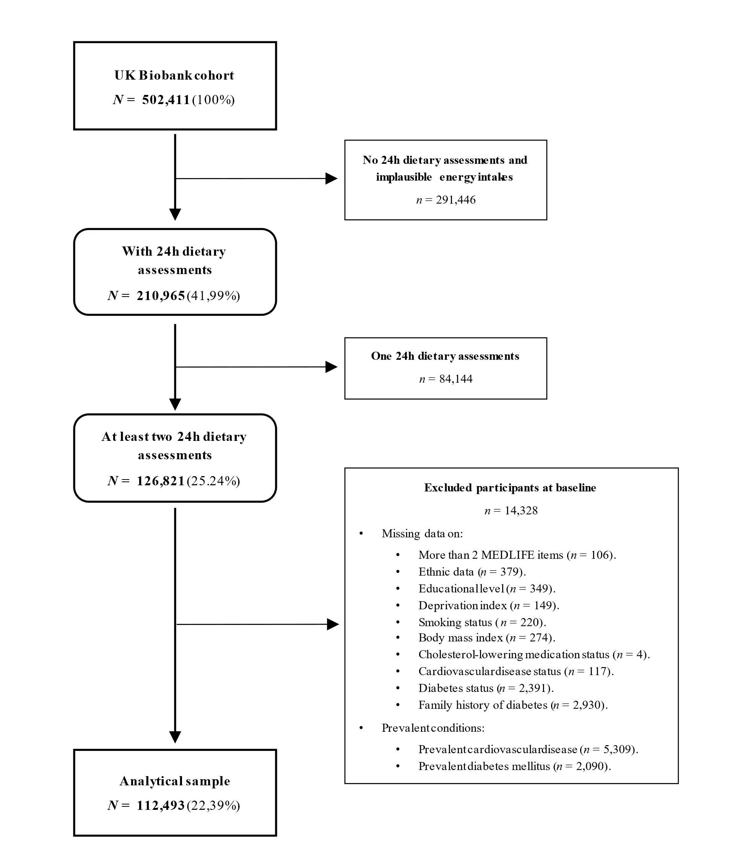

Supplementary Figure S2. Associations between the MEDLIFE index (per 1 point) and risk of type 2 diabetes in the UK Biobank, excluding items from the score (N = 112,493).
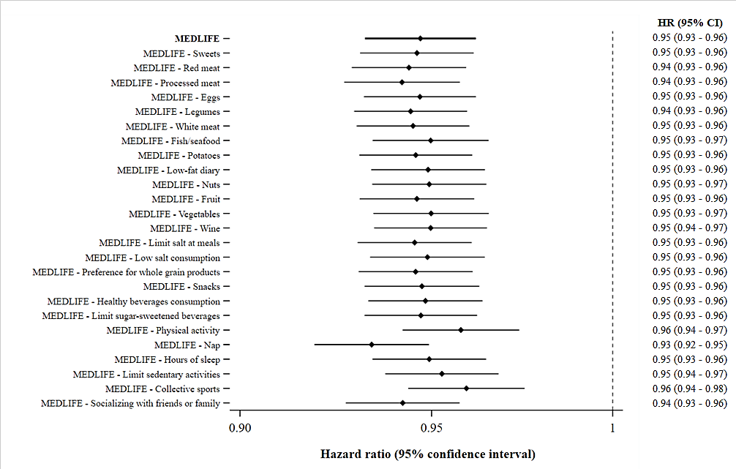
Adjusted for sex, age, ethnicity, education, deprivation index, region of assessment, smoking status, energy intake, hypertension, cholesterol-lowering medication, body mass index, family history of diabetes, and the subtracted item. Abbreviations: N, total number of participants.

