Supplementary materials

Supplement to: High triglyceride-glucose (TyG) index is associated with poor prognosis of heart failure with preserved ejection fraction

Table of contents
Supplementary Figure 1. Comparison of TyG index levels among HFpEF, HFmrEF and HFrEF
Supplementary Figure 2. ROC curves of MAGGIC risk score and the composite score of MAGGIC and TyG index
Supplementary Table 1. Subgroup analyses of the association between TyG index and all-cause death according to patient characteristics and comorbidities
Supplementary Table 2. Subgroup analyses of the association between TyG index and CV death according to patient characteristics and comorbidities
Supplementary Table 3. Subgroup analyses of the association between TyG index and HF rehospitalization according to patient characteristics and comorbidities
Supplementary Table 4. The number of events among the three TyG index groups

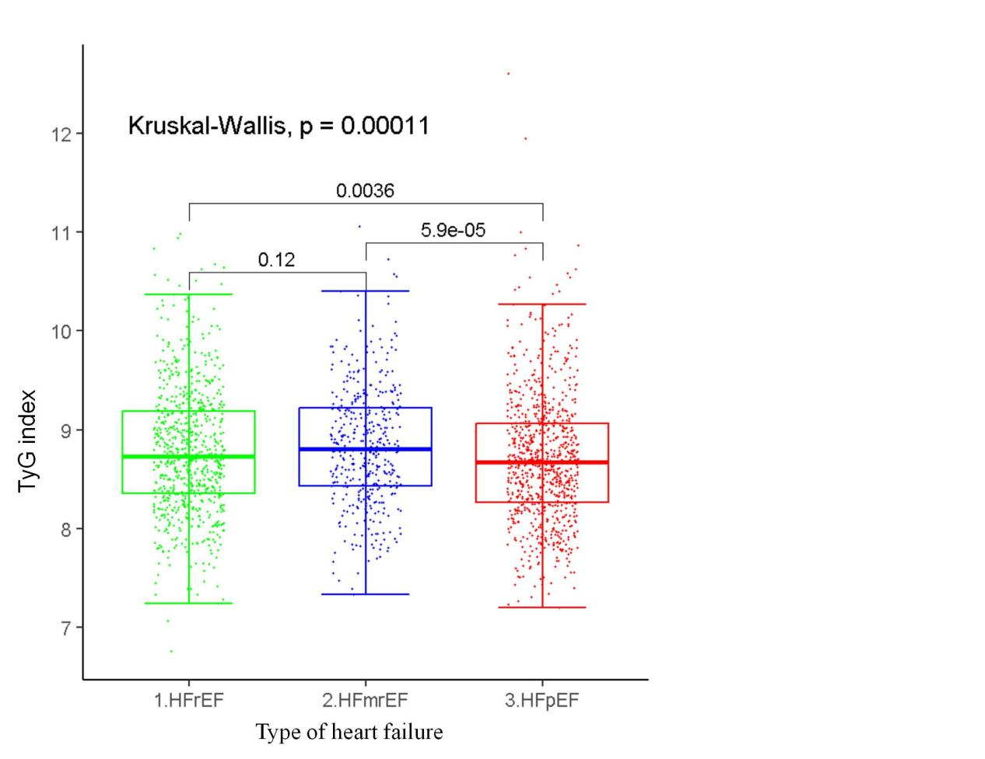
Supplementary Figure 1. Comparison of TyG index levels among HFpEF, HFmrEF and HFrEF.

Abbreviations: TyG, triglyceride-glucose; HFrEF, heart failure with reduced ejection fraction; HFmrEF, heart failure with mid-range ejection fraction; HFpEF, heart failure with preserved ejection fraction.
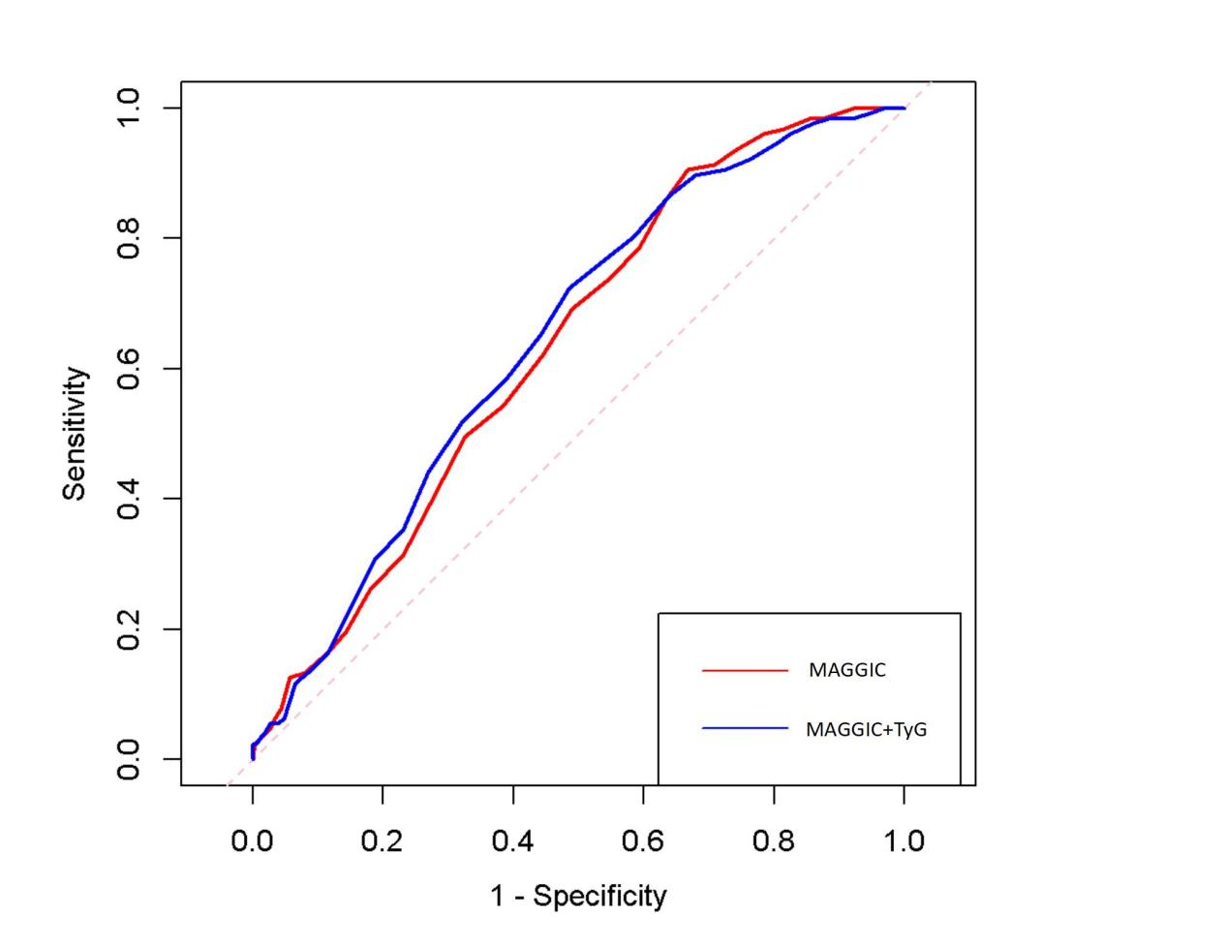
Supplementary Figure 2. ROC curves of MAGGIC risk score and the composite score of MAGGIC and TyG index.

Abbreviations: TyG, triglyceride-glucose; MAGGIC, Meta-Analysis Global Group in Chronic Heart Failure
Supplementary Table 1. Subgroup analyses of the association between TyG index and all-cause death according to patients characteristics and comorbidities.
Subgroup | Events/Total | HR | 95%CI | P-value | P_{interaction}
Age, year
<65 | 17/188 | 1.30 | 1.01-1.66 | 0.042 | 0.754
≥65 | 130/635 | 1.56 | 1.07-2.28 | 0.022
Gender
Female | 73/396 | 1.56 | 1.16-2.10 | 0.004 | 0.178
Male | 74/427 | 1.26 | 1.01-1.58 | 0.045
BMI
<25 kg/m² | 132/694 | 1.40 | 1.06-1.84 | 0.017 | 0.306
≥25 kg/m² | 15/129 | 1.42 | 1.02-2.09 | 0.040
Cause of HFpEF
CHD | 75/414 | 1.43 | 1.08-1.89 | 0.012 | 0.977
Other causes | 72/409 | 1.27 | 1.01-1.60 | 0.045
Diabetes
Yes | 68/346 | 1.53 | 1.09-2.17 | 0.017 | 0.589
No | 79/477 | 1.36 | 1.01-1.85 | 0.049
Hyperlipidemia
Yes | 34/266 | 1.67 | 1.03-2.72 | 0.040 | 0.653
No | 113/557 | 1.49 | 1.23-1.81 | <0.001
Renal dysfuncion
Yes | 31/116 | 1.33 | 1.10-1.61 | 0.003 | 0.450
No | 116/707 | 1.53 | 1.09-2.17 | 0.017
LVEF
>60% | 92/562 | 1.31 | 1.01-1.73 | 0.049 | 0.643
50%-60% | 55/261 | 1.60 | 1.02-2.48 | 0.037

HR and 95%CI was based on per 1-uint increase in TyG index.
HR, hazard ratio; CI, confidence interval; BMI, body mass index; HFpEF, heart failure with preserved ejection fraction; CHD, coronary heart disease.

Supplementary Table 2. Subgroup analyses of the association between TyG index and CV death according to patients characteristics and comorbidities.
Subgroup | Events/Total | HR | 95%CI | P-value | P_{interaction}
Age, year
<65 | 17/188 | 1.31 | 1.02-1.68 | 0.033 | 0.676
≥65 | 122/635 | 1.49 | 1.03-2.17 | 0.035
Gender
Female | 71/427 | 1.48 | 1.03-2.12 | 0.033 | 0.193
Male | 68/396 | 1.31 | 1.01-1.69 | 0.043
BMI
<25 kg/m² | 125/694 | 1.39 | 1.06-1.82 | 0.017 | 0.255
≥25 kg/m² | 14/129 | 1.68 | 1.03-2.73 | 0.040
Cause of HFpEF
CHD | 72/414 | 1.46 | 1.01-2.12 | 0.047 | 0.981
Other causes | 67/409 | 1.29 | 1.04-1.59 | 0.020
Diabetes
Yes | 66/346 | 1.70 | 1.05-2.75 | 0.034 | 0.462
No | 73/477 | 1.36 | 1.01-1.84 | 0.045
Hyperlipidemia
Yes | 31/266 | 0.97 | 0.65-1.45 | 0.893 | 0.771
No | 108/557 | 1.51 | 1.18-1.93 | 0.001
Renal dysfuncion
Yes | 28/116 | 1.38 | 1.02-1.87 | 0.038 | 0.491
No | 111/707 | 1.38 | 1.09-1.76 | 0.008
LVEF
>60% | 88/562 | 1.34 | 1.01-1.78 | 0.040 | 0.609
50%-60% | 51/261 | 1.55 | 1.02-2.35 | 0.041
HR and 95%CI was based on per 1-uint increase in TyG index.
HR, hazard ratio; CI, confidence interval; CV, cardiovascular; BMI, body mass index; HFpEF, heart failure with preserved ejection fraction; CHD, coronary heart disease.

Supplementary Table 3. Subgroup analyses of the association between TyG index and HF rehospitalization according to patients characteristics and comorbidities.
Subgroup | Events/Total | HR | 95% CI | P-value | P_{interaction}
Age, year
<65 | 41/188 | 1.36 | 1.03-1.78 | 0.030 | 0.845
≥65 | 181/635 | 1.29 | 1.04-1.59 | 0.020
Gender
Female | 124/427 | 1.14 | 0.98-1.32 | 0.087 | 0.256
Male | 98/396 | 1.15 | 1.00-1.32 | 0.045
BMI
<25 kg/m² | 191/694 | 1.19 | 0.90-1.59 | 0.225 | 0.278
≥25 kg/m² | 31/129 | 1.30 | 1.05-1.60 | 0.015
Cause of HFpEF
CHD | 113/414 | 1.04 | 1.01-1.07 | 0.017 | 0.798
Other causes | 109/409 | 1.11 | 0.89-1.37 | 0.364
Diabetes
Yes | 98/346 | 1.40 | 1.08-1.80 | 0.011 | 0.576
No | 124/477 | 1.78 | 1.13-2.82 | 0.015
Hyperlipidemia
Yes | 73/266 | 0.89 | 0.66-1.21 | 0.455 | 0.731
No | 149/557 | 1.29 | 1.05-1.59 | 0.014
Renal dysfuncion
Yes | 35/116 | 1.27 | 0.85-1.88 | 0.239 | 0.245
No | 187/707 | 1.38 | 1.04-1.83 | 0.021
LVEF
>60% | 151/562 | 1.18 | 0.95-1.46 | 0.123 | 0.376
50%-60% | 71/261 | 1.21 | 0.84-1.73 | 0.299
HR and 95%CI was based on per 1-uint increase in TyG index.
HR, hazard ratio; CI, confidence interval; BMI, body mass index; HF, heart failure; HFpEF, heart failure with preserved ejection fraction; CHD, coronary heart disease.
Supplementary Table 4. The number of events among the three TyG index groups.
Endpoints | Overall  n = 823 | Tertile 1  n = 276 | Tertile 2  n = 273 | Tertile 3  n = 274
All-cause death | 147 (17.9) | 52 (19.0) | 41 (15.0) | 54 (19.6)
CV death | 139 (16.9) | 50 (18.2) | 37 (13.6) | 52 (18.8)
HF rehospitalization | 222 (27.0) | 72 (26.1) | 70 (25.6) | 80 (29.2)
The numbers of events are shown as n (%).
CV cardiovascular, HF heart failure

