Safety and efficacy of Bempedoic Acid: a systematic review and metanalysis of randomized controlled trials.
Additional file appendix

Table of contents
Search strategy (PubMed example)
Additional file 1: Figure S1. PRISMA flowchart for study selection
Additional file 1: Table S1. Baseline features of included patients.
Additional file 1: Figure S2. Risk of Bias assessment of included trials.
Additional file 1: Figure S3. Peto Odds ratio for stroke, cardiovascular death and all-cause death.
Additional file 1: Figure S4. Risk of MACE according to inclusion criteria and background medical history. (excel sheet provided separately)
Table S2. Endpoint definition (provided in a separate file)
Additional file 1: Figure S5. Sensitivity analysis for MACE (excluding trials with arms of BA and ezetimibe)
Additional file 1: Figure S6. Efficacy of BA compared to control for percentage reduction at 12 weeks of LDL-cholesterol, total cholesterol and non-HDL cholesterol, apolipoprotein B, high-sensitivity C reactive protein (hs-CRP).
Additional file 1: Figure S7. Efficacy of BA on laboratory endpoints at latest available follow-up: effect of LDL-C, total cholesterol, and non-HDL-C
Additional file 1: Figure S8. Efficacy of BA on laboratory endpoints at latest available follow-up: effect on Apo-B and hs-PCR
Additional file 1: Figure S9. Sensitivity analysis: efficacy of BA on % reduction of LDL-c after excluding arms of BA+ ezetimibe.
Additional file 1: Figure S10. Efficacy of BA on LDL-C % reduction according to background medical history and trials’ inclusion criteria
Additional file 1: Figure S11. Efficacy of BA on total cholesterol and non HDL-cholesterol according to background medical history and trials’ inclusion criteria
Additional file 1: Figure S12. efficacy of BA on HS CPR and ApoB lipoprotein according to background medical history and trials’ inclusion criteria
Additional file 1: Figure S13. Efficacy of BA on LDL reduction according to statin background therapy.
Additional file 1: Figure S14. Efficacy of BA on LDL reduction according to background ezetimibe therapy
Additional file 1: Figure S15. Risk of any adverse event, serious adverse events and drug discontinuation due to an adverse event
Additional file 1: Table S3. Metaregression analysis
Additional file 1: Figure S16. Metaregression analysis. Impact of age on the risk of MACE
Additional file 1: Figure S17. Metaregression analysis. Impact of male gender on the risk of MACE
Additional file 1: Figure S18. Metaregression analysis. Impact of baseline LDL-C on the risk of MACE
Additional file 1: Figure S19. Metaregression analysis. Impact of diabetes on the risk of MACE
Additional file 1: Figure S20. Metaregression analysis. Impact of age on the difference in reduction of LDL-c between patients receiving bempedoic acid and control treatment group
Additional file 1: Figure S21. Metaregression analysis. Impact of male gender on the difference in reduction of LDL-c between patients receiving bempedoic acid and control treatment group
Additional file 1: Figure S22. Metaregression analysis. Impact of baseline LDL-c on the difference in reduction of LDL-c between patients receiving bempedoic acid and control treatment group
Additional file 1: Figure S23. Metaregression analysis. Impact of diabetes on the difference in reduction of LDL-c between patients receiving bempedoic acid and control treatment group

Search strategy
PubMed search Keywords Number of results
(bempedoic acid OR ETC-1002) 60
(bempedoic acid OR ETC-1002) AND (cholesterol) 228
(bempedoic acid OR ETC-1002) AND (cholesterol OR hypercholesterolemia) 245
(bempedoic acid OR ETC-1002) AND (cholesterol OR hypercholesterolemia OR hypercholesterolemic) 245
(bempedoic acid OR ETC-1002) AND (cholesterol OR hypercholesterolemia OR hypercholesterolemic OR lipoprotein) 247
(bempedoic acid OR ETC-1002) AND (cholesterol OR hypercholesterolemia OR hypercholesterolemic OR lipoprotein OR LDL) 248

Additional file 1: Figure S1. PRISMA flowchart for study selection

Additional file 1: Table S1. Baseline features of patients enrolled in trials included in the meta-analysis. BMI: body mass index; HDL-C: high density lipoprotein cholesterol; LDL-C: low density lipoprotein cholesterol; APO-B: apolipoprotein-B; Hs-CPR: high sensitivity C-reactive protein; T2DM: type 2 diabetes mellitus

First Author, year  (Study acronym) | Population |  |  | Patients, n | Male (%) | Ezetimibe (%) | Statin (%) | High intensity statin (%) | BMI | ASCVD (%) | FH (%) | Hypertension | Diabetes (%) | Baseline total Cholesterol | Baseline HDL-C | Baseline  Non HDL-C | Baseline LDL-C | Baseline triglycerides | Apo-B | Baseline Hs- CPR
Ray 2019,  (CLEAR HARMONY) | ASCVD and/or FH |  | BA | 1448 | 73.9 | 7.8 | 99.8 | 49.9 | N/A | 97.4 | 3.8 | 78.9 | 28.6 | 179.7 ± 35.1 | 48.7 ± 11.9 | 130.9 ± 33.7 | 103.6 ± 29.1 | 126  (98-166) | 88.5 ±21.6 | 1.49  (0.74- 3.28)
Ray 2019,  (CLEAR HARMONY) |  |  | Control | 742 | 71.3 | 7.5 | 100 | 49.9 | N/A | 98 | 3.1 | 80.1 | 28.6 | 178.6 ± 35.6 | 49.3 ± 11.5 | 129.4 ± 33.9 | 102.3 ± 30.0 | 123  (96-170) | 86.8 ±21.8 | 1.51  (0.79-3.3)
Ballantyne 2019 | CAD and/or FH and/or multiple CV risk factors |  | BA + EZE | 108 | 46.3 | 100 | 69,4 | 38,9 | 31,2 | 55,6 |  | 87 | 45.4 | 236.0 ± 49.0 | 49.0 ± 15.0 | 188.0 ± 47.0 | 152.0 ± 41.0 | 157  (106-209) | 121.1 ± 30.9 | 3.1  (1.7-6.2)
Ballantyne 2019 |  |  | Control | 55 | 60 | 0 | 74,5 | 21 | 30,5 | 56,4 |  | 85,5 | 43.6 | 233.0 ± 50.0 | 50.0 ±14.0 | 181.0 ± 50.0 | 153.0 ± 47.0 | 139  (105-168) | 115.1 ± 32.5 | 3  (1.4-5.5)
Ballantyne 2019 | CAD and/or FH and/or multiple CV risk factors |  | BA | 110 | 40,9 | 0 | 75,4 | 36,4 | 30,6 | 57,3 |  | 89,1 | 56.5 | 229.0 ± 43.0 | 50.0 ± 12.0 | 176.0 ± 41.0 | 147.0 ± 41.0 | 141  (108-190) | 113.4 ±26.4 | 2.9  (1.4-5)
Ballantyne 2019 |  |  | Control | 55 | 60 | 0 | 74,5 | 21 | 30,5 | 56,4 |  | 85,5 | 43.6 | 233.0 ± 50.0 | 50.0 ± 14.0 | 181.0 ± 50.0 | 153.0 ± 47.0 | 139  (105-168) | 115.1 ± 32.5 | 3  (1.3-5.5)
Goldberg 2019,  (CLEAR WISDOM) | ASCVD and/or FH |  | BA | 522 | 62.8 | 7.3 | 90 | 53.3 | 30 | 94.8 | 5.2 | 83.9 | 29.7 | 202.1 ± 42.7 | 51.4 ± 12.9 | 150.7 ± 42.7 | 119.4 ± 37.7 | 139  (102-190) | 116.2 ± 29.6 | 1.61  (0.87-3.46)
Goldberg 2019,  (CLEAR WISDOM) |  |  | Control | 257 | 65.4 | 9.3 | 88.8 | 52.5 | 30.6 | 93.8 | 6.2 | 87.2 | 31.5 | 204.8 ± 46.1 | 51.1 ± 13.1 | 153.7 ± 44.4 | 122.4 ± 38.3 | 143  (106-189) | 118.6 ± 30.5 | 1.88  (0.92-3,79)
Lalwani 2019 | Hypercholesterolemic |  | BA | 41 | 48,8 | 0 | 100 | 100 | 31 | 0 | 0 | NA | NA | 146.0 ± 27.0 | 49.0 ± 16.0 | 96.0 ± 24.0 | 71.0 ± 19.0 | 104  (52-331) | 70 ± 15 | 3.2  (0.1-14.8)
Lalwani 2019 |  |  | Control | 23 | 56,5 | 0 | 100 | 100 | 31 | 0 | 0 | NA | NA | 161.0 ± 28.0 | 47.0 ± 9.0 | 114.0 ± 28.0 | 86.0 ± 26.0 | 124  (74-286) | 82 ± 21 | 2.5  (0.1-17.0)
Ballantyne 2016 | Hypercholesterolemic |  | BA | 45 | 52 | 0 | 100 | NA | 30 | 0 | NA | NA | NA | 229.0 ± 29.0 | 55.0 ± 14.0 | NA | 142.0 ± 28.0 | 145  (122-196) | NA | 1.8  (1.20-4.00)
Ballantyne 2016 |  |  | Control | 45 | 32 | 0 | 100 | NA | 31 | 0 | NA | NA | NA | 212.0 ± 24.0 | 54.0 ± 14.0 | NA | 131.0 ± 22.0 | 119  (82-159) | NA | 1.8  (1.10-4.60)
Laufs 2019 | Statin intolerant patients |  | BA | 234 | 43.2 |  | 18 | 0 | 30.1 | 38.5 | 1.7 | 67.5 | 26.9 | 245.7 ± 47.3 | 52.2 ± 14.5 | 193.5 ± 45.1 | 158.5 ± 40.4 | 156.5  (114.5-219.0) | 141.0 ±31.6 | 2.92  (1.34, 5.29)
Laufs 2019 |  |  | Control | 111 | 45 |  | 11 | 0 | 30.6 | 39.6 | 2.7 | 67.6 | 23.4 | 241.1 ± 44.3 | 50.4 ± 14.4 | 190.7 | 155.6 ± 38.8 | 164.0  (120-225.5) | 141.9 ± 30.4 | 2.78  (1.21, 5.15)
Ballantyne 2018 | Hypercolesterolemic |  | BA | 181 | 39.8 | 100 | 21 | 0 | 29.5 | 27.1 | NA | 61.3 | 19.3 | 228.2 ± 35.9 | 55.8 ± 16.3 | 162.4 ± 35.4 | 129.8 ± 30.9 | 153.0  (12.0-209.0) | 123.33 ± 26.5 | 2.21  (1.10, 4.00)
Ballantyne 2018 |  |  | Control | 88 | 36.7 | 100 | 8 | 0 | 30.5 | 25.0 | NA | 58.0 | 19.3 | 206.8 ± 35.7 | 57.1 ± 21.3 | 151.7 ± 32.7 | 123.0 ± 27.2 | 135.5  (99.8-175.8) | 115.88 ± 23.5 | 2.26  (1.06, 4.50)
Rubino 2020 | Hypercolesterolemic |  | BA | 43 | 40 | 5 | 56 | N/A | 29.3 | 0 | 29,3 | 53 | 0 | 235.7 ± 27.9 | 51.2 ± 12.9 | 183.1 ± 18.4 | 154.3 | 126.5  (88.0-190.5) | 118.0 ± 19.9 | 1.0  (1.04-7.0).
Rubino 2020 |  |  | Control | 20 | 30 | 5 | 45 | N/A | 28.4 | 0 | 2.44 | 35 | 0 | 235.1 ± 21.2 | 52.0 ± 13.0 | 183.1 | 155.9 | 125.0  (90.2, 171.0) | 119.2 ± 15.2 | 1.6  (0.9, 3.2)
Bays 2021 | T2DM and Hypercholesterolemic |  | BA | 60 | 55 | 100 | 0 | 0 | 31.1 | 0 | 0 | NA | 100 | 230.3 ± 37.2 | 48.7 ± 13.1 | 181.7 ± 36.7 | 145.1 ± 31.5 | 172.2  (128-239) | 121.6 ± 23 | 2.6  (1.7-4.9)
Bays 2021 |  |  | Control | 119 | 50.5 | 50 | 0 | 0 | 31.4 | 0 | 0 | NA | 100 | 223.6 ± 33.2 | 48.2 ± 11.7 | 175,1 ± 31.2 | 141.3 ± 27.3 | 161  (118-236) | 119 ± 20.7 | 2.9  (1.5-7)
Rubino 2021 | Hypercolesteolemic |  | BA | 28 | 25 | 0 | 0 | 0 | 2.,6 | 0 | 0 | NA | 0 | 186.2 ± 38.3 | 56.5 ± 12.3 | 129.7 ± 36.3 | 102.1 ± 29.0 | 130.2  (92.8-176,5 | 87.5 ± 27 | 3.1  (1.3-4.6)
Rubino 2021 |  |  | Control | 30 | 50 | 0 | 0 | 0 | 28.2 | 0 | 0 | NA | 0 | 190.3 ± 39.4 | 57.3 ± 15.5 | 133.0 ± 36.6 | 104.1 ± 32.1 | 129.0  (101-190.5) | 87.9 ± 28.3 | 2.1  (1.1, 4.7)
Niessen 2023 |  | Statin intolerant patients | BA | 7001 | 51.8 | 11.5 | 22.9 | N/A | 29.9 | 70 | N/A | N/A | 45.6 | 223.5±40.6 | 49.6±13.3 | 173.8±39.5 | 139.0±34.9 | 159.5 (118.0–216.5) | N/A | 2.3  (2.0-4.5)
 |  | Statin intolerant patients | Control | 6964 | 51.9 | 11.6 | 22.5 | N/A | 30.0 | 69.8 | N/A | N/A | 45.9 | 223.3±41.1 | 49.4±13.3 | 173.9±40.2 | 139.0±35.2 | 158.5 (118.0–215.0) | N/A | 2.3  (2.0-4.5)

Additional file 1: Figure S2. Risk of Bias assessment of included trials.
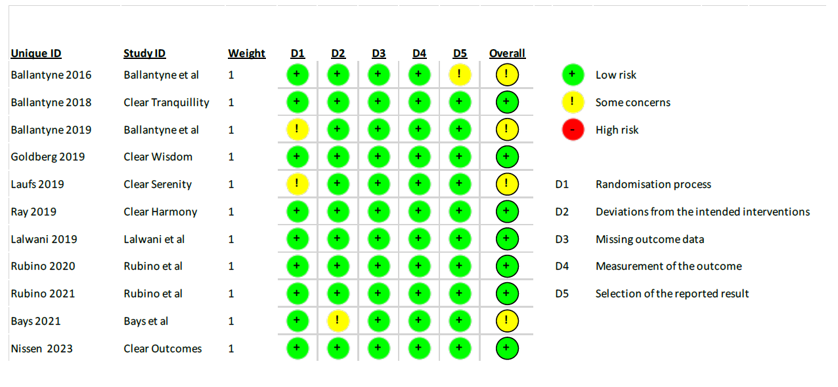

Additional file 1: Figure S3. Peto Odds ratio for stroke, cardiovascular death and all-cause death.
Legend as in figure 1.
Additional file 1: Figure S4. Risk of MACE according to inclusion criteria and background medical history.
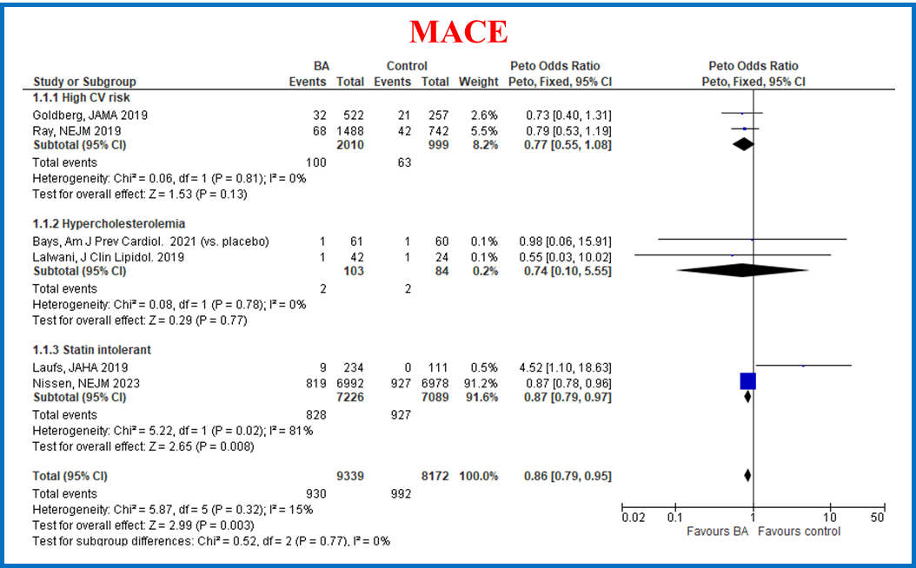
Legend. CI: confidence intervals; BA: bempedoic acid.

Additional file 1: Figure S5. Sensitivity analysis for MACE (excluding trials with arms of BA and ezetimibe)
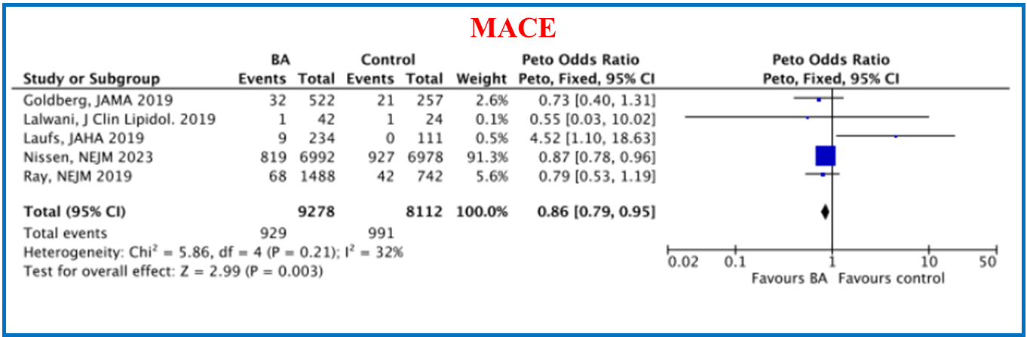
Legend as in Additional file 1: Figure S2.

Additional file 1: Figure S6. Efficacy of BA compared to control for percentage reduction at 12 weeks of LDL-cholesterol, total cholesterol and non-HDL cholesterol, apolipoprotein B, high-sensitivity C reactive protein (hs-CRP).
Legend as in figure 1.

Additional file 1: Figure S7. Efficacy of BA on laboratory endpoints at latest available follow-up
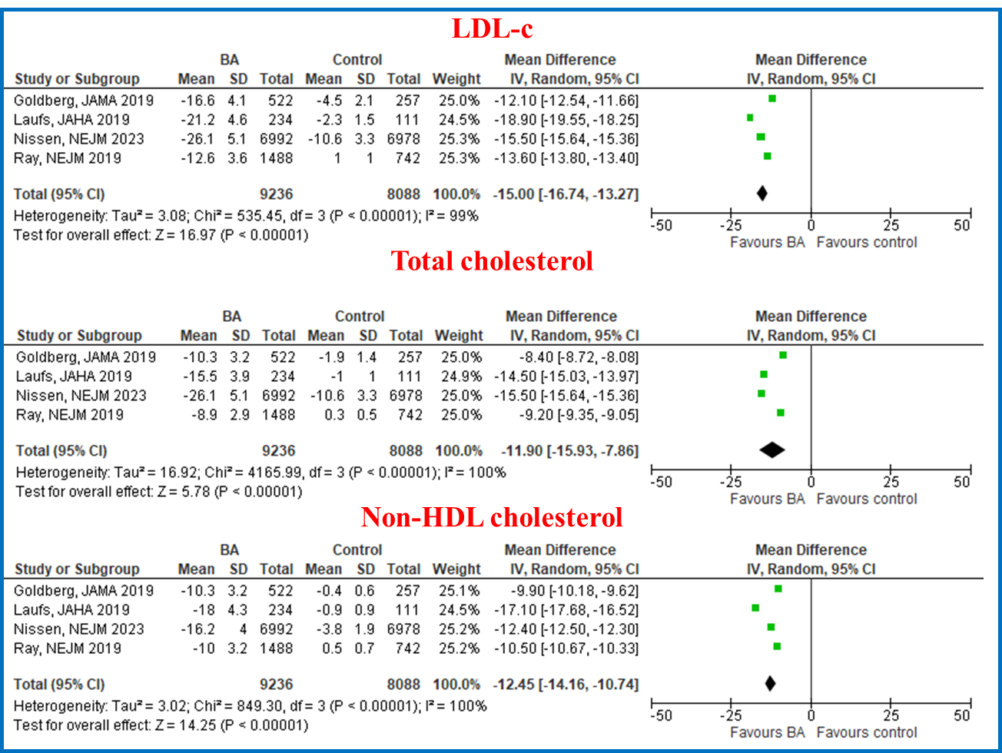
Legend as in Additional file 1: Figure S2. Data are observed over a median FU of 52 weeks (IQR, 45-79.5)

Additional file 1: Figure S8. Efficacy of BA on laboratory endpoints at latest available follow-up: effect on Apo-B and hs-PCR
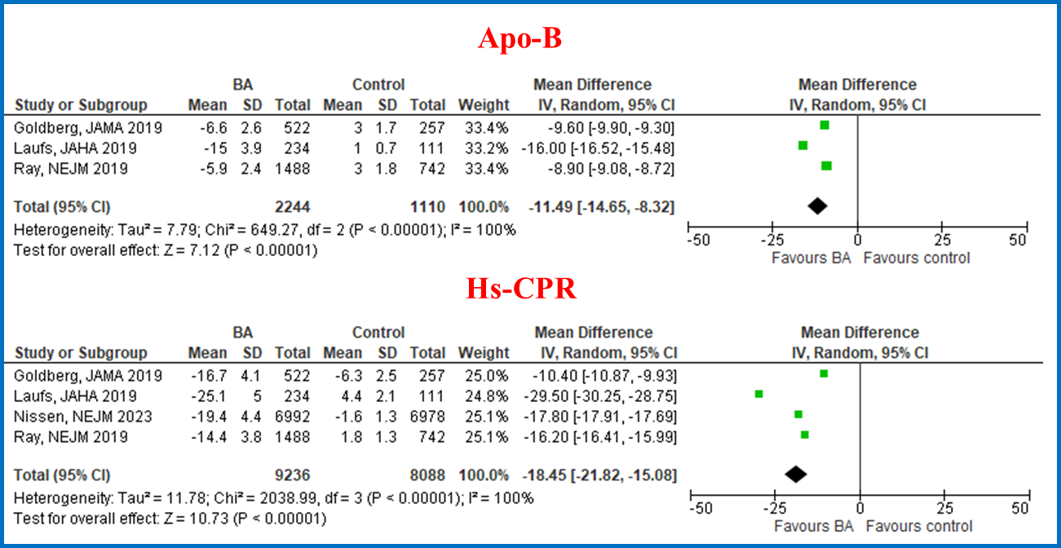
Legend as in Additional file 1: Figure S2. median observation period 52 weeks (IQR 45-79.5) for hs-CPR and 52 weeks (IQR 38-52) for ApoB.

Additional file 1: Figure S9. Sensitivity analysis: efficacy of BA on % reduction of LDL-c after excluding arms of BA+ ezetimibe
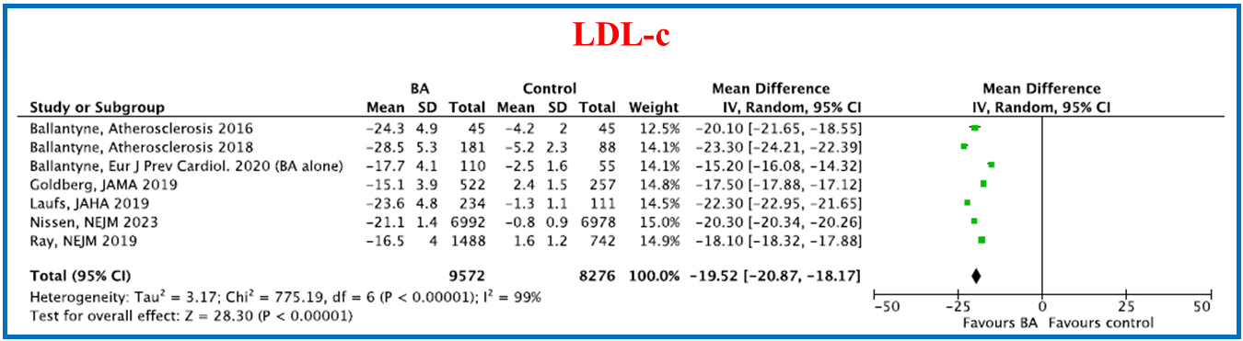
Legend as in Additional file 1: Figure S2.

Additional file 1: Figure S10. Efficacy of BA on LDL-C % reduction according to background medical history and trials’ inclusion criteria

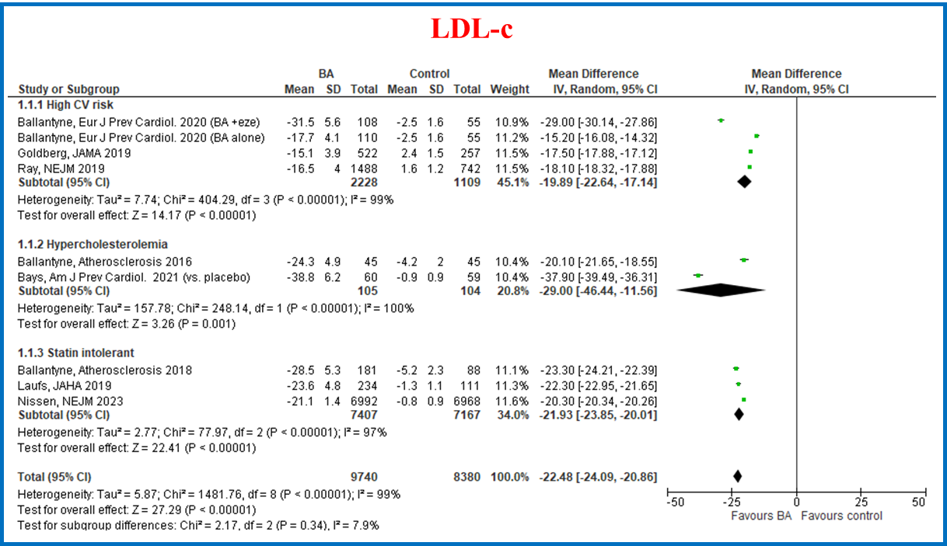
Legend as in Additional file 1: Figure S2.

Additional file 1: Figure S11. Efficacy of BA on total cholesterol and non HDL-cholesterol according to background medical history and trials’ inclusion criteria

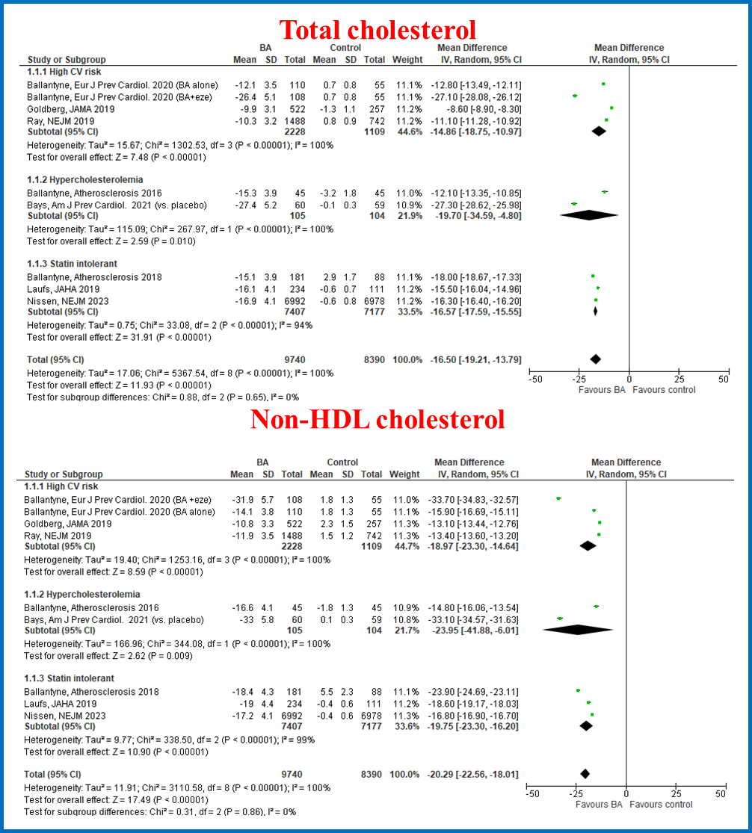
Legend as in Additional file 1: Figure S2
Additional file 1: Figure S12. Efficacy of BA on HS CPR and ApoB lipoprotein according to background medical history and trials’inclusion criteria
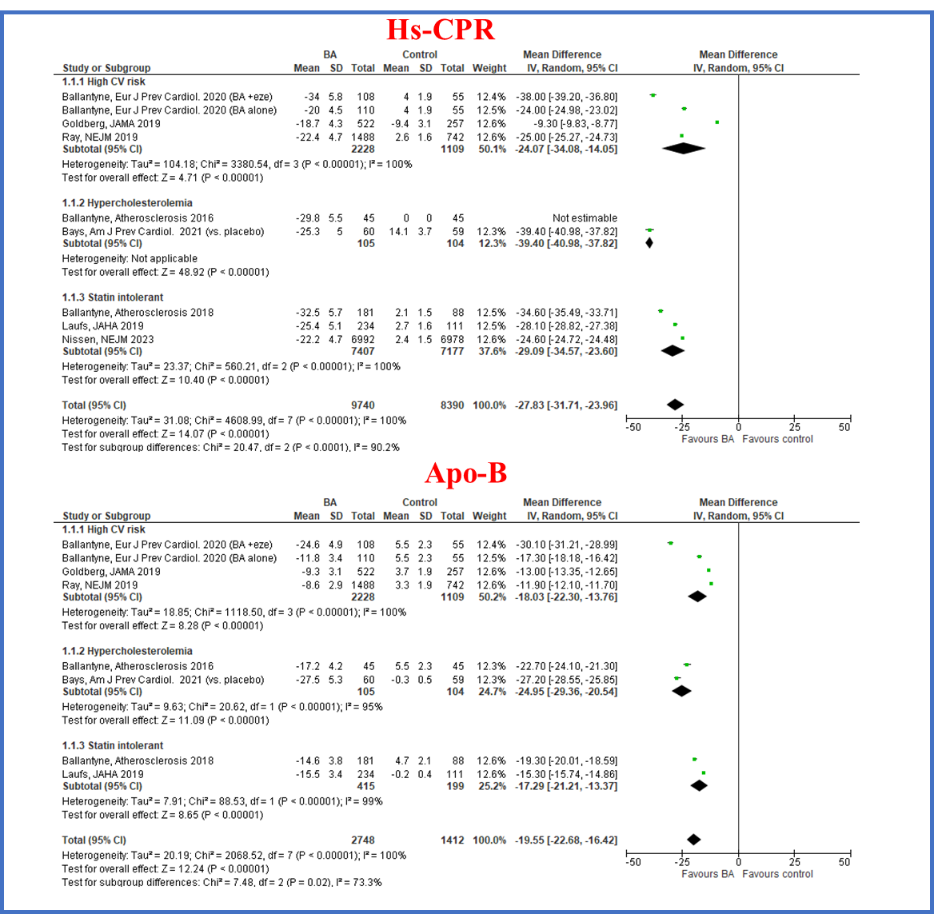
Legend as in Additional file 1: Figure S2

Additional file 1: Figure S13. Efficacy of BA on 12 weeks reduction of LDL-C according to statin background therapy
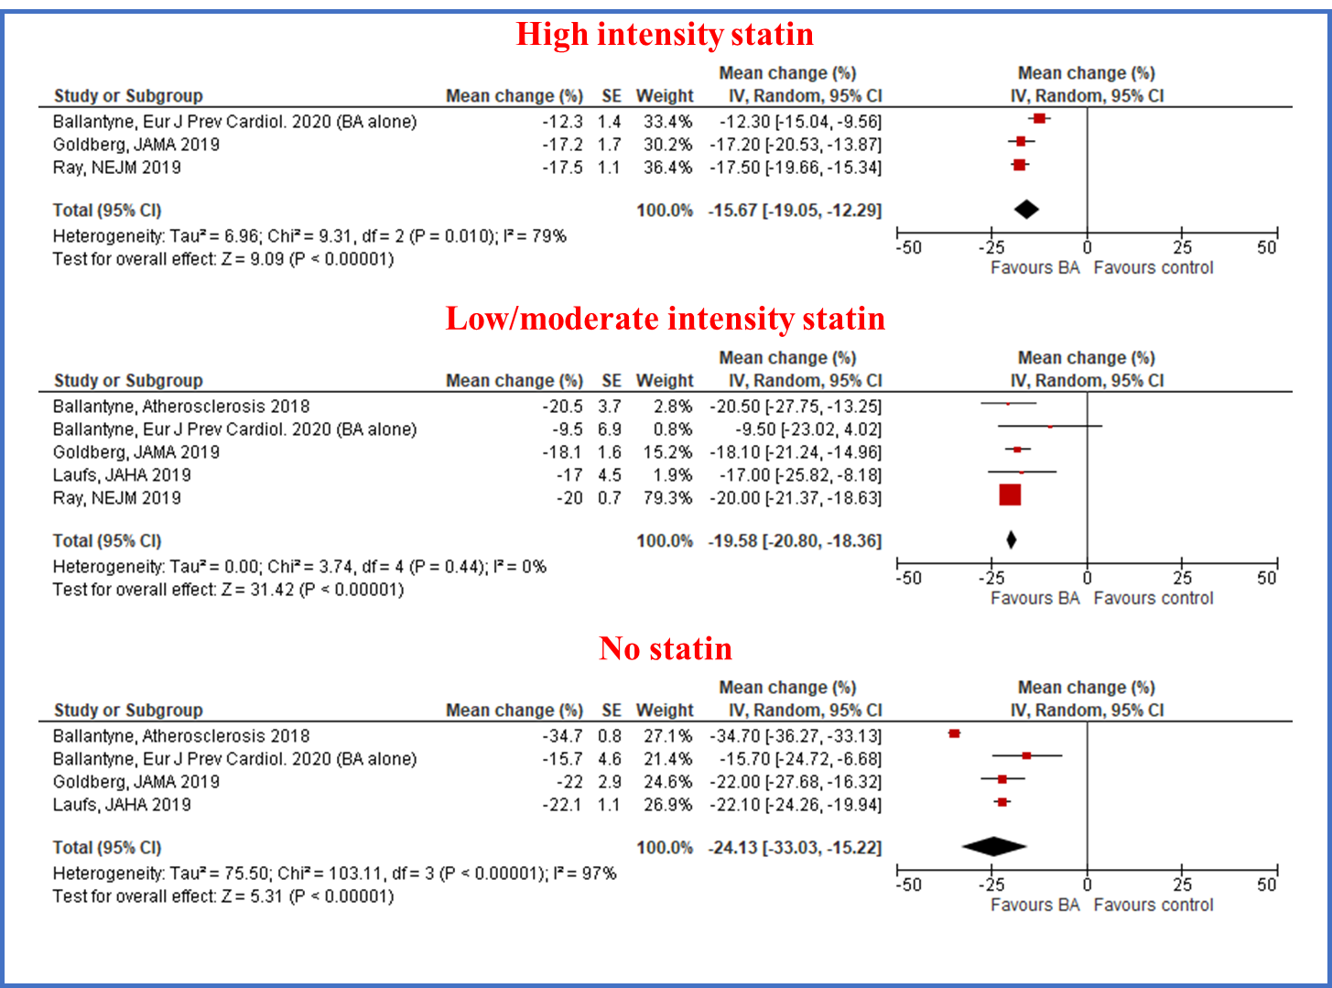
Legend as in Additional file 1: Figure S2.

Additional file 1: Figure S14. Efficacy of BA on LDL reduction according to background ezetimibe therapy
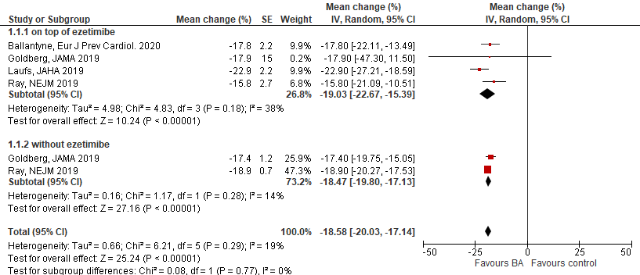

Additional file 1: Figure S15. Risk of any adverse event, serious adverse events and drug discontinuation due to an adverse event

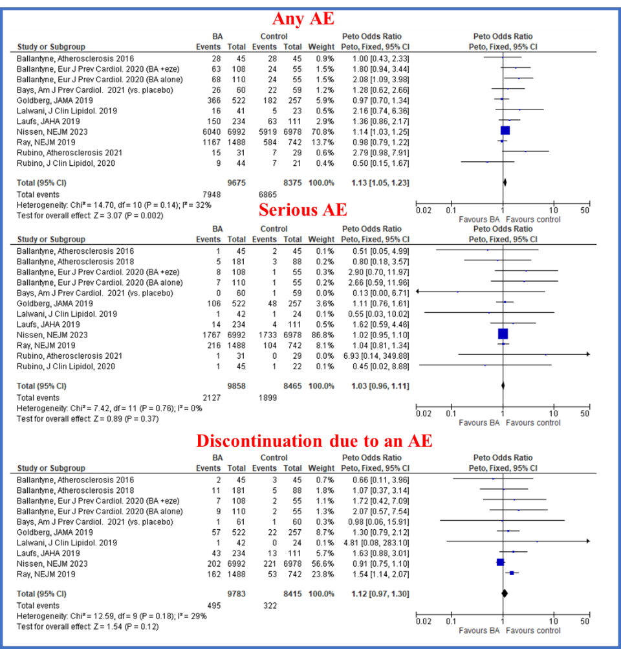
AE: adverse events. BA: bempedoic acid

Additional file 1: Table S3. Metaregression analysis

COVARIATES |  | MACE | LDL-C change
AGE | Beta | 0.03 | 0.09
AGE | 95% CI | $-$0.41 to 0.48 | 0.01 to 0.16
AGE | P value | 0.9 | 0.03
Male sex | Beta | $-$0.009 | $-$0.002
Male sex | 95% CI | $-$0.041 to $-$0.022 | $-$0.006 to 0.002
Male sex | P value | 0.6 | 0.4
Diabetes | Beta | 0.001 | 0.002
Diabetes | 95% CI | $-$0.04 to 0.04 | $-$0.001 to 0.006
Diabetes | P value | 1.0 | 0.1
Baseline cholesterol | Beta | 0.003 | 0.001
Baseline cholesterol | 95% CI | $-$0.006 to 0.011 | $-$0.003 to 0.003
Baseline cholesterol | P value | 0.5 | 1.0
Baseline LDL-c | Beta | 0.004 | 0.02
Baseline LDL-c | 95% CI | $-$0.007 to 0.01 | $-$0.51 to 0.38
 | P value | 0.5 | 0.8

MACE: major adverse cardiovascular events; CI: confidence intervals; LDL-C: low density lipoprotein cholesterol.

Additional file 1: Figure S16. Metaregression analysis. Impact of age on the risk of MACE
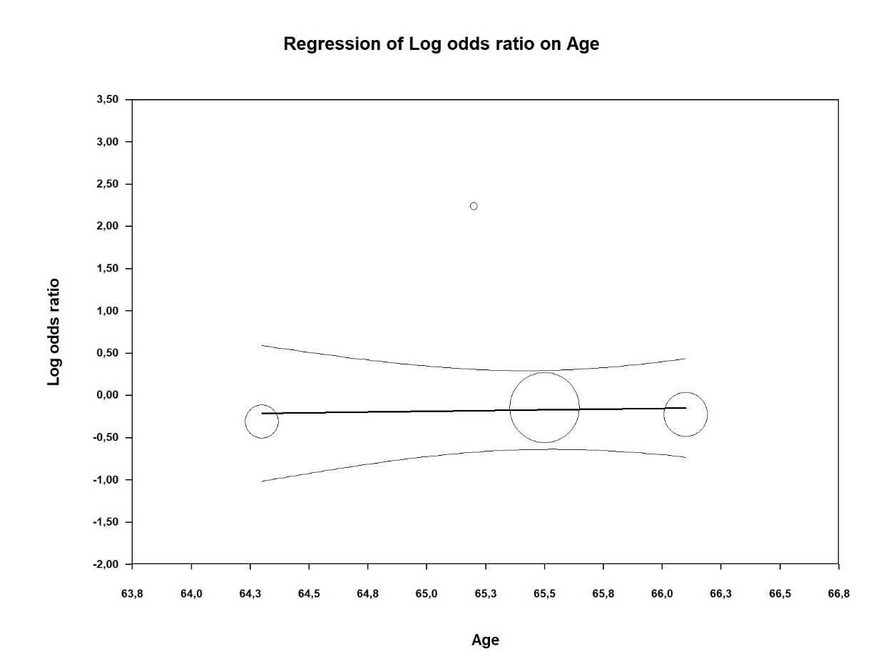

Additional file 1: Figure S17. Metaregression analysis. Impact of male on the risk of MACE
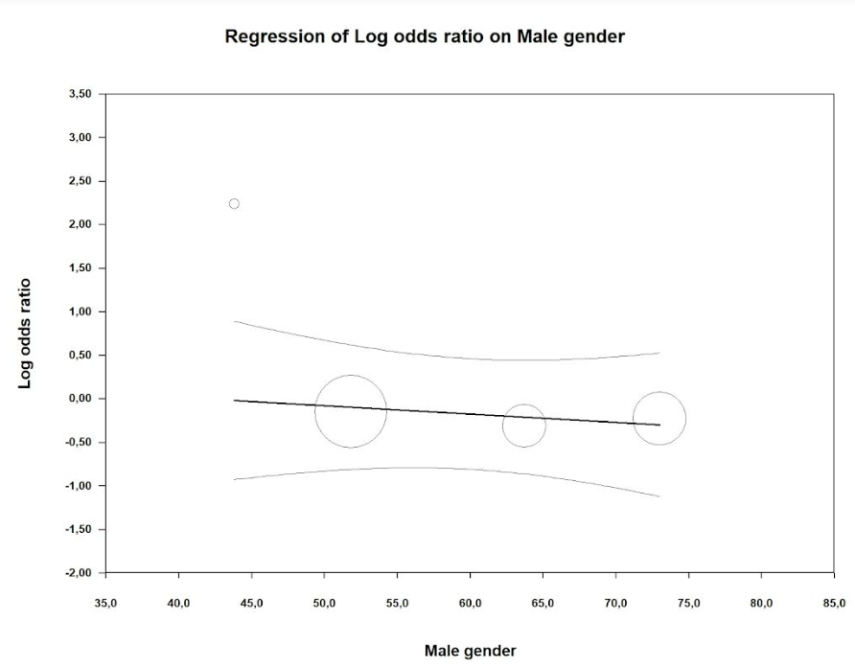

Additional file 1: Figure S18. Metaregression analysis. Impact of baseline LDL-C on the risk of MACE

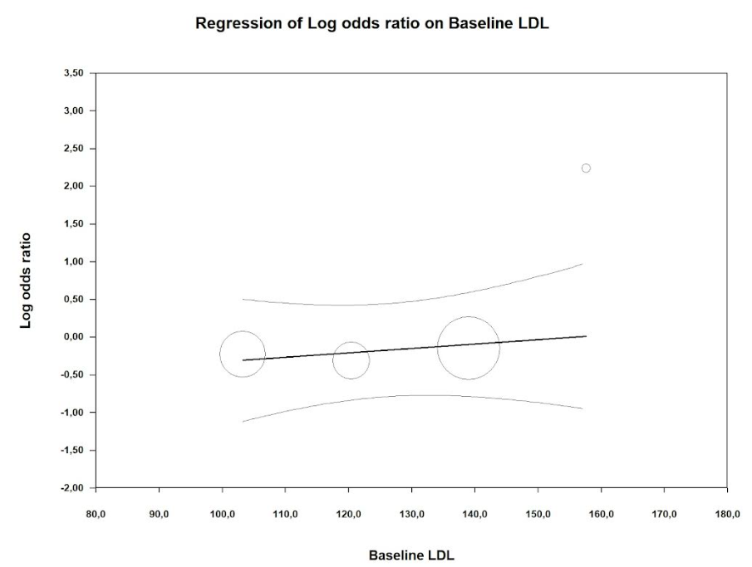

Additional file 1: Figure S19. Metaregression analysis. Impact of diabetes on the risk of MACE
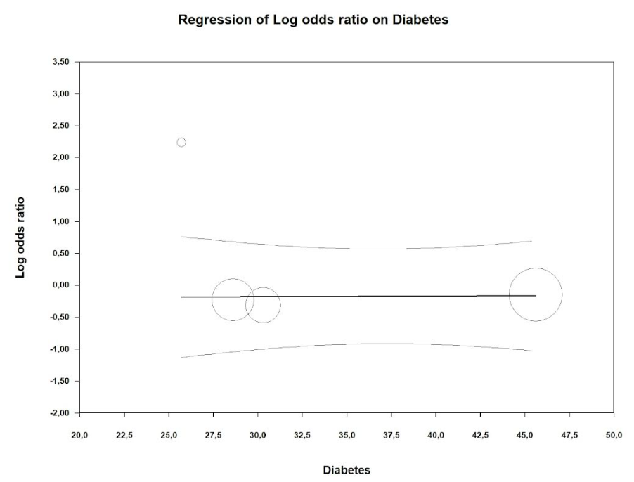

Additional file 1: Figure S20. Metaregression analysis. Impact of age on the difference in reduction of LDL-c between patients receiving bempedoic acid and control treatment group

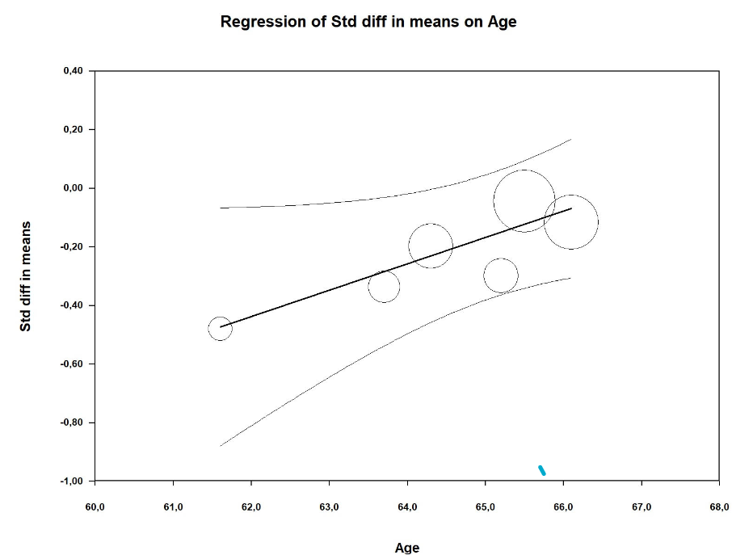

Additional file 1: Figure S21. Metaregression analysis. Impact of male gender on the difference in reduction of LDL-c between patients receiving bempedoic acid and control treatment group
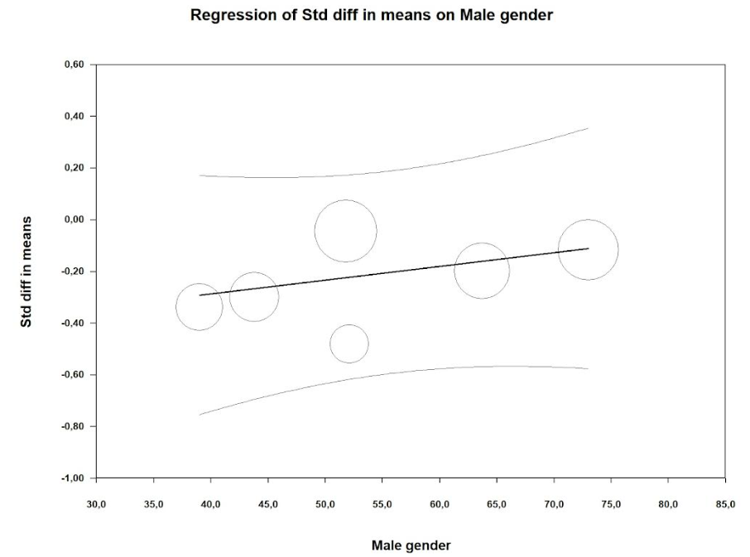

Additional file 1: Figure S22. Metaregression analysis. Impact of baseline LDL-c on the difference in reduction of LDL-c between patients receiving bempedoic acid and control treatment group

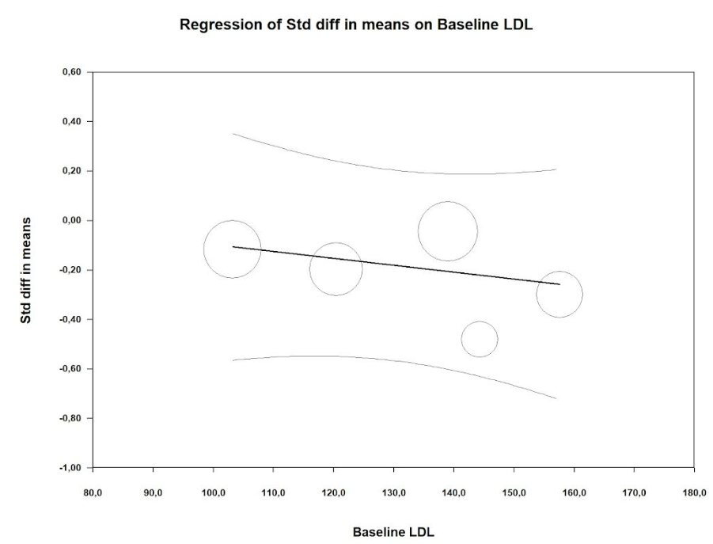

Additional file 1: Figure S23. Metaregression analysis. Impact of diabetes on the difference in reduction of LDL-c between patients receiving bempedoic acid and control treatment group
