Table 1. Selected pathological findings in nailfold capillaroscopy in relation to the group studied
Features of the capillaroscopic image |  | Group B (n = 86)  n / % | Group C (n = 35)  n / % | p
Enlarged capillaries | ≤ 4  ≥ 5 | 15 / 17.40 %  13 / 15.10 % | 2 / 5.70 %  2 / 5.70 % | 0.063
Meandering capillaries | ≤ 4  ≥ 5 | 7 / 8.10 %  18 / 20.90 % | 6 / 17.10 %  1 / 2.90 % | 0.026
Tortuous capillaries | ≤ 4  ≥ 5 | 14 / 16.30 %  21 / 24.40 % | 10 / 28.60 %  3 / 8.60 % | 0.076
Elongated capillaries | ≤ 4  ≥ 5 | 7 / 8.10 %  3 /3.50 % | 2 / 5.70 %  1 / 2.90% | 1
Hemorrhages | ≤ 4  ≥ 5 | 5 / 5.80 %  3 / 3.50 % | 1 / 2.90 %  1 / 2.90% | 0.860
p – level of significance, n – number of studied patients
Table 2. Capillaroscopic changes severity concerning the group studied
Severity scale | Group B (n = 86)  n / % | Group C (n = 35)  n / % | p
0 | 49 / 57.00 % | 31 / 88.60 % | 0.001
1 | 30 / 34.90 % | 2 / 5.70 % | 0.001
2 | 4 / 4.70 % | 0 / 0.00 % | 0.001
3 | 3 /3.50 % | 2 / 5.70 % | 0.001
p – level of significance, n – number of studied patients
Table 3. Summary of abnormalities in the capillaroscopic images in group A (n=118).
Features of the capillaroscopic image | Feature present  n/% | ≤ 4  n/% | ≥ 5  n/%
Enlarged capillaries | 41 / 34.75 % | 22 / 18.64 % | 19 / 16.10 %
Megakapillaries | 0 / 0.00 %
Meandering capillaries | 39 / 33.05 % | 10 / 8.47 % | 29 / 24.58 %
Bushy capillaries | 1 / 0.85 %
Tortuous capillaries | 45 / 38.14 % | 21 / 17.8 % | 24 / 20.34 %
Elongated capillaries | 15 / 12.71 % | 9 / 7.63 % | 6 / 5.08 %
Hemorrhages | 13 / 11.01 % | 7 / 5.93 % | 4 / 3.39 %
Cap shaped hemorrhages | 2 / 1.69 %
Decreased capillary density | 3 / 2.54 %
Invisible venous plexus | 5 / 4.24 %
Granular flow | 8 / 6.78 %
Abnormal overall pattern | 80 / 67.80 %
n – number of studied patients
Table 4. Presentation of capillaroscopic images severity scale in Group A
Severity scale | Group A (n = 118)  n / %
0 | 65 / 55.08 %
1 | 43 / 36.44 %
2 | 5 / 4.24 %
3 | 5 / 4.24 %
n – number of studied patients
Table 5. Number of fingers with specific photoplethysmographic curves in the groups
Number of fingers | Group A  Mean ± SD | Group B  Mean ± SD | Group C  Mean ± SD | Comparison of Group B and C
Normal curve | 6.59 ± 3.08 | 6.49 ± 3.06 | 7.03 ± 3.40 | p = 0.403
Incorrect curve | 1.61 ± 1.74 | 1.58 ±1.74 | 1.29 ± 1.29 | p = 0.398
SD- standard deviation; p – level of significance;
Table 6. Correlations between the mean number of fingers with specific photoplethysmographic curves and clinical parameters in group A
 |  | Curve shape  Normal | Curve shape  Incorrect
BMI-SDS | R_{P}  p | 0.141  0,125 | -0.087  0.347
BF(%) | R_{P}  p | 0.190  0.047 | -0.036  0.707
HbA_{1c} last | R_{P}  p | 0.198  0.033 | -0.113  0.227
HbA_{1c} mean | R_{P}  p | 0.149  0.120 | -0.105  0.274
BMI-SDS – body mass index standard deviation score; BF (%) - body fat mass percentage; HbA1c last – glycated hemoglobin – the result obtained during last three months; HbA1c mean – glycated hemoglobin, the arithmetic mean of results obtained during last year. p – level of significance; R_{P} – Pearson correlation coefficient
Table 7. Statistical significance of relationships between the mean number of fingers with specific curves and selected microangiopathic complications and comorbidities
 | Curve shape  Normal | Curve shape  Incorrect
Albuminuria (n = 3) | p = 0.068 | p = 0.288
Neuropathy (n = 2) | p <0.001 | p = 0.050
Hypertension | p = 0.908 | p = 0.196
Dyslipidemia | p = 0.398 | p = 0.878
Autoimmune thyroiditis | p = 0.712 | p = 0.838
Celiac disease | p = 0.035 | p = 0.214
Asthma | p = 0.282 | p = 0.345
Vitiligo | p = 0.763 | p = 0.286
p – level of significance, n – number of studied patients
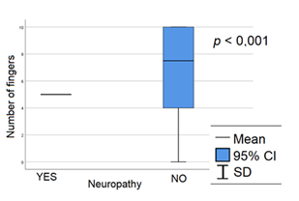  Fig. 1. relation between the number of fingers with normal photoplethysmographic curve and the presence of neuropathy in group A | 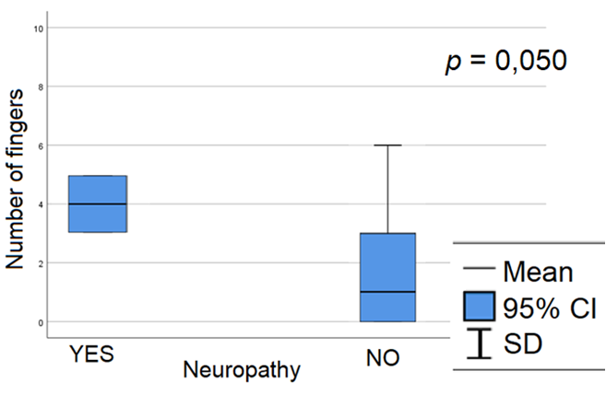  Fig. 2. relation between the number of fingers with photoplethysmographic curve indicating flow disturbances and presence of neuropathy in group A

