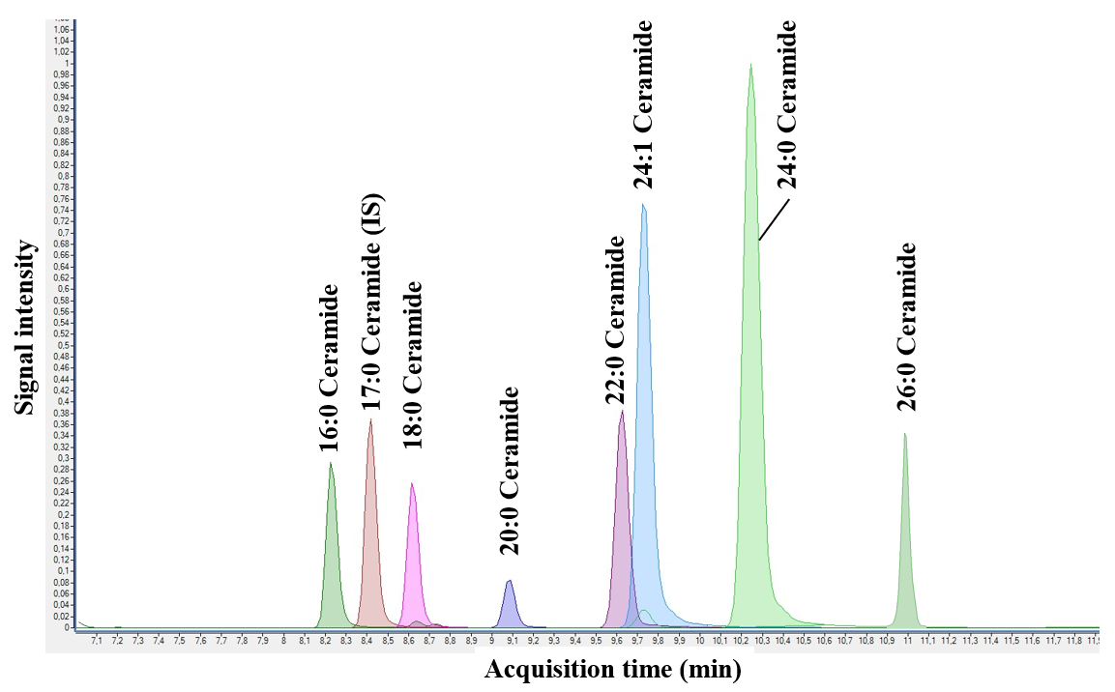

Supplementary Fig. 1 A representative chromatogram of external and internal standards.

