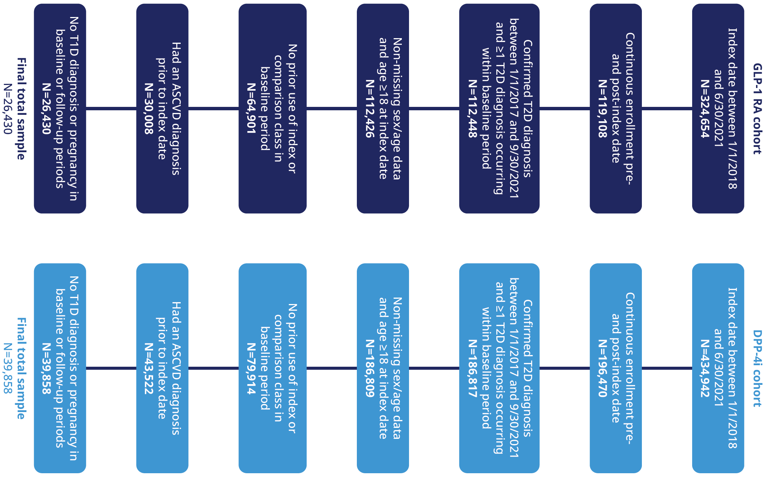
Additional File 3. Patient attrition flow chart. ASCVD, atherosclerotic cardiovascular disease; DPP-4i, dipeptidyl peptidase-4 inhibitor; GLP-1 RA, glucagon-like peptide-1 receptor agonist; T1D, type 1 diabetes; T2D, type 2 diabetes.

