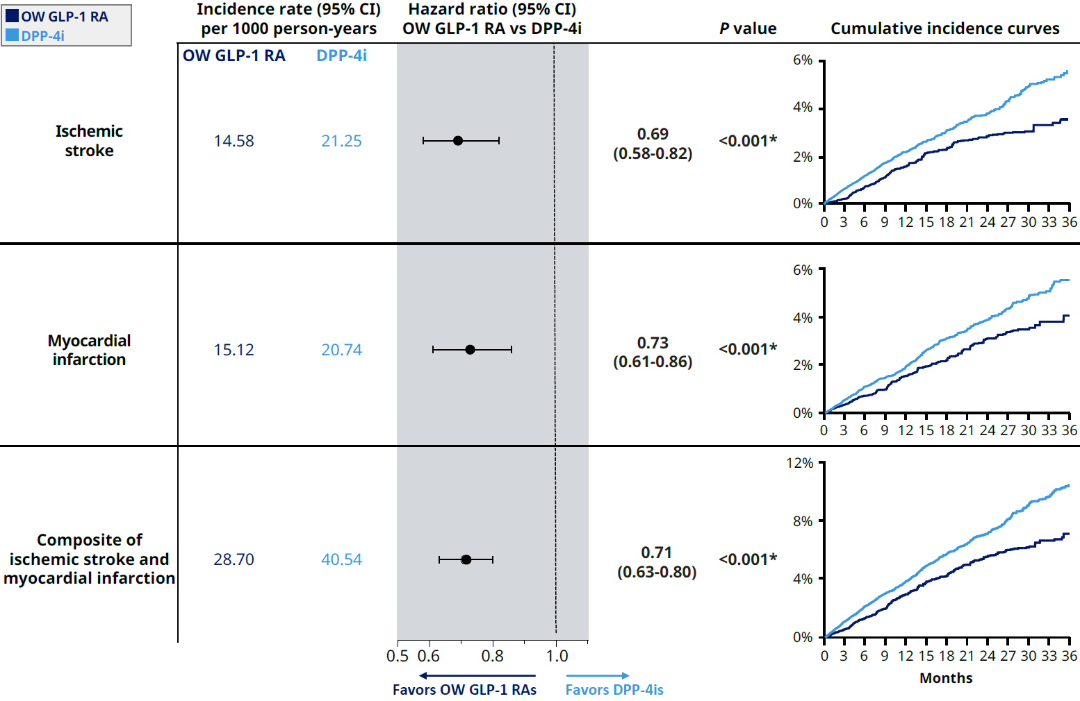
Additional File 9. IPCW Analysis of Clinical Outcomes in Adults With T2D and ASCVD on OW GLP-1 RAs or DPP-4is. IPCW analysis of weighted incidence rates, hazard ratios, and cumulative incidence curves of clinical outcomes comparing OW GLP-1 RAs with DPP-4is among adults with T2D and ASCVD. *Indicates statistical significance (P<0.05). ASCVD, atherosclerotic cardiovascular disease; DPP-4is, dipeptidyl peptidase-4 inhibitors; GLP-1 RAs, glucagon-like peptide-1 receptor agonists; IPCW, inverse probability of censoring weighting; OW, once-weekly; T2D, type 2 diabetes.

