Table S1. Clinical baseline information according to the grouping of collateral circulation
 | Poor CCC  (n=205) | Good CCC  (n=476) | P
Age (years) | 60.19±10.15 | 59.58±10.00 | 0.773
Male (n, %) | 154(75.1%) | 376(79.0%) | 0.129
SBP (mmHg) | 133.33±17.43 | 133.54±17.73 | 0.735
DBP (mmHg) | 78.84±11.24 | 78.55±1.34 | 0.960
Smoking history (n, %) | 82(40.0%) | 203(42.6%) | 0.521
Drinking history (n, %) | 55(26.8%) | 120(25.2%) | 0.657
History of hypertension (n, %) | 121(59.0%) | 281(59.0%) | 0.998
Previous medication
Antihypertensive drugs (n, %) | 118(57.6%) | 275(57.8%) | 0.959
Lipid-lowering drugs (n, %) | 198(96.6%) | 450(94.5%) | 0.254
Antiplatelet drugs (n, %) | 194(94.6%) | 441(92.6%) | 0.343
antidiabetic drugs (n, %) | 78(38.0%) | 124(26.1%) | 0.002*
Laboratory examination
cTNI(ng/mL) | 0.01(0.01-0.02) | 0.01(0.01-0.02) | 0.982
NT-proBNP (pg/mL) | 123.50(81.65-168.20) | 126.00(79.71-174.00) | 0.654
Cr (μmol/L) | 66.91±14.13 | 69.90±14.33 | 0.723
eGFR (ml/min/1.73 m²) | 94.60 ±13.23 | 92.63±12.82 | 0.826
CRP (mg/L) | 1.33(0.77-1.83) | 1.31(0.77-1.90) | 0.507
TC (mg/dL) | 3.71(3.16-4.38) | 3.42(2.92-4.08) | ＜0.001*
TG (mg/dL) | 1.85(1.27-2.60) | 1.32(0.98-1.71) | ＜0.001*
HDL-C (mg/dL) | 0.90 (0.78-1.02) | 0.93(0.80-1.08) | 0.026*
LDL-C((mg/dL) | 2.09(1.65-2.66) | 2.03(1.61-2.56) | 0.142
FPG (mmol/L) | 7.24(5.31-9.43) | 5.17(4.60-6.28) | ＜0.001*
HbA1c (%) | 7.60(6.10-9.20) | 6.10(5.70-6.90) | ＜0.001*
LVEF (%) | 61.00(52.00-64.00) | 61.00(53.00-63.50) | 0.989
TyG index | 9.35(8.81-9.70) | 8.67(8.31-8.99) | ＜0.001*
Glucose metabolism status
NGR | 24(11.7%) | 115(24.2%) | ＜0.001*
Pre-DM | 42(20.5%) | 176(37.0%)
DM | 139(67.8%) | 185(38.9%)
Number of vascular stenosis
1 | 16(7.8%) | 46(9.7%) | 0.061
2 | 62(30.2%) | 104(21.8%)
3 | 127(62.0%) | 326(68.5%)
CTO related artery
LAD | 85(35.1%) | 212(35.2%) | 0.414
LCX | 67(27.7%) | 143(23.7%)
RCA | 90(37.2%) | 248(41.1%)
Rentrop collateral grading
0 | 54(26.3%)
1 | 151(73.7%)
2 |  | 254(53.4%)
3 |  | 222(46.6%)
SBP Systolic blood pressure, DBP Diastolic blood pressure, cTnI: cardiac troponin I, NT-pro BNP: N-terminal B-type natriuretic peptide, Cr: creatinine, eGFR: estimated glomerular filtration rate, CRP: C-reactive protein, TC: total cholesterol, TG: triglyceride, HDL-C: high-density lipoprotein cholesterol, LDL-C: low-density lipoprotein cholesterol, FPG: fasting plasma glucose, HbA1c: glycated hemoglobin LVEF: left ventricular ejection fraction, TyG: triglyceride glucose, NGR: normal glucose regulation, Pre-DM: prediabetes mellitus, DM: diabetes mellitus, LAD: Left anterior descending artery, LCX: Left circumflex coronary artery, RCA: Right coronary artery, *: statistically significant difference between two groups
Table S2. Poor collateral circulation formation in relation to various risk factors
 | Univariate analysis |  |  | Multivariate analysis
 | OR (95%Cl) | β | P | OR (95%Cl) | β | P
TC | 1.403(1.177-1.673) | 0.339 | ＜0.001 | 1.089(0.874-1.356) | 0.085 | 0.448
HDL-C | 0.349(0.163-0.748) | -1.053 | 0.007 | 1.155(0.436-3.059) | 0.144 | 0.773
HbA1c | 1.679(1.497-1.883) | 0.518 | ＜0.001 | 1.278(1.120-1.458) | 0.245 | ＜0.001
TyG index | 7.188(4.998-10.338) | 1.972 | ＜0.001 | 5.104(3.323-7.839) | 1.630 | ＜0.001
TC: total cholesterol, HDL-C: high-density lipoprotein cholesterol, HbA1c: glycosylated hemoglobin, TyG: triglyceride glucose, OR:Odds ratios CI: confidence interval
TC was adjusted for HDL-C、HbA1c、TyG index, HDL was adjusted for TC、HbA1c、TyG index, TyG index was adjusted for TC、HDL-C、HbA1c.

Table S3. Comparison of TyG index and other factors AUC in different glucose metabolic states
 | Pair comparison of ROC curves | Difference between areas | P value
Total | TyG index-TC | 0.185 | ＜0.001
Total | TyG index-TG | 0.088 | ＜0.001
Total | TyG index-FPG | 0.048 | 0.027
Total | TyG index-HbA1c | 0.078 | 0.004
Total | TyG index-HDL-C | 0.208 | ＜0.001
NGR | TyG index-TC | 0.040 | 0.683
NGR | TyG index-TG | 0.017 | 0.364
NGR | TyG index-FPG | 0.031 | 0.701
NGR | TyG index-HbA1c | 0.001 | 0.993
NGR | TyG index-HDL-C | 0.052 | 0.411
Pre-DM | TyG index-TC | 0.020 | 0.001
Pre-DM | TyG index-TG | 0.122 | 0.032
Pre-DM | TyG index-FPG | 0.205 | 0.003
Pre-DM | TyG index-HbA1c | 0.197 | 0.006
Pre-DM | TyG index-HDL-C | 0.132 | 0.025
DM | TyG index-TC | 0.035 | ＜0.001
DM | TyG index-TG | 0.099 | ＜0.001
DM | TyG index-FPG | 0.031 | 0.043
DM | TyG index-HbA1c | 0.081 | 0.012
DM | TyG index-HDL-C | 0.241 | ＜0.001
TC: total cholesterol, HDL-C: high-density lipoprotein cholesterol, HbA1c: glycosylated hemoglobin, TyG: triglyceride glucose, FPG: fasting plasma glucose.

Table S4. Comparison of AUC of TyG index in different glucose metabolic states
Pair comparison of ROC curves | Difference between areas | P value
NGR-Pre-DM | 0.165 | P=0.043
NGR-DM | 0.236 | P＜0.001
NGR-Total | 0.214 | P=0.001
Pre-DM-DM | 0.071 | P=0.205
Pre-DM-Total | 0.049 | P=0.367
DM-Total | 0.022 | P=0.505
NGR: normal glucose regulation, Pre-DM: prediabetes mellitus, DM: diabetes mellitu.

Figure S1 Biochemical indexes in different glucose metabolic states. a HDL-C, b TG, c TyG index, d FPG, e HbA1c.

Figure S2 TyG index and poor CCC restricted cubic spline curves in different glucose metabolic states. a: normal glucose regulation, b: prediabetes mellitus, c: diabetes mellitu.
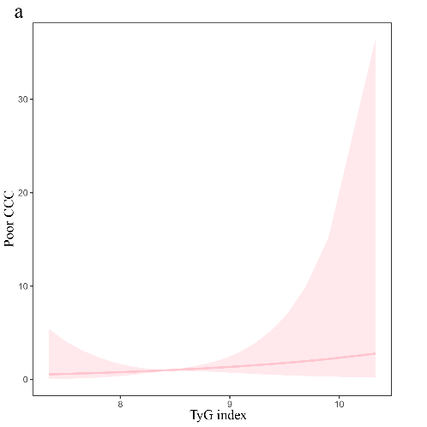 | 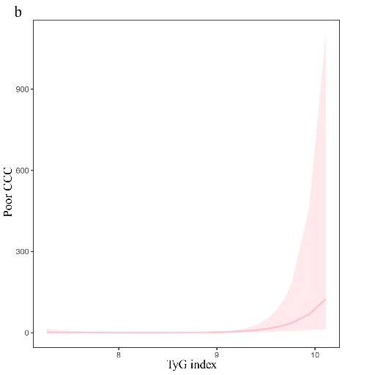 | 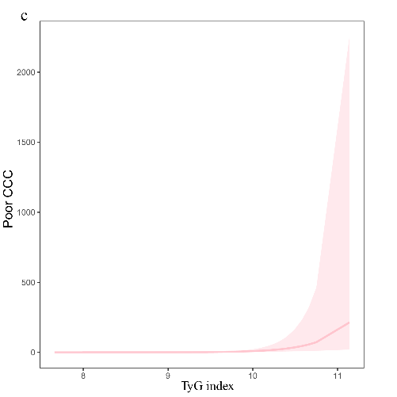

Figure S3. TyG index and other factors predicted poor collateral circulation formation in different glucose metabolic states.
NGR: normal glucose regulation, Pre-DM: prediabetes mellitus, DM: diabetes mellitu.
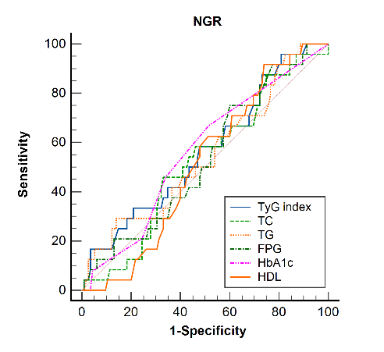 | 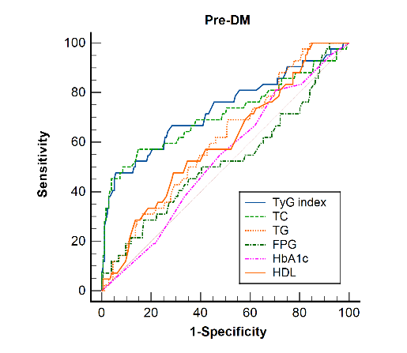
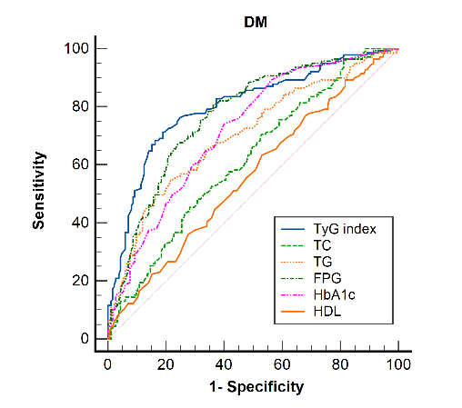 | 