Characterizing Diabetic Cardiomyopathy: Baseline Results from the ARISE-HF Trial

Supplemental Appendix

Supplemental Figure 1: Countries participating in the ARISE-HF Trial and enrollment statistics.
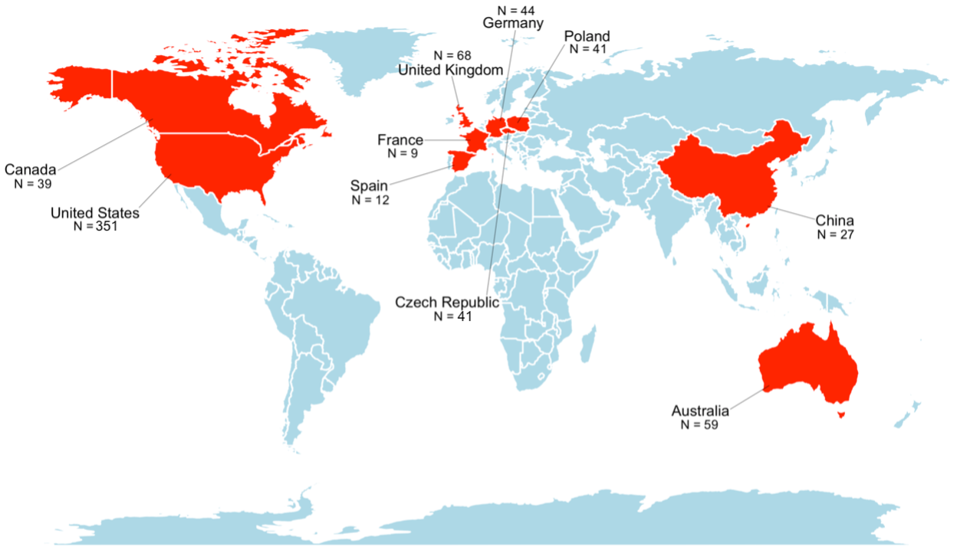

Supplemental Table 1: Key inclusion/exclusion criteria for the ARISE-HF Trial.
Inclusion Criteria | Exclusion Criteria
- Diagnosis of T2DM  - High risk for HF including advanced age, longstanding T2DM or CKD  - Demonstration of DbCM with at least one of the following:  - Structural heart disease on echocardiography*  - NT-proBNP ≥ 50 ng/L  - hs-cTnT ≥ 6 ng/L  - Impaired exercise tolerance on cardiopulmonary exercise testing, with peak oxygen uptake <75% of predicted and adequate exercise effort with a respiratory exchange ratio ≥ 1.05 | - Past or present diagnosis of symptomatic (stage C/D) HF or other forms of heart muscle disease  - Past or present LVEF <40%  - Past or present use of loop diuretics  - Prior acute coronary syndrome or stroke  - Significant coronary artery disease with or without revascularization  - Severe valvular heart disease  - Recent cardiac arrhythmia  - Uncontrolled hypertension  - Hemoglobin A1c > 8.5%  - Hemoglobin < 10.0 g/dL  - eGFR < 45 mL/min/1.73m²  - Body-mass index ≥ 45 Kg/m²  - Inability to exercise  - Recurrent kidney stones

T2DM denotes: type 2 diabetes mellitus; HF denotes: heart failure; CKD denotes: chronic kidney disease; DbCM denotes: diabetic cardiomyopathy; LVEF denotes: left ventricular ejection fraction; g/dL denotes: grams/deciliter; eGFR denotes: estimated glomerular filtration rate; mL/min/1.73m² denotes: milliliters/minute/1.73 squared meters; Kg/m² denotes: kilograms per squared meter

Supplemental Table 2: A comparison of selected baseline characteristics of those patients not included versus those included in the ARISE-HF Trial.

 | Excluded | Included | p
n | 1416 | 691
Age, mean (SD) | 66.8 (8.2) | 67.4 (7.2) | 0.12
Female sex, N (%) | 670 (47.3) | 348 (50.4) | 0.21
Race, N (%) |  |  | 0.15
White, non-Hispanic | 877 (61.9) | 432 (62.5)
Hispanic | 294 (20.8) | 151 (21.9)
Black | 119 (8.4) | 42 (6.1)
Asian | 109 (7.7) | 56 (8.1)
American Indian or Alaskan Native | 2 (0.1) | 4 (0.6)
Other | 15 (1.1) | 6 (0.9)
Smoking, N (%) |  |  | 0.81
Current | 135 (9.6) | 64 (9.3)
Previous | 470 (33.3) | 240 (34.7)
Never | 806 (57.1) | 387 (56.0)
Duration of T2DM, years, mean (SD) | 14.2 (8.3) | 14.5 (10.1) | 0.75

SD denotes: standard deviation, T2DM denotes: type 2 diabetes mellitus

