Table S1. Baseline characteristics, laboratory, medications, and echocardiography data of the study population.
 | All patients  (n=400) | HFpEF with  events (n=190) | HFpEF without  events (n=210) | P value
Age (years) | 71.0±7.8 | 71.9±8.2 | 70.1±7.4 | 0.019
Female, n (%) | 226 (56.5) | 106 (55.8) | 120 (57.1) | 0.785
BMI (kg/m2) | 25.2±3.8 | 25.7±4.2 | 24.7±3.3 | 0.014
NYHA class III-IV, n (%) | 201 (50.3) | 102 (53.7) | 99 (47.1) | 0.191
Systolic BP (mmHg) | 140.9±23.2 | 139.2±24.5 | 142.4±21.9 | 0.160
Diastolic BP (mmHg) | 77.9±13.5 | 76.5±14.6 | 79.2±12.2 | 0.044
Heart rate (beats per minute) | 80.8±17.2 | 81.8±19.3 | 79.9±15.1 | 0.272
Comorbidities, n (%)
CHD | 162 (40.5) | 75 (39.5) | 87 (41.4) | 0.691
Atrial fibrillation | 103 (25.8) | 67 (35.3) | 36 (17.1) | 0.001
Smoking | 86 (21.5) | 49 (25.8) | 37 (17.6) | 0.047
Alcohol | 43 (10.8) | 24 (12.6) | 19 (9.0) | 0.248
Hypertension | 298 (74.5) | 143 (75.3) | 155 (73.8) | 0.739
Diabetes | 166 (41.5) | 95 (50.0) | 71 (33.8) | 0.001
Hyperlipidemia | 124 (31.0) | 69 (36.3) | 55 (26.2) | 0.029
Chronic Kidney Disease | 52 (13.0) | 28 (14.7) | 24 (11.4) | 0.326
Laboratory data
HbA1c (g/L) (%) | 6.6±1.3 | 6.6±1.3 | 6.5±1.2 | 0.459
ABG (μmol/L) | 6.9±2.7 | 7.4±3.1 | 6.4±2.2 | <0.001
SHR | 0.88±0.2 | 0.94±0.3 | 0.83±0.2 | <0.001
Haemoglobin, g/dL | 126.9±19.1 | 124.6±20.8 | 129.1±17.3 | 0.021
TSH (mg/l) | 3.8±9.0 | 4.2±10.9 | 3.5±6.6 | 0.445
ALT | 26.5±24.9 | 25.9±22.9 | 27.01±26.6 | 0.662
Troponin T | 0.06±0.1 | 0.06±0.1 | 0.05±0.1 | 0.576
NT-proBNP (pg/mL) | 1127.0 (573.8-2216.3) | 1295.0 (702.0-2747.5) | 878.5 (440.5-1803.3) | 0.001
LDL | 2.1±0.8 | 2.2±0.9 | 2.0±0.8 | 0.056
Total cholesterol | 3.9±1.1 | 4.0±1.2 | 3.9±1.1 | 0.787
Creatinine (mg/dl) | 90.3±39.6 | 95.8±43.3 | 85.4±35.4 | 0.009
eGFR | 70.5±23.5 | 66.2±22.4 | 74.4±23.9 | 0.001
Blood urea | 7.6±6.4 | 7.9±4.5 | 7.2±7.8 | 0.336
Potassium (mmol/L) | 4.0±0.6 | 4.0±0.7 | 4.0±0.5 | 0.922
C-reactive protein | 3.3 (3.0-6.3) | 3.3 (3.0-7.5) | 3.3 (3.0-5.5) | 0.064
Medications data, n (%)
Beta-blockers | 242 (60.5) | 112 (58.9) | 130 (61.9) | 0.546
Diuretics | 192 (48.0) | 95 (50.0) | 97 (46.2) | 0.446
MCRA | 129 (32.3) | 64 (33.7) | 65 (31.0) | 0.559
Calcium channel blockers | 124 (31.0) | 53 (27.9) | 71 (33.8) | 0.201
ACEI+ARB | 197 (49.3) | 90 (47.4) | 107 (51.0) | 0.474
Statins | 335 (83.8) | 152 (80.0) | 183 (87.1) | 0.053
Echocardiography
LAVI, mL/m2 | 42.6±6.2 | 43.6±5.8 | 41.8±6.3 | 0.003
LVEDD (mm) | 47.4±5.6 | 47.7±5.3 | 47.0±5.9 | 0.246
LVESD (mm) | 31.8±6.8 | 31.8±6.0 | 31.8±7.5 | 0.972
LVEF (%) | 60.5±5.0 | 59.9±4.9 | 61.0±4.9 | 0.033
e', cm/s | 7.0 (6.0-8.0) | 6.0 (5.8-8.0) | 7.0 (6.0-8.0) | 0.011
Septal E/e’ | 15.0±3.0 | 15.4±2.9 | 14.7±3.1 | 0.020
PASP (mmHg) | 38.7±11.4 | 39.9±12.5 | 37.6±10.4 | 0.044
BMI: body mass index; NYHA class: New York heart association; BP: blood pressure; CHD: coronary heart disease; HbA1c: glycated hemoglobin; ABG: admission blood glucose; SHR: stress hyperglycemia ratio; TSH: thyroid stimulating hormone; ALT: alanine aminotransferase; NT-proBNP: N-terminal pro–B-type natriuretic peptide; LDL: low-density lipoprotein; eGFR: estimated glomerular filtration rate; MCRA: mineralocorticoid receptor antagonist; ACEI+ARB angiotensin-converting enzyme inhibitors/angiotensin receptor blockers; LAVI: left atrial volume index; LVEDD: left ventricular end-diastolic diameter; LVESD: left ventricular end-systolic diameter; LVEF: left ventricular ejection fraction; e': peak LV velocity; E/e': mean septal velocity; PASP: pulmonary artery systolic pressure.

Table S2. Outcomes of study population according to SHR cut-off
 | All patients  (n=400) | Patients with  SHR>0.99 (n=124) | Patients with  SHR≤0.99 (n=276) | P value
Total Events | 190 (47.5) | 88 (71.0) | 102 (37.0) | <0.001
All-cause mortality | 75 (18.8) | 35 (28.2) | 40 (14.5) | 0.001
Cardiovascular mortality | 62 (15.5) | 28 (22.6) | 34 (12.3) | 0.009
HF readmissions | 115 (28.8) | 53 (42.7) | 62 (22.5) | <0.001
SHR: stress hyperglycemia ratio; HF: heart failure.

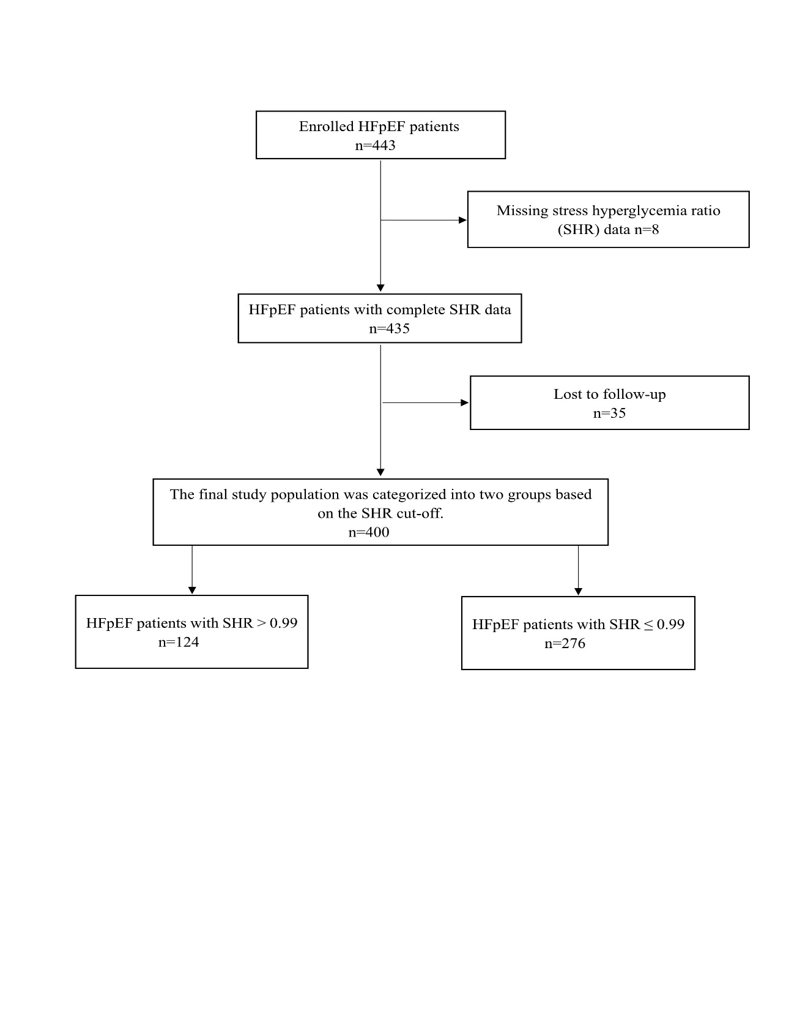
Figure S1: Flowchart of patients enrolled.
HFpEF: heart failure with preserved ejection fraction; SHR: stress hyperglycemia ratio.

Figure S2. The distribution of SHR among HFpEF patients with and without events.
SHR: stress hyperglycemia ratio; HFpEF: heart failure with preserved ejection fraction

Figure S3. Relationship between SHR and HF parameters.
A. Correlation between SHR and NT-proBNP; B. Correlation between SHR and E/e'; C. Correlation between SHR and e'.
SHR: stress hyperglycemia ratio; NT-proBNP: N-terminal pro–B-type natriuretic peptide; E/e': mean septal velocity; e': peak LV velocity.

Figure S4. Outcomes stratified according to SHR tertiles.
SHR1: ≤0.74, SHR2: >0.74 - ≤0.98, SHR3: >0.98.
SHR: stress hyperglycemia ratio

